APPENDIX 2-6. Carbaryl Species Sensitivity Distribution Analysis for Aquatic Invertebrates
SSDs were fit to test results for aquatic invertebrates exposed to carbaryl. The aquatic invertebrate dataset was separated into two groups (non-mollusk and mollusk; freshwater and saltwater species data were pooled together for the two different groups). Four distributions were used to fit the pooled results.

For non-mollusks and mollusks, the logistic and triangular distribution provided the best fit for the datasets, respectively. This decision was based on the AIC_{c} weight, CVs and confidence limits for the different distributions. Summary statistics from the fitted SSDs are provided below in Table 1. Detailed results follow.

Table 1. Summary statistics for SSDs fit to carbaryl test results.
Statistic | All non-mollusk  Invertebrates | Mollusks
CV of the HC₀₅ | 0.51 | 0.24
HC₀₅ | 1.6 | 6600
HC₅₀ | 140 | 19000
HC₉₅ | 12000 | 54000
Mortality Thresh.¹  (slope = 4.5) | 0.14 | 580
Indirect Effects Threshold¹  (slope = 4.5) | 0.81 | 3400
¹ Slope = default slope of 4.5 used as no slope was available for species near the HC₀₅.

Data

Data used in this analysis are from literature that passed the ECOTOX quality screen (catalogued in APPENDIX 2-2) plus data from submitted studies and are detailed in Table 7 and 8 (end of document). The EC/LC₅₀ values that were included in the analysis were all mortality or immobility endpoints from either 48 or 96-hour tests with technical grade active ingredient. Table 2 provides the distribution of the test results and the number of species represented.

Table 2. Distribution of test results available for carbaryl.
Media | Test results | Species
All | 379 | 68
Mollusk | 37 | 15
Non-mollusk | 342 | 53

Figure 1 shows the distribution of test results among subsets of invertebrate test results. In general, most species have been tested once or twice, with only four species tested more than 10 times.

Figure 1. Distribution of test results among taxa in all carbaryl test results.

Four potential distributions for the carbaryl data were considered (log-normal, log-logistic, log-triangular, log-gumbel,). To fit each of the four distributions, the toxicity values were common log (log₁₀) transformed. An evaluation for fitting separate distributions using Akaike’s information criterion (AIC_{c}) was conducted. Finally, direct and indirect effect thresholds and report quantiles from the fitted SSDs (e.g., HC₀₅, HC₅₀, HC₉₅) were calculated.

Comparison of distributions using AICc

Akaike’s Information Criterion corrected for sample size (AIC_{c}) was used to compare the four distributions for both datasets (mollusk and non-mollusk). For this comparison all SSDs were fit using maximum likelihood (Table 3 and 4).

Table 3. Comparison of distributions for all aquatic non-mollusk invertebrate toxicity data for carbaryl.
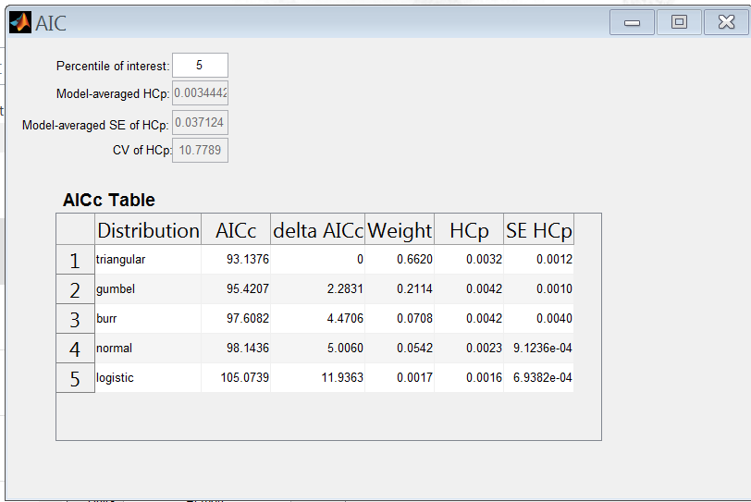

Table 4. Comparison of distributions for all aquatic mollusk invertebrate toxicity data for carbaryl.
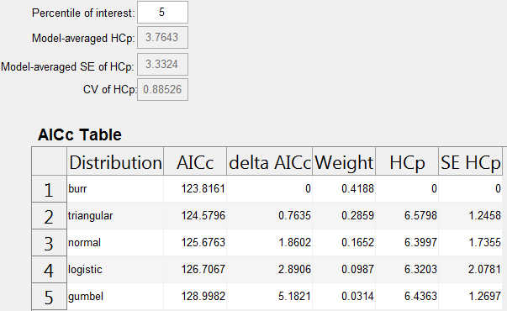

Distributions

The cumulative distribution functions for the full SSDs is presented in Figure 2 and 3 below.

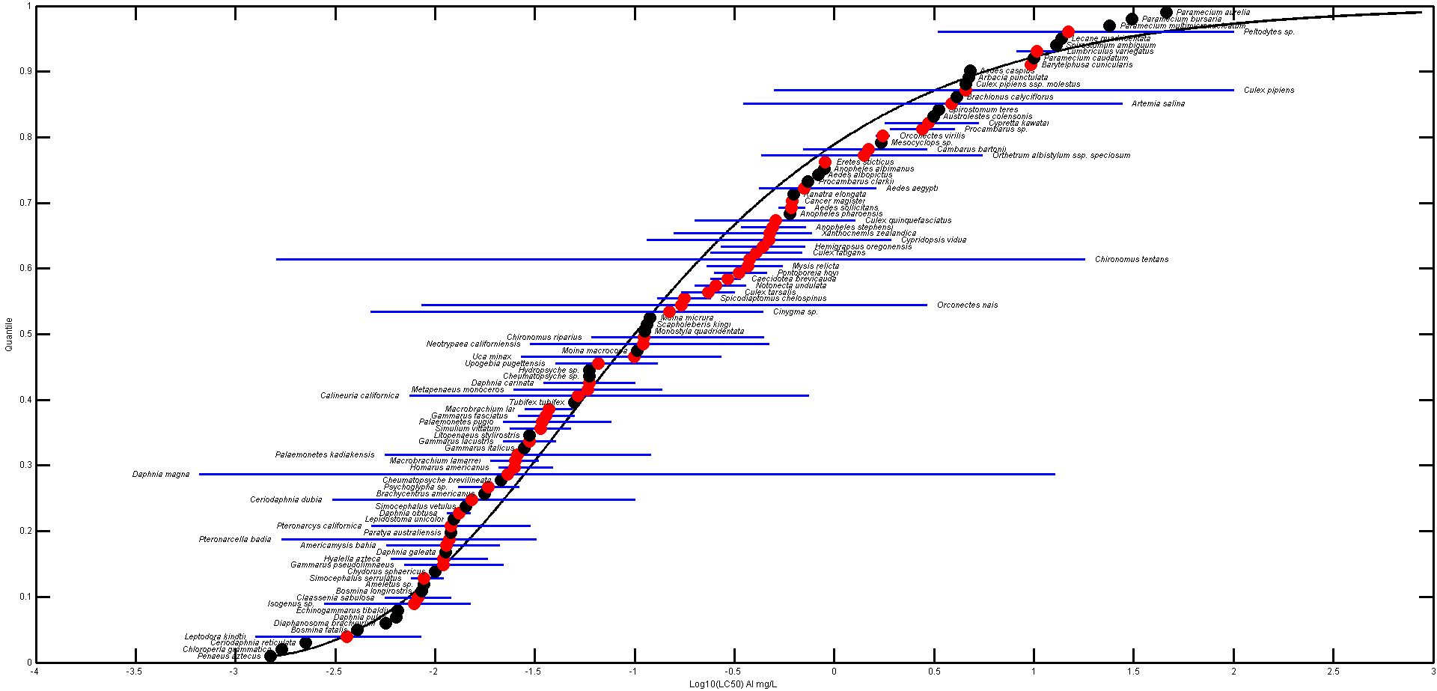
Figure 2. Log-logistic SSD for Carbaryl toxicity values for all aquatic non-mollusk invertebrates.

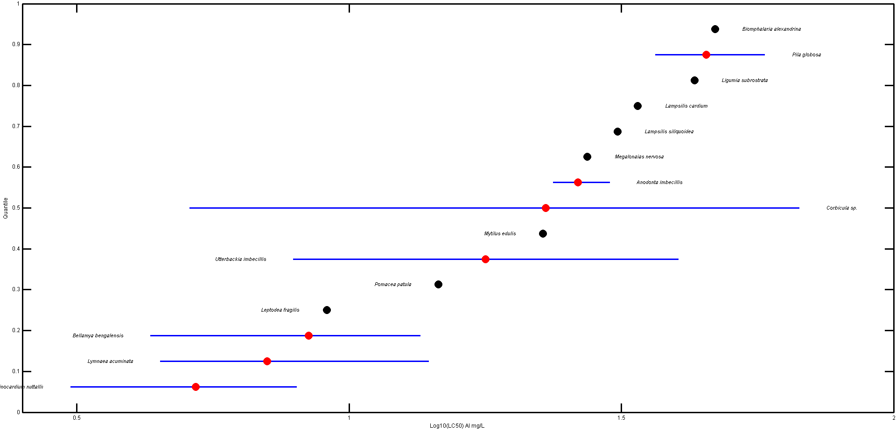
Figure 3. Log-triangular SSD for Carbaryl toxicity values for all aquatic mollusk invertebrates.

Goodness of fit

Finally, to test goodness-of-fit, all four distributions for carbaryl were fit and ran bootstrap goodness-of-fit tests with 10,000 bootstrap replicates. Maximum likelihood (ML) was used. The results of these fitting exercises are presented below. (Table 5 and 6).

Table 5. Range of HC₀₅ values for carbaryl SSDs fit to all non-mollusk invertebrates.
LC_{p} and UC_{p}=projections of the confidence limits of the HC₀₅ (LC_{x} and UC_{x}) onto the cumulative distribution functions of the fitted distribution.

Table 6. Range of HC₀₅ values for carbaryl SSDs fit to all mollusk invertebrates.
LC_{p} and UC_{p}=projections of the confidence limits of the HC₀₅ (LC_{x} and UC_{x}) onto the cumulative distribution functions of the fitted distribution.

Calculation of other quantiles

For non-mollusks, the HC₅₀ and HC₉₅ values were 0.140 and 12 mg/L, respectively, based on the logistic distribution. For mollusks, the HC₅₀ and HC₉₅ values were 19 and 54 mg/L, respectively, based on the triangular distribution.

Determination of thresholds

HC₀₅ values from the most appropriate distribution and method were used as the thresholds for mollusks and non-mollusks. The threshold for mollusks is the HC₀₅ value 6600 µg ai/L, based on the triangular distribution and maximum likelihood (ML) method. The threshold for non-mollusks is the HC₀₅ value 1.6 µg ai/L, based on the logistic distribution and ML method.
Table 7 provides all of the available EC/LC₅₀ values (based on immobility and mortality) for non-mollusk aquatic invertebrates (within the 24- or 48-hour timeframe unless otherwise noted). These data sets are the same as reported in the effects characterization. The dataset contained 53 species.

Table 7. Distribution of test results available for carbaryl for non-mollusks.
Species | Acute LC₅₀ value (mg/L) | Reference
Aedes aegypti | 0.42 | 116328
Aedes aegypti | 0.56 | 101154
Aedes aegypti | 0.66 | 101154
Aedes aegypti | 1.62 | 170313
Aedes albopictus | 0.83 | 87671
Aedes caspius | 4.79 | 13544
Aedes sollicitans | 0.525 | 119693
Aedes sollicitans | 0.71 | 119693
Ameletus sp. | 0.008772 | 62451
Americamysis bahia | 0.0057 | MRID 42343401
Americamysis bahia | 0.0077 | 4891
Americamysis bahia | 0.00845 | 115740
Americamysis bahia | 0.00846 | 115740
Americamysis bahia | 0.00884 | 115740
Americamysis bahia | 0.0091 | 115740
Americamysis bahia | 0.019 | 115739
Americamysis bahia | 0.019 | 115739
Americamysis bahia | 0.019 | 115739
Americamysis bahia | 0.021 | 115739
Anopheles albimanus | 0.89 | 11596
Anopheles pharoensis | 0.6 | 100907
Anopheles stephensi | 0.3425 | 109633
Anopheles stephensi | 0.45 | 101154
Anopheles stephensi | 0.53 | 101154
Anopheles stephensi | 0.72 | 11799
Arbacia punctulata | 4.7 | 115739
Artemia salina | 0.350131 | 20076
Artemia salina | 5.916009 | 20076
Artemia salina | 27.5678 | 20076
Austrolestes colensonis | 3.1309 | 67674
Barytelphusa cunicularis | 9.55 | 88807
Barytelphusa cunicularis | 9.65 | 88807
Barytelphusa cunicularis | 9.75 | 88807
Bosmina fatalis | 0.004075 | 81396
Bosmina longirostris | 0.008597 | 81396
Brachionus calyciflorus | 4.1 | 160585
Brachycentrus americanus | 0.017716 | 62451
Caecidotea brevicauda | 0.24 | 887
Caecidotea brevicauda | 0.28 | 6797
Caecidotea brevicauda | 0.32 | 887
Caecidotea brevicauda | 0.34 | 6797
Calineuria californica | 0.007439 | 62451
Calineuria californica | 0.01075 | 62451
Calineuria californica | 0.0129 | 62451
Calineuria californica | 0.489942 | 62450
Calineuria californica | 0.7439 | 62450
Cambarus bartonii | 0.7 | 19508
Cambarus bartonii | 0.7 | 19508
Cambarus bartonii | 0.94 | 19508
Cambarus bartonii | 2.23 | 19508
Cambarus bartonii | 2.24 | 19508
Cambarus bartonii | 2.41 | 19508
Cambarus bartonii | 2.9 | 19508
Cancer magister | 0.6 | 4825
Cancer magister | 0.63 | 4825
Ceriodaphnia dubia | 0.00306 | 17138
Ceriodaphnia dubia | 0.0116 | 3590
Ceriodaphnia dubia | 0.1 | 81810
Ceriodaphnia reticulata | 0.00225 | 154905
Cheumatopsyche brevilineata | 0.0214 | 152279
Cheumatopsyche sp. | 0.0594 | 171507
Chironomus riparius | 0.061 | 2993
Chironomus riparius | 0.071 | 2993
Chironomus riparius | 0.072 | 2993
Chironomus riparius | 0.086 | 2993
Chironomus riparius | 0.086 | 2993
Chironomus riparius | 0.096 | 3278
Chironomus riparius | 0.096 | 2993
Chironomus riparius | 0.102 | 18935
Chironomus riparius | 0.102 | 2993
Chironomus riparius | 0.1045 | 6830
Chironomus riparius | 0.107 | 2993
Chironomus riparius | 0.107 | 3278
Chironomus riparius | 0.11 | 2993
Chironomus riparius | 0.11 | 2993
Chironomus riparius | 0.11 | 18935
Chironomus riparius | 0.115 | 2993
Chironomus riparius | 0.119 | 2993
Chironomus riparius | 0.12 | 2993
Chironomus riparius | 0.125 | 2993
Chironomus riparius | 0.128 | 3278
Chironomus riparius | 0.128 | 2993
Chironomus riparius | 0.133 | 2993
Chironomus riparius | 0.133 | 2993
Chironomus riparius | 0.144 | 2993
Chironomus riparius | 0.442 | 18935
Chironomus tentans | 0.0016 | 6267
Chironomus tentans | 0.0042 | 6267
Chironomus tentans | 0.007 | 6267
Chironomus tentans | 5.9 | 7796
Chironomus tentans | 12 | 7796
Chironomus tentans | 18 | 7796
Chironomus tentans | 18 | 7796
Chloroperla grammatica | 0.0017 | MRID 40098001
Chydorus sphaericus | 0.01002 | 154905
Cinygma sp. | 0.004773 | 62451
Cinygma sp. | 0.07095 | 62450
Cinygma sp. | 0.08772 | 62450
Cinygma sp. | 0.08772 | 62450
Cinygma sp. | 0.0946 | 62450
Cinygma sp. | 0.17544 | 62450
Cinygma sp. | 0.17544 | 62450
Cinygma sp. | 0.17544 | 62450
Cinygma sp. | 0.36464 | 62450
Cinygma sp. | 0.4386 | 62450
Cinygma sp. | 0.4386 | 62450
Cinygma sp. | 0.4386 | 62450
Cinygma sp. | 0.4386 | 62450
Claassenia sabulosa | 0.0056 | 6797
Claassenia sabulosa | 0.012 | 6797
Culex fatigans | 0.24 | 101154
Culex fatigans | 0.69 | 101154
Culex pipiens | 0.5 | 103319
Culex pipiens | 0.54 | 103319
Culex pipiens | 0.69 | 103319
Culex pipiens | 0.86 | 103319
Culex pipiens | 32.8 | 61088
Culex pipiens | 77.9 | 103319
Culex pipiens | 100 | 103319
Culex pipiens ssp. molestus | 4.56 | 13544
Culex quinquefasciatus | 0.2 | 63336
Culex quinquefasciatus | 0.3794 | 119438
Culex quinquefasciatus | 0.701 | 61088
Culex quinquefasciatus | 1.27 | 63336
Culex tarsalis | 0.172 | 94524
Culex tarsalis | 0.315 | 94524
Cypretta kawatai | 1.8 | 7796
Cypretta kawatai | 1.8 | 7796
Cypretta kawatai | 4.45 | 7796
Cypretta kawatai | 5.28 | 7796
Cypridopsis vidua | 0.115 | 6797
Cypridopsis vidua | 1.92 | 6797
Daphnia carinata | 0.035 | 5194
Daphnia carinata | 0.1 | 5194
Daphnia galeata | 0.01132 | 154905
Daphnia magna | 0.00066 | 5539
Daphnia magna | 0.0056 | 6797
Daphnia magna | 0.006 | 120562
Daphnia magna | 0.0066 | 120562
Daphnia magna | 0.007 | 171521
Daphnia magna | 0.0072 | 171521
Daphnia magna | 0.0073 | 120562
Daphnia magna | 0.0078 | 171521
Daphnia magna | 0.0078 | 120562
Daphnia magna | 0.0078 | 171521
Daphnia magna | 0.0079 | 171521
Daphnia magna | 0.0082 | 171521
Daphnia magna | 0.0083 | 120562
Daphnia magna | 0.009 | 171521
Daphnia magna | 0.009 | 171521
Daphnia magna | 0.0093 | 171521
Daphnia magna | 0.0093 | 120562
Daphnia magna | 0.0094 | 171521
Daphnia magna | 0.0095 | 5370
Daphnia magna | 0.0095 | 120562
Daphnia magna | 0.0096 | 171521
Daphnia magna | 0.0097 | 171521
Daphnia magna | 0.0098 | 120562
Daphnia magna | 0.0098 | 171521
Daphnia magna | 0.0099 | 171521
Daphnia magna | 0.01 | 171521
Daphnia magna | 0.01 | 120562
Daphnia magna | 0.0101 | 17138
Daphnia magna | 0.0102 | 171521
Daphnia magna | 0.0102 | 171521
Daphnia magna | 0.0108 | 171521
Daphnia magna | 0.0117 | 171521
Daphnia magna | 0.0119 | 171521
Daphnia magna | 0.012 | 96171
Daphnia magna | 0.012 | 9659
Daphnia magna | 0.0125 | 120562
Daphnia magna | 0.0136 | 171521
Daphnia magna | 0.021 | 17714
Daphnia magna | 0.23 | 55506
Daphnia magna | 1 | 6191
Daphnia magna | 1.9 | 50679
Daphnia magna | 1.9 | 81810
Daphnia magna | 2 | 6191
Daphnia magna | 5.4 | 50679
Daphnia magna | 7.47 | 171508
Daphnia magna | 12.76 | 171508
Daphnia obtusa | 0.0115 | 20191
Daphnia obtusa | 0.015 | 20191
Daphnia pulex | 0.0064 | 6797
Diaphanosoma brachyurum | 0.00565 | 154905
Echinogammarus tibaldii | 0.0065 | 18621
Eretes sticticus | 0.89 | 5182
Eretes sticticus | 0.91 | 5182
Gammarus fasciatus | 0.026 | 6797
Gammarus fasciatus | 0.05 | 6797
Gammarus italicus | 0.028 | 18621
Gammarus lacustris | 0.022 | 6797
Gammarus lacustris | 0.04 | 6797
Gammarus pseudolimnaeus | 0.007 | 6797
Gammarus pseudolimnaeus | 0.0072 | 6797
Gammarus pseudolimnaeus | 0.0078 | 6797
Gammarus pseudolimnaeus | 0.008 | 6797
Gammarus pseudolimnaeus | 0.0105 | 6797
Gammarus pseudolimnaeus | 0.0115 | 6797
Gammarus pseudolimnaeus | 0.0126 | 6797
Gammarus pseudolimnaeus | 0.013 | 6797
Gammarus pseudolimnaeus | 0.019 | 6797
Gammarus pseudolimnaeus | 0.022 | 6797
Hemigrapsus oregonensis | 0.27 | 4825
Hemigrapsus oregonensis | 0.71 | 4825
Homarus americanus | 0.02089 | 115741
Homarus americanus | 0.02089 | 115741
Homarus americanus | 0.02313 | 115741
Homarus americanus | 0.03873 | 115741
Hyalella azteca | 0.006 | 52121
Hyalella azteca | 0.0065 | 52121
Hyalella azteca | 0.007 | 52121
Hyalella azteca | 0.0105 | 52121
Hyalella azteca | 0.0115 | 52121
Hyalella azteca | 0.0125 | 52121
Hyalella azteca | 0.0151 | 52121
Hyalella azteca | 0.0152 | 52121
Hyalella azteca | 0.0156 | 52121
Hyalella azteca | 0.0183 | 52121
Hydropsyche sp. | 0.0594 | 171507
Isogenus sp. | 0.0028 | 6797
Isogenus sp. | 0.0036 | 6797
Isogenus sp. | 0.0066 | 6797
Isogenus sp. | 0.0066 | 6797
Isogenus sp. | 0.008 | 6797
Isogenus sp. | 0.008 | 6797
Isogenus sp. | 0.0087 | 6797
Isogenus sp. | 0.009 | 6797
Isogenus sp. | 0.0092 | 6797
Isogenus sp. | 0.012 | 6797
Isogenus sp. | 0.015 | 6797
Isogenus sp. | 0.015 | 6797
Lecane quadridentata | 13.72 | 171514
Lepidostoma unicolor | 0.01247 | 62451
Leptodora kindtii | 0.00126 | 171510
Leptodora kindtii | 0.00197 | 171510
Leptodora kindtii | 0.001998 | 81396
Leptodora kindtii | 0.003605 | 81396
Leptodora kindtii | 0.00462 | 171510
Leptodora kindtii | 0.00619 | 171510
Leptodora kindtii | 0.00664 | 171510
Leptodora kindtii | 0.00846 | 171510
Litopenaeus stylirostris | 0.0298 | 73317
Lumbriculus variegatus | 8.2 | 6502
Lumbriculus variegatus | 13 | 6502
Macrobrachium lamarrei | 0.019 | 11541
Macrobrachium lamarrei | 0.024 | 11541
Macrobrachium lamarrei | 0.027 | 11541
Macrobrachium lamarrei | 0.033 | 11541
Macrobrachium lar | 0.0283 | 157374
Macrobrachium lar | 0.0486 | 157374
Mesocyclops sp. | 1.715 | 100488
Metapenaeus monoceros | 0.02487 | 17176
Metapenaeus monoceros | 0.137 | 3724
Moina macrocopa | 0.10321 | 154905
Moina micrura | 0.1196 | 87649
Monostyla quadridentata | 0.112 | 16799
Mysis relicta | 0.23 | 18931
Mysis relicta | 0.4 | 18931
Mysis relicta | 0.55 | 18931
Neotrypaea californiensis | 0.03 | 4825
Neotrypaea californiensis | 0.08 | 4825
Neotrypaea californiensis | 0.13 | 4825
Neotrypaea californiensis | 0.47 | 4825
Notonecta undulata | 0.2 | 7775
Notonecta undulata | 0.23 | 7775
Notonecta undulata | 0.36 | 7775
Orconectes nais | 0.0086 | 887
Orconectes nais | 0.034 | 887
Orconectes nais | 1 | 887
Orconectes nais | 2.9 | 887
Orconectes virilis | 1.61 | 19508
Orconectes virilis | 1.89 | 19508
Orthetrum albistylum ssp. Speciosum | 0.43 | 7119
Orthetrum albistylum ssp. speciosum | 0.55 | 7119
Orthetrum albistylum ssp. speciosum | 0.55 | 7119
Orthetrum albistylum ssp. speciosum | 3 | 7119
Orthetrum albistylum ssp. speciosum | 3.7 | 7119
Orthetrum albistylum ssp. speciosum | 5.5 | 7119
Palaemonetes kadiakensis | 0.0056 | 6797
Palaemonetes kadiakensis | 0.12 | 6797
Palaemonetes pugio | 0.022 | 115739
Palaemonetes pugio | 0.022 | 115739
Palaemonetes pugio | 0.031 | 115739
Palaemonetes pugio | 0.04302 | 112130
Palaemonetes pugio | 0.076 | 115739
Paramecium aurelia | 46 | 11588
Paramecium bursaria | 31 | 11588
Paramecium caudatum | 10 | 11588
Paramecium multimicronucleatum | 24 | 11588
Paratya australiensis | 0.012 | 121117
Peltodytes sp. | 3.3 | 7775
Peltodytes sp. | 6 | 7775
Peltodytes sp. | 25 | 7775
Peltodytes sp. | 100 | 7775
Penaeus aztecus | 0.0015 | 3947
Pontoporeia hoyi | 0.25 | 18931
Pontoporeia hoyi | 0.29 | 18931
Pontoporeia hoyi | 0.37 | 18931
Pontoporeia hoyi | 0.46 | 18931
Procambarus clarkia | 0.74 | 4678
Procambarus sp. | 1.9 | 6797
Procambarus sp. | 4 | 6797
Psychoglypha sp. | 0.013029 | 62451
Psychoglypha sp. | 0.02623 | 62451
Pteronarcella badia | 0.0017 | 6797
Pteronarcella badia | 0.005 | 6797
Pteronarcella badia | 0.011 | 6797
Pteronarcella badia | 0.013 | 6797
Pteronarcella badia | 0.018 | 6797
Pteronarcella badia | 0.019 | 6797
Pteronarcella badia | 0.029 | 6797
Pteronarcella badia | 0.032 | 6797
Pteronarcys californica | 0.0048 | 6797
Pteronarcys californica | 0.03 | 6797
Ranatra elongate | 0.624 | 4596
Scapholeberis kingi | 0.11476 | 154905
Simocephalus serrulatus | 0.0076 | 6797
Simocephalus serrulatus | 0.0081 | 6797
Simocephalus serrulatus | 0.011 | 6797
Simocephalus vetulus | 0.01424 | 154905
Simulium vittatum | 0.02372 | 71060
Simulium vittatum | 0.04776 | 152234
Spicodiaptomus chelospinus | 0.13 | 5264
Spicodiaptomus chelospinus | 0.24 | 5264
Spirostomum ambiguum | 12.9 | 69821
Spirostomum teres | 3.34 | 20057
Tubifex tubifex | 0.05 | 17386
Uca minax | 0.027 | 4624
Uca minax | 0.135 | 4624
Uca minax | 0.27 | 4624
Upogebia pugettensis | 0.04 | 4825
Upogebia pugettensis | 0.04 | 4825
Upogebia pugettensis | 0.09 | 4825
Upogebia pugettensis | 0.13 | 4825
Xanthocnemis zealandica | 0.1566 | 171567
Xanthocnemis zealandica | 0.3818 | 171567
Xanthocnemis zealandica | 0.4377 | 171567
Xanthocnemis zealandica | 0.6 | 67674
Xanthocnemis zealandica | 0.6 | 171567
Xanthocnemis zealandica | 0.76 | 171567
Xanthocnemis zealandica | 0.77 | 171567

Table 8 provides all of the available EC/LC₅₀ values (based on immobility and mortality) for mollusk aquatic invertebrates (within the 24- or 48-hour timeframe unless otherwise noted). These data sets are the same as reported in the effects characterization. The dataset contained 15 species.

Table 8. Distribution of test results available for carbaryl for mollusks.
Species | Acute LC₅₀ value (mg/L) | Reference
Anodonta imbecillis | 23.7 | 50679
Anodonta imbecillis | 25.6 | 50679
Anodonta imbecillis | 30.1 | 50679
Bellamya bengalensis | 4.32 | 4953
Bellamya bengalensis | 9.02 | 4953
Bellamya bengalensis | 9.6 | 4953
Bellamya bengalensis | 13.5 | 4953
Biomphalaria alexandrina | 47 | 6332
Clinocardium nuttallii | 3.08 | 17741
Clinocardium nuttallii | 3.08 | 171590
Clinocardium nuttallii | 3.2 | 17741
Clinocardium nuttallii | 3.2 | 171590
Clinocardium nuttallii | 7.3 | 4825
Clinocardium nuttallii | 8 | 17741
Clinocardium nuttallii | 8 | 17741
Clinocardium nuttallii | 8 | 171590
Clinocardium nuttallii | 8 | 171590
Corbicula sp. | 5.1 | 18189
Corbicula sp. | 16.6 | 18189
Corbicula sp. | 49.2 | 18189
Corbicula sp. | 67.01 | 18189
Lampsilis cardium | 33.9 | 81810
Lampsilis siliquoidea | 31.1 | 81810
Leptodea fragilis | 9.1 | 81810
Ligumia subrostrate | 43.1 | 81810
Lymnaea acuminata | 4.5 | 917
Lymnaea acuminata | 5.6 | 917
Lymnaea acuminata | 14 | 917
Megalonaias nervosa | 27.4 | 81810
Mytilus edulis | 22.7 | 8127
Pila globose | 36.5 | 917
Pila globose | 41 | 917
Pila globose | 48.5 | 917
Pila globose | 58 | 917
Pomacea patula | 14.6 | 52354
Utterbackia imbecillis | 7.9 | 74236
Utterbackia imbecillis | 40.2 | 81810

