APPENDIX 1-5. PVP ANALYSIS

Analysis of the variability in dry weight and height data from negative controls of commonly tested species in vegetative vigor and seedling emergence studies

- Background

The Office of Chemical Safety and Pollution Prevention’s (OCSPP), Office of Pesticide Programs, Environmental Fate and Effects Division (EFED) evaluates ecotoxicity studies submitted in support of pesticide registrations. Among these are terrestrial plant studies that fall within the OCSPP harmonized test guidelines of accepted scientific methodologies and protocols. Vegetative Vigor (VV) studies (OCSPP 850.4100; U.S. EPA 2012b) are designed to expose young plants at the 2-4 leaf stage to either a single maximum labeled rate (Tier I Limit Test) or to a geometric series of pesticide rates (Tier II Definitive Test) for comparison to concurrently grown negative control plants. Percent survival, average per plant shoot height, and average per plant dry weight are recorded on the final day of the VV study (typically 21 days). Seedling Emergence (SE) studies (OCSPP 850.4100; U.S. EPA 2012a) expose planted seeds to either a single maximum labeled rate of a pesticide (Tier I) or to a geometric series of pesticide rates (Tier II) for comparison to concurrently grown negative control plants. Percent emergence, percent survival, average per plant shoot height, and average per plant dry weight are recorded on the final day of the SE study (typically 21 days).

Tier II VV and SE studies are designed for estimation of the inhibition concentration (IC) at a chosen level of percent effect (x) and for determination of a No Observed Adverse Effect Concentration (NOAEC) for the continuous response variables of shoot height and dry weight. Non-linear regression is used to fit a probit-shaped curve to the continuous response data and the resulting IC₂₅ represents the concentration at which a 25% reduction in the average response relative to the negative control is expected to occur. The IC₂₅ is then used for risk estimation in pesticide risk assessments for non-listed terrestrial and wetland plant species and to represent impacts to the prey or habitat of a listed species. The NOAEC is used for risk estimation in pesticide risk assessments for listed terrestrial and wetland plant species. The NOAEC is defined as the highest tested exposure concentration that is less than the Lowest Observed Adverse Effect Concentration (LOAEC). A LOAEC is the lowest tested exposure concentration with a statistically significant toxicological response compared with controls as identified by hypothesis testing statistical analysis. Occasionally, a reliable, definitive NOAEC cannot be determined from a submitted study (e.g., all tested concentration levels had a statistically significant reduction in the response relative to the control or no tested concentration levels had statistically significant reductions in the response relative to the control but the observed magnitude of the effect is toxicologically or biologically meaningful). Current EFED policy states that in cases when a NOAEC is not reliable, an IC₀₅ should be used in its place for risk estimation. Concerns have been raised that the IC₀₅ may fall within the natural, background variation in height and dry weight measurements of untreated plants and, therefore, is uncertain.

2. Objective

The objective of this work is to characterize the variation in shoot height and dry weight of terrestrial plant species by conducting a retrospective evaluation of the controls from VV and SE studies. EFED will use the inferences from these analyses to identify new values of “x” in the IC_{x} as a replacement for the IC₀₅ that is used currently used in risk estimation when a definitive NOAEC is not reliable or available.

This analysis does not consider the biological significance of the percent effect but rather identifies an IC_{x} value at which EFED has confidence the measured effect is real based on available guideline studies. This analysis also does not identify or characterize potential sources of within-species between-test variability. These sources of variation in control data could include differences in laboratory protocols, study conditions across and within testing facilities (e.g., lighting, pot size, soil chemistry), time of year study is conducted in greenhouse, and biological variability in seed sources.

Although survival (for VV and SE tests) and emergence (for SE tests only) are also reported and statistically analyzed for determination of EC₂₅ and NOAEC values, they were not evaluated in this retrospective analysis. Test guidelines specify that the exposure concentrations should be optimized to facilitate the estimation of IC₂₅ and NOAEC from the apical endpoints of shoot height and dry weight. It is anticipated that the growth endpoints of height and dry weight would be more sensitive than survival or emergence, and, therefore, the endpoints from those growth parameters would be utilized for risk estimation.

3. Methods

Database development

EFED compiled a robust and reliable database using replicate level negative control data from VV and SE studies that were submitted to the Agency as part of the pesticide registration or registration review process. All included studies were reviewed by EFED and classified as either Acceptable or Supplemental. Included studies were conducted in a wide range of laboratories from the late 1980s to the present. Replicate level data for each study were obtained from registrant-submitted study reports or from an internal-EFED database used for statistical analysis of ecotoxicity data. EFED compiled the data into separate databases for VV and SE.

After data entry and compilation, EFED followed a formal Quality Control (QC) process to ensure high quality and accuracy of both the VV and the SE databases. EFED evaluated all data at the replicate level verifying control treatment shoot height and dry weight data for each study for the following issues: checking the recorded data against the registrant study report, confirming measurement units were correct, confirming dry (not fresh) weights were reported, and confirming dry weight data were reported as average per surviving plant and making corrections as necessary. Plots of raw data at the replicate level were explored to identify potential outliers. EFED corrected any errors in the database and documented them on reviewer sheets. The final datasets used for this analysis consisted of 1448 tests containing 18 unique species for VV and 1345 tests containing 19 unique species for SE.

Metrics for evaluation of between-replicate variation

EFED summarized the data at a study level using descriptive statistics to better understand and estimate the variation in the control replicates for height and dry weight measured across test species. To evaluate the control data variation of the shoot height and dry weight of various terrestrial plant species, EFED calculated two metrics: (1) the coefficient of variation (CV) and (2) the minimum detectable difference expressed as a percentage (MDD%).

The CV is a common statistical measure interpreted as the percentage of the standard deviation relative to the mean and is calculated as shown in Equation 1 (where s is the sample standard deviation and x̅ is the sample mean):
$CV=\frac{100s}{x̅}$ (1)

MDD% indicates the likelihood of finding a specific size effect statistically significant from a hypothesis test, such as Dunnett, Williams, or a corresponding nonparametric alternative (Dunn or Jonckheere-Terpstra). Using the derivation described in Staveley et al. (2018), the minimum magnitude difference that can be detected with 95% confidence is obtained from a standard formula (e.g., Hogg and Tanis 1988) to compare two sample means from normal populations with the same variance and sample sizes, by replacing the Student’s t-statistic with 2(n – 1) degrees of freedom (df) by T(0.975, df), which is approximately equal to 2. Thus, EFED used the formula:
$MDD\%=CV\sqrt{\frac{8}{n}}$ (2)

As different studies had different numbers of replicates (nearly all studies had between 3 and 10 replicates), the multiplicative factor in Eq. 2 ($\sqrt{(8}/n)$) varied across studies.

Both the CV and MDD% provide useful unitless estimates of variation for comparison across species. While CV is a more commonly used measure, the MDD% provides an adjustment to account for varying numbers of replicates across studies. Both CV and MDD% are unitless measures of the variability of a sample; however, their interpretations differ slightly. In practice, the CV typically measures the variability in values of a sample relative to the magnitude of the sample mean to draw inferences about the population variability. If a sample of a population has a CV% = 15%, then the standard deviation of the sample of the population is 15% of the sample of the population mean. Conversely, the MDD is analogous to a power calculation and can estimate the size of the effect that can be detected from a given sample. For example, if the MDD% = 15%, then it is unlikely to be able to detect or estimate an effect of less than 15% but likely able to estimate an effect of 15% or more.

Exploratory Data Analysis and Toxicity Endpoint Determination

EFED summarized the study level CV and MDD% values for the two study types (VV and SE) and the two apical endpoints (shoot height and dry weight). To explore the data, EFED evaluated a variety of summary statistics and side-by-side box plots with the goal of qualitatively identifying systematic differences in the shapes and central tendencies of the distributions of CV and MDD% among species and plant classes [monocotyledoneae species (monocots) and dicotyledoneae species (dicots)]. EFED also visually evaluated differences in the distributions of CV and MDD% between the apical endpoints and study types. These analyses can be used to guide the establishment of toxicity endpoints used in risk estimation as appropriate when a definitive, reliable NOAEC is not available, and thresholds are based on these guideline studies.

4. Results

Species summaries and qualitative comparisons

For VV, average shoot height greatly varied across species (Table 1). Average shoot height among species ranged from 11 cm for radish to 86 cm for corn. CV and MDD% also varied among species (Table 1; Figures 1-2). For VV shoot height, the average CV ranged from 4 for wheat to 13 for cucumber, and the average MDD% ranged from 4.7 for wheat to 15% for cucumber. The shoot height side-by-side boxplots for species CV and MDD% (Figure 1b and 2b, respectively) show that while there is variation among species in the mean (diamond) and median (horizontal line in the middle of each box), the spread of the CV and MDD% values across individual tests for each species is also very large. This is evidenced by the relatively large distance between the 25th and 75th percentiles (i.e., interquartile range (IQR); calculated as the difference between the 75th and 25th percentiles) for each species. In addition, most species have several individual studies with high variability resulting in positively skewed (i.e., right-skewed) distributions for nearly all species.

Table 1. Summary of Vegetative Vigor shoot height and weight for each evaluated species
Scientific name | Common name |  |  | Shoot Height Averages |  |  | Shoot Dry Weight Averages
Monocots |  |  | Total  study count | n | Mean (cm) | CV  (%) |  | MDD  (%) | n | Mean  (g) | CV  (%) | MDD  (%)
Allium cepa | onion |  | 142 | 141 | 26.8 | 8.93 |  | 11.1 | 142 | 0.16 | 23.3 | 28.5
Avena sativa | oat |  | 80 | 79 | 56.2 | 6.20 |  | 8.07 | 80 | 0.82 | 13.6 | 17.5
Lolium perenne | perennial ryegrass |  | 117 | 116 | 28.4 | 7.30 |  | 9.18 | 116 | 0.52 | 15.9 | 20.2
Sorghum bicolor | sorghum |  | 15 | 15 | 72.8 | 6.31 |  | 7.72 | 15 | 6.14 | 15.8 | 18.7
Triticum aestivum | common wheat |  | 68 | 68 | 49.9 | 4.15 |  | 4.71 | 68 | 1.45 | 13.0 | 14.7
Zea mays | corn |  | 140 | 138 | 86.2 | 6.49 |  | 7.51 | 140 | 3.70 | 15.3 | 17.5
Dicots
Beta vulgaris | common beet |  | 62 | 61 | 25.7 | 7.48 |  | 8.78 | 62 | 3.08 | 13.0 | 15.2
Brassica napus | rape |  | 88 | 86 | 31.4 | 8.59 |  | 9.58 | 88 | 4.00 | 13.7 | 15.1
Brassica oleracea | cabbage |  | 85 | 85 | 18.8 | 7.36 |  | 8.96 | 85 | 2.52 | 12.4 | 15.1
Cucumis sativus | cucumber |  | 99 | 98 | 43.2 | 13.2 |  | 14.9 | 99 | 3.40 | 13.9 | 16.3
Daucus carota | carrot |  | 41 | 41 | 20.4 | 7.93 |  | 9.56 | 41 | 0.60 | 15.1 | 19.1
Glycine max | soybean |  | 146 | 144 | 59.4 | 9.48 |  | 10.9 | 146 | 3.52 | 11.6 | 13.2
Helianthus annuus | sunflower |  | 16 | 15 | 49.2 | 8.05 |  | 8.59 | 15 | 2.96 | 13.4 | 13.5
Lactuca sativa | lettuce |  | 98 | 98 | 15.5 | 9.19 |  | 11.3 | 98 | 2.15 | 15.8 | 19.7
Phaseolus vulgaris | common bean |  | 26 | 26 | 47.7 | 13.40 |  | 13.7 | 26 | 2.33 | 15.0 | 15.4
Pisum sativum | pea |  | 25 | 25 | 33.0 | 9.92 |  | 11.4 | 25 | 2.34 | 16.3 | 18.9
Raphanus sativus | radish |  | 57 | 57 | 14.4 | 9.22 |  | 10.1 | 57 | 0.85 | 12.9 | 14.2
Solanum lycopersicum | tomato |  | 143 | 143 | 38.2 | 8.72 |  | 10.1 | 143 | 3.45 | 15.0 | 18.1

Table 2. Summary of Seedling Emergence shoot height and weight for each evaluated species
Scientific name | Common name |  | Shoot Height Averages |  |  |  |  | Shoot Dry Weight Averages
Monocots |  | Total  study count | n |  | Mean (cm) | CV (%) | MDD (%) | n | Mean (g) | CV (%) | MDD (%)
Allium cepa | onion | 134 | 131 | 13.1 |  | 14.2 | 16.8 | 119 | 0.203 | 22.0 | 28.8
Avena sativa | oat | 83 | 79 | 36.2 |  | 7.83 | 9.60 | 73 | 0.368 | 13.8 | 16.7
Lolium perenne | perennial ryegrass | 124 | 121 | 17.9 |  | 11.2 | 13.4 | 114 | 0.0511 | 25.1 | 29.7
Sorghum bicolor | sorghum | 11 | 10 | 39.0 |  | 7.35 | 7.35 | 8 | 0.361 | 20.0 | 21.7
Triticum  aestivum | common wheat | 56 | 54 | 42.1 |  | 5.76 | 6.73 | 53 | 0.337 | 14.5 | 16.5
Zea mays | corn | 126 | 122 | 55.7 |  | 9.77 | 10.3 | 112 | 1.00 | 18.9 | 19.6
Dicots

Beta vulgaris | common beet | 68 | 67 | 13.2 |  | 10.1 | 11.4 | 47 | 0.256 | 23.2 | 24.7
Brassica napus | rape | 96 | 93 | 16.0 |  | 10.3 | 11.4 | 83 | 0.443 | 21.5 | 22.8
Brassica oleracea | cabbage | 74 | 74 | 12.3 |  | 10.9 | 12.1 | 68 | 0.427 | 22.3 | 23.8
Brassica rapa | turnip | 7 | 5 | 16.8 |  | 17.1 | 21.9 | 6 | 0.254 | 20.4 | 20.4
Cucumis sativus | cucumber | 83 | 79 | 12.1 |  | 12.2 | 12.9 | 63 | 0.732 | 18.6 | 18.3
Daucus carota | carrot | 37 | 35 | 7.98 |  | 14.2 | 16.7 | 30 | 0.0636 | 24.1 | 27.6
Glycine max | soybean | 137 | 133 | 25.9 |  | 13.1 | 14.1 | 111 | 0.797 | 15.4 | 16.1
Helianthus annuus | sunflower | 18 | 14 | 22.6 |  | 7.86 | 8.02 | 15 | 0.599 | 22.6 | 22.6
Lactuca sativa | lettuce | 80 | 79 | 8.60 |  | 13.9 | 15.4 | 72 | 0.154 | 27.5 | 30.6
Phaseolus vulgaris | common bean | 27 | 27 | 18.0 |  | 16.3 | 16.5 | 27 | 0.514 | 18.0 | 18.8
Pisum sativum | pea | 19 | 17 | 13.0 |  | 11.3 | 18.1 | 17 | 1.02 | 18.8 | 24.4
Raphanus sativus | radish | 43 | 43 | 7.39 |  | 12.5 | 13.5 | 39 | 0.344 | 18.3 | 20.1
Solanum lycopersicum | tomato | 123 | 122 | 12.6 |  | 12.7 | 14.1 | 113 | 0.260 | 25.3 | 27.8

b.
a.
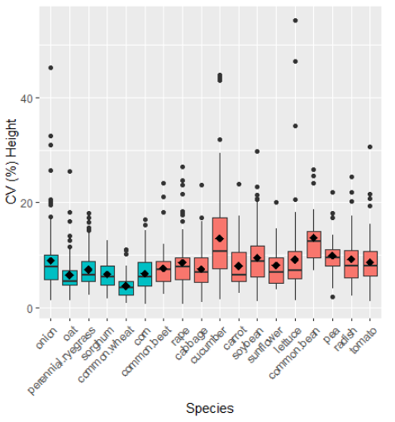
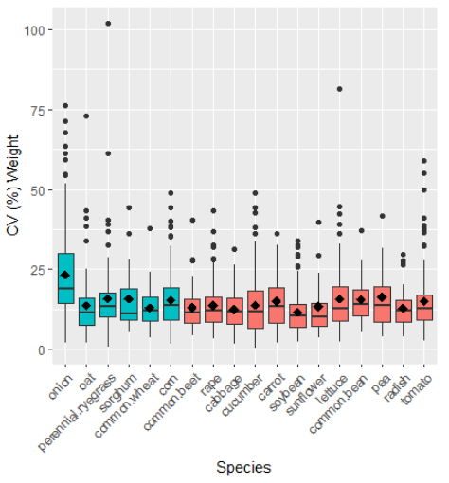
Figure 1. Vegetative Vigor data Boxplots of the CV (%) in dry weight (a.) and shoot height (b.) for each species. The blue color represents monocots (first 6 species on x axis) and the red are dicots. Solid circles represent individual data points outside of 1.5 times the interquartile range; vertical lines indicate the upper-bound and lower-bound of the interquartile range; the middle (upper; lower) horizontal line of the white box marks the median (75%; 25% quartile); the diamond point shows the mean. Y-axes intentionally scaled differently.

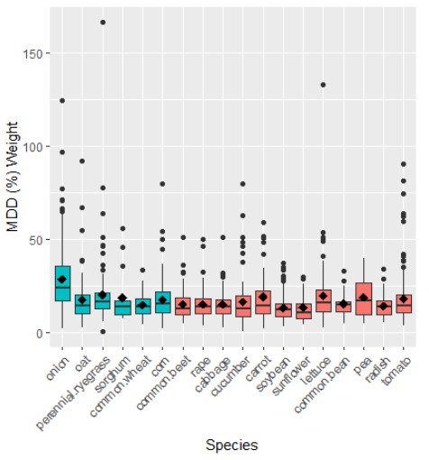
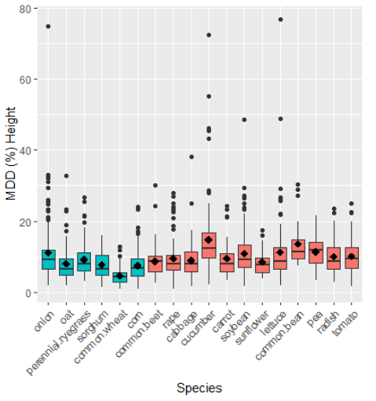
b.
a.
Figure 2. Vegetative Vigor data Boxplots of the MDD (%) in dry weight (a.) and shoot height (b.) for each species. The blue color represents monocots (first 6 species on x axis) and the red are dicots. Solid circles represent individual data points outside of 1.5 times the interquartile range; vertical lines indicate the upper-bound and lower-bound of the interquartile range; the middle (upper; lower) horizontal line of the white box marks the median (75%; 25% quartile); the diamond point shows the mean. Y-axes intentionally scaled differently.

Average dry weight also varied across VV species (Table 1). Average dry weight among species ranged from 0.16 g for onion to 6.0 g for sorghum. CV and MDD% also varied among species (Table 1; Figures 1-2); the average CV ranged from 11.6 for soybean to 23.3 for onion, and the average MDD% ranged from 13.2 for soybean to 28.5% for onion. The dry weight side-by-side boxplots for species CV and MDD% (Figure 1a and 2a, respectively) show that while there is variation among species in the mean (diamond) and median (horizontal line in the middle of each box), the spread of the CV and MDD% values across individual tests for each species is also very large. This is evidenced by the relatively large value of the IQR for each species. In addition, most species have several individual studies that had very high variability as evidenced by the high CV and MDD% outliers resulting in positively-skewed (i.e., right-skewed) distributions. Unlike shoot height, one species (onion) does visually appear to have a higher dry weight variability then the other species based on the CV side-by-side boxplots (Figure 1a). However, some of that larger variation in onion dry weight may be attributed to differences in number of replicates because when MDD% is plotted (Figure 2a), the difference in the onion boxplot relative to the other species is reduced.

For SE, average shoot height greatly varied across species (Table 2). Average shoot height among species ranged from 7.4 cm for radish to 56 cm for corn. CV and MDD% also varied among species (Table 2; Figures 3-4) For SE shoot height, the average CV ranged from 5.8 for wheat to 17 for turnip, and the average MDD% ranged from 6.7 for wheat to 22 for turnip. The shoot height side-by-side boxplots for species CV and MDD% (Figure 3b and 4b, respectively) show that while there is variation among species in the mean (diamond) and median (horizontal line in the middle of each box), the spread of the CV and MDD% values among individual tests for most species is also very large. This is evidenced by the relatively large value of the IQR for each species. Variation in onion shoot height appears to be slightly higher than other species, and, in contrast, oat, wheat, and sunflower appear to have slightly lower shoot height CV and MDD% relative to the other species. Most species have several individual studies that had very high variability as evidenced by outliers resulting in positively skewed distributions for nearly all species.
a.
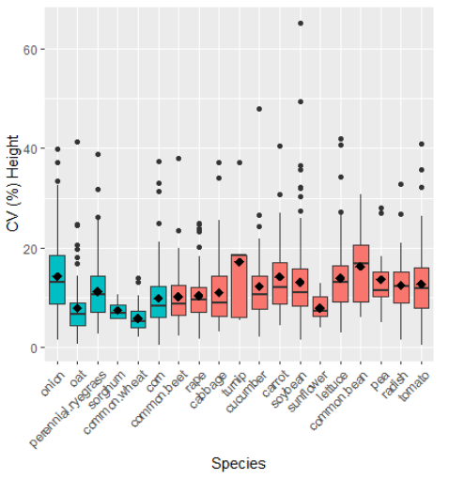
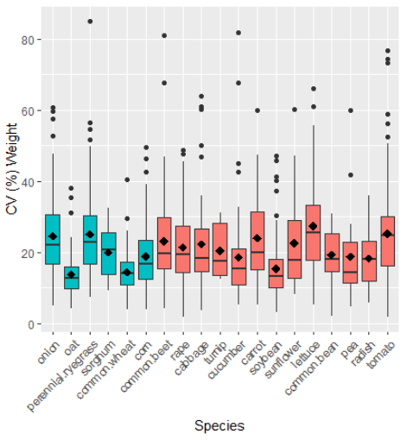
b.
Figure 3. SE data Boxplots of the CV (%) in dry weight (upper) and shoot height (lower) for each species. The blue color represents monocots (first 6 species on x axis) and the red are dicots. Solid circles represent individual data points outside of 1.5 times the interquartile range; vertical lines indicate the upper-bound and lower-bound of the interquartile range; the middle (upper; lower) horizontal line of the white box marks the median (75%; 25% quartile); the diamond point shows the mean. Y-axes intentionally scaled differently.

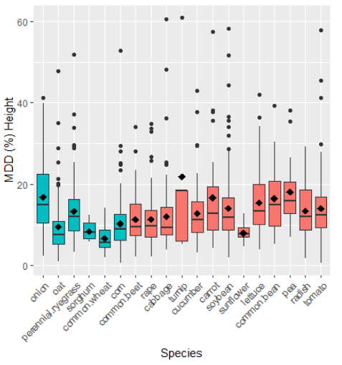
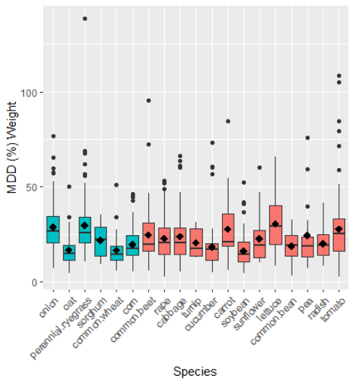
b.
a.

Figure 4. SE data Boxplots of the MDD (%) in dry weight (upper) and shoot height (lower) for each species. The blue color represents monocots (first 6 species on x axis) and the red are dicots. Solid circles represent individual data points outside of 1.5 times the interquartile range; vertical lines indicate the upper-bound and lower-bound of the interquartile range; the middle (upper; lower) horizontal line of the white box marks the median (75%; 25% quartile); the diamond point shows the mean. Y-axes intentionally scaled differently.

Average dry weight also varied across SE species (Table 2). Average dry weight among species ranged from 0.051 g for ryegrass to 1.0 g for peas. CV and MDD% also varied among species (Table 2; Figures 3-4); the average CV ranged from 14.5 for wheat to 27.5 for lettuce, and the average MDD% ranged from 16.1 for soybean to 30.6% for lettuce. The dry weight side-by-side boxplots for species CV and MDD% (Figure 3a and 4a, respectively) show that while there is variation among species in the mean (diamond) and median (horizontal line in the middle of each box), the spread of the CV and MDD% values across individual tests for each species is also very large. This is evidenced by the relatively large value of the IQR for each species. In addition, most species have several individual studies with high variability as evidenced by the high CV and MDD% outliers that resulted in positively-skewed distributions for nearly all species. As with SE shoot height, oat, wheat, and sunflower appear to have slightly lower dry weight CV and MDD% relative to the other species.

Plant class summaries and qualitative comparisons

Species listings in Tables 1 and 2 and Figures 1 through 4 are ordered to facilitate visual comparisons among the two plant classes of monocot and dicot. As when comparing across individual species, no consistent, meaningful differences between monocots and dicots were evident. For example, for VV dry weight CV (Figure 1a), except for onion, there was little variation in the common summary statistics (e.g., mean, median, 25th percentile, and 75th percentile) across all species, and there was observable difference in those summary statistics between the monocot and dicot species. Similarly, for all other endpoints, EFED did not find any systematic differences in the distributions of the CV and MDD% for the available monocots and dicots when looking at each of the growth endpoints of VV dry weight, VV shoot height, SE dry weight, and SE shoot height (Figures 1-4). Given the lack of consistent, meaningful differences between monocots and dicots, EFED combined the CVs and MDD%s for all species for each of the four growth endpoints, resulting in distributions of CV and MDD% for VV dry weight, VV shoot height, SE dry weight, and SE shoot height (Tables 3 and 4 and Figures 5 and 6).

Table 3. Vegetative Vigor Variability Metrics for Dry Weight and Shoot Height for all Species
 | Dry Weight (n=1446 studies) |  | Shoot Height (n=1436 studies)
Statistic | CV (%) | MDD (%) | CV (%) | MDD (%)
Mean | 15.0 | 17.8 | 8.40 | 9.87
Quantiles
0.05 | 4.90 | 6.06 | 2.63 | 3.29
0.10 | 6.01 | 7.32 | 3.32 | 4.13
0.15 | 6.92 | 8.38 | 3.99 | 4.82
0.25 | 8.52 | 10.2 | 4.94 | 5.83
0.50 (median) | 12.7 | 14.6 | 7.24 | 8.44
0.75 | 18.0 | 21.0 | 10.2 | 11.9
0.90 | 26.6 | 30.4 | 14.8 | 16.8
0.95 | 34.8 | 41.8 | 18.0 | 21.6
IQR (interquartile range) | 9.48 | 10.8 | 5.26 | 6.07

Table 4. Seedling Emergence Variability Metrics for Dry Weight and Shoot Height for all Species
 | Dry Weight (n=1170 studies) |  | Shoot Height (n=1305 studies)
Statistic | CV (%) | MDD (%) | CV (%) | MDD (%)
Mean | 21.1 | 23.3 | 11.6 | 13.0
Quantiles
0.05 | 6.96 | 8.56 | 3.60 | 4.16
0.10 | 8.91 | 10.3 | 4.40 | 5.31
0.15 | 10.6 | 11.4 | 5.33 | 6.02
0.25 | 12.8 | 14.2 | 6.72 | 7.49
0.50 (median) | 18.4 | 20.2 | 10.0 | 11.1
0.75 | 26.6 | 28.3 | 14.7 | 16.2
0.90 | 36.0 | 40.2 | 20.4 | 22.8
0.95 | 45.1 | 49.6 | 24.6 | 28.9
IQR (interquartile range) | 13.8 | 14.1 | 7.98 | 8.71

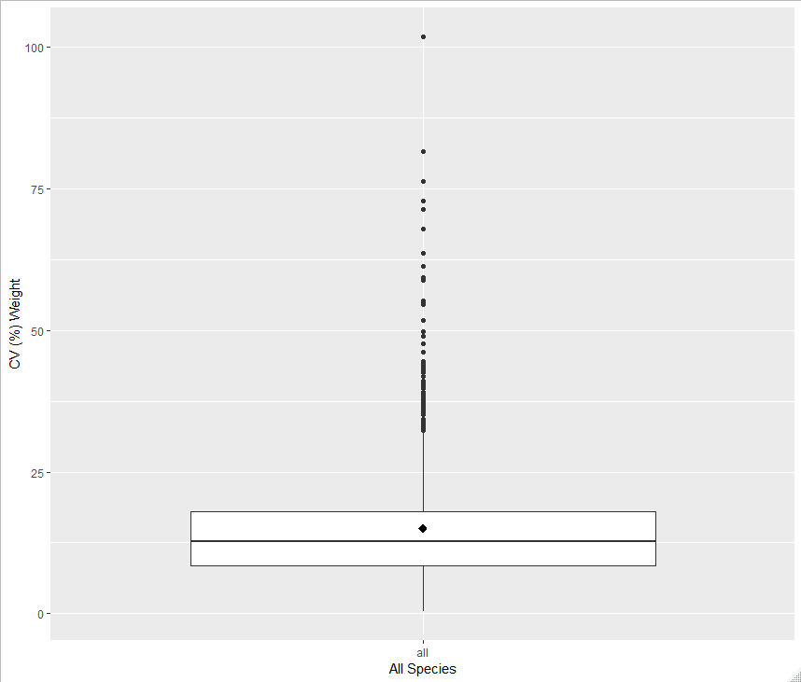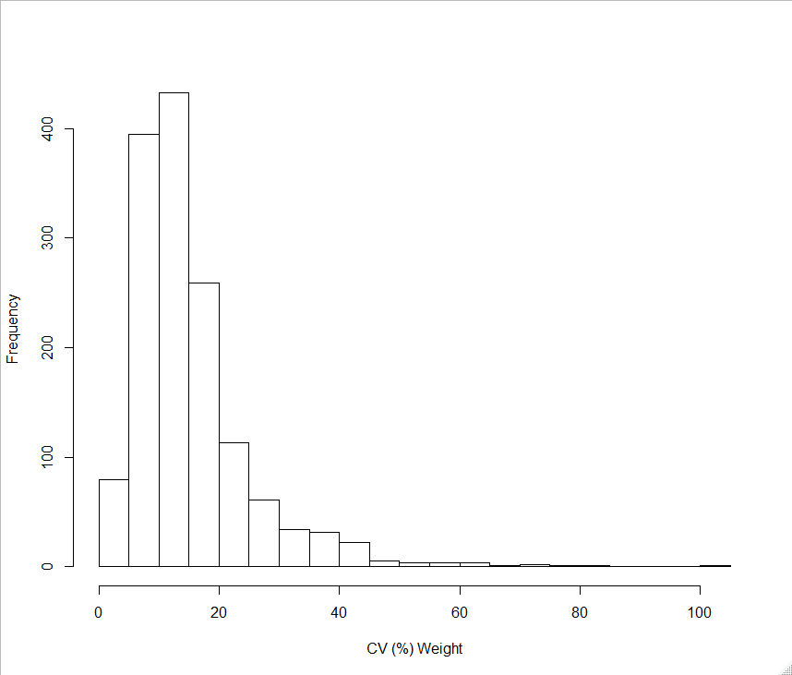  15.0  12.7  18.0  8.52 | 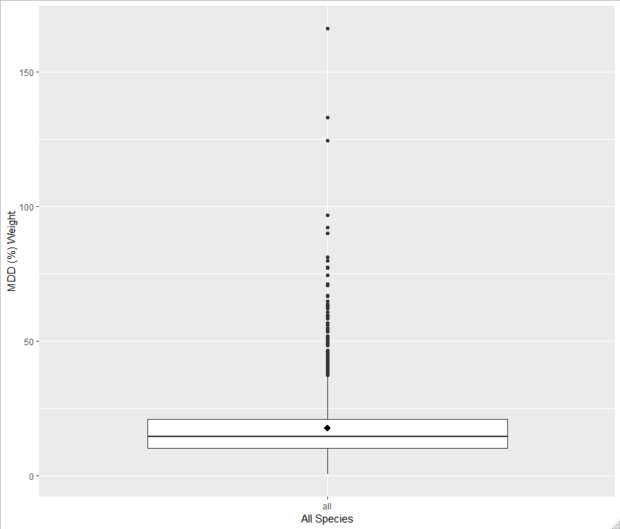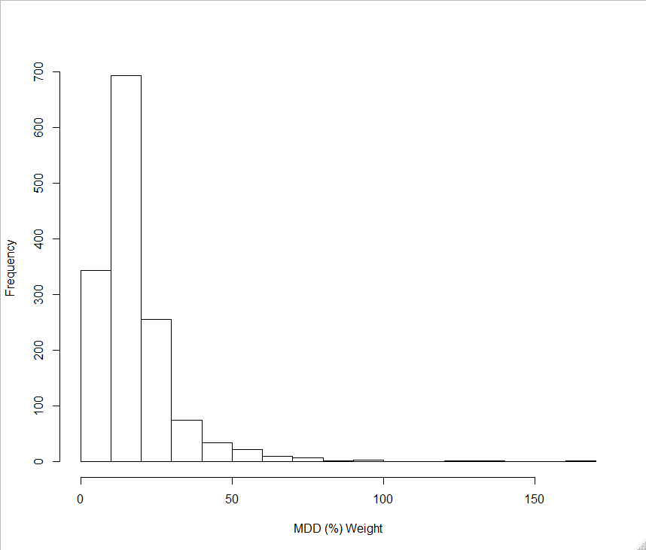  17.8  14.6  10.2  21.0
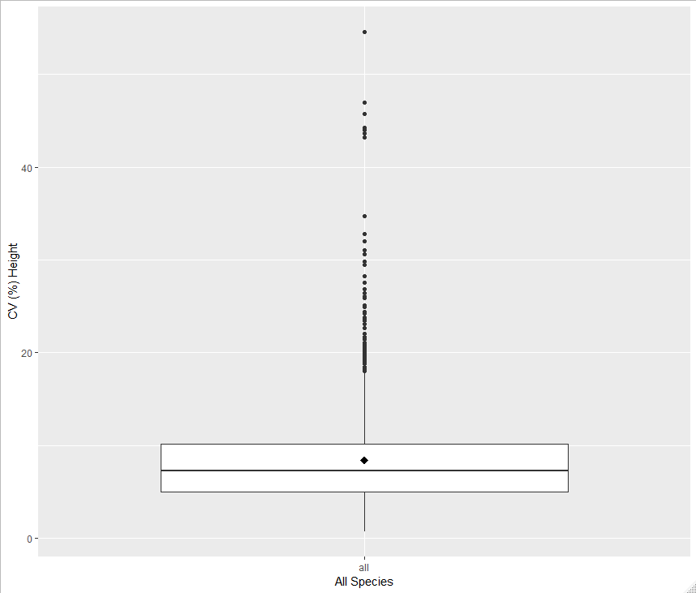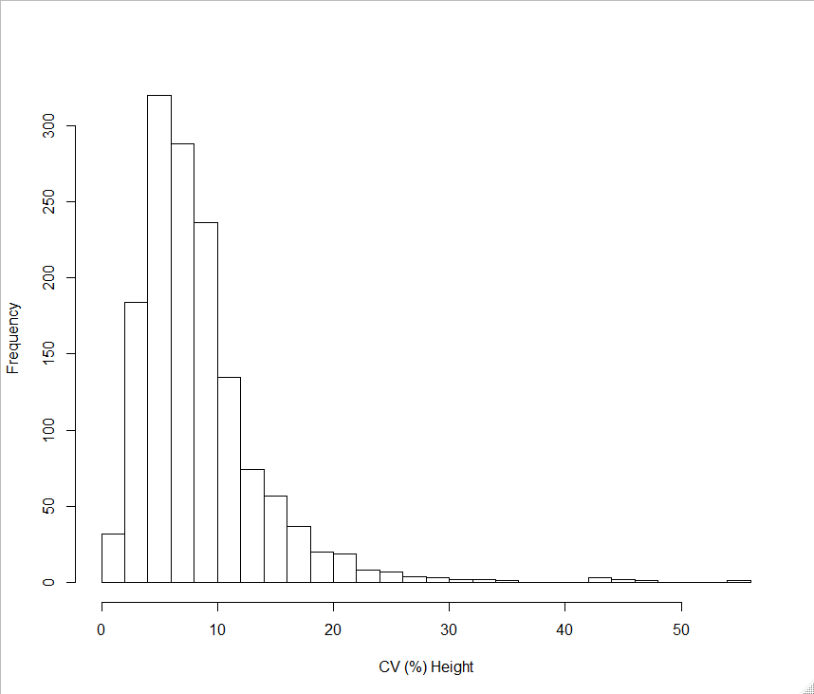  8.40  7.24  4.94  10.2 | 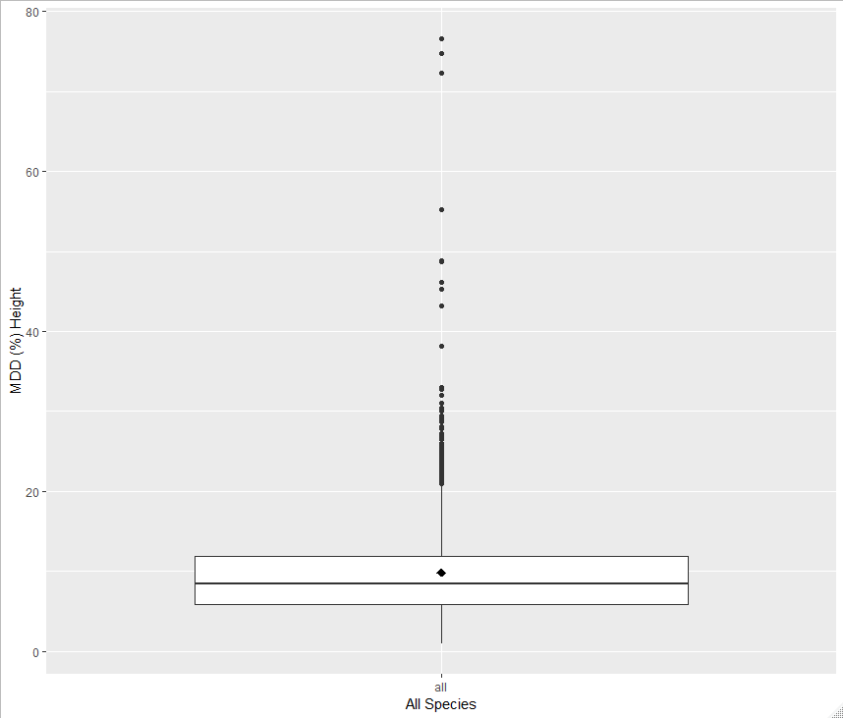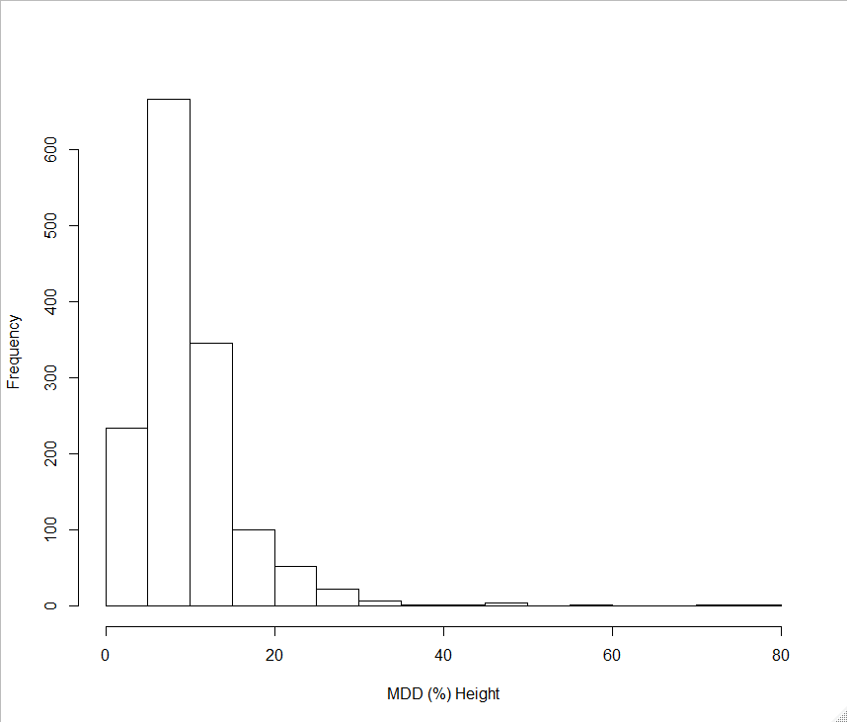  9.87  8.44  11.9  5.83
Figure 5. Vegetative Vigor Variability Metrics (CV in first column and MDD% in second column) for Dry Weight (top row) and Shoot Height (bottom row) across all Species. Solid circles represent individual data points outside of 1.5 times the interquartile range; vertical lines indicate the upper-bound and lower-bound of the interquartile range; the middle (upper; lower) horizontal line of the white box marks the median (75%; 25% quartile); the diamond point shows the mean. The inset bar graph illustrates the frequency distribution of the growth metric of that row/column. Y-axes intentionally scaled differently.

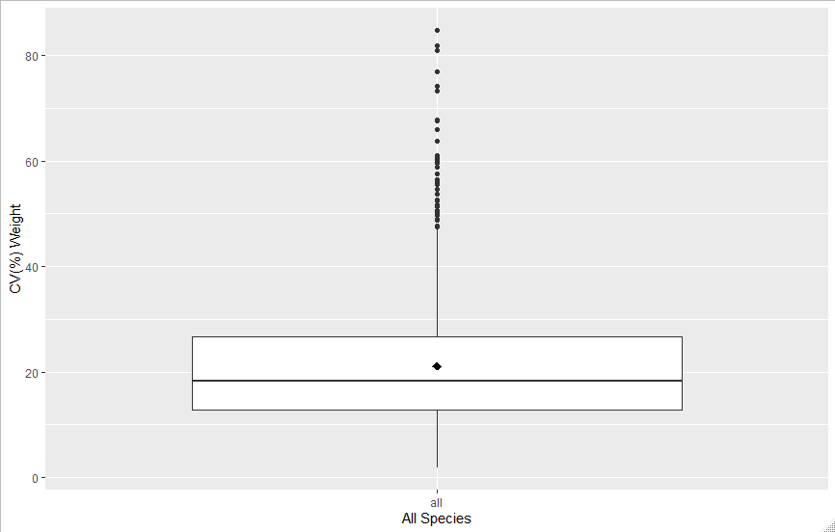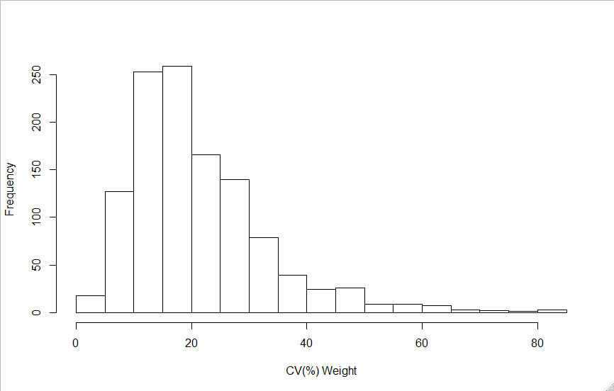  12.8  26.6  18.4  21.1 | 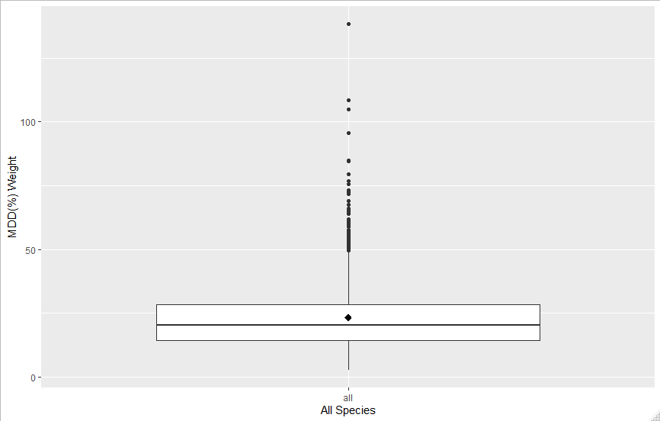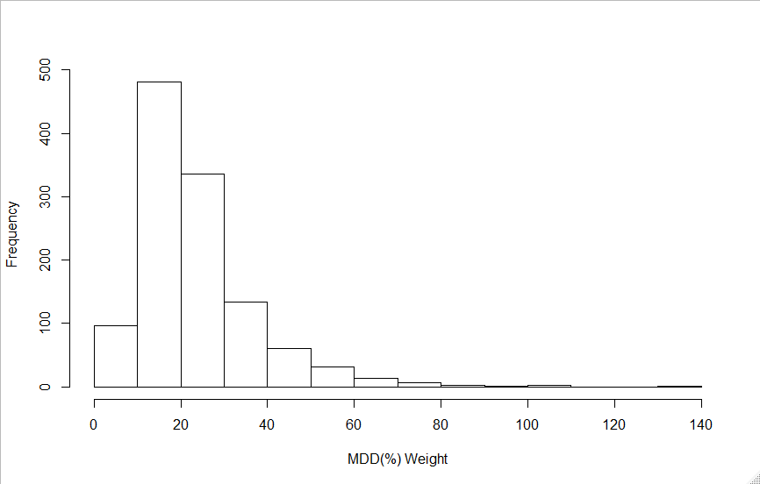  14.17  28.3  20.2  23.3
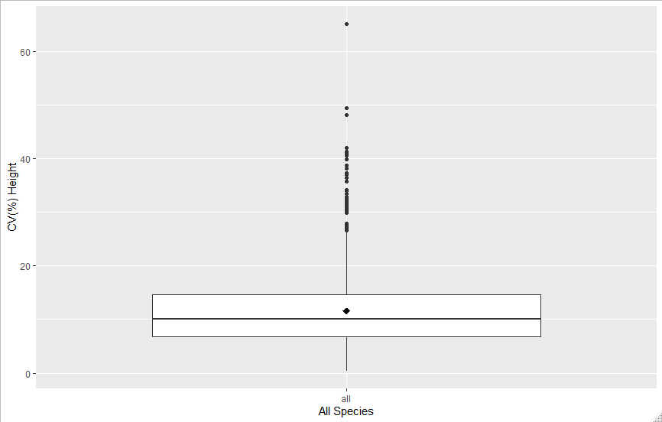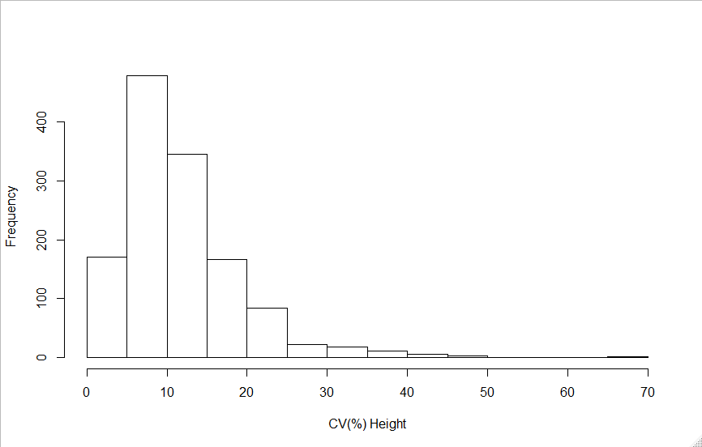  6.72  14.7  10.0  11.6 | 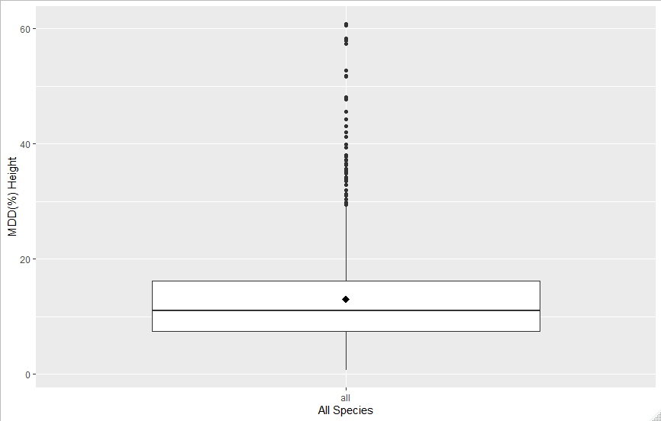  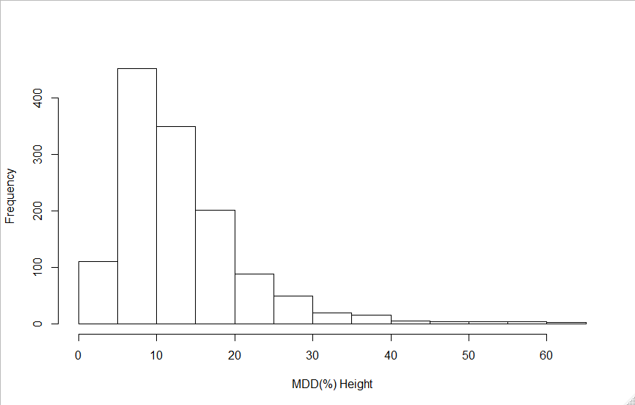  11.1  16.2  7.49  13.0
Figure 6. Seedling Emergence Variability Metrics (CV in first column and MDD% in second column) for Dry Weight (top row) and Shoot Height (bottom row) across all Species. Solid circles represent individual data points outside of 1.5 times the interquartile range; vertical lines indicate the upper-bound and lower-bound of the interquartile range; the middle (upper; lower) horizontal line of the white box marks the median (75%; 25% quartile); the diamond point shows the mean. The inset bar graph illustrates the frequency distribution of the growth metric of that row/column.

Tables 3 and 4 provide summaries of the CV and MDD% descriptive statistics for VV dry weight and shoot height and for SE dry weight and shoot height, respectively. While these distributions are not symmetric, the positive skewness is not extreme (inset bar graphs, see Figures 5 and 6) and large number of studies included in the datasets, either the mean or the median could be used to represent the central tendency for each distribution.
For VV, variance in dry weight is greater than variance in shoot height as the mean and median MDD% for dry weight are 18 and 15, respectively, compared to the mean and median MDD% for shoot height which is 9.9 and 8.4. In addition, the IQRs for VV dry weight and shoot height MDD% are 11 and 6.1, respectively. The larger value for the dry weight IQR indicates a larger spread in within test variation for dry weight than for shoot height.
SE follows a similar pattern, as the variance in dry weight is greater than variance is shoot height. The mean and median MDD% for dry weight are 23 and 20, respectively, compared to the mean and median MDD% for shoot height which is 13 and 11. In addition, the IQRs for SE dry weight and shoot height MDD% are 14 and 8.7, respectively. The larger value for the dry weight IQR indicates a wider variation in within test variation for dry weight than for shoot height.

Variation in both SE growth endpoints is greater than the variation in the VV growth endpoints. The difference is more pronounced for dry weight than it is for shoot height. The mean and median MDD% for SE dry weight are 23 and 20, respectively, compared to the mean and median MDD% for VV dry weight which is 18 and 15. Similarly, the mean and median MDD% for SE shoot height are 13 and 11, respectively, compared to the mean and median MDD% for VV shoot height which is 9.9 and 8.4.
Determination of a meaningful percent effect for shoot height and dry weight

The four distributions of CV data and four distributions of MDD% data (Tables 3 and 4; Figures 5 and 6). were used to identify the typical (based on mean and median) amount of background variability present in each endpoint (VV dry weight, VV shoot height, SE dry weight, and SE shoot height). EFED considered the central tendency estimates (i.e., the mean and median values) for both the CV and MDD% for all species combined to determine the appropriate IC_{x} value.

Tables 3 and 4 provide a summary of the descriptive statistics for VV and SE, respectively. Given the positive skew in the dataset (inset bar graphs, see Figures 5 and 6), the mean and the median values may not best represent the range in control data variability observed for some species/test combinations; however, in the context of listed species, they represent conservative estimates because they assume less variability in the control data. This central tendency estimate of variability can be used to represent an alternative endpoint that is based on the ability of these studies to identify an effect for listed plants when a NOAEC is not reliable based on these guideline studies. Growth (i.e., dry weight and shoot height) endpoint estimates for VV and SE are provided in Table 5.

Table 5. Estimates for growth endpoints (i.e., dry weight and shoot height) for VV and SE based on effects that can be distinguished from controls.
 | Dry Weight | Shoot Height
Vegetative Vigor | IC₁₅ | IC₁₀
Seedling Emergence | IC₂₀ | IC₁₀

For dry weight in the VV studies, the analysis indicates that an effect of 15% or more can be meaningfully distinguished from controls. This is based on a compilation of dry weight data from all tested species and represents a mid-point of the median and mean values of the CV (12.7 and 15.0, respectively) and MDD% (14.6 and 17.8, respectively; Table 3). For VV dry weight, the alternative endpoint is an IC₁₅.

For shoot height in the VV studies, a 10% effect or greater can be distinguished from controls. This is based on a compilation of height data from all tested species and represents an approximate mid-point of the median and mean values of the CV (7.2 and 8.4, respectively) and MDD% (8.4 and 9.9, respectively; Table 3).

For dry weight in the SE studies, the analysis indicates that an effect of 20% or more can be meaningfully distinguished from controls. This is based on a compilation of dry weight data from all tested species and represents an approximate mid-point of the median and mean values of the CV (18.4 and 21.1, respectively) and MDD% (20.2 and 23.3, respectively; Table 4).

For shoot height in the SE studies, a 10% effect or greater can be distinguished from controls. This is based on a compilation of height data from all tested species and represents an approximate mid-point of the median and mean values of the CV (10.0 and 11.6, respectively) and MDD% 11.1 and 13.0, respectively; Table 4).

5. Conclusions
For assessing potential effects to listed terrestrial and wetland plant species for risk estimation when a valid NOAEC is not available, the IC₁₅ and IC₁₀ estimates, represent levels that can be distinguished from controls for VV dry weight and shoot height, respectively. For SE dry weight and shoot height, IC₂₀ and IC₁₀ estimates, respectively, can be statistically distinguished from controls in guideline studies. Therefore, these ICx values represent reasonable values that can be used to identify exposure levels associated with the endpoints evaluated in this analysis based on standard guideline vegetative vigor and seedling emergence studies when a valid NOAEC is not available. These values are approximate mid-points between the mean and median values of the CV and MDD% for the four groups described above.

6. References

- Hogg RV and EA Tanis. 1982. Probability and statistical inference. 3rd ed. New York (NY): Macmillan. 424 p.
- Staveley JP, JW Green, J Nusz, D Edwards, K Henry, M Keren, AM Deines, R Brain, B Glenn, N Ehresman, T Kung, K Ralston-Hooper, F Kee, S McMaster. 2018. Variability in nontarget terrestrial plant studies should inform endpoint selection. IEAM. 14(5): 639-648.
- U.S. EPA. 2012a. Ecological Effects Test Guidelines OCSPP 850.4100: Seedling Emergence and Seedling Growth. EPA 712-C-012. https://www.epa.gov/test-guidelines-pesticides-and-toxic-substances/series-850-ecological-effects-test-guidelines
- U.S. EPA. 2012b. Ecological Effects Test Guidelines OCSPP 850.4150: Vegetative Vigor. EPA 712-C-011. https://www.epa.gov/test-guidelines-pesticides-and-toxic-substances/series-850-ecological-effects-test-guidelines

