APPENDIX 2.7 Atrazine Supplemental Data on Fish and Amphibian Sublethal Effects

This appendix provides additional information regarding available atrazine studies on sublethal effects in fish and amphibians and the selection of threshold values.

As discussed in Chapter 2, EPA has an extensive history of evaluating aquatic-phase amphibian literature for atrazine. The amphibian data has been given notable consideration in the past through various analyses and FIFRA Scientific Advisory Panels (SAPs), and much of this history and data was discussed in the 2016 DRA (USEPA, 2003; 2007; 2012; 2016). Previously, reviews of studies specific to the potential effects of atrazine on amphibian gonadal development were written in support of consultations with the SAP. Detailed transcripts and recommendations from those SAPs can be found at https://www.epa.gov/ingredients-used-pesticide-products/atrazine. For this biological evaluation, in addition to the data available from the 2016 DRA, ECOTOX was reviewed for any new studies on the effects of atrazine to amphibians. In addition, any new data submitted by the registrant was also considered; however, no new data on amphibians was submitted.

Fish data has also had extensive past reviews, including in the 2016 DRA, weight of evidence analyses published in the literature and public comments provided on the 2016 DRA (USEPA, 2016). For this assessment, in addition to the previously available data, ECOTOX was reviewed for any new studies on the effects of atrazine to fish and new data submitted by the registrant was also considered.

Figures 1 and 2 below display the available endpoints for mortality, growth, reproductive and behavioral endpoints in fish and amphibians. Although not an apical endpoint, behavioral effects are also shown due to the potential concern for survival effects due to behavioral changes, particularly swimming, on fish and amphibians. As shown in the figures, the range of effects endpoints, as well as no effects endpoints, span several orders of magnitude. In Figure 1, displaying fish endpoints, there are 18 LOAEC values displayed (with 13 associated NOAEC values) and 16 unbounded NOAECs (no effects observed in study at any test concentration). In Figure 2, displaying aquatic amphibian endpoints, there are 77 LOAEC values displayed (with 48 associated NOAEC values) and 192 unbounded NOAECs. All of these endpoints come from the ECOTOX database or registrant submitted studies.

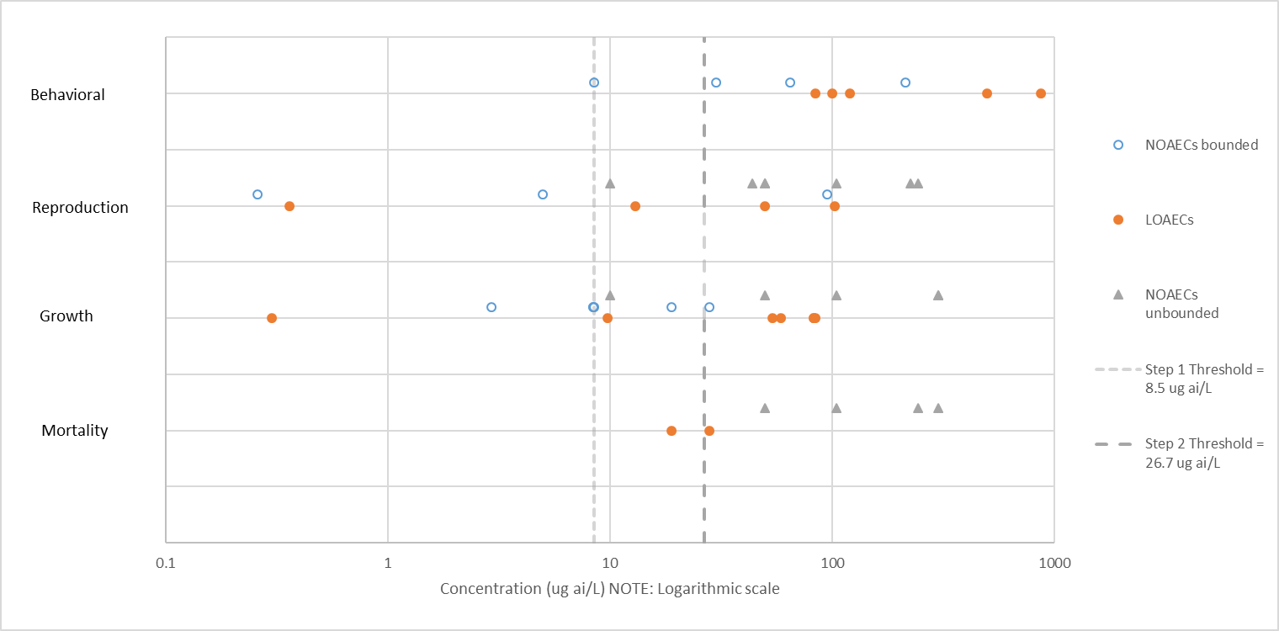
Figure 1. Effect and no effect endpoints in fish.

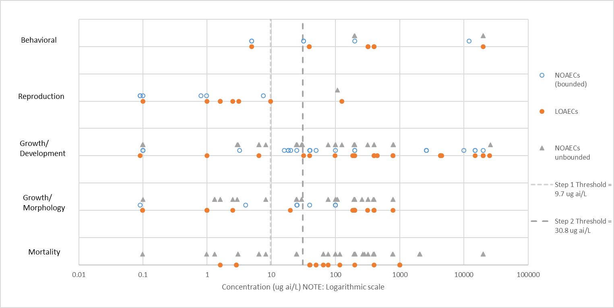
Figure 2. Effect and no effect endpoints in aquatic-phase amphibians.

For comparison, the threshold values for fish and amphibians are also displayed in the figures. Notably, there are a number of reported effects below the threshold value, but far more at concentrations greater than the thresholds for both fish and amphibians. When considering endpoints that were reported at concentrations lower than the thresholds, individual study quality becomes more significant, as all of these endpoints are associated with a higher degree of uncertainty and less confidence based on either the study quality or the relevance of the endpoint (USEPA, 2012; USEPA, 2016). Additionally, for amphibians, although there are effects endpoints less than the thresholds, there are as many or more data points that demonstrated no effects at or below the thresholds. When the new thresholds are evaluated in consideration of these factors, the thresholds used in this BE are considered protective for predicted effects to fish and amphibians in those studies that have a higher degree of confidence. Based on this evaluation, the Step 1 threshold level is established at 8.5/9.7 ug a.i. /L (~10 µg/L) for fish and amphibians and a Step 2 threshold is established at 26.7/30.8 ug a.i./L (~30 µg/L) for fish and amphibians, respectively.

New fish and amphibian studies reviewed from the open literature or submitted by the registrant are summarized below, as well as those used for endpoint selection. Previous study reviews can be found in the 2016 DRA and the atrazine 2012 Problem Formulation, presented at the 2012 SAP (USEPA, 2012; 2016).

Fish studies

In a recent study reported in ECOTOX (Wirbisky et al, 2016, E#174483), zebrafish were exposed to 0, 0.3, 3, or 30 µg a.i./L atrazine through embryogenesis and then allowed to mature to adulthood. A decrease in spawning was observed in the adult fish, with morphological alterations in their offspring. In addition, adult females displayed an increase in ovarian progesterone and follicular atresia. While no significant differences were observed for mortality or hatching rate, a decrease in head length-to-body ratio in offspring from the 30 µg a.i./L treatment group and an increase in head width-to-body ratio in offspring from the 0.3 and 3 µg a.i./L treatment groups was observed. [A previous study from the same laboratory (Weber et al, 2013, E#164783) reported an increase in head length and head-to-body ratio in zebrafish larvae exposed to 0.3, 3, or 30 µg a.i./L atrazine through embryogenesis.] The average number of breeding pairs that spawned was significantly lower in the 30 µg a.i./L treatment group as compared to other treatment groups, but the average number of embryos per pair and total number of live embryos in each treatment were not statistically different among treatments. Approximately 5% of the females from the 30 µg a.i./L treatment groups displayed an increase in abdominal swelling. Two of these individuals had severe swelling to the point of rupture. Pathological assessment indicated swelling was due to the inability to release eggs. Several endpoints were then assessed to further investigate this observation. No significant differences were observed in the total weight of females in the 30 µg a.i./L treatment groups compared to the control treatment group but there was a significant increase in ovarian weight.

In another study by Nieves-Puigdoller et al. (2007; E#93473; supporting PhD thesis, E# 112625) investigators studied the effects of atrazine exposure to Atlantic Salmon smolts through freshwater exposure to atrazine for 21 days at 10 and 100 µg a.i./L (measured concentrations of 8.5 and 84.3 µg a.i./L) and subsequent saltwater challenge. During the freshwater exposure period, 9% of the fish exposed to atrazine at 100 µg a.i./L died (compared to 0% mortality in control and 10 µg a.i./L groups). Fish in this treatment group also exhibited significantly reduced feeding after 10 days of exposure (69-88% decrease by Day 10 as compared to control and 100% decrease (zero food consumption reported) when measured on day 15), decreased growth rate in freshwater and decreased growth after the first month in saltwater. A compensatory growth period occurred in the second and third month in saltwater. Freshwater smolts in the 100 µg a.i./L group also had decreased plasma Cl⁻, Mg²⁺, Na⁺ and Ca²⁺ ions and increased cortisol. Following the SW challenge, fish previously exposed to 100 µg a.i./L atrazine had significant increases in hematocrit, plasma cortisol, Cl⁻, Mg²⁺, Na⁺, Ca²⁺ and a decrease in T4 and T3. There was an increase in the hepatosomatic Index (HSI) in females in the 100 µg a.i./L group and a decrease in the male gonadosometic index (GSI) in this group after 21 days of atrazine exposure. The study authors also reported decreased activity and response to external stimuli in the 100 µg a.i./L treatment group during freshwater expoure.
In a study by Liu ZZ et al.; 2016 (E#174516) zebrafish were exposed to atrazine (ATZ) and its main chlorometabolites, (i.e., diaminochlorotriazine (DACT), deisopropylatrazine (DIP), and deethylatrazine (DE)) at 30, 100, 300 µg/L (6 larvae/replicate, 4 replicates). Several developmental endpoints such as the heartbeat, hatchability, and morphological abnormalities were investigated as well as swimming behavior. Although no malformation effects were noted from atrazine exposure, heartbeat was significantly decreased with metabolites, [i.e., 9.08%, (DACT 100 µg/L), and 10.7%, 6.85% (DIP), 10.39%, 8.84% (DE) for100 and 300 µg/L, respectively]. High doses of DACT also led to an increase in the malformations and a shorter body length. After 5 days of exposure, the swimming behaviors of larval zebrafish were significantly disturbed, and the acetylcholinesterase (AChE) activities were consistently inhibited. Swimming distances were significantly decreased in larvae at 100 and 300 µg/L for atrazine, DIP and DE and at all test concentrations for DACT. Only nominal concentrations were reported in the study, and no negative control was used (solvent control only; 1% DMSO).

As part of the public comment period on the 2016 DRA, the registrant submitted 2 additional fish studies with both the fathead minnow and Japanese medaka (MRIDs 50349204 and 50349203, respectively). Both of these studies were conducted in accordance with the USEPA 890.1350 Fish Short Reproduction Assay developed under the Endocrine Disruption Screening Program. These studies are designed to measure the reproductive potential of groups of fathead minnows as a primary indicator of endocrine disruption. Measurements include those of survival, reproductive behavior, secondary sex characteristics, fecundity and fertilization success as well as a number of endpoints reflective of the status of the reproductive endocrine system, including the gonado-somatic index (GSI), gonadal histology ad plasma concentrations of vitellogenin (Vtg). Details of these studies are described below.

A 28-day short-term reproduction assay of atrazine with Fathead Minnow (Pimephales promelas) was conducted under continuous flow (MRID 50349204). In this study, adult fish, 20 spawning groups (5 males and 5 females in each group) were exposed to atrazine at measured concentrations of 1.0, 10, 26, 52, and 105 µg a.i./L. There were no significant differences between the treatment levels and negative control for fecundity, fertility success, female body weight, or female GSI compared to the negative control. There was a significant increase in female body length of 4% at 1.0 µg a.i./L level compared to the negative control and decreases in female Vtg at 1.0 and 52 µg a.i./L levels compared to the negative control (inhibitions of 22 and 36%, respectively); these effects did not show a dose-dependent response. There were no significant differences between the treatment levels and negative control for male body weight or length, male Vtg, male GSI or male tubercle score compared to the negative control.

In male and female fish, there were no meaningful histopathological findings related to atrazine exposure. Additional observations indicated a slight increase in mean testicular stage score at the 10 µg a.i./L treatment relative to the negative control; however, there was no dose-response pattern and the study author concluded this was not a treatment related effect. In female fish, there was an increased proportion of stage 4 ovaries (severe) and grade 3 post-ovulatory follicles (moderate) at 105 µg a.i./L. None of the other male or female histological parameters showed a dose-response. Daily observations were recorded throughout the test. Sporadic conditions not considered to be treatment related by the study author included a few observations of females with swollen or red ovipositors, bruising, enlarged abdomens and black spots on abdomen throughout the exposure. There were also observations of bruising, weak fish and loss of equilibrium noted occasionally throughout the exposure period. However, these observations were sporadic and occurred across controls and treatment groups.

In addition to the fathead minnow, an additional Fish Short-term Reproduction Assay was conducted with the Japanese Medaka (Oryzias latipes) (MRID 50349203). This was in addition to the short-term reproduction study on the Japanese medaka submitted in 2015 (MRID 49694001), and reported in the 2016 DRA, where no significant effects on fertility or fecundity at 0.5, 5.0, and 50 µg a.i./L treatment levels. In this recent study, Japanese medaka were exposed to atrazine at nominal concentrations of 0, 10, 50, 75, 100 and 250 µg a.i./L; mean-measured concentrations were 9.4, 48, 74, 97, and 244 µg a.i./L. There were no significant differences between the treatment levels and negative control for fecundity, fertility success, female body weight, female body length, and female Vtg endpoints compared to the negative control. There was a statistically significant inhibition in mean male body weight of 14% at the 97 µg a.i./L level, and in male body length of 5 and 6% at the 74 and 97 µg a.i./L treatment compared to the negative control; however, these effects were not concentration-dependent responses. There were also statistically significant increases in mean male Vtg at the 48, 74, 97 and 244 µg a.i./L levels compared to the negative control. The study author noted these data were on the lower end of the historical control data range and were within historical control values. Median male and female tubercle scores, GSI and plasma sex steroids (testosterone and 17β-estradiol) were not reported. Additional observations indicated there was a slight decrease in mean testicular stage score at the 48, 74, 97 and 244 µg a.i./L level relative to the negative control; however, a dose-response pattern was not observed.

As discussed in Chapter 2, with the submission of the three new registrant studies, there are now 3 additional studies on reproduction in fish not previously available that did not find any significant effects to fecundity or fertility in either the Japanese Medaka (in two studies) or the fathead minnow. In addition, as part of the public comment period, the registrant submitted additional discussion of the uncertainties related to the Papoulious study used in the 2016 DRA as a quantitative endpoint. With the addition of 2 new reproductive studies in the Japanese Medaka that addressed and corrected issues and concerns raised by the EPA in the Papoulious study review, additional uncertainty is raised on the reproducibility and reliability of the endpoint from the Papoulious study.

Amphibian studies

In a study by Sai et al. (2016, E178653), developing tadpoles (Xenopus laevis) were exposed to concentration of atrazine at 0.1, 1, 10 or 100 µg a.i./L continuously for 90 days (measured concentrations of 0.10 ± 0.02, 0.9 ± 0.4, 9.7 ± 1.9, and 97.7 ± 7.5 µg a.i./L). Compared with froglets in the control group, there were no significant differences in body length, body weight, liver weight and hepatosomatic index (HSI) of males. Atrazine treatment at 100 µg a.i./L caused a significant reduction of gonad weight and gonadosomatic index (GSI) of males. In addition, atrazine at all dose levels caused testicular degeneration based on histopathological evaluation especially in froglets from the groups with 0.1 and 100 µg a.i./L.

In addition to this study, Saka et al. (2018, E178499) exposed amphibian tadpoles (Silurana tropicalis) to seven 1,3,5- triazine (s-triazine) herbicides (ametryn, prometryn, dimethametryn, simazine, atrazine, propazine, and cyanazine). Tadpoles were exposed to atrazine at 101 and 996 µg a.i./L (measured concentration) until all tadpoles in the control group reached either the late prometamorphic stages or the initial stage of metamorphic climax. Statistically significant developmental effects were noted in atrazine in both test concentration groups. Developmental changes included delay in developmental stage reached by end of study (57 in treatment group vs 58 in control), hind limb length (25% decrease), ratio of hindlimb length to body length (22% decrease) and thyroid gland size (30% decrease). A significant decrease in total body length and body mass and significant increase in the degree of scoliosis present were noted at the highest test concentration.

In a study by Ehrsam and Rohr (2016; E174486), Cuban tree frog tadpoles (Osteopilus septentrionalis) were exposed to atrazine at 178 µg a.i./L for 7 days to examine the ability of tadpoles to detect and respond to chemical cues from larval dragonfly (Libellulidae sp.) predators. Eighty tadpoles (Gosner stages ranging from 25 to 41) were kept individually in 250 mL of pond water in standard mason jars. One-half the tadpoles were exposed to acetone and one half were exposed to atrazine at 178 µg a.i./L, intended to represent relevant concentrations of atrazine expected in farm ponds. Aquatic dragonfly larvae were housed in a separate aquarium; water from this tank was used as a predator cue source. Individual tadpoles were transferred to plastic shoeboxes and monitored for response to chemical cue added to the box. Tadpoles exposed to atrazine were significantly hyperactive relative to those exposed to solvent control. In addition, control tadpoles significantly avoided predator chemical cues, but tadpoles exposed to atrazine did not.

References

U.S. Environmental Protection Agency (USEPA). 2003d. FIFRA Scientific Advisory Panel: A Set of Scientific Issues Being Considered by the Environmental Protection Agency Regarding: Potential Developmental Effects of Atrazine on Amphibians. June 17 - 20, 2003. Available at EPA-HQ-OPP-2003-0186.

U.S. Environmental Protection Agency (USEPA). 2007a. The Potential for Atrazine to Affect Amphibian Gonadal Development. Prepared for October 9 - 12, 2007 FIFRA Scientific Advisory Panel. Document Available at EPA-HQ-OPP-2007-0498

U.S. Environmental Protection Agency (USEPA). 2012. FIFRA Scientific Advisory Panel: Problem Formulation for the Reassessment of Ecological Effects from the Use of Atrazine. June 12-14, 2012.

U.S. Environmental Protection Agency (USEPA). 2016. Refined Ecological Risk Assessment for Atrazine. Office of Pesticide Programs, Environmental Fate and Effects Division. April 12, 2016.

