APPENDIX 2-6. Atrazine Species Sensitivity Distribution Analysis for Terrestrial Plants

SSDs were fit to toxicity data for terrestrial plants exposed to atrazine. Five distributions were tested and a variety of methods were used to determine whether different subsets of data should be modeled independently. Ultimately, the results from the vegetative vigor and seedling emergence SSDs were used. Table 1 provides a summary of the results.

Table 1. Summary statistics for SSDs fit to atrazine test results.
Statistic | Vegetative Vigor | Seedling Emergence
Best Distribution (by AIC_{c}) | Normal | Gumbel
Goodness of fit  P-value | 0.813 | 0.7602
CV of the HC₀₅ | 0.2717 | 0.4707
HC₀₅ | 0.0242 | 0.0037
HC₁₀ | 0.0347 | 0.0047
HC₅₀ | 0.1233 | 0.0146
HC₉₀ | 0.4376 | 0.0855
HC₉₅ | 0.6958 | 0.169

- Data

Data used in this analysis are detailed in Tables 9 and 10 (at the end of the document) and were from registrant submitted studies as well as an ECOTOX query (APPENDIX 2-2). Table 2 provides the distribution of the test results for atrazine including the number of species represented. Distributions were created for terrestrial plants based on IC₂₅ values for various metrics of growth from 14- and 28-d seedling emergence studies and 14-, 28-, and 42-d vegetative vigor studies.

Table 2. Distribution of test results available for atrazine.
Data Subset | Test results | Species
Vegetative Vigor | 93 | 36
Seedling Emergence | 16 | 9

Figures 1 and 2 show the distribution of test results among species from the vegetative vigor and seedling emergence studies, respectively, indicating that several species have been repeatedly tested (seven species have been tested at least 5 times each), but the majority of species have been tested fewer than three times.
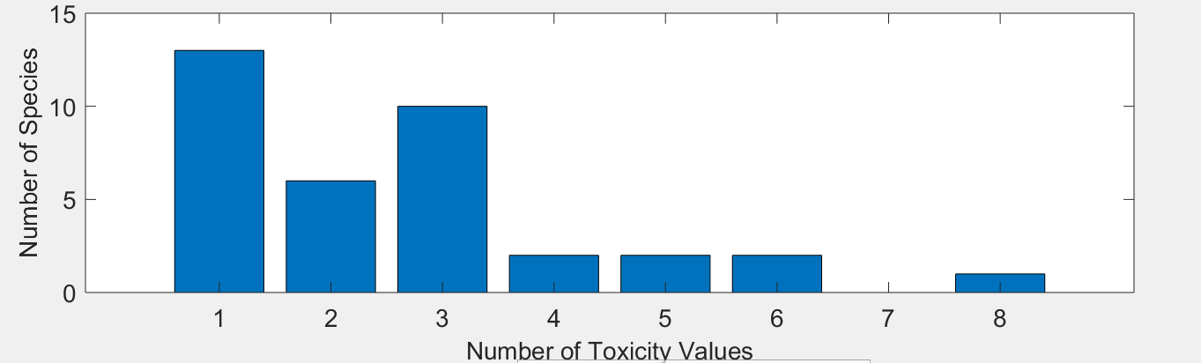
Figure 1. Distribution of the number of test results per species in atrazine vegetative vigor data.

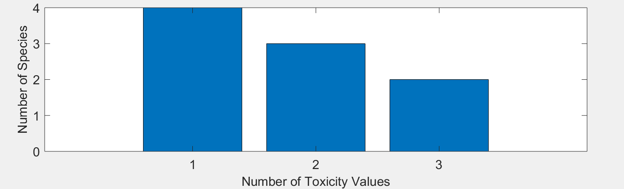
Figure 2. Distribution of the number of test results per species in atrazine seedling emergence data.

Five potential distributions for the atrazine data were considered, including log-normal, log-logistic, log-triangular, log-gumbel, and Burr. To fit each of the first four distributions, the toxicity values were first common log (log₁₀) transformed. Finally, effect thresholds and five quantiles from the fitted SSDs (HC₀₅, HC₁₀, HC₅₀, HC₉₀, HC₉₅) were calculated and reported.

- Comparison of distributions using AIC_{c}

Akaike’s Information Criterion corrected for sample size (AIC_{c}) was used to compare the five distributions for the aquatic plant dataset. For these comparisons all SSDs were fit using maximum likelihood. The AIC_{c} suggested that the normal distribution provided the best fit for the vegetative vigor data and the gubmel distribution provided the best fit for the seedling emergence data (Tables 3 and 4).

Table 3. Comparison of distributions for vegetative vigor toxicity data for atrazine.
Distribution | AIC_{c} | ∆AIC_{c} | Weight | HC₀₅
normal | -45.0266 | 0 | 0.3265 | 0.0242
logistic | -44.9734 | 0.0532 | 0.3179 | 0.0234
gumbel | -43.1765 | 1.8501 | 0.1295 | 0.0282
triangular | -42.9126 | 2.1140 | 0.1135 | 0.0235
burr | -42.8993 | 2.1273 | 0.1127 | 0.0264

Table 4. Comparison of distributions for seedling emergence toxicity data for atrazine.
Distribution | AIC_{c} | ∆AIC_{c} | Weight | HC₀₅
gumbel | -39.6212 | 0 | 0.2971 | 0.0037
triangular | -39.4532 | 0.1680 | 0.2732 | 0.0028
logistic | -38.8917 | 0.7295 | 0.2063 | 0.0025
normal | -38.7859 | 0.8353 | 0.1957 | 0.0027
burr | -34.8808 | 4.7404 | 0.0278 | 0.0036

- Goodness of fit

The plot of the cumulative distribution functions for the best-fit distributions (as determined by AIC_{c}) suggest little evidence of lack-of-fit (Figures 3 and 4). Bootstrap goodness-of-fit tests did not show evidence for lack-of-fit (P-values > 0.05, Tables 5 and 6) for any of the distributions. The coefficient of variation for the HC₀₅ was below 1 for all distributions.

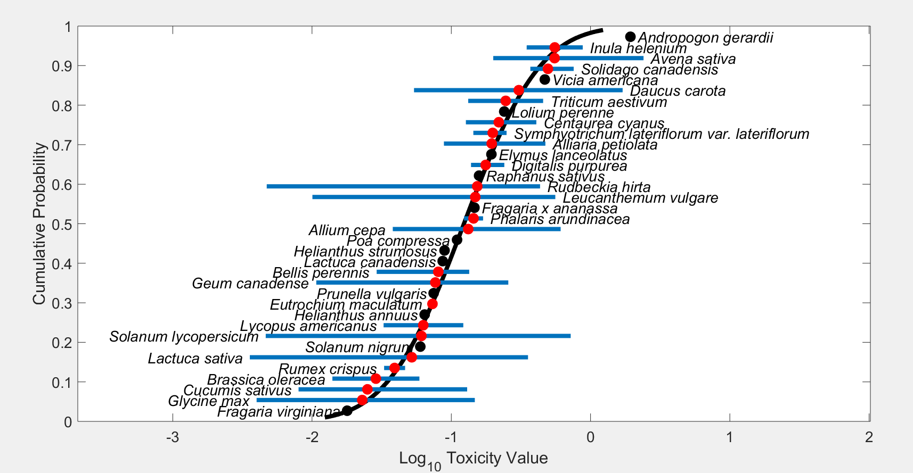
Figure 3. Log-normal SSD for atrazine toxicity values for terrestrial plants at the vegetative vigor life stage. Black points indicate single toxicity values. Red points indicate average of multiple toxicity values for a single species. Blue line indicates full range of toxicity values for a given taxon.

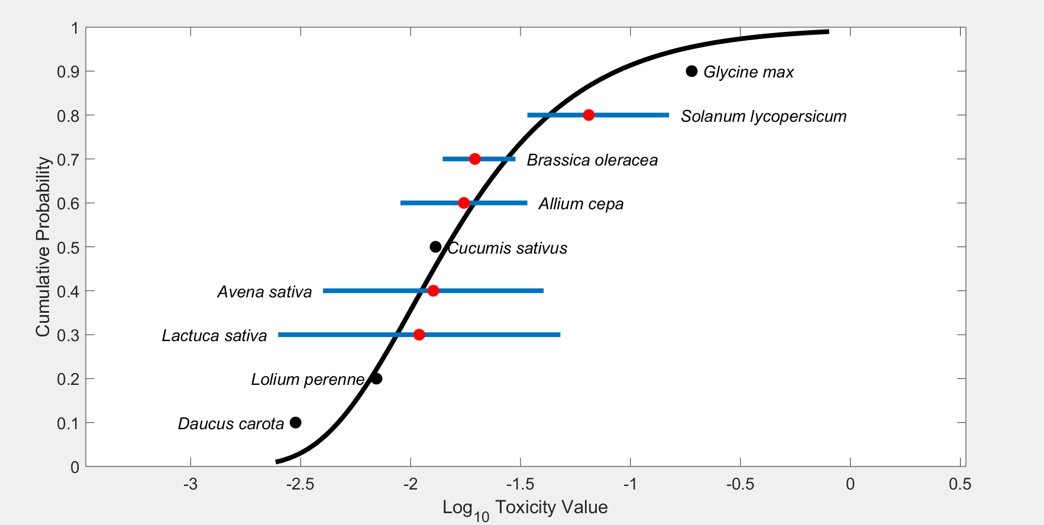
Figure 4. Log-gumbel SSD for atrazine toxicity values for terrestrial plants at the seedling emergence. Black points indicate single toxicity values. Red points indicate average of multiple toxicity values for a single species. Blue line indicates full range of toxicity values for a given taxon.

Table 5. Range of HC₀₅ values for atrazine SSDs for terrestrial plants at the vegetative vigor life stage.
Distribution | Method | HC₀₅ | SE | CV | Lower CI | Upper CI | P
Normal | ML | 0.0242 | 0.0066 | 0.2717 | 0.015 | 0.0407 | 0.8132
Normal | MO | 0.0237 | 0.0063 | 0.2657 | 0.0143 | 0.0386 | 0.7802
Normal | GR | 0.0213 | 0.0061 | 0.2844 | 0.0108 | 0.0346 | 0.6424
Logistic | ML | 0.0234 | 0.0071 | 0.3052 | 0.0132 | 0.0415 | 0.6683
Logistic | MO | 0.0242 | 0.007 | 0.2893 | 0.0131 | 0.0394 | 0.8002
Logistic | GR | 0.0203 | 0.0058 | 0.287 | 0.0089 | 0.0318 | 0.8002
Triangular | ML | 0.0235 | 0.0063 | 0.2672 | 0.0177 | 0.0414 | 0.0629
Triangular | MO | 0.023 | 0.0058 | 0.2536 | 0.0142 | 0.0373 | 0.5784
Triangular | GR | 0.022 | 0.0057 | 0.2583 | 0.0129 | 0.0354 | 0.4745
Gumbel | ML | 0.0282 | 0.0051 | 0.1828 | 0.0209 | 0.0409 | 0.2607
Gumbel | MO | 0.0333 | 0.0066 | 0.199 | 0.0227 | 0.0489 | 0.2787
Gumbel | GR | 0.0302 | 0.0061 | 0.2022 | 0.0177 | 0.0408 | 0.3077
Burr | ML | 0.0264 | 0.0082 | 0.3117 | 0.0146 | 0.0463 | 0.5764
ML=maximum likelihood, MO= moment estimators, and GR=graphical methods
LCp and UCp=projections of the confidence limits of the HC₀₅ (LCx and UCx) onto the cumulative distribution function of the fitted distribution.

Table 6. Range of HC₀₅ values for atrazine SSDs for terrestrial plants at the seedling emergence life stage.
Distribution | Method | HC₀₅ | SE | CV | Lower CI | Upper CI | P
Normal | ML | 0.0027 | 0.0022 | 0.8378 | 0.001 | 0.0098 | 0.3616
Normal | MO | 0.0024 | 0.0021 | 0.881 | 0.000704 | 0.0081 | 0.2887
Normal | GR | 0.0017 | 0.0015 | 0.8828 | 0.000252 | 0.0059 | 0.1998
Logistic | ML | 0.0025 | 0.0021 | 0.8472 | 0.00077 | 0.009 | 0.4595
Logistic | MO | 0.0025 | 0.0023 | 0.9467 | 0.000561 | 0.0094 | 0.4046
Logistic | GR | 0.0015 | 0.0014 | 0.9479 | 8.47E-05 | 0.0053 | 0.2408
Triangular | ML | 0.0028 | 0.0025 | 0.9063 | 0.0015 | 0.0108 | 0.5295
Triangular | MO | 0.0023 | 0.002 | 0.8497 | 0.000793 | 0.0081 | 0.2488
Triangular | GR | 0.0019 | 0.0016 | 0.8306 | 0.000435 | 0.0064 | 0.1688
Gumbel | ML | 0.0037 | 0.0017 | 0.4707 | 0.0021 | 0.009 | 0.7602
Gumbel | MO | 0.0036 | 0.002 | 0.5517 | 0.0016 | 0.0094 | 0.7113
Gumbel | GR | 0.0026 | 0.0015 | 0.5823 | 0.000579 | 0.0067 | 0.3976
Burr | ML | 0.0036 | 0.0022 | 0.606 | 0 | 0.0091 | 0.6454
ML=maximum likelihood, MO= moment estimators, and GR=graphical methods
LCp and UCp=projections of the confidence limits of the HC₀₅ (LCx and UCx) onto the cumulative distribution function of the fitted distribution.

- Test for the need to model results separately by vegetative vigor and seedling emergence life stage

Examination of the cumulative distribution functions plotted on similar axes for vegetative vigor and seedling emergence studies does not support combining the datasets into one distribution. The 95% bootstrap confidence intervals for the separate distributions do not overlap substantially (Figure 5). Given these differences, the vegetative vigor and seedling emergence distributions will be used separately.

Figure 5. SSDs for vegetative vibor IC₂₅s (normal) and seedling emergence IC₂₅s (gumbel) for atrazine. Blue lines show the distribution and upper and lower confidence interval for species from vegetative vigor studies. Red lines show the distribution and upper and lower confidence interval for species from seedling emergence studies.

- Calculation of other quantiles

Tables 7 - 9 provides estimates of the HC₀₅ as well as other quantiles of the fitted SSDs.

Table 7. Estimated quantiles of the fitted SSDs for atrazine IC₂₅s for terrestrial plants at the vegetative vigor life stage.
Distribution | Method | HC₀₅ | HC₁₀ | HC₅₀ | HC₉₀ | HC₉₅
Normal | ML | 0.0242 | 0.0347 | 0.1233 | 4.38E-01 | 6.27E-01
Normal | MO | 0.0237 | 0.0341 | 0.1233 | 4.46E-01 | 6.41E-01
Normal | GR | 0.0213 | 0.0314 | 0.1233 | 4.83E-01 | 7.12E-01
Logistic | ML | 0.0234 | 0.0355 | 0.1207 | 4.10E-01 | 6.22E-01
Logistic | MO | 0.0242 | 0.0366 | 0.1233 | 4.15E-01 | 6.28E-01
Logistic | GR | 0.0203 | 0.032 | 0.1233 | 4.74E-01 | 7.50E-01
Triangular | ML | 0.0235 | 0.0335 | 0.1502 | 6.73E-01 | 9.59E-01
Triangular | MO | 0.023 | 0.0317 | 0.1233 | 4.79E-01 | 6.61E-01
Triangular | GR | 0.022 | 0.0306 | 0.1233 | 4.96E-01 | 6.90E-01
Gumbel | ML | 0.0282 | 0.0357 | 0.1062 | 5.86E-01 | 1.13E+00
Gumbel | MO | 0.0333 | 0.0409 | 0.1045 | 4.56E-01 | 8.00E-01
Gumbel | GR | 0.0302 | 0.0378 | 0.1061 | 5.35E-01 | 9.93E-01
Burr | ML | 0.0264 | 0.0374 | 0.1173 | 4.39E-01 | 7.01E-01

Table 8. Estimated quantiles of the fitted SSDs for atrazine IC₂₅s for terrestrial plants at the seedling emergence life stage.
Distribution | Method | HC₀₅ | HC₁₀ | HC₅₀ | HC₉₀ | HC₉₅
Normal | ML | 0.0027 | 0.0041 | 0.0176 | 7.61E-02 | 1.15E-01
Normal | MO | 0.0024 | 0.0037 | 0.0176 | 8.32E-02 | 1.29E-01
Normal | GR | 0.0017 | 0.0029 | 0.0176 | 1.07E-01 | 1.78E-01
Logistic | ML | 0.0025 | 0.004 | 0.0157 | 6.25E-02 | 9.99E-02
Logistic | MO | 0.0025 | 0.004 | 0.0176 | 7.64E-02 | 1.26E-01
Logistic | GR | 0.0015 | 0.0028 | 0.0176 | 1.11E-01 | 2.09E-01
Triangular | ML | 0.0028 | 0.004 | 0.0185 | 8.61E-02 | 1.24E-01
Triangular | MO | 0.0023 | 0.0034 | 0.0176 | 9.08E-02 | 1.34E-01
Triangular | GR | 0.0019 | 0.0029 | 0.0176 | 1.07E-01 | 1.63E-01
Gumbel | ML | 0.0037 | 0.0047 | 0.0146 | 8.68E-02 | 1.71E-01
Gumbel | MO | 0.0036 | 0.0046 | 0.0144 | 8.55E-02 | 1.69E-01
Gumbel | GR | 0.0026 | 0.0036 | 0.0152 | 1.44E-01 | 3.41E-01
Burr | ML | 0.0036 | 0.0048 | 0.015 | 7.80E-02 | 1.44E-01

Table 9 provides all of the available IC₂₅ values for vegetative vigor and seedling emergence studies. These data sets are the same as reported in the effects characterization and provide additional data for the formulated products. Values that were included in the SSD (i.e., TGAI) are marked with an *.

Table 9. Nontarget Terrestrial Plant Seedling Emergence Toxicity (Tier II). All definitive endpoints are used quantitatively in the SSD
Genus | Species | IC₂₅
Avena | sativa | 0.004
Allium | cepa | 0.009
Lolium | perenne | 0.007
Brassica | oleracea | 0.014
Daucus | carota | 0.003
Cucumis | sativus | 0.013
Lactuca | sativa | 0.0025
Glycine | max | 0.19
Solanum | lycopersicum | 0.034
Avena | sativa | 0.0403
Brassica | oleracea | 0.03
Solanum | lycopersicum | 0.053
Allium | cepa | 0.034
Brassica | oleracea | 0.018
Lactuca | sativa | 0.048
Solanum | lycopersicum | 0.15

Table 10. Nontarget Terrestrial Plant Vegetative Vigor Toxicity (Tier II). All definitive endpoints are used quantitatively in the SSD
Genus | Species | IC₂₅
Lactuca | sativa | 0.003577
Solanum | lycopersicum | 0.00465
Rudbeckia | hirta | 0.00473
Leucanthemum | vulgare | 0.010059
Geum | canadense | 0.01073
Fragaria | virginiana | 0.017883
Bellis | perennis | 0.029123
Lactuca | sativa | 0.029776
Lycopus | americanus | 0.032637
Rumex | crispus | 0.032941
Lactuca | sativa | 0.035767
Rumex | crispus | 0.046578
Solanum | lycopersicum | 0.04918
Lycopus | americanus | 0.051504
Solanum | nigrum | 0.05991
Lycopus | americanus | 0.061698
Helianthus | annuus | 0.064381
Geum | canadense | 0.065275
Eutrochium | maculatum | 0.069746
Prunella | vulgaris | 0.07469
Eutrochium | maculatum | 0.076899
Lycopus | americanus | 0.077793
Geum | canadense | 0.078956
Lactuca | canadensis | 0.086735
Alliaria | petiolata | 0.088523
Lactuca | sativa | 0.089328
Helianthus | strumosus | 0.089417
Solanum | lycopersicum | 0.089775
Poa | compressa | 0.109983
Lycopus | americanus | 0.121965
Phalaris | arundinacea | 0.123396
Centaurea | cyanus | 0.127348
Triticum | aestivum | 0.132338
Bellis | perennis | 0.134126
Bellis | perennis | 0.134448
Digitalis | purpurea | 0.138561
Symphyotrichum | lateriflorum var. lateriflorum | 0.143962
Fragaria | x ananassa | 0.146645
Glycine | max | 0.147539
Rudbeckia | hirta | 0.148531
Raphanus | sativus | 0.158269
Digitalis | purpurea | 0.165226
Phalaris | arundinacea | 0.168999
Alliaria | petiolata | 0.177047
Geum | canadense | 0.188134
Elymus | lanceolatus | 0.194107
Centaurea | cyanus | 0.203004
Symphyotrichum | lateriflorum var. lateriflorum | 0.217284
Digitalis | purpurea | 0.240327
Leucanthemum | vulgare | 0.244253
Symphyotrichum | lateriflorum var. lateriflorum | 0.249475
Geum | canadense | 0.256628
Rudbeckia | hirta | 0.279921
Inula | helenium | 0.34778
Leucanthemum | vulgare | 0.355613
Lactuca | sativa | 0.355613
Solidago | canadensis | 0.369294
Rudbeckia | hirta | 0.37186
Centaurea | cyanus | 0.407824
Rudbeckia | hirta | 0.413511
Solidago | canadensis | 0.432038
Rudbeckia | hirta | 0.434041
Triticum | aestivum | 0.456655
Vicia | americana | 0.469442
Alliaria | petiolata | 0.473913
Leucanthemum | vulgare | 0.558144
Solidago | canadensis | 0.756677
Inula | helenium | 0.878983
Andropogon | gerardii | 1.933205
Avena | sativa | 2.4
Allium | cepa | 0.61
Brassica | oleracea | 0.014
Daucus | carota | 1.7
Cucumis | sativus | 0.008
Lactuca | sativa | 0.33
Glycine | max | 0.026
Solanum | lycopersicum | 0.72
Avena | sativa | 0.35
Allium | cepa | 0.038
Lolium | perenne | 0.24
Brassica | oleracea | 0.059
Daucus | carota | 0.054
Cucumis | sativus | 0.015
Lactuca | sativa | 0.022
Glycine | max | 0.018
Solanum | lycopersicum | 0.029
Avena | sativa | 0.2
Allium | cepa | 0.1
Daucus | carota | 0.31
Cucumis | sativus | 0.13
Lactuca | sativa | 0.061
Glycine | max | 0.004
Solanum | lycopersicum | 0.12

* Indicates study was conducted with TGAI and value used to derive SSD.
NA = Studies are acceptable for ECOTOX but have not been formally reviewed by EFED scientists.
¹If a species was not represented with a 96 hour study, and other values were available from shorter/longer duration studies (up to 10 days) then the data were included and the duration was listed next to the LC₅₀ value as an indicator. If there were multiple other durations, the value from the study closer to a 96h duration was selected and if there were multiple values for the same duration, the range is indicated.

