APPENDIX 2-5. Atrazine Species Sensitivity Distribution Analysis for Aquatic Plants

SSDs were fit to toxicity data for vascular, nonvascular, and all aquatic plants exposed to atrazine. Five distributions were tested and a variety of methods were used to determine whether different subsets of data should be modeled independently. Ultimately, the results from the all aquatic plant SSDs was used. Table 1 provides a summary of the results.

Table 1. Summary statistics for SSDs fit to atrazine test results.
Statistic | All Aquatic Plants
Best Distribution (by AIC_{c}) | Gumbel
Goodness of fit  P-value | 0.13
CV of the HC₀₅ | 0.49
HC₀₅ | 14.4
HC₁₀ | 22.4
HC₅₀ | 164
HC₉₀ | 3758
HC₉₅ | 12427

- Data

Data used in this analysis are detailed in Table 12 (at the end of the document) and were from registrant submitted studies as well as an ECOTOX query (APPENDIX 2-2). Table 2 provides the distribution of the test results for atrazine including the number of species represented. Distributions were created for vascular aquatic plants based on EC₅₀ values for various metrics of growth from 7-d studies, nonvascular aquatic plants based on EC₅₀ values for various metrics of growth from 72- and 96-h studies, and all aquatic plants (combines vascular and aquatic vascular plant datasets)

Table 2. Distribution of test results available for atrazine.
Data Subset | Test results | Species
All Aquatic Plants | 184 | 34
Nonvascular Aquatic Plants | 114 | 25
Vascular Aquatic Plants | 70 | 9

Figure 1 shows the distribution of test results among species, indicating that several species have been repeatedly tested (seven species have been tested at least 5 times each), but the majority of species have been tested fewer than three times, with 11 species having only one test result.
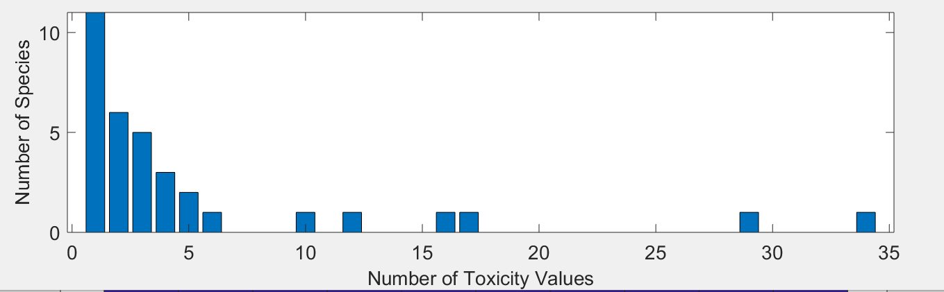
Figure 1. Distribution of the number of test results per species in atrazine aquatic plant data.

Five potential distributions for the atrazine data were considered, including log-normal, log-logistic, log-triangular, log-gumbel, and Burr. To fit each of the first four distributions, the toxicity values were first common log (log₁₀) transformed. Finally, effect thresholds and five quantiles from the fitted SSDs (HC₀₅, HC₁₀, HC₅₀, HC₉₀, HC₉₅) were calculated and reported.

- Comparison of distributions using AIC_{c}

Akaike’s Information Criterion corrected for sample size (AIC_{c}) was used to compare the five distributions for the aquatic plant dataset. For these comparisons all SSDs were fit using maximum likelihood. The AIC_{c} suggested that the gumbel distribution provided the best fit for the all aquatic plant and nonvascular aquatic plant distributions (Tables 3 and 4) while the triangular distribution provided the best fit for the vascular aquatic plant distribution (Table 5).

Table 3. Comparison of distributions for all aquatic aquatic plant toxicity data for atrazine.
Distribution | AIC_{c} | ∆AIC_{c} | Weight | HC₀₅
gumbel | 480.4234 | 0 | 0.7678 | 20.0419
burr | 482.9008 | 2.4774 | 0.2225 | 20.0917
logistic | 490.2380 | 9.8146 | 0.0057 | 6.0419
normal | 491.5476 | 11.1242 | 0.0029 | 7.4044
triangular | 493.4478 | 13.0244 | 0.0011 | 7.3865

Table 4. Comparison of distributions for all nonvascular aquatic aquatic plant toxicity data for atrazine.
Distribution | AIC_{c} | ∆AIC_{c} | Weight | HC₀₅
gumbel | 330.6417 | 0 | 0.7650 | 19.6959
burr | 333.2447 | 2.6030 | 0.2082 | 19.6877
logistic | 337.4789 | 6.8372 | 0.0251 | 8.8743
normal | 342.8469 | 12.2052 | 0.0017 | 7.7745
triangular | 352.4765 | 21.8348 | 1.3878e-05 | 3.6661
Table 5. Comparison of distributions for all vascular aquatic aquatic plant toxicity data for atrazine.
Distribution | AIC_{c} | ∆AIC_{c} | Weight | HC₀₅
triangular | 169.4126 | 0 | 0.3244 | 38.3812
gumbel | 169.6605 | 0.2480 | 0.2866 | 41.6812
normal | 170.0711 | 0.6585 | 0.2334 | 23.3218
logistic | 171.2483 | 1.8357 | 0.1296 | 13.2127
burr | 174.4628 | 5.0502 | 0.0260 | 41.6383

- Goodness of fit

The plot of the cumulative distribution functions for the best-fit distributions (as determined by AIC_{c}) suggest little evidence of lack-of-fit (Figure 2). Bootstrap goodness-of-fit tests did not show evidence for lack-of-fit (P-values > 0.05, Tablea 6-8) for the log-gumbel or burr distributions, but the rest of the distributions showed significant lack-of-fit. The coefficient of variation for the HC₀₅ was below 1 for all distributions.

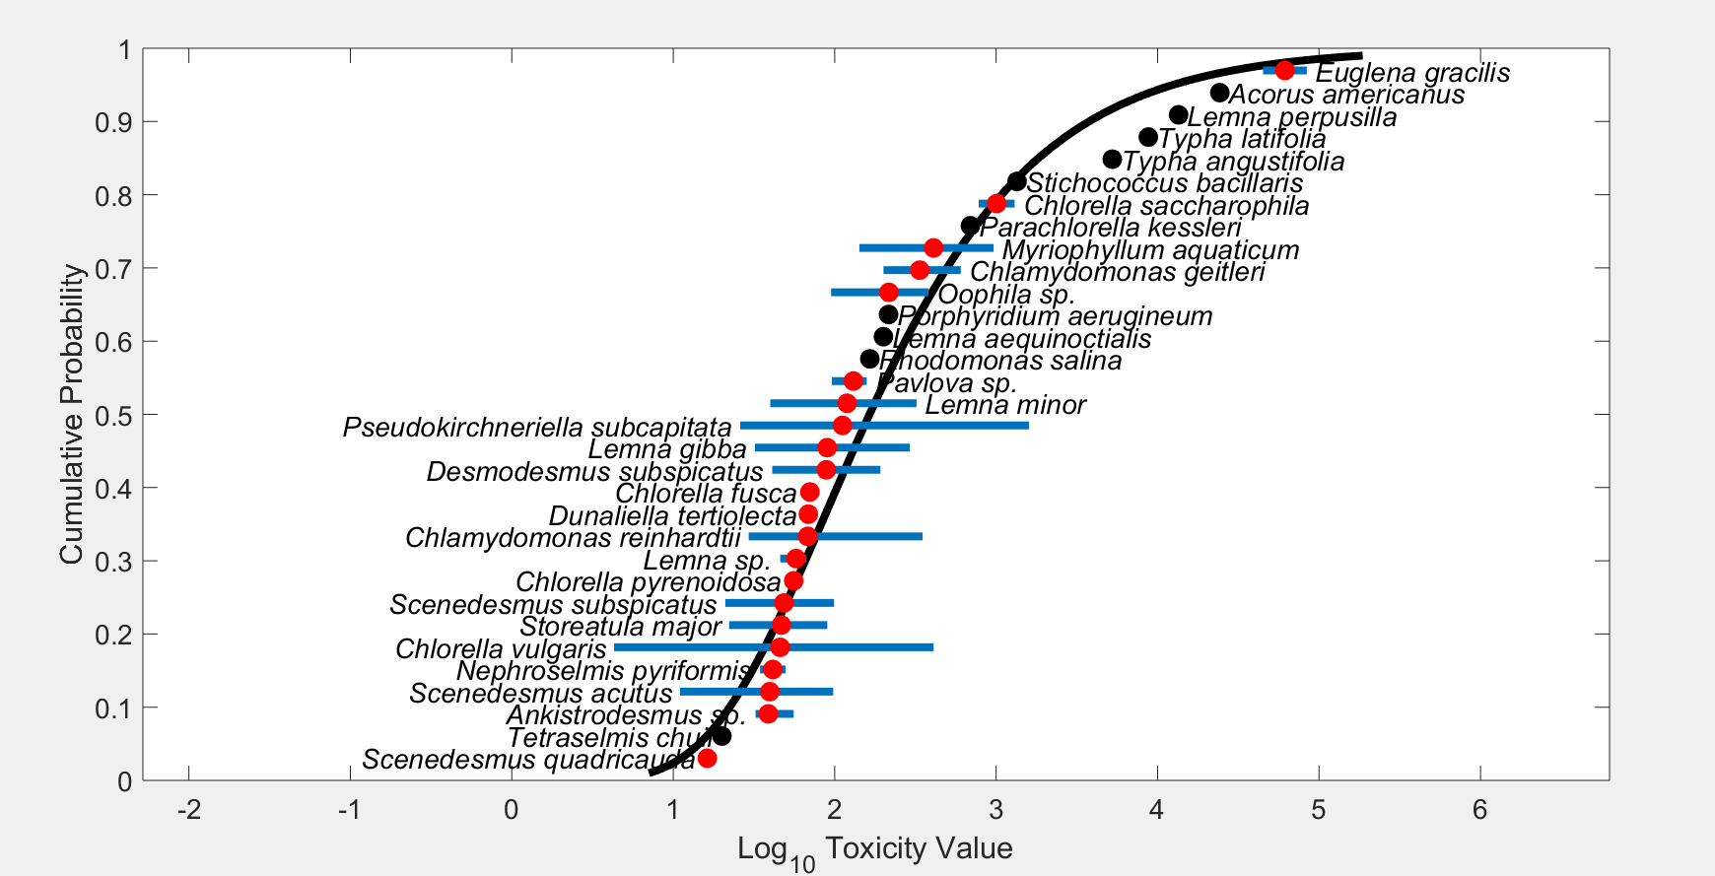
Figure 2. Log-gumbel SSD for atrazine toxicity values for all aquatic aquatic plants. Black points indicate single toxicity values. Red points indicate average of multiple toxicity values for a single species. Blue line indicates full range of toxicity values for a given taxon.

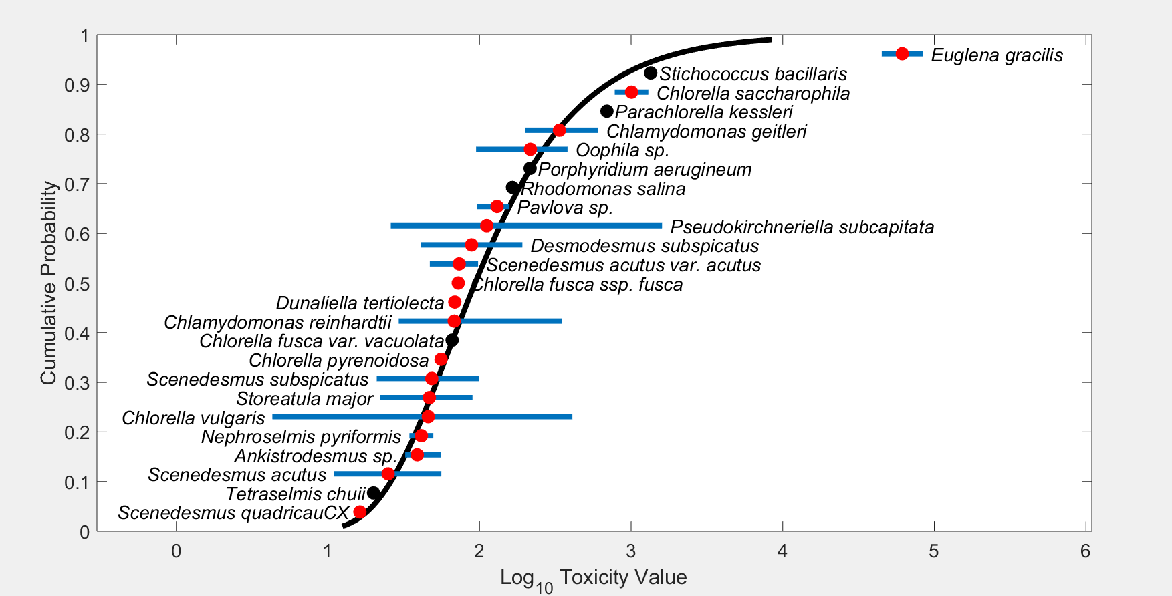
Figure 3. Log-gumbel SSD for atrazine toxicity values for nonvascular aquatic aquatic plants. Black points indicate single toxicity values. Red points indicate average of multiple toxicity values for a single species. Blue line indicates full range of toxicity values for a given taxon.

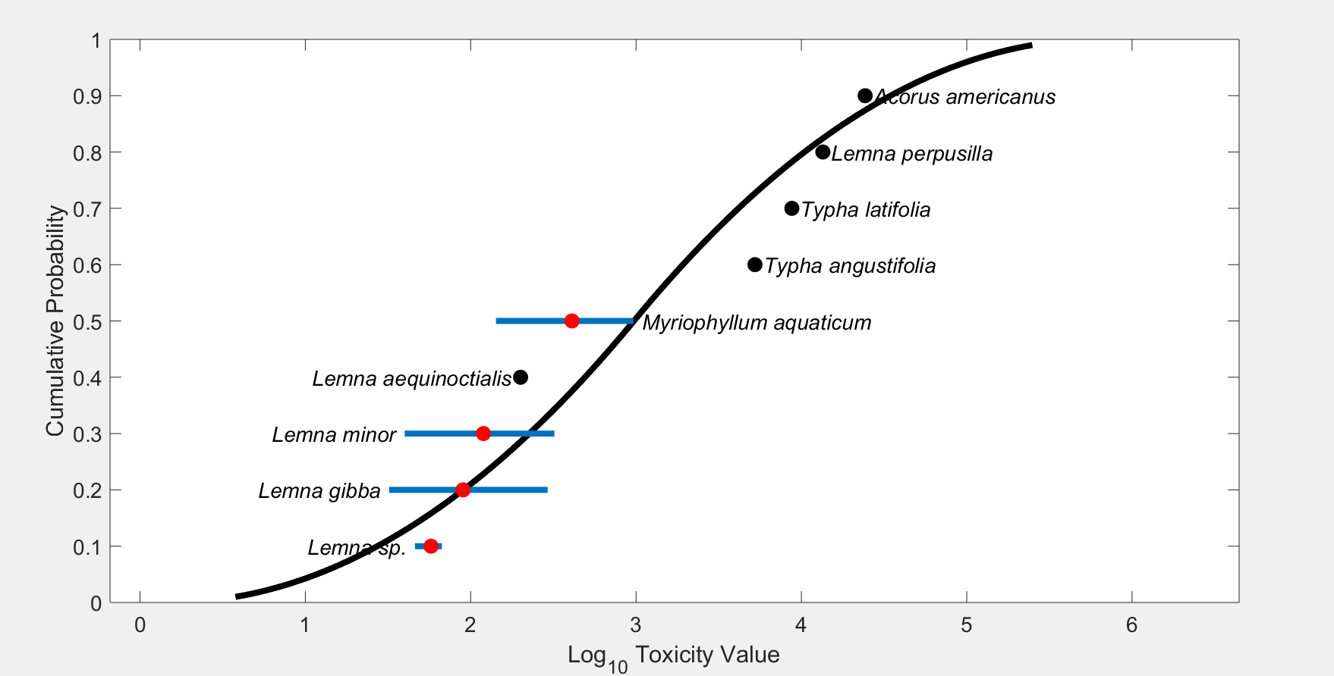
Figure 4. Log-triangular SSD for atrazine toxicity values for vascular aquatic aquatic plants. Black points indicate single toxicity values. Red points indicate average of multiple toxicity values for a single species. Blue line indicates full range of toxicity values for a given taxon.

Table 6. Range of HC₀₅ values for atrazine SSDs for all aquatic plants.
Distribution | Method | HC₀₅ | SE | CV | Lower CI | Upper CI | P
Normal | ML | 7.4044 | 5.6891 | 0.7683 | 2.4671 | 22.9197 | 9.99E-04
Normal | MO | 7.0068 | 5.4131 | 0.7725 | 2.2855 | 21.6351 | 9.99E-04
Normal | GR | 6.8384 | 4.5022 | 0.6584 | 1.7135 | 18.8413 | 9.99E-04
Logistic | ML | 6.0419 | 4.9865 | 0.8253 | 1.8505 | 20.9251 | 0.004
Logistic | MO | 7.3352 | 6.4121 | 0.8742 | 1.9151 | 25.4161 | 0.002
Logistic | GR | 6.1374 | 4.2552 | 0.6933 | 0.8192 | 17.7206 | 9.99E-04
Triangular | ML | 7.3865 | 5.9887 | 0.8108 | 4.0037 | 23.6793 | 9.99E-04
Triangular | MO | 6.5723 | 4.8055 | 0.7312 | 2.4017 | 20.8212 | 0.002
Triangular | GR | 7.2705 | 4.2744 | 0.5879 | 2.3525 | 17.5419 | 9.99E-04
Gumbel | ML | 20.0419 | 6.4553 | 0.3221 | 12.2932 | 36.5103 | 0.0569
Gumbel | MO | 14.4391 | 7.0343 | 0.4872 | 6.541 | 34.5555 | 0.1279
Gumbel | GR | 11.7671 | 5.1221 | 0.4353 | 3.7893 | 22.8014 | 0.0679
Burr | ML | 20.0917 | 6.9484 | 0.3458 | 11.5836 | 38.1623 | 0.039
ML=maximum likelihood, MO= moment estimators, and GR=graphical methods
LCp and UCp=projections of the confidence limits of the HC₀₅ (LCx and UCx) onto the cumulative distribution function of the fitted distribution.

Table 7. Range of HC₀₅ values for atrazine SSDs for nonvascular aquatic plants.
Distribution | Method | HC₀₅ | SE | CV | Lower CI | Upper CI | P
Normal | ML | 7.7745 | 5.5559 | 0.7146 | 3.0858 | 23.9168 | 0.004
Normal | MO | 7.3423 | 4.7057 | 0.6409 | 2.5577 | 19.6013 | 0.005
Normal | GR | 7.9242 | 4.4241 | 0.5583 | 2.1961 | 18.8993 | 0.002
Logistic | ML | 8.8743 | 5.293 | 0.5964 | 3.3001 | 23.6413 | 0.0869
Logistic | MO | 7.6191 | 5.7507 | 0.7548 | 2.4854 | 24.5299 | 0.006
Logistic | GR | 6.9929 | 4.3315 | 0.6194 | 1.1679 | 17.0585 | 0.006
Triangular | ML | 3.6661 | 4.3728 | 1.1928 | 1.611 | 17.9519 | 9.99E-04
Triangular | MO | 6.9724 | 4.509 | 0.6467 | 2.7761 | 20.0757 | 9.99E-04
Triangular | GR | 8.547 | 4.2515 | 0.4974 | 3.1794 | 19.3244 | 9.99E-04
Gumbel | ML | 19.6959 | 5.3197 | 0.2701 | 13.0717 | 33.6413 | 0.4116
Gumbel | MO | 13.1663 | 6.1812 | 0.4695 | 6.2876 | 30.0679 | 0.2877
Gumbel | GR | 11.6856 | 4.5667 | 0.3908 | 4.1128 | 21.822 | 0.1069
Burr | ML | 19.6877 | 5.8227 | 0.2958 | 12.4171 | 34.4647 | 0.3077
ML=maximum likelihood, MO= moment estimators, and GR=graphical methods
LCp and UCp=projections of the confidence limits of the HC₀₅ (LCx and UCx) onto the cumulative distribution function of the fitted distribution.

Table 8. Range of HC₀₅ values for atrazine SSDs for vascular aquatic plants.
Distribution | Method | HC₀₅ | SE | CV | Lower CI | Upper CI | P
Normal | ML | 23.3218 | 89.3204 | 3.8299 | 3.4052 | 253.5225 | 0.0549
Normal | MO | 18.6011 | 72.7744 | 3.9124 | 1.7324 | 249.429 | 0.0639
Normal | GR | 9.7597 | 43.2731 | 4.4338 | 0.1635 | 100.7301 | 0.1499
Logistic | ML | 13.2127 | 66.8711 | 5.0611 | 0.7982 | 237.6368 | 0.029
Logistic | MO | 19.5879 | 76.849 | 3.9233 | 1.2445 | 248.0522 | 0.05
Logistic | GR | 7.5255 | 35.9831 | 4.7815 | 0.0338 | 91.4558 | 0.1658
Triangular | ML | 38.3812 | 106.927 | 2.7859 | 13.9492 | 391.5553 | 0.036
Triangular | MO | 17.3051 | 88.3969 | 5.1081 | 2.3622 | 212.243 | 0.0939
Triangular | GR | 11.6941 | 41.5683 | 3.5546 | 0.4894 | 135.1144 | 0.1688
Gumbel | ML | 41.6812 | 63.2857 | 1.5183 | 13.6456 | 237.1448 | 0.0809
Gumbel | MO | 42.0573 | 68.9389 | 1.6392 | 7.8328 | 254.2242 | 0.1189
Gumbel | GR | 24.3877 | 55.9558 | 2.2944 | 1.1712 | 216.0552 | 0.2527
Burr | ML | 41.6383 | 60.882 | 1.4622 | 13.0192 | 241.1582 | 0.0539
ML=maximum likelihood, MO= moment estimators, and GR=graphical methods
LCp and UCp=projections of the confidence limits of the HC₀₅ (LCx and UCx) onto the cumulative distribution function of the fitted distribution.

- Test for the need to model results separately by vascular and nonvascular aquatic plants

Examination of the cumulative distribution functions plotted on similar axes for vascular aquatic plants and nonvascular aquatic plants does not support combining the datasets into one distribution. The 95% bootstrap confidence intervals for the separate distributions do not overlap substantially (Figure 5). While the HC₀₅ values for each distribution were simlar, there is on order of magnitude difference in the HC₅₀ values and more than an order of magnitude difference in the HC₉₀ values. Given these differences, the vascular and nonvascular aquatic plant distributions will be used separately.
The combined SSD better represents the prey/habitat of a listed species. The HC₀₅ generated using this distribution has a tighter confidence interval. This value is also lower (i.e., more conservative) than the vascular plant value, which is uncertain due to the limited number of species. The value is also very similar to the non-vascular plant HC₀₅, so, the inclusion of the vascular plant endpoints s is not having a large impact on the HC₀₅.

Figure 5. SSDs for nonvascular aquatic plant EC₅₀s (gumbel), and vascular aquatic plant EC₅₀s (gumbel) for atrazine. Blue lines show the distribution and upper and lower confidence interval for nonvascular aquatic plants. Red lines show the distribution and upper and lower confidence interval for vascular aquatic plants. Black lines show the distribution and upper and lower confidence interval for all aquatic plants.

- Calculation of other quantiles

Tables 9 - 11 provides estimates of the HC₀₅ as well as other quantiles of the fitted SSDs.

Table 9. Estimated quantiles of the fitted SSDs for atrazine EC₅₀s for all aquatic plants.
Distribution | Method | HC₀₅ | HC₁₀ | HC₅₀ | HC₉₀ | HC9₅
Normal | ML | 7.4044 | 15.8638 | 233.1926 | 3.43E+03 | 7.34E+03
Normal | MO | 7.0068 | 15.196 | 233.1926 | 3.58E+03 | 7.76E+03
Normal | GR | 6.8384 | 14.9107 | 233.1926 | 3.65E+03 | 7.95E+03
Logistic | ML | 6.0419 | 14.0291 | 167.0526 | 1.99E+03 | 4.62E+03
Logistic | MO | 7.3352 | 17.6463 | 233.1926 | 3.08E+03 | 7.41E+03
Logistic | GR | 6.1374 | 15.4481 | 233.1926 | 3.52E+03 | 8.86E+03
Triangular | ML | 7.3865 | 15.3528 | 336.6274 | 7.38E+03 | 1.53E+04
Triangular | MO | 6.5723 | 13.0209 | 233.1926 | 4.18E+03 | 8.27E+03
Triangular | GR | 7.2705 | 14.1283 | 233.1926 | 3.85E+03 | 7.48E+03
Gumbel | ML | 20.0419 | 29.0615 | 158.3221 | 2.26E+03 | 6.26E+03
Gumbel | MO | 14.4391 | 22.3574 | 164.3165 | 3.76E+03 | 1.24E+04
Gumbel | GR | 11.7671 | 19.0287 | 170.4893 | 5.32E+03 | 1.98E+04
Burr | ML | 20.0917 | 29.1282 | 157.9638 | 2.23E+03 | 6.14E+03

Table 10. Estimated quantiles of the fitted SSDs for atrazine EC₅₀s for nonvascular aquatic plants.
Distribution | Method | HC₀₅ | HC₁₀ | HC₅₀ | HC₉₀ | HC₉₅
Normal | ML | 7.7745 | 14.3462 | 124.5314 | 1.08E+03 | 1.99E+03
Normal | MO | 7.3423 | 13.721 | 124.5314 | 1.13E+03 | 2.11E+03
Normal | GR | 7.9242 | 14.5609 | 124.5314 | 1.07E+03 | 1.96E+03
Logistic | ML | 8.8743 | 16.2532 | 96.3221 | 5.71E+02 | 1.05E+03
Logistic | MO | 7.6191 | 15.4819 | 124.5314 | 1.00E+03 | 2.04E+03
Logistic | GR | 6.9929 | 14.5221 | 124.5314 | 1.07E+03 | 2.22E+03
Triangular | ML | 3.6661 | 8.0094 | 216.7265 | 5.86E+03 | 1.28E+04
Triangular | MO | 6.9724 | 12.1115 | 124.5314 | 1.28E+03 | 2.22E+03
Triangular | GR | 8.547 | 14.2788 | 124.5314 | 1.09E+03 | 1.81E+03
Gumbel | ML | 19.6959 | 26.0672 | 93.6235 | 6.96E+02 | 1.50E+03
Gumbel | MO | 13.1663 | 18.7425 | 93.8609 | 1.18E+03 | 3.09E+03
Gumbel | GR | 11.6856 | 17.1299 | 98.071 | 1.52E+03 | 4.32E+03
Burr | ML | 19.6877 | 26.0626 | 93.633 | 6.96E+02 | 1.50E+03

Table 11. Estimated quantiles of the fitted SSDs for atrazine EC₅₀s for vascular aquatic plants.
Distribution | Method | HC₀₅ | HC₁₀ | HC₅₀ | HC₉₀ | HC₉₅
Normal | ML | 23.3218 | 53.1378 | 970.482 | 1.77E+04 | 4.04E+04
Normal | MO | 18.6011 | 44.5528 | 970.482 | 2.11E+04 | 5.06E+04
Normal | GR | 9.7597 | 26.955 | 970.482 | 3.49E+04 | 9.65E+04
Logistic | ML | 13.2127 | 38.5515 | 898.5604 | 2.09E+04 | 6.11E+04
Logistic | MO | 19.5879 | 52.7388 | 970.482 | 1.79E+04 | 4.81E+04
Logistic | GR | 7.5255 | 25.8291 | 970.482 | 3.65E+04 | 1.25E+05
Triangular | ML | 38.3812 | 70.9797 | 950.588 | 1.27E+04 | 2.35E+04
Triangular | MO | 17.3051 | 37.4268 | 970.482 | 2.52E+04 | 5.44E+04
Triangular | GR | 11.6941 | 27.2635 | 970.482 | 3.45E+04 | 8.05E+04
Gumbel | ML | 41.6812 | 68.0619 | 637.4794 | 2.13E+04 | 8.16E+04
Gumbel | MO | 42.0573 | 68.8777 | 653.8116 | 2.23E+04 | 8.61E+04
Gumbel | GR | 24.3877 | 44.9154 | 728.4134 | 5.77E+04 | 3.07E+05
Burr | ML | 41.6383 | 68.0261 | 637.6894 | 2.13E+04 | 8.15E+04

Table 12 provides all of the available EC₅₀ values for aquatic plants from 72 to 96-h studies for nonvascular plants and from 7-d studies for vascular plants. These data sets are the same as reported in the effects characterization and provide additional data for the formulated products. Values that were included in the SSD (i.e., TGAI) are marked with an *.

Table 12. Available effective concentration (EC₅₀) data for aquatic plants exposed to atrazine used to contruct the SSD.
Genus | Species | EC₅₀ug/L
Acorus | americanus | 24300
Ankistrodesmus | sp. | 32.36
Ankistrodesmus | sp. | 32.5
Ankistrodesmus | sp. | 55.7
Chlamydomonas | reinhardtii | 29.32
Chlamydomonas | reinhardtii | 49.82208
Chlamydomonas | reinhardtii | 51
Chlamydomonas | reinhardtii | 56.0768
Chlamydomonas | geitleri | 200.5824
Chlamydomonas | geitleri | 265.2864
Chlamydomonas | geitleri | 280.384
Chlamydomonas | geitleri | 301.952
Chlamydomonas | geitleri | 308.4224
Chlamydomonas | geitleri | 310.5792
Chlamydomonas | geitleri | 317.0496
Chlamydomonas | geitleri | 321.3632
Chlamydomonas | reinhardtii | 350
Chlamydomonas | geitleri | 373.1264
Chlamydomonas | geitleri | 401.1648
Chlamydomonas | geitleri | 532.7296
Chlamydomonas | geitleri | 603.904
Chlorella | vulgaris | 4.3
Chlorella | vulgaris | 4.3
Chlorella | pyrenoidosa | 52.44
Chlorella | pyrenoidosa | 55.1
Chlorella | pyrenoidosa | 60
Chlorella | fusca | 66
Chlorella | fusca | 68.2
Chlorella | fusca | 76.9
Chlorella | vulgaris | 157.016
Chlorella | vulgaris | 172
Chlorella | vulgaris | 409.792
Chlorella | saccharophila | 780
Chlorella | saccharophila | 1300
Desmodesmus | subspicatus | 41
Desmodesmus | subspicatus | 192
Dunaliella | tertiolecta | 66.35
Dunaliella | tertiolecta | 68.66
Dunaliella | tertiolecta | 69
Dunaliella | tertiolecta | 69.4
Dunaliella | tertiolecta | 69.44
Dunaliella | tertiolecta | 69.44
Euglena | gracilis | 45000
Euglena | gracilis | 84000
Lemna | gibba | 32.1
Lemna | minor | 39.9
Lemna | minor | 42.3
Lemna | sp. | 46
Lemna | gibba | 46.5
Lemna | gibba | 57
Lemna | gibba | 60
Lemna | minor | 61
Lemna | minor | 61.71
Lemna | sp. | 62
Lemna | gibba | 64.2
Lemna | gibba | 64.3
Lemna | gibba | 65
Lemna | minor | 66.8
Lemna | sp. | 67
Lemna | minor | 73.5
Lemna | minor | 79.9
Lemna | minor | 84.5
Lemna | minor | 86.3
Lemna | gibba | 89
Lemna | gibba | 93
Lemna | gibba | 94
Lemna | minor | 100
Lemna | gibba | 100
Lemna | minor | 100.9
Lemna | minor | 105.08
Lemna | minor | 109.1
Lemna | minor | 114
Lemna | gibba | 120
Lemna | minor | 121.85
Lemna | gibba | 124
Lemna | minor | 125
Lemna | minor | 125.23
Lemna | gibba | 128.4
Lemna | minor | 133.6
Lemna | gibba | 146.1
Lemna | minor | 146.9
Lemna | minor | 160.5
Lemna | minor | 180
Lemna | gibba | 187.9
Lemna | minor | 188.75
Lemna | minor | 197.42
Lemna | aequinoctialis | 200.3667
Lemna | minor | 215
Lemna | minor | 215
Lemna | minor | 215.45
Lemna | minor | 218.2
Lemna | minor | 252
Lemna | gibba | 292.2
Lemna | minor | 321
Lemna | perpusilla | 13487
Myriophyllum | aquaticum | 142.2
Myriophyllum | aquaticum | 154.5
Myriophyllum | aquaticum | 170
Myriophyllum | aquaticum | 261
Myriophyllum | aquaticum | 294
Myriophyllum | aquaticum | 317
Myriophyllum | aquaticum | 438.9
Myriophyllum | aquaticum | 442
Myriophyllum | aquaticum | 458.8
Myriophyllum | aquaticum | 499
Myriophyllum | aquaticum | 606
Myriophyllum | aquaticum | 645.3
Myriophyllum | aquaticum | 680.6
Myriophyllum | aquaticum | 714.7
Myriophyllum | aquaticum | 857.9
Myriophyllum | aquaticum | 965.1
Nephroselmis | pyriformis | 34.5088
Nephroselmis | pyriformis | 49.6064
Oophila | sp. | 95
Oophila | sp. | 171
Oophila | sp. | 172
Oophila | sp. | 175
Oophila | sp. | 200
Oophila | sp. | 230
Oophila | sp. | 284
Oophila | sp. | 304
Oophila | sp. | 309
Oophila | sp. | 381
Parachlorella | kessleri | 693.12
Pavlova | sp. | 96
Pavlova | sp. | 147
Pavlova | sp. | 157.8578
Porphyridium | aerugineum | 215.68
Pseudokirchneriella | subcapitata | 26
Pseudokirchneriella | subcapitata | 26
Pseudokirchneriella | subcapitata | 41.16
Pseudokirchneriella | subcapitata | 41.8
Pseudokirchneriella | subcapitata | 48.77
Pseudokirchneriella | subcapitata | 50
Pseudokirchneriella | subcapitata | 63.4
Pseudokirchneriella | subcapitata | 65
Pseudokirchneriella | subcapitata | 76.4
Pseudokirchneriella | subcapitata | 81.4
Pseudokirchneriella | subcapitata | 86.1
Pseudokirchneriella | subcapitata | 87.6
Pseudokirchneriella | subcapitata | 89.9
Pseudokirchneriella | subcapitata | 92.9
Pseudokirchneriella | subcapitata | 94.9
Pseudokirchneriella | subcapitata | 103
Pseudokirchneriella | subcapitata | 107
Pseudokirchneriella | subcapitata | 115
Pseudokirchneriella | subcapitata | 118
Pseudokirchneriella | subcapitata | 126
Pseudokirchneriella | subcapitata | 130
Pseudokirchneriella | subcapitata | 138
Pseudokirchneriella | subcapitata | 158
Pseudokirchneriella | subcapitata | 159
Pseudokirchneriella | subcapitata | 164
Pseudokirchneriella | subcapitata | 164.3
Pseudokirchneriella | subcapitata | 191
Pseudokirchneriella | subcapitata | 196
Pseudokirchneriella | subcapitata | 200
Pseudokirchneriella | subcapitata | 200
Pseudokirchneriella | subcapitata | 220
Pseudokirchneriella | subcapitata | 277
Pseudokirchneriella | subcapitata | 300
Pseudokirchneriella | subcapitata | 1600
Rhodomonas | salina | 165
Scenedesmus | acutus | 11
Scenedesmus | acutus | 14
Scenedesmus | quadricauda | 15.58
Scenedesmus | quadricauda | 16.96
Scenedesmus | subspicatus | 21
Scenedesmus | subspicatus | 36.72
Scenedesmus | acutus | 45
Scenedesmus | acutus | 47.006
Scenedesmus | acutus | 56
Scenedesmus | subspicatus | 72
Scenedesmus | acutus | 86
Scenedesmus | acutus | 97.91872
Scenedesmus | subspicatus | 99.2
Stichococcus | bacillaris | 1347.16
Storeatula | major | 22.17
Storeatula | major | 48.45
Storeatula | major | 49.16
Storeatula | major | 89.97
Tetraselmis | chuii | 20
Typha | angustifolia | 5240
Typha | latifolia | 8760

