APPENDIX 1-7. Determination of Overlap of Likely Atrazine Exposure Area and Species Ranges and Critical Habitat for Species Located in the 48 Contiguous United States (ConUS)

The extent of overlap of atrazine’s likely exposure areas and the range of a species integrates information on potential use sites and usage data. This approach considers overlap of the species range (or critical habitat) with areas directly treated with atrazine and those receiving spray drift. To address uncertainties associated with how treated acres may be distributed within a state (relative to a species range or critical habitat), and the magnitude of usage on any given year, approaches are employed to represent a central estimate of overlap as well as upper and lower bounds. These different estimates are considered in the Weight of Evidence when deciding whether use of atrazine is likely or not likely to adversely affect (LAA or NLAA) an individual of an assessed species. The estimated overlap extent of the likely exposure area and species range (or critical habitat) is used in Step 2 as a surrogate for the percent of the listed population that could be exposed to atrazine. Additional details are provided in the Revised Method document. This appendix describes the approach for determining the extent of overlap.

1. Potential Use Sites

Atrazine’s registered uses include both agricultural and non-agricultural sites. Potential agricultural use sites of atrazine are represented by 9 Use Data Layers (UDLs) generated by aggregating crops originally represented by USDA’s Crop Data Layer (CDL). This process for developing theses agricultural UDL is described in detail in **APPENDIX 1-5 and APPENDIX 1-6**. For specific information on the geographic restriction indicated below **see APPENDIX 1-6**. The atrazine specific agricultural UDLs include several individual crops, including:

1. Corn
2. Soybeans (KS only)

Potential agricultural use sites for atrazine also include several UDLs that represent aggregated crops; for additional detail see **APPENDIX 1-5**:

1. Other grains
2. Other orchards
3. Vegetables and ground fruit
4. Wheat Corn Fallow (CO, KS, ND, NE, SD, WY only)
5. Wheat Sorghum Fallow (AR, CO, GA, IL, KS, LA, MS, MO, NE, NM, NC, OK, SD, TX only)
6. Wheat Fallow Wheat (CO, KS, ND, NE, SD, WY, OK (excluding panhandle, OK) only)
7. Wheat Fallow Wheat IDOR (ID panhandle and Oregon only)

Potential non-agricultural use sites of atrazine are represented by 5 UDLs. The data sources used to generate these UDLs were use specific, for additional details see **APPENDIX 1-6**. The atrazine specific non-agricultural UDLs include:

1. Developed (Limit to the warm season grass boundary)
2. Open Space Developed (Limit to the warm season grass boundary)
3. Other crops (Limit to the warm season grass boundary)
4. Right of way (OK only)
5. Conservation Reserve Program (CRP) (IA only)

In total 14 UDLs represent the agricultural and non-agricultural uses for atrazine. To incorporate usage, an aggregated percent crop treated (PCT) is generated for each of the UDLs. The crosswalk in **ATTACHMENT 1-4** is used to link the usage information provided by the EPA’s Science Information & Analysis Branch (SIAB) in their Use and Usage Matrix (SUUM) with the additional data needed from the Census of Agriculture for calculating the aggregated PCTs for agricultural uses on a state/crop basis. **APPENDIX 1-6** uses the chemical independent information provided in **ATTACHMENT 1-4** to provide an atrazine specific crosswalk across crop data sources for atrazine uses. Aggregated PCTs for non-agricultural UDLs are generated based on the information provided in the SUUM, additional details are provided in the following section.

Because the pesticide usage data available are based on surveys of growers and/or other user groups, the lowest possible PCT is 2.5%, due to the uncertainty associate with these surveys. These surveys are designed to be statistically robust, but by definition sample the target populations rather than provide a complete accounting of all pesticide usage. Therefore, PCT estimates resulting in values below 2.5% are generally a good indicator of limited usage of an active ingredient but by using 2.5% the PCT accounts for possible usage not captured by the survey data.

1. Applying Usage Data to UDLs
   1. Agricultural Uses

The goal of this approach is to determine the amount of area within each state that is treated with atrazine (referred to as “treated acres”). This is accomplished by combining data representing the potential use sites, including the UDLs and acres grown from the 2012 Census of Agriculture with available usage data. For the agricultural UDLs, multiple years of data are included to capture temporal changes such as crop rotations. The current years of the CDL included in the UDLs are 2013-2017.

For atrazine’s agricultural crop uses, usage data are available to quantify the percent of crop area that has been treated (PCT). The PCT can be used to adjust the extent of the potential use overlapping with a listed species’ range or critical habitat representing the more likely extent of overlap that is directly treated with atrazine. PCT data are available for specific crops and states. Atrazine usage data are summarized in the Science Information and Analysis Branch (SIAB) Use and Usage Matrix (SUUM; **APPENDIX 1-4**). The atrazine SUUM reports PCT data based on usage for a window of 5 years depending on sources; see **APPENDIX 1-4** for the specific years. Three statistics for PCT are reported for each state and crop combination (where crops are surveyed): average, minimum and maximum annual. The method discussed below is applied separately to the average, minimum and maximum annual PCT data in order to quantify the overlap of species range and exposure areas, while accounting for variability in usage over time. A flow chat describing the process to incorporate usage data to the spatial results is provided in **Figure 1.**

The flow chart below **(Figure 1)** diagrams the process for generating the data used to apply the usage method. Each dashed box is an individual workflow or tool. Blue boxes represent original data, green boxes processed data, orange boxes highlight specific steps from a tool and yellow boxes represent a review process. Tools published with the BE are highlighted with letters in the title and have yellow and peach backgrounds and non-automated workflows are indicated with a gray background.

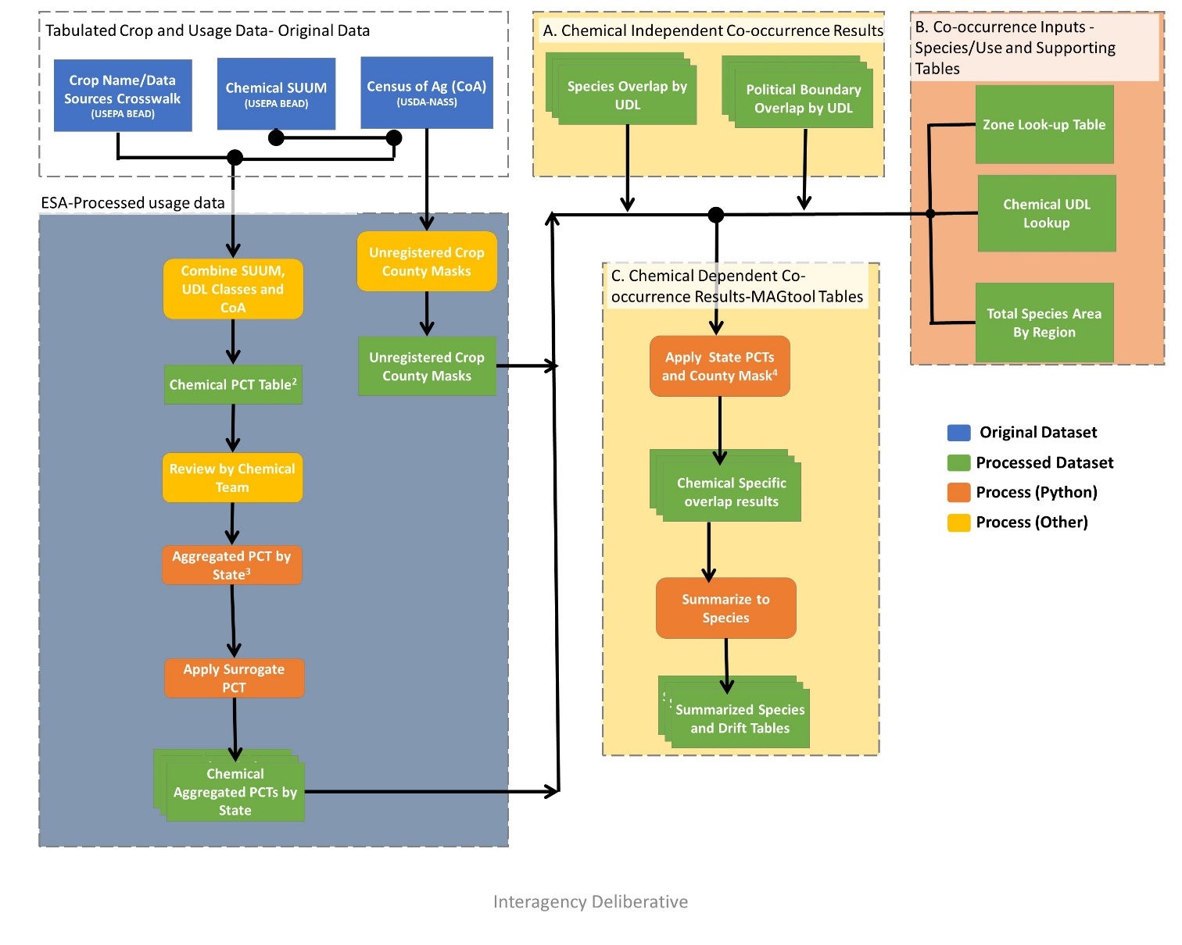

Figure 1. Flow chart of the usage application to the UDLs and species co-occurrence results.

Usage data are applied to the 9 agricultural UDLs discussed above. Crops reported in the SUUM are crossed with the categories used for the UDLs using the crosswalk in **APPENDIX 1-6**. For categories represented by a single crop in both the SUUMs and landcover UDLs (*e.g.,* corn, soybean), the available PCT data for a given state are applied directly to the acres of the UDL in that state to calculate the acres treated (acres treated = acres grown x PCT). If the PCT is not available for a specific state/crop combination, a surrogate PCT is applied using the process described in the next section.

For those categories representing multiple crops in either the SUUMs or landcover UDLs (*e.g.,* vegetables and ground fruit), an aggregated PCT is calculated. In order to calculate the aggregated PCT, the acres grown and PCT for each crop in the category is needed by state. Both pieces of information are found in the SUUM for each state/crop combination with reported usage. Acreage in the SUUM can come from a variety of sources, including, but not limited to, Kynetec USA, Inc. data, USDA’s National Agricultural Statistics Service (NASS), and California’s Pesticide Use Reporting (PUR). While all these sources provide slightly different results, they are all similar to the acreage developed by NASS. If the state/crop combination does not have reported usage, the information in the SUUM is supplemented with data from the 2012[1] Census of Agriculture (USDA-NASS, 2012, see **ATTACHMENT 1-3** for details on tabulating the Census of Agriculture). The Census of Agriculture is also used to account for crops in the UDL that are not registered. In this situation, information is not provided for these crops in the SUUM, but the crops would be included in the UDL. The crosswalk in **ATTACHMENT 1-4** is used to supplement the SUUM information with the additional data needed from the Census of Agriculture for calculating the aggregated PCTs on a state/crop basis. **APPENDIX 1-6** uses the chemical independent information provided in **ATTACHMENT 1-4** to provide an atrazine specific crosswalk across crop data sources for atrazine uses. This process results in three scenarios:

* The Census of Agriculture crop/state combination is found in the SUUM, and the acres grown and crop specific PCT from the SUUM are used directly.
* The Census of Agriculture crop is registered but there is no state specific usage information reported in the SUUM. In this scenario the acres grown for the state are extracted from the Census of Agriculture and a surrogate for the crop specific PCT is assigned using the method described in the next section.
* The Census of Agriculture crop is not a registered use. In this scenario, the acres grown for the state are extracted from Census of Agriculture and a PCT of 0 is used in the calculation of the aggregated PCT. This is done to account for crops found in the UDL that are not registered.

At the end of this process all state/crop combinations found in the Census of Agriculture are accounted for, with acres grown and a crop specific PCT. The aggregated PCT for a state is generated by first calculating the acres treated for each crop based on the crop specific acres grown and PCT information, summing these treated acres for all crops in the UDL category. This value is then divided by the total acres grown for all crops. For state/crops combinations with usage data, the acres grown are extracted from the SUUM; for state/crops combination without usage the acres grown are extracted from the Census of Agriculture; see **ATTACHMENT 1-3** for details on tabulating the Census of Agriculture. **Equation 1** isused to generate the aggregated PCTs.

**Equation 1**.

Where:

|  |  |
| --- | --- |
| i = | crop (within land cover class j) that is surveyed in state |
| j = | land cover class (e.g., vegetables and ground fruit) |
| n = | number of crops (within land cover class j) with acres grown in state |
| PCTi = | percent crop treated of crop i (from SUUM) |
| PCTtot-j = | aggregated PCT (for land cover class j in state) $${PCT}_{tot-j}=\frac{Acres treated}{Acres grown}=\frac{\sum_{i=1}^{n}{\left({PCT}_{i}*G_{i}\right)}}{\sum_{i=1}^{n}{G_{i}}}$$ |
| Gi = | acres of crop i grown (in state) (from SUUM) |

Acres treated for UDLs with multiple crops are calculated by multiplying this aggregated PCT by the area of the UDL for the state. The total area of the UDL for the state only includes those counties with at least 1 registered use as reported in the Census of Agriculture. If the Census of Agriculture reports all registered crops in a given UDL as not grown in a county, the county is excluded from the totals prior to calculating the treated acres.

One conservative assumption of this approach is that it does not account for multiple applications to the same fields. Usage data represents the potential acres where a single atrazine application occurred. The data do not identify sites where multiple applications occur within the same year. The approach used here assumes that all treated acres are independent. Therefore, if the available usage data represent sites where multiple applications occurred (which is permitted on atrazine labels), then the extent of the treated acres is overestimated. The aggregated UDLs will also overestimate the treated acres in a given year due to the conservative nature of the aggregation, especially when the total area in the UDL exceeds what is reported in the Census of Agriculture.

* 1. Non-Agricultural Uses

Non-agricultural national level usage data for the contiguous United States (ConUS) are available in the SUUM (and includes all use sites from the SUUM (**APPENDIX 1-4; see Table 3).** The usage information can be available as treated area based on survey data or reported as average pound applied for the use.

If information on treatable acres, base acres treated for all herbicides and treated acres for atrazine is available from survey data this information is used to calculate the aggregated maximum and average PCTs (**Equation 2-1, 2-2**). The survey information is available for some of the developed uses and all of the open space developed, rights of way and other crops-sod farm uses. The maximum PCT is based on the ratio of base acres treated with all herbicides to the total treatable acres for the non-agricultural use while the average PCT is based on the ratio of acres treated with atrazine to the total treatable acres. If treatable acres are unavailable the value is estimated based on the acres found in the associated UDL.

**Equation 2-1**.

$${PCT}_{max}=\frac{Base Acres treated}{Total Treatable Acres}$$

Where:

|  |  |
| --- | --- |
| Base Acres Treated = | Base acres for this use that is treated with any herbicide |
| Total Treatable Acres = | Total acreage for this use that could be treated |
| PCT max = | Calculated maximum PCT |

**Equation 2-2**

$${PCT}_{avg}=\frac{Acres {treated}_{atz}}{Total Treatable Acres}$$

Where:

|  |  |
| --- | --- |
| Acres treated sim = | Acreage that is treated with atrazine |
| Total Treatable Acres = | land cover class (e.g., vegetables and ground fruit) |
| PCT avg = | Calculated average PCT |

When survey information related to treated acres is unavailable, estimates for treated area are calculated based on the avg. annual pounds active ingredient (a.i.) applied, minimum label rate, and maximum label rate found in the SUUM. These treated area estimates are used to develop the aggregated maximum and average PCTs (**Equation 3-1, 3-2, 3-3**). In this situation, the maximum estimated treated acres are equal to the average annual pounds a.i. applied divided by the minimum application rate. The average number of treated acres is estimated by taking the number of pounds applied and dividing by ½ of the maximum application plus the minimum application rate. To generate the PCTs these estimated treated acres are divided by total treatable acres reported in the SUUM if available or the estimated treatable acres based on the area found in the UDL.

**Equation 3-1**.

$${Treated Acres}_{max}=\frac{Annual pounds AI {applied}_{avg}}{Label {Rate}_{min}}$$

Where:

|  |  |
| --- | --- |
| Annual pounds AI applied avg = | Annual average pounds applied of Active Ingredient |
| Label Ratemin= | Minimum application rate for the chemical in the SUUM (lb ai/a) |
| Treated Acresmax = | Estimated maximum treated acres based on label rates |

**Equation 3-2**.

$${Treated Acres}_{avg}=\frac{Annual pounds AI {applied}_{avg}}{\left(\frac{Label {Rate}_{min}+Label {Rate}_{max}}{2}\right)}$$

Where:

|  |  |
| --- | --- |
| Annual pounds AI applied avg = | Annual average pounds applied of Active Ingredient |
| Label Rate min= | Minimum application rate for the chemical in the SUUM (lb ai/a) |
| Label Rate max = | Maximum application rate for the chemical in the SUUM (lb ai/a) |
| Treated Acres avg = | Estimated maximum treated acres based on label rates |

**Equation 3-3**.

$${Treated Acres}_{min}=\frac{Annual pounds AI {applied}_{avg}}{Label {Rate}_{max}}$$

Where:

|  |  |
| --- | --- |
| Annual pounds AI appliedavg = | Annual average pounds applied of Active Ingredient |
| Label Ratemax= | Maximum application rate for the chemical in the SUUM (lb ai/a) |
| Treated Acresmin = | Estimated minimum treated acres based on label rates |

The minimum PCT always uses the method for estimating treated acres and is generated by dividing the average pounds applied divided by the maximum application rate. To calculate the PCT these estimated treated acres are divided by the total treatable acres reported in the SUUM if available or the estimated treatable acres based on the UDL (**Equation 4**). Due to the uncertainty related to estimating the treated acres based on application rates, if this method results in a minimum PCT that is greater than the average, the minimum PCT is set equal to the average. The following sections provides additional information for each use based the corresponding UDL.

When considering the available usage data for atrazine, the majority of non-agricultural pounds applied is for developed land (*e.g.*, applied by Consumers - residential uses). Open space developed, rights of way and other crops (ornamental Sod farms -turf) are the other non-agricultural uses and their detailed usage information are given in the following sections.

**Equation 4**.

$${PCT}_{i}=\frac{{Treated Acres}_{i}}{Total Treatable Acres}$$

Where:

|  |  |
| --- | --- |
| i = | PCT Estimate, max, avg, or min |
| Treated Acres= | Estimated treated acres |
| Total Treatable Acres= | Total treated acres as reported in the SUUM or estimated based on the UDL |

## Developed

National level usage data for the contiguous United States (ConUS) for developed uses are available in the SUUM and includes the sites Applied by Lawn Care Operators and Applied by Consumers from the SUUM under the heading Ornamental Lawn & Turf; information across uses is summarized in **Table 1**. Some survey information related to base treated acres, total treatable acres, and acres treated with atrazine was available. PCTs were generated based on the available information, using either reported treated acres or estimated based on label rates and pounds applied. Treated acres for each site are calculated using the available information and then aggregated.

The base treated acres for all herbicides, atrazine treated acres and total treatable acres are available for site Ornamental Lawns & Turf/ Applied by Lawn Care Operators. This surveyed information is combined with the estimated treated acres for Ornamental Lawns & Turf/ Applied by Consumers to develop the maximum and average PCT estimates for developed land. The estimated maximum PCT is 10% where the average and minimum PCT estimates are less than 2.5% and the default lowest PCT value of <2.5% is used.

Average annual pounds a.i. applied used in the minimum PCT estimate is not available for Ornamental Lawns & Turf/ Applied by Lawn Care Operators; however, this does not impact the minimum PCT estimate because it would not exceed the average PCT of <2.5%. Final estimates for the minimum, average, and maximum treated acres and PCTs can be found in **Table 1**.

Table 1. Atrazine usage data (from SUUM) relevant to potential use sites represented by developed landcover.

|  |  |  |  |  |  |  |  |
| --- | --- | --- | --- | --- | --- | --- | --- |
| **Site** | **Treatable Acres a** | **Max Acres Treated b, c** | **Avg Acres Treated d, e** | **Min Acres Treated f** | **Avg. Annual Pounds AI Applied g** | **Max Single Labeled Rate (lbs a.i./A) h** | **Min Single Labeled Rate (lbs a.i./A) i** |
| **Ornamental Lawns & Turf** |  | | | | | | |
| Applied by Lawn Care Operators | 30,000,000 **a** | 3,000,000 **b** | 20,000 **d** | **--** | **--** | 2 | 1 |
| Applied by Consumers | **--** | 300,000c | 200,000e | 150,000f | 300,000 | 2 | 1 |
| Total Estimated Treated Acres | | 3,300,000 | 220,000 | 150,000 |  |  |  |
| Total Treatable Developed Acres | | 30,000,000 | 30,000,000 | 30,000,000 |  |  |  |
| PCT | | 10% | <2.5%j | <2.5%j |  |  |  |

a All possible treatable acres found nationally as reported in the SUUM (**APPENDIX 1-4**).

b Base acres treated with herbicides as reported in the SUUM (**APPENDIX 1-4**).

c Estimated maximum acres treated by dividing the avg. annual pounds a.i. applied in the SUUM (**APPENDIX 1-4)** and the minimum application rate of 1 lbs a.i./A.

d Base acres treated with atrazine as reported in the SUUM (**APPENDIX 1-4**).

e Estimated average acres treated by dividing the avg. annual pounds a.i. applied in the SUUM (**APPENDIX 1-4**) and ½ of maximum single labeled rate plus the minimum rate.

f Estimated minimum acres treated by dividing the avg. annual pounds a.i. applied in the SUUM (**APPENDIX 1-4**) and the maximum application rate of 2 lbs a.i./A.

g - The pounds AI displayed in this document may differ from those displayed in the SLUA and other BEAD documents, because different calculation methods were used.

h-Maximum labeled rate as reported in the SUUM (APPENDIX 1-4) from 2019 Atrazine Pesticide Label Use Summary (PLUS) Report.

i-Minimum max labeled rate from 2019 Atrazine Pesticide Label Use Summary (PLUS) Report.

j Default lowest PCT value of 2.5%

-- Data unavailable (not surveyed or surveyed but undisclosed in study).

## Open space developed

The available usage information for open space developed is national and includes sites from the SUUM under the headings Ornamental Lawn & Turf/applied by Institutional Turf Facilities, and Golf Course information across uses is summarized in **Table 2**. Maximum, average and minimum treated acres for open space develop are estimated in a similar way as developed area using survey information on treated acres when available or estimated using pounds applied and label rates found in the SUUM.

The base treated acres, atrazine treated acres and total treatable acres are available from survey information for both of the pertinent use sites and are used to calculate the maximum and average PCTs. The estimated maximum PCT is 35% where the average PCT estimate is <2.5%.

Average annual pounds a.i. applied used in the minimum PCT estimate is not available for Golf Courses; however, this does not impact the minimum PCT estimate because it would not exceed the average PCT of <2.5%. Final estimates for the minimum, average, and maximum treated acres and PCTs can be found in **Table 2.**

**Table 2. Summarized regional atrazine usage data (from SUUM) relevant to all potential use sites represented by open space developed landcover.**

|  |  |  |  |  |  |  |  |
| --- | --- | --- | --- | --- | --- | --- | --- |
| **Site** | **Treatable Acres a** | **Max Acres Treated b** | **Avg Acres Treated c** | **Min Acres Treated d** | **Avg. Annual Pounds AI Applied e** | **Max Single Labeled Rate (lbs a.i./A) f** | **Min Single Labeled Rate (lbs a.i./A) g** |
| **Grass/Turf (Golf Courses)** | 1,700,000 a | 1,300,000 **b** | 20 **c** | -- | -- | 2 | 1 |
| **Ornamental Lawns & Turf** |  | | | | | | |
| Applied by institutional Turf Facilities | 7,800,000 a | 2,000,000 **b** | 25,000 **c** | 50,000 d | 100,000 | 2 | 1 |
| Total Estimated Treated Acres | | 3,300,000 | 25,020 | 50,000 |  |  |  |
| Total Treatable Open Space Developed Acres | | 9,500,000 | 9,500,000 | 9,500,000 |  |  |  |
| PCT | | 35% | <2.5%h | <2.5%h |  |  |  |

a All possible treatable acres found nationally as reported in the SUUM (**APPENDIX 1-4**).

b Base acres treated with herbicides as reported in the SUUM (**APPENDIX 1-4**).

and the minimum application rate of 1 lbs a.i./A.

c Base acres treated with atrazine as reported in the SUUM (**APPENDIX 1-4**).

d Estimated minimum acres treated by dividing the avg. annual pounds a.i. applied in the SUUM (**APPENDIX 1-4**) and the maximum application rate of 2 lbs a.i./A.

e The pounds AI displayed in this document may differ from those displayed in the SLUA and other BEAD documents, because different calculation methods were used.

f Maximum labeled rate as reported in the SUUM (APPENDIX 1-4) from 2019 Atrazine Pesticide Label Use Summary (PLUS) Report.

g Minimum max labeled rate from 2019 Atrazine Pesticide Label Use Summary (PLUS) Report.

h Default lowest PCT value of 2.5%

-- Data unavailable (not surveyed or surveyed but undisclosed in study).

## Right of way

The available usage information for right of way is national and includes sites from the SUUM under the heading Roadside Rights-of-Way, information is summarized in **Table 3**. Maximum, average and treated acres for rights of way are estimated in a similar way to the other non-agricultural uses using survey information on treated acres when available or estimated using pounds applied and label rates found in the SUUM. The maximum PCT is calculated based on the ratio of base acres treated with all herbicides to the total treatable acres for right of way. There was no reported usage of atrazine on rights of way and therefore the default assumption of <2.5 is used for the average and minimum PCTs. These national PCT values are applied to right of way landcover for each state.

**Table 3. Atrazine usage data (from SUUM) relevant to potential use sites with usage represented by right of way landcover.**

|  |  |  |  |  |  |  |  |
| --- | --- | --- | --- | --- | --- | --- | --- |
| **Site** | **Treatable Acres a** | **Max Acres Treated b** | **Avg Acres Treated c,d** | **Min Acres Treated e** | **Avg. Annual Pounds AI Applied f** | **Max Single Labeled Rate (lbs a.i./A) g** | **Min Single Labeled Rate (lbs a.i./A) h** |
| **Roadside Rights-of-Way** | 12,000,000 a | 6,500,000 **b** | -- | -- | -- | 1 | 1 |
| Total Estimated Treated Acres | | 6,500,000 | -- |  |  |  |  |
| Total Treatable Roadside Rights-of-Way Acres | | 12,000,000 | 12,000,000 | 12,000,000 |  |  |  |
| PCT | | 50% | <2.5%i | <2.5%i |  |  |  |

a All possible treatable acres found nationally as reported in the SUUM (**APPENDIX 1-4**).

b Base acres treated with herbicides as reported in the SUUM (**APPENDIX 1-4**).

c Base acres treated with atrazine as reported in the SUUM (**APPENDIX 1-4**).

d Estimated average acres treated by dividing the avg. annual pounds a.i. applied in the SUUM (**APPENDIX 1-4**) and ½ of maximum single labeled rate plus the minimum rate.

e Estimated minimum acres treated by dividing the avg. annual pounds a.i. applied in the SUUM (**APPENDIX 1-4**) and the maximum application rate

f - The pounds AI displayed in this document may differ from those displayed in the SLUA and other BEAD documents, because different calculation methods were used.

g Maximum labeled rate as reported in the SUUM (APPENDIX 1-4) from 2019 Atrazine Pesticide Label Use Summary (PLUS) Report.

h Minimum max labeled rate from 2019 Atrazine Pesticide Label Use Summary (PLUS) Report.

i Default lowest PCT value of 2.5%

-- Data unavailable (not surveyed or surveyed but undisclosed in study).

## Other Crops (Sod Farms)

The available usage information for other crops is national and includes sites from the SUUM under the heading Ornamental Lawns & Turf Applied by Ornamental Sod Farms (Turf), information is summarized in **Table 4**. Maximum, average and treated acres for other crops (sod farms) are estimated using survey information on treated acres when available or estimated using label rates and average annual a.i. applied found in the SUUM. The maximum PCT was calculated based on all treatable acres of other crops-sod farms and the acres treated for all herbicides and the average PCT used the acres treated with atrazine, whereas the minimum PCT was calculated using the maximum label rate and average annual a.i. applied from the SUUM. **Table 4** summarized the other crops treated acres and PCT values.

**Table 4. Atrazine usage data (from SUUM) relevant to potential use sites with usage represented by Other Crops.**

|  |  |  |  |  |  |  |  |
| --- | --- | --- | --- | --- | --- | --- | --- |
| **Site** | **Treatable Acres a** | **Max Acres Treated b** | **Avg Acres Treated c** | **Min Acres Treated d** | **Avg. Annual Pounds AI Applied e** | **Max Single Labeled Rate (lbs a.i./A) f** | **Min Single Labeled Rate (lbs a.i./A) g** |
| Applied by Ornamental Sod Farms (Turf) | 320,000 a | 310,000 **b** | 100,000 | 25,000 | 100,000 | 4 | 1 |
| Total Estimated Treated Acres | | 310,000 | 100,000 | 25,000 |  |  |  |
| Total Treatable Other Crops (Sod Farms) | | 320,000 | 320,000 | 320,000 |  |  |  |
| PCT | | 97% | 30% | 8% |  |  |  |

a All possible treatable acres found nationally as reported in the SUUM (**APPENDIX 1-4**).

b Base acres treated with herbicides as reported in the SUUM (**APPENDIX 1-4**).

c Base acres treated with atrazine as reported in the SUUM (**APPENDIX 1-4**).

d Estimated minimum acres treated by dividing the avg. annual pounds a.i. applied in the SUUM (**APPENDIX 1-4**) and the maximum application rate of 4 pounds a.i./A.

e The pounds AI displayed in this document may differ from those displayed in the SLUA and other BEAD documents, because different calculation methods were used.

f Maximum labeled rate as reported in the SUUM (APPENDIX 1-4) from 2019 Atrazine Pesticide Label Use Summary (PLUS) Report.

g Minimum max labeled rate from 2019 Atrazine Pesticide Label Use Summary (PLUS) Report.

-- Data unavailable (not surveyed or surveyed but undisclosed in study).

## Conservation Reserve Program (CRP)

For atrazine, the conservation reserve program (CRP) layer is limited to Iowa. When setting the geographic restrictions for atrazine uses, currently registered labels were considered in addition to any agreed upon changes to labels from the registrants. These agreed upon changes were provided by the registrant in the form of commitment letters (**APPENDIX 1-2**). Limiting the CRP use to Iowa is a change found in the commitment letters. The available usage data is specific to states outside of Iowa. For this reason, 100% PCT was assumed. Further refinement may be considered in the final atrazine BE assessment.

1. Applying Surrogate Usage Data

Some uses are not surveyed for usage at all and some uses are only surveyed for usage in some states. For crops without surveyed usage that are included in aggregated UDLs, usage data from the same state for other crops in the UDL will be used as surrogates. If no data for crops within a UDL are available in a state, surrogate PCT will be applied using data available for the same crop or UDL but a different state. If a UDL has no usage data for any state, the highest available PCT from all state-crop combinations will be used. The decision tree below (**Figure 2**) outlines the approach for determining which data will be used as surrogates.

The surrogacy approach is designed to use the best available data to identify the likely extent of treated area when usage data are not available for a given crop. Surrogate data are ideally assigned using crops within the same landcover (UDL) and then using data from the same crop but different spatial location. If the first two options are not possible, then a conservative approach is employed where the greatest extent of usage on any crop-state combination is used as the surrogate. After applying the surrogacy method all UDL/state combinations will have an associated aggregated PCT. Use of surrogate data represents an uncertainty. In cases where a species has potential risk concerns, a Weight of Evidence analysis will be conducted prior to making the NLAA/LAA determination. In this Weight of Evidence analysis, the impact of the surrogacy assumptions on the overlap analysis will be considered.

Yes

Is crop-specific PCT available for assessed state?

No

No

No

Yes

Is use surveyed in other states?

Yes

Is a PCT available for a use within the same UDL and state?

**Figure 2. Decision framework for applying surrogate usage data.**

1. Calculation of Extent of Direct Overlap of Species Range or Critical Habitat and Treated Acres

The aggregate PCT is used to calculate the total number of acres treated within a state for each UDL (PCT x total acres within a UDL = total acres treated for a UDL). The approach described above combines data that are at different spatial scales, *i.e.,* 30-meter pixel, county and state, for UDLs, Census of Agriculture and usage, respectively. Because of the differences in scales, the usage of atrazine can be limited to county and sub-county areas representing potential use sites; however, the actual location of the treated acres within the state is unknown.

Three different assumptions are employed to represent how the treated acres are attributed to potential use site acres within the species range (or critical habitat): upper bound (concentrated within the species range), uniform distribution, and lower bound (concentrated outside of species range). Each of these approaches are discussed below. In all three approaches the estimated treated area within the species range (or critical habitat) is used to calculate the direct overlap of treated sites and the species range (or critical habitat). Direct overlap is equal to the total treated area within the species range divided by the total area of the species range (or critical habitat).

The upper bound approach assumes that all the treated acres in a state occur within the species range (or critical habitat). In this approach, the total acres treated for the state are calculated using the aggregated PCTs. The total treated acres for the state are compared to the total number of acres within a species’ range that overlaps with that UDL. If the number of treated acres in a state is greater than the number of acres in the UDL overlapping the species range, it will be assumed that all acres within the species range that overlap with the UDL are treated. As described above, treated acres are only placed in counties within the species range where at least 1 registered labeled use for the UDL occurs, as identified by Census of Agriculture. If the number of treated acres is less than the total overlapping with the species’ range, then the number of acres overlapping with the species range is reduced to the number of treated acres in the state.

For the uniform distribution approach, the aggregated PCT is applied directly to the acres of the UDL occurring within the species range to calculate the estimated treated acres. This approach assumes that the treated acres are distributed uniformly throughout the state.

The lower bound approach is essentially the opposite of the upper bound. In the lower bound approach, it is assumed that the treated acres are distributed outside of the species range to the greatest extent possible. The total acres treated for the state are compared to the total number of acres outside of a species’ range for the UDL. If the number of treated acres in a state is greater than the number of acres of UDL outside of the species range, it will be assumed that all acres outside the species range are treated, with the excess treated acres assumed to occur within the species range. If the number of treated acres is less than those outside of the species’ range, it is assumed that all treated acres for the state in that UDL occur outside of the range of a species.

When a species range spans multiple states, the uniform, upper, and lower bound approaches are individually applied to each state relevant to a species. The treated acres across all pertinent states are summed to calculate the number of treated acres overlapping with the whole species range (or critical habitat).

The calculation of total treated area based the temporally aggregated UDLs likely overestimates the area where crops could be found in a given year and is a conservatism in the process. The upper bound or concentrating all the treated acres in the species range (or critical habitat) results in more treated area for a given state than expected when considering all species in the state. Additional assumptions and uncertainties related to the calculation of total treated acres and the distributions of the treated acres related to the species range (or critical habitat) are presented in the Revised Method**.**

1. Calculation of Composite Drift Layer Overlapping with Species Range or Critical Habitat

When the action area is derived, each relevant UDL is combined into a composite layer representing all potential uses. The composite layer is generated by placing all relevant UDLs on top of each other and merging them together to set the footprint for the chemical as a single layer. This composite layer is then buffered out in all directions based on the application method with the greatest drift potential for the chemical. For atrazine this is the aerial application, resulting in a maximum buffer distance of 2600 ft, or approximately 792 meters. For an individual species, the composite drift area is then refined by considering only the uses with overlap when applying the maximum buffer for the chemical. The specific application methods and rates relevant to these uses and the species-specific endpoints that result in the farthest distance from the treated field, where effects may occur, are used to determine the extent of the composite drift layer for that species.

When usage data are considered, it is necessary to account for a decrease in the extent of areas receiving spray drift because the treated area has deceased. The total possible area receiving drift is based on all potential use sites found in the action area. Prior to applying usage, drift in all directions is calculated. After applying usage only, a portion of potential use sites in the action area will be treated, changing the drift extent.

Since the actual location of the treated acres within a state is unknown, specific areas are not buffered in the Step 2 approach. To account for the reduction in actual acres treated, a factor is applied to this composite drift area based on a state aggregated PCT for all of the uses combined. Additionally, a factor is applied to account for the distribution of theses acres under an upper bound (maximum acres within the species range), lower bound (maximum acres outside the species range) or uniformly distributed within the range as previously discussed. The distribution of acres within the state relative to the species range will also affect the impact of spray drift. For the upper bound scenario, no additional factor is applied to the aggregated PCT, but for the uniform and minimum scenarios, the ratio of the number of treated acres calculated for the uniform or lower bound scenario to the upper bound scenario is applied to the PCT. Lastly, to account for the uncertainty in the true spatial distribution of the use sites, as well as the uncertainty of multiple sites potentially impacting the same locations, the adjusted PCT value is rounded up to the nearest ten place value (*e.g.,* factor of 0.056 is rounded to 0.1). This composite factor is used to scale the number of acres impacted by off-site drift and subsequently lower the total predicted overlap with a species range (or critical habitat) due to drift.

Another factor often discussed for consideration in spray drift is the impact of wind direction on off-site transport for species ranges that are impacted by spray drift occurring in all directions. Methods have been proposed in the past to account for this, including the use of wind rose plots to better predict off-site movement of a chemical. As a simplified method to account for the impacts of wind direction, an additional factor is applied to spray drift based on the number of applications that can occur for the use patterns that are relevant to a species. For the composite factor determined above, a wind direction scaling factor is applied where the factor is scaled to 25% for each application allowed, to represent movement of a chemical off-site in only one direction, or essentially ¼ of a circle when one application is made. More specifically, if only one yearly application is allowed for the relevant use sites, a factor of 0.25 is applied, if 2 applications are allowed, a factor of 0.5, if 3 applications are allowed, a factor of 0.75 and if 4 or more applications are allowed, a factor of 1 (or no additional scaling is applied). The equations used to scale the spray drift overlap are provided below in **Equation 5** and **Equation 6**.

**Equation 5. $Composite drift factor=Aggregated PCT* \frac{\begin{aligned}Number of treated acres in direct overlap scenario \\ considered (upper bound, uniform, lower bound)\end{aligned}}{Number of acres in upper bound direct overlap scenario}$**

**Equation 6. $Final Drift Scaling factor= Composite drift factor rounded up to next 0.1 value * Wind factor$**

In summary, the number of acres in a species range (or critical habitat) potentially exposed due to spray drift is calculated using the equations above for each state. This total number of acres is then divided by the total acres in the species range to determine the overlap area due to drift. For predicting relative EECs in the drift zone, the number of acres is further refined to how many are in each 30-meter increment off-site; starting at 30 meters and continuing to 792 meters off-site or the limit of aerial drift. Additional uncertainties and conservatism of the method for applying usage data to drift are provided in the Revised Method.

1. Determination of Overlap of Exposure Area and Species Range or Critical Habitat

To determine the total overlap exposure area, the total number of treated acres within the species range (direct overlap) are added to the scaled number of acres receiving spray drift then divided by the total number of acres of the species range (or critical habitat). This can be considered the percent of the species range/habitat that is likely to be exposed to the pesticide of interest. For species whose life history information indicates the species will not utilize the potential use site areas, overlap of direct treated sites will be zero for direct exposure and only the scaled areas receiving spray drift are considered for the species overlap.

There are 5 different overlap scenarios generated for consideration. The first represents the unadjusted overlap, the 2nd and 3rd incorporate the chemical specific usage information and accounts for the redundancy in the UDL layers, and the 4th and 5th incorporate species life history information by removing direct overlap if the species will not utilize the potential use site and limiting the overlap extent to just the areas represented by suitable habitat. These 5 overlap scenarios are discussed in more detail in the following section.

When considering the three different assumptions related to distribution of treated acres relative to species range (*i.e.,* concentrated in species range (upper), uniform throughout state (uniform) and concentrated outside of species range (lower)) and the three different assumptions regarding the amount of usage on a given year (*i.e.,* maximum, average or minimum annual PCT), there are 9 different estimates of the overlap of the species range (or critical habitat) and the exposure area for each overlap scenario. The overlap estimates for pertinent scenarios are considered in addition to the influence of using surrogate usage data when none are available as part of the Weight of Evidence. The information is considered in the Weight of Evidence to determine the likelihood that an individual will be exposed and adversely affected.

1. Background - Spatial Co-occurrence of Species Location and Potential Use Sites

The co-occurrence analysis identifies if a species range (or critical habitat) and UDL overlap, and if so by how much. Required inputs to conducting the co-occurrence analysis include a list of species, species location files, pesticide Use Data Layers (UDLs), and any additional supporting species life history information used to supplement the analysis. The species list needs to include all species and designated critical habitat subjects to section 7 of the Endangered Species Act. Location files for each species range and critical habitat need to be accounted for prior to use in the co-occurrence analysis. The pesticide Use Data Layers (UDLs) representing each label use also need to be accounted for prior to completing the analysis. Finally, any additional species life history or spatial datasets, (*e.g.,* GAP/Landfire habitat layer) used to supplement the co-occurrence analysis need to be identified. Additional detail on these spatial inputs and the tools use to generated them can be found with the BE models/tools.

All inputs are finalized and standardized using the Co-occurrence Inputs-Species/Use and Supporting Tables tool. The co-occurrence analysis leverages the ArcGIS Tabulate Area tool, executed as a batch using Chemical Independent Co-occurrence Results-Parent Use Overlap Tables tool. The Chemical Dependent Co-occurrence Results-MAGtool Tables tool generates the standard output tables summarized by UDL and species used in the BE; incorporating usage and species life information into the results. The five different overlap scenarios are generated as output from this tool. Additional information on each of these tools can be found with the respective tool documentation.

The first overlap scenario provides a usage independent overlap, without any adjustments to account for usage or species life history. The remaining overlap scenarios apply usage and species information to the overlap. First the aggregated PCTs for atrazine, described above, are applied to the species/UDL overlap using the three different distribution methods for the treated acres. Following the application of usage information, results are scaled to account for the redundancy in the UDLs. Additional detail on the method for applying the redundancy scaling factors is provided below. The last two overlap scenarios account for species life history information. First, if the species will not utilize the potential use site directly the overlap representing the direct overlap is excluded, limiting the results to the areas of drift overlap. Lastly, if the species is more likely to use certain habitats this can be considered by limiting the extent of overlap to just the areas of the species range with those habitats. This suitable habitat consideration is not applicable to designated critical habitat and is considered in conjunction with the results representing the full range as part of the Weight of Evidence.

1. Input Data Used for Co-occurrence Analysis
   1. Master Species List

Species subject to section 7 under the Endangered Species Act are obtained from the US Fish and Wildlife Threatened and Endangered Species System[2] (TESS). The resulting table is filtered to include listing statuses[3] currently subject to section 7 or potentially subject to section 7 during the registration time period. Information from TESS for species under the jurisdiction of the National Marine Fisheries Service (NMFS) is supplemented with information from the NMFS website[4], deferring to the NMFS website if conflicts exist between the sources. The species list used for this assessment was generated in January 2019.

* 1. Species Locations

The FWS ECOS Portal (<http://ecos.fws.gov>) houses spatial data that represents species’ ranges and designated critical habitat[5]. Managed by the species experts and therefore considered the best available information for section 7 consultation, the co-occurrence analysis utilizes this information. The ECOS Portal points users to NMFS websites to access spatial information for species under NMFS jurisdiction not found on the ECOS website. For NMFS species not found in either location a request was made directly to the NMFS scientists. The last download of the species locations occurred in January 2019.

After accounting for each species, the input files used for the co-occurrence analysis are generated with the ESRI ArcGIS Union Toolbox[6]. The union tool generates the geometric union of the species files and their attributes are presented as non-overlapping ‘zones’. Each unique zone may be occupied by multiple species. The species found in each zone are tracked in a look-up table generated at the time of the union. By using these non-overlapping ‘zones’ a given location is only run once in the analysis, rather than for each overlapping species.

Additional information on this process can be found with the Co-occurrence Inputs-Species/Use and Supporting Tables tool.

* 1. Use Data Layers (UDLs)

The data and process to generate the Use Data Layers is described in **APPENDIX 1-5 and APPENDIX 1-6.**

* 1. Other Inputs

In addition to the usage data and Census of Agriculture described above, species life history information can be considered. Species life history information is incorporated into two of the overlap scenarios. The first considers if the species will be found on potential use sites or exclusively off the use sites. Off use site determinations were made based on species documentation generated by the Services (*e.g.* Recovery Plan, 5-year Reviews). These determinations were reviewed and updated based on feedback provided by US Fish and Wildlife Service in the Fall of 2019[7]. The second scenario suitable habitat for a species was exacted from the GAP/Landfire [8] and overlap specific to these areas generated. The overlap for the suitable habitat is used to supplement the overlap for the full species range.

All spatial files, UDLs, species, and supplemental information, are standardized into the selected regional projections prior to use in the co-occurrence analysis. For the contiguous United States, there is only one projection used, Albers Conical Equal Area projections (Albers_Conical_Equal_Area.prj). Projected coordinated system were selected to preserve area calculations.

1. Co-occurrence Analysis

The co-occurrence analysis uses the ArcGIS Tabulate Area tool, executed as a batch with the Chemical Independent Co-occurrence Results-Parent Use Overlap Tables tool. Additional information on this tool can be found with the tool documentation. As described above, the species input files used for the co-occurrence are generated by ESRI ArcGIS Union Toolbox, which creates a series of non-overlapping ‘zones’. Each unique zone may be occupied by multiple species. **Figure 3** provides an example species range, and the same range broken up into the non-overlapping ‘zones’ used as the species input file.

In order to apply usage and Census of Agriculture information the state and county boundaries are added to the species input files using the ESRI Intersect Toolbox. The final ‘zones’ allows for the overlap of a UDL to be reported out by species for a given county or state. The state and county breaks allow for the application of the usage data. The total overlap for each county and state is also calculated so the treated acres for the state can be calculated for the upper and lower distributions of treated acres described above.

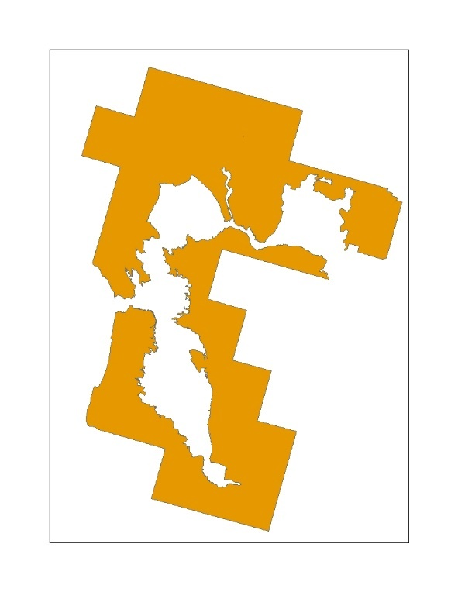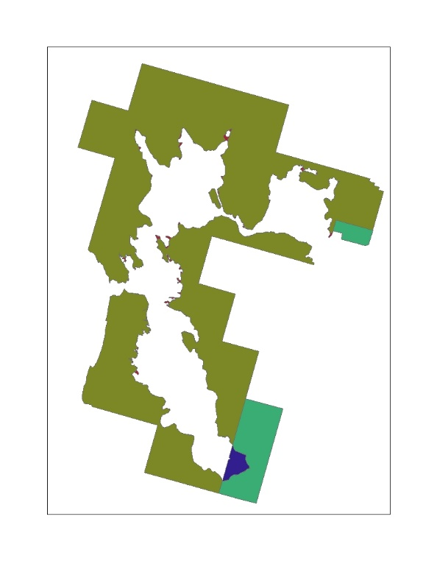

**Figure 3. Example of species range represented by zones used as the input for the co-occurrence analysis.**

* 1. Overlap Scenarios

Five different overlap scenarios are generated for consideration in the Weight of Evidence. The first is usage independent and provides results for the species with no adjustment to the overlap. This is followed by incorporating the usage data, scaling for redundancy of the UDLs, and then adding species life history information to the overlap results.

Applying the usage method described above, the aggregated PCTs and Census of Agricultural are applied to the state and county results to calculate the total treated acres for the state. This information is used for the upper and lower distribution of the treated acres. The treated acres are concentrated within the species range (or critical habitat) and the given state for the upper distribution or outside the species range (or critical habitat) and within the given state for the lower distribution. For the uniform distribution, the aggregated PCTs and Census of Agricultural are applied directly to the species results, broken down for a species in a given county and state. After calculating the treated acres for each state within the species range (or critical habitat), all states are summed to get the total treated acres for the species. This process is completed for all UDLs and each of the aggregated PCTs; minimum, maximum and average. The five overlap scenarios are:

* Overlap Scenario 1: Unadjusted
* Overlap Scenario 2: PCT Overlap
* Overlap Scenario 3:PCT and Redundancy
* Overlap Scenario 4:PCT, Redundancy, Off-site
* Overlap Scenario 5: PCT, Redundancy, Off-site, Habitat

**Figure 4** provides an example of the three distributions of the treated acres. The dark gray is the extent of the UDL, the green area represents the treated area for a PCT of 10%. These treated acres are distributed into the species range, in orange, using the three different methods; upper to left, uniform in the middle and lower to the right.

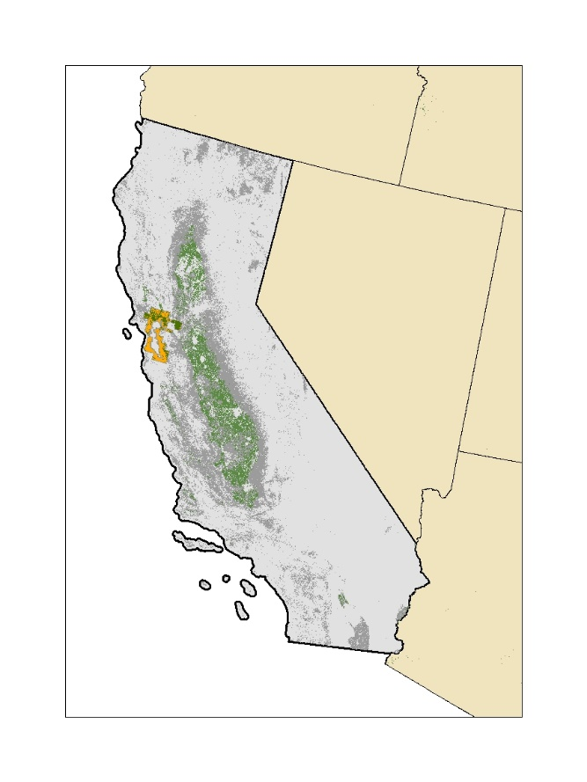

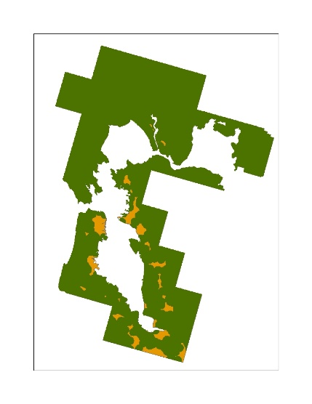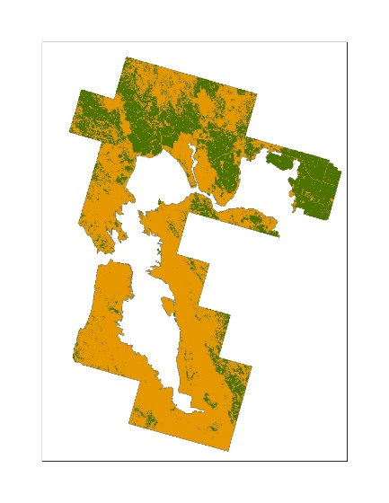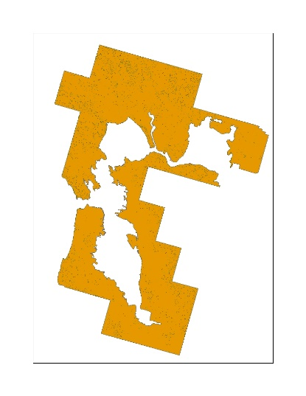

**Upper Uniform Lower**

**Figure 4: Conceptual example of the application of an aggregated PCT to a UDL and the three different distribution methods for treated acres.**

* 1. Scaling for Redundancy in the UDLs

Many UDLs overlap with each other, identifying a single location as multiple potential uses sites, causing the sum of the individual UDLs to be greater than the action area, and often greater than the 100% of the species range (or critical habitat). If each UDL was independent the sum of the UDLs would equal the action area. To account for this redundancy between use sites three different factors are applied to results for the individual UDLs; the composite factor, the agricultural factor and the non-agricultural factor.

In order to calculate the composite factor, an agricultural composite containing all agricultural UDLs and a non-agricultural composite containing all non-agricultural UDLs are generated. The composite factor is equal to the sum of the agricultural and non-agricultural composite divided by the action area. This factor accounts for the redundancy between the agricultural and non-agricultural uses. If all uses are independent the sum of the two composites would equal the action area, and the factor would be equal to 1. Each individual UDL is divided by this composite factor.

An agricultural factor is calculated by summing the results of all the agricultural UDLs and dividing by the agricultural composite. This factor is applied to all of the agricultural UDLs to account for the redundancy between agricultural UDLs. Similarly, a non-agricultural factor is calculated by summing the results of all the non-agricultural UDLs and dividing by the non-agricultural composite. This factor is applied to all of the non-agricultural UDLs to account for the redundancy between non-agricultural UDLs. If all uses are independent the sum of the individual UDLs would equal the composite, and the factor would be equal to 1.

After scaling the results to account for redundancy the sum of the individual UDLs will not exceed the action area percent overlap. Equations used in the calculation of these factors are shown below in **Equation 7-9.**

**Equation 7**. $Composite Factor=\frac{Perecent Overlap Ag Composite+Percent Overlap NonAg Composite}{Perecent Overlap Action Area}$

**Equation 8**. $Agricultural Factor=\frac{Total Percent Overlap Ag UDLs}{Percent Overlap AgComposite}=\frac{\sum_{i=1}^{n}{\left(POi\right)}}{POj}$

Where:

|  |  |
| --- | --- |
| i = | Agricultural UDLs |
| n= | Number of agricultural UDLs |
| j = | Agricultural composite layer |
| PO = | Unadjusted percent overlap |

**Equation 9**. $Non-Agricultural Factor=\frac{Total Percent Overlap Non-Ag UDLs}{Percent Overlap Non-Ag Composite}=\frac{\sum_{i}^{n}{\left(POi\right)}}{POj}$

Where:

|  |  |
| --- | --- |
| i = | Non-agricultural UDLs |
| n= | Number of non-agricultural UDLs |
| j = | Non-agricultural composite layer |
| PO = | Unadjusted percent overlap |

1. Results Co-occurrence Analysis – Examples Species for Atrazine

The final results of the co-occurrence analysis provide the percent of the species range (or critical habitat) that overlaps with each UDL. This metric is provided for each of the overlap scenario. The mean percent overlap and standard deviation for the atrazine UDLs across each overlap scenario for all ConUS species range are provided in **Table 5.** The final overlap scenario incorporating species life history related to habitat is presented in **Table 7.** Atrazine’s action area had a mean overlap of 17%. The mean overlap out to the limits of ground and aerial drift were 53% and 70%, respectively. The mean overlaps for the individual UDLs range from <1 to 5% before incorporating usage and species life history information and <1 to 5% after incorporating for this information.

**Table 6** presents the same information for all ConUS designated critical habitats. For critical habitat, atrazine’s action area had a mean overlap of 4%. The mean overlap out to the limits of ground and aerial drift were 19% and 24%, respectively. The mean overlaps for the individual UDLs range from <1 to 2% before incorporating usage and species life history information and <1 to 2% after accounting for this information.

**Table 5. Mean percent overlap and standard deviation for ConUS species range and each atrazine uses in the ConUS for each overlap scenario.**

| **Use** | **Overlap Scenario 1: Unadjusted (mean, std)** | **Overlap Scenario 2: PCT Overlap (mean, std)** | **Overlap Scenario 3:**  **PCT and Redundancy (mean, std)** | **Overlap Scenario 4:**  **PCT, Redundancy, Off-site**  **(mean, std)** |
| --- | --- | --- | --- | --- |
| Atrazine Action Areas | 17,15 | 17, 15 | 17, 15 | 17, 15 |
| Corn | 3, 7 | 3, 7 | 2, 6 | 2, 5 |
| Conservation Reserve Program (CRP) | <1, 2 | <1, 2 | <1, 1 | <1, 1 |
| Developed | 5, 9 | 5, 8 | 5, 8 | 4, 8 |
| Open Space Developed | 5, 4 | 5, 4 | 4, 4 | 5, 6 |
| Other Crops | 2, 4 | 2,4 | 2, 3 | 1,3 |
| Other Grains | 1, 3 | 1, 3 | 1, 2 | <1, 2 |
| Other Orchards | 1, 5 | <1, <1 | <1, <1 | <1, <1 |
| Right of Way | <1, <1 | <1, <1 | <1, <1 | <1, <1 |
| Soybeans | <1, 1 | <1, 1 | <1, <1 | <1, <1 |
| Vegetables and Ground Fruit | 1, 2 | <1, 1 | <1, 1 | <1, <1 |
| Wheat Corn Fallow | <1, 1 | <1, <1 | <1, <1 | <1, <1 |
| Wheat Sorghum Fallow | <1, <1 | <1, <1 | <1, <1 | <1, <1 |
| Wheat Fallow Wheat | <1, 1 | <1, 1 | <1, 1 | <1, 1 |
| Wheat Fallow Wheat IDOR | <1, 1 | <1, <1 | <1, <1 | <1, <1 |
| Limit Ground Drift (300 m or 1000 ft) | 53, 28 | 53, 28 | 53, 28 | 53, 28 |
| Limit Aerial Drift (792 m or 2600ft) | 70, 30 | 70,30 | 70, 30 | 70, 30 |

**Table 6. Mean percent overlap and standard deviation for ConUS designated critical habitat and each atrazine uses in the ConUS for each overlap scenarios.**

| **Use** | **Overlap Scenario 1: Unadjusted (mean, std)** | **Overlap Scenario 2: PCT Overlap (mean, std)** | **Overlap Scenario 3:**  **PCT and Redundancy (mean, std)** | **Overlap Scenario 4:**  **PCT, Redundancy, Off-site**  **(mean, std)** |
| --- | --- | --- | --- | --- |
| Atrazine Action Areas | 4,11 | 4,11 | 4, 11 | 4,11 |
| Corn | <1, 3 | <1, 3 | <1, 2 | <1, 2 |
| Conservation Reserve Program (CRP) | <1, 2 | <1, 2 | <1, 1 | <1, 1 |
| Developed | 1, 4 | 1, 4 | 1, 4 | 1, 4 |
| Open Space Developed | 2, 5 | 2, 5 | 2, 5 | 2, 5 |
| Other Crops | 1, 3 | 1, 3 | 1, 3 | 1, 2 |
| Other Grains | <1, 1 | <1, 1 | <1, 1 | <1, <1 |
| Other Orchards | <1, 3 | <1, 1 | <1, <1 | <1, <1 |
| Right of Way | <1, <1 | <1, <1 | <1, <1 | <1, <1 |
| Soybeans | <1, 1 | <1, 1 | <1, <1 | <1, <1 |
| Vegetables and Ground Fruit | <1, 1 | <1, 1 | <1, <1 | <1, <1 |
| Wheat Corn Fallow | <1, <1 | <1, <1 | <1, <1 | <1, <1 |
| Wheat Sorghum Fallow | <1, <1 | <1, <1 | <1, <1 | <1, <1 |
| Wheat Fallow Wheat | <1, 1 | <1, 1 | <1, <1 | <1, <1 |
| Wheat Fallow Wheat IDOR | <1, <1 | <1, <1 | <1, <1 | <1, <1 |
| Limit Ground Drift (300 m or 1000 ft) | 19, 32 | 19, 32 | 19, 32 | 19, 32 |
| Limit Aerial Drift (792m or 2600ft) | 24, 39 | 24, 39 | 24, 39 | 24, 39 |

**Figure 5** and **Figure 6** provide two species examples, the first is an example of a species with medium impact to overlap from usage and the second example is a species with lower impact of usage on overlap.In these examples the dark gray is the extent of the atrazine action area. The state images show the extent of the action area with example total treated acres for atrazine highlighted in orange, accounting for all uses. The aggregated maximum PCT was used to calculate treated acres.

For the species in **Figure 5** example treated acres for the state, across all uses, are highlighted in orange but the total area is so low you can only see a few pockets in the image left. In both images, the grey mask represents the footprint of all use sites prior to adding drift. The right image in **Figure 5** presents the upper distribution of the treated acres, moving all of the treated acres within the state into the species range. Under this condition, the orange highlighted areas are more visible. This difference is seen by comparing the footprint of the potential use sites, outlined by the gray mask, to the footprint of the estimated treated acres in orange. The full exposure area under this scenario is significantly less than the footprint for the action area without drift.

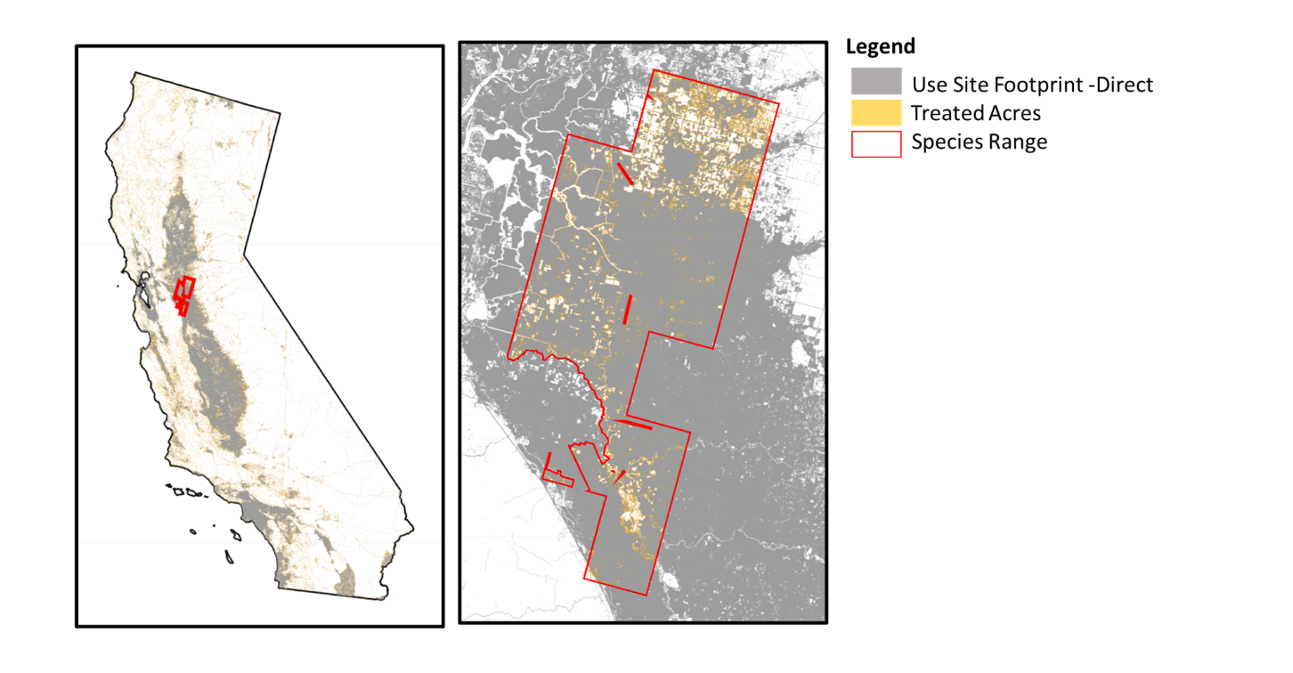

**Figure 5. Example of a species with medium impact of usage for atrazine; species Riparian brush rabbit (*Sylvilagus bachmani riparius).***

For the species in **Figure 6** the treated acres, across all uses for the state, highlighted in orange, are more visible (figure on far left). In these images the grey mask represents the action area, or all potential uses sites plus drift. The middle image in **Figure 6** presents the upper distribution of the treated acres, reaching the limit of overlap for this species. The visible portion of the action area accounts for drift, and the drift area is added to treated acres. In this situation, the overlap for the upper distribution of the treated acres would be the same as overlap for the species without usage. The right image in **Figure 6** represents the uniform distribution of treated acres. While this uniform estimate of overlap does not reach the overlap limit for the species, a difference in overlap is observed compared to the maximum treated acres distribution.

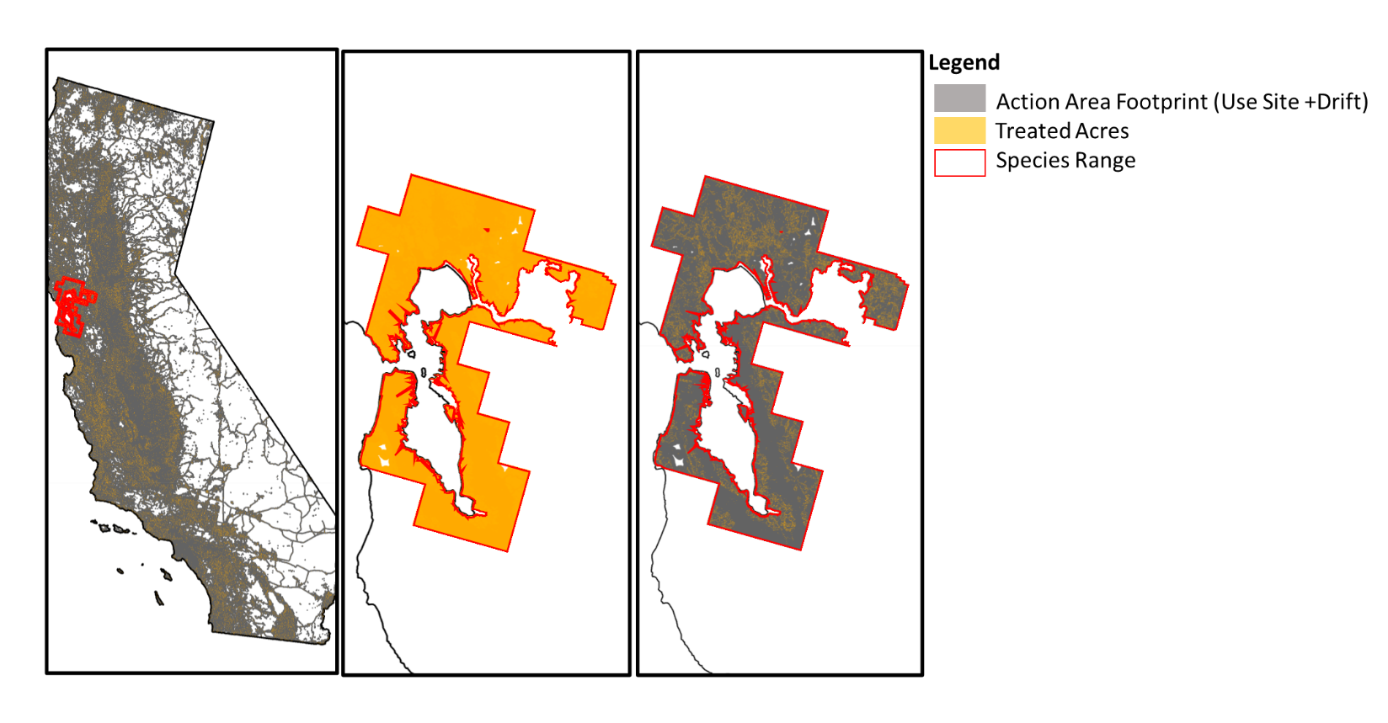

**Figure 6. Example of a species with low impact of usage for atrazine; species Salt marsh harvest mouse (Reithrodontomys raviventris).**

* 1. Suitable Habitat Overlap

In total suitable habitat was identified for 106 species that occur in the ConUS. **Table 7** provides themean percent overlap and standard deviation for these 106 species after accounting for usage in the full range and limiting the overlap and usage extent to suitable habitat within the range. This information is considered with the results for the full species range as part of the Weight of Evidence.

**Table 7. Mean percent overlap and standard deviation for uses in ConUS and suitable habitat species before and after limiting the overlap extent to suitable habitat.**

| **Use** | **Overlap Scenario 4: PCT, Redundancy, Off-site (mean, std)** | **Overlap Scenario 5:**  **PCT, Redundancy, Off-site, Habitat (mean, std)** |
| --- | --- | --- |
| Atrazine Action Areas | 17, 15 | 15, 16 |
| Corn | 2, 5 | 1, 5 |
| Conservation Research Program (CRP) | <1, 1 | <1, 1 |
| Developed | 4, 8 | 4, 8 |
| Open Space Developed | 5, 6 | 4, 6 |
| Other Crops | 1, 3 | 1, 3 |
| Other Grains | <1, 2 | <1,2 |
| Other Orchards | <1, <1 | <1, <1 |
| Right of Way | <1, <1 | <1, <1 |
| Soybeans | <1, <1 | <1, <1 |
| Vegetables and Ground Fruit | <1, <1 | <1, <1 |
| Wheat Corn Fallow | <1, <1 | <1, <1 |
| Wheat Sorghum Fallow | <1, <1 | <1, <1 |
| Wheat Fallow Wheat | <1, 1 | <1, 1 |
| Wheat Fallow Wheat IDOR | <1, <1 | <1, <1 |
| Limit Ground Drift (300 m or 1000 ft) | 53, 28 | 45, 31 |
| Limit Aerial Drift (792m or 2600 ft) | 70, 30 | 59, 36 |

1. At the time when the potential use site data were compiled and the UDLs were developed, only the 2012 Census of Agriculture was available. Although the 2017 census data are now available, by the time the new census data were released, there were insufficient time to incorporate them into this biological evaluation. New data will be incorporated into future analyses if time allows.
2. Query used to extract species from TESS: https://ecos.fws.gov/services/TessQuery?request=query&xquery=/SPECIES_DETAIL
3. Statuses included: Threatened, Endangered, Experimental Population Non-Essential, Proposed Threatened, Proposed Endangered, and Candidate
4. <https://www.fisheries.noaa.gov/national/endangered-species-conservation/esa-threatened-endangered-species>
5. Website for designated critical habitat: ([http://ecos.fws.gov/crithab)](http://ecos.fws.gov/crithab)
6. <http://desktop.arcgis.com/en/arcmap/10.3/tools/analysis-toolbox/union.htm>
7. USFWS, personal communication, November 2019
8. U.S. Geological Survey Gap Analysis Program, 20160513, GAP/LANDFIRE National Terrestrial Ecosystems 2011: U.S. Geological Survey: Boise, ID, http://gapanalysis.usgs.gov/gaplandcover/. doi:10.5066/F7ZS2TM0.