Diazinon Effects Characterization

Table of Contents

1. Introduction 6
2. Effects Characterization for Fish and Aquatic-Phase Amphibians 7
2.1. Introduction to Fish and Aquatic-Phase Amphibian Toxicity 7
2.2. Threshold Values for Fish and Aquatic-Phase Amphibians 8
2.3. Summary of Data Arrays for Fish and Aquatic-Phase Amphibians 9
2.4. Lines of Evidence for Fish and Aquatic-Phase Amphibians 11
2.4.1. Effects on Mortality of Fish and Aquatic-Phase Amphibians 11
2.4.2. Sublethal Effects to Fish and Aquatic-Phase Amphibians 18
2.4.2.1. Effects on Growth of Fish and Aquatic-Phase Amphibians 19
2.4.2.2. Effects on Reproduction of Fish and Aquatic-Phase Amphibians 21
2.4.2.3. Effects on Behavior of Fish and Aquatic-Phase Amphibians 22
2.4.2.4. Effects on Sensory Function of Fish and Aquatic-Phase Amphibians 24
2.4.2.5. Acetylcholinesterase (AChE) Inhibition in Fish and Aquatic-Phase Amphibians 24
3. Effects Characterization for Aquatic Invertebrates 28
3.1. Introduction to Aquatic Invertebrate Toxicity 28
3.2. Threshold Values for Aquatic Invertebrates 28
3.3. Summary Data Arrays for Aquatic Invertebrates 30
3.4. Lines of Evidence for Aquatic Invertebrates 33
3.4.1. Effects on Mortality of Aquatic Invertebrates 33
3.4.2. Sublethal Effects on Aquatic Invertebrates 41
3.4.2.1. Effects on Growth of Aquatic Invertebrates 42
3.4.2.2. Effects on Reproduction of Aquatic Invertebrates 44
3.4.2.3. Effects on Behavior of Aquatic Invertebrates 45
3.4.2.4. Effects on Sensory Function of Aquatic Invertebrates 46
3.4.2.5. AChE Inhibition in Aquatic Invertebrates 47
3.5. Incident Reports for Aquatic Invertebrates 47
3.6. Summary of Effects to Aquatic Invertebrates 48
4. Effects Characterization for Aquatic Plants 48
5. Aquatic Community-based (mesocosm) Studies 53
6. Effects Characterization for Birds 59
6.1. Introduction to Bird Toxicity 59
6.2. Threshold Values for Birds 59
6.3. Summary Data Arrays for Birds 61
6.4. Lines of Evidence for Birds 65
6.4.1. Effects on Mortality of Birds 65
6.4.2.1. Effects on Growth of Birds 73
6.4.2.2. Effects on Reproduction of Birds 75
6.4.2.3. Effects on Behavior of Birds 77
6.4.2.4. Effects on Sensory Function of Birds 82
7. Effects Characterization for Reptiles 84
8. Effects Characterization for Terrestrial-phase Amphibians 85
9. Effects Characterization for Mammals 85
9.1. Introduction to Mammal Toxicity 85
9.2. Threshold Values for Mammals 86
9.3. Summary Data Arrays for Mammals 87
9.4. Lines of Evidence for Mammals 88
9.4.1. Effects on Mortality of Mammals 88
9.4.2. Sublethal Effects to Mammals 90
9.4.2.1. Effects on Growth of Mammals 90
9.4.2.2. Effects on Reproduction of Mammals 92
9.4.2.3. Effects on Behavior of Mammals 93
9.4.2.4. Effects on Sensory Function of Mammals 94
9.4.2.5. Cholinesterase Inhibition in Mammals 95
9.4.2.6. Other effects on Mammals: Genetic, Cellular, and Biochemical Parameters 98
9.4.3. Field and Field-like Studies and Population-level Effects with Mammals 102
9.5 Effects to Mammals Not Included in Arrays 105
9.6. Incident Reports for Mammals 106
10. Effects Characterization for Terrestrial Invertebrates 107
10.1. Introduction to Terrestrial Invertebrate Toxicity 107
10.2. Threshold Values for Terrestrial Invertebrates 107
10.3. Summary Data Arrays for Terrestrial Invertebrates 110
10.4. Lines of Evidence for Diazinon Toxicity to Terrestrial Invertebrates 113
10.4.1 Effects on Mortality of Terrestrial Invertebrates 113
10.4.2. Sublethal Effects to Terrestrial Invertebrates 125
10.4.2.1. Effects on Growth of Terrestrial Invertebrates 125
10.4.2.2. Effects on Reproduction of Terrestrial Invertebrates 126
10.4.2.3 Effects on Behavior of Terrestrial Invertebrates 128
10.4.2.4. Effects on Sensory Function of Terrestrial Invertebrates 130
10.4.2.5. Other Effects Reported for Terrestrial Invertebrates 130
10.5 Field and Field-like Studies and Population-level Effects for Terrestrial Invertebrates 135
10.6. Other Data Excluded from Arrays 141
10.7. Incident Reports for Terrestrial Invertebrates 141
11. Effects Characterization for Terrestrial Plants 143
11.1. Introduction to Terrestrial Plant Toxicity 143
11.2. Threshold Values for Terrestrial Plants 143
11.3. Summary Data Arrays for Terrestrial Plants 143
11.4. Lines of Evidence for Terrestrial Plants 144
11.4.1. Effects on Mortality of Terrestrial Plants 144
11.4.2. Sublethal Effects to Terrestrial Plants 145
11.5. Incident Reports for Terrestrial Plants 151

List of Tables

Table 2-1. Direct Effects Thresholds for Determining Effects to Listed Fish and Aquatic-phase Amphibians 9
Table 2-2. Indirect Effects Thresholds for Determining Effects to Listed Species That Depend on Fish and Aquatic-phase Amphibians 9
Table 2-3. Available Median Lethal Concentration (LC₅₀) Data for Fish and Amphibians Exposed to Diazinon as TGAI or Formulation 12
Table 2-4. Model-averaged Quantile Estimates (in ug/L) from Five Distributions Fit Using Maximum Likelihood 17
Table 2-5. Most Sensitive Reviewed Fish and Aquatic-phase Amphibians Sublethal Effects Data 18
Table 2.6. Comparison Anti-cholinesterase Activity and Whole-Organism Effects in Fish 26
Table 3-1. Direct Effects Thresholds for Determining Effects to Listed Aquatic Invertebrates 29
Table 3-2. Indirect Effects Thresholds for Determining Effects to Listed Species That Depend on Aquatic Invertebrates 30
Table 3-3. Available Median Lethal Concentration (LC₅₀) Data for Aquatic Invertebrates Exposed to Diazinon as TGAI or Formulation for 48 or 96 Hours. 34
Table 3-4. Summary Statistics for Best-fit SSDs for Aquatic Invertebrates Exposed to Diazinon 40
Table 3-5. Most Sensitive Freshwater Invertebrate Sublethal Effects Data 41
Table 3-6. Most Sensitive Estaurine/Marine Invertebrate Sublethal Effects Data 42
Table 3-7. Studies Reporting Effects to Growth in Aquatic Invertebrates 43
Table 3-8. Studies Reporting Effects to Behavior in Aquatic Invertebrates 46
Table 3-9. Studies Reporting Effects to Acetylcholinesterase Activity (AChE) in Aquatic Invertebrates 47
Table 4-1. Direct and Indirect Effects Thresholds for Aquatic Plants Exposed to Diazinon 48
Table 4-2. NOEC and LOEC Values from Lab Studies Involving Aquatic Plants Exposed to Diazinon 50
Table 4-3. Effects Data (ECx values) for Aquatic Plants Exposed to Diazinon 52
Table 5-1. Effects Data for Mesocosm Studies Involving Diazinon 55
Table 5-2. Mesocosm or Field Studies for Diazinon with Fish or Aquatic-phase Amphibians Available in ECOTOX 57
Table 6-1. Direct Effects Thresholds for Determining Effects to Listed Birds 60
Table 6-2. Indirect Effects Thresholds for Determining Effects to Listed Species That Depend upon Birds 60
Table 6-3. Median Lethal Concentrations Resulting from Sub-acute Dietary Exposures 68
Table 6-4. Available Median Lethal Doses (oral) for Birds Exposed to Diazinon as TGAI or Formulation 69
Table 6-5. Summary Statistics for SSDs Fit to Diazinon Test Results for Birds 71
Table 6-6. LD50 Values (mg/kg-bw) for Red-winged Blackbirds and Starlings of Different Ages Exposed to Diazinon 72
Table 6-7. Reproductive Effects Observed in Studies Involving Diazinon 75
Table 6-8. Behavioral Effects Observed in Studies Involving Diazinon 78
Table 6-9. Decreases in AChE Observed in Reproductive Studies 82
Table 6-10. Results from Sub-acute Dietary Toxicity Studies Conducted with Goslings Exposed to TGAI and Formulated Diazinon 83
Table 6-11. Reported Mortalities of Birds Associated with Uses of Diazinon 84
Table 9-1. Direct and Indirect Effects Thresholds Based on the Most Sensitive Acute (single dose) Mortality Endpoints (LD50). 87
Table 9-2. Sublethal Direct and Indirect Effects Thresholds for Mammals 87
Table 9-3. Observations from Field and Field-like Studies with Diazinon Reported in ECOTOX Database 103
Table 10-1. Direct and Indirect Effects Thresholds Based on the Most Sensitive Acute (<96 hr) Mortality Endpoints (LC50 or LD50) 108
Table 10-2. Direct and Indirect Effects Thresholds Based on the Most Sensitive Endpoints for All Exposure Durations. 109
Table 10-3. Median Lethal Values for Acute Mortality in Terrestrial Invertebrates Exposed to Diazinon Residues through Contact 114
Table 10-4. Median Lethal Values for Acute Mortality in Terrestrial Invertebrates Exposed to Diazinon Residues through Diet. 115
Table 10-5. Additional Mortality Observations in Terrestrial Invertebrates Exposed to Diazinon Residues through Contact with Soil or Substrate. 116
Table 10-6. Additional Mortality Observations in Terrestrial Invertebrates Exposed to Diazinon Residues through Contact in the Diet. 117
Table 10-7. Sublethal Effects in Terrestrial Invertebrates (adults) Exposed to Diazinon Residues through Contact with Soil or Substrate. 131
Table 10-8. Sublethal Effects in Terrestrial Invertebrates Exposed to Diazinon Residues in the Diet. 132
Table 11-1. Direct and Indirect Effects Thresholds for Listed Terrestrial and Wetland Plants Exposed to Diazinon. 143
Table 11-2. LOEL Values from Studies Involving Terrestrial Plants Exposed to Diazinon via Direct Spray. NOECs Included When Established. 145
Table 11-3. Effects Data for Terrestrial Plants Exposed to Diazinon (TGAI) 146
Table 11-4. Tested Levels Where No Effects Were Observed in Terrestrial Plants Exposed to Diazinon 147

List of Figures

Figure 2-1. Summary Array of Fish (freshwater and estuarine/marine) Exposed to Diazinon 10
Figure 2-2. Toxicity Endpoints for Amphibians Exposed to Diazinon 11
Figure 2-3. Mortality Endpoints for Fish Exposed to Diazinon 15
Figure 2-4. Mortality Endpoints for Aquatic-phase Amphibians Exposed to Diazinon 16
Figure 2-5 Mode- averaged SSD for Aquatic Vertebrates Exposed to Diazinon 17
Figure 2-6. Growth Endpoints for Fish Exposed to Diazinon 20
Figure 2-7. Growth Endpoints for Aquatic Amphibians Exposed to Diazinon 21
Figure 2-8. Behavior Endpoints for Fish Exposed to Diazinon 23
Figure 2-9. Behavior Endpoints for Aquatic Amphibians Exposed to Diazinon 24
Figure 3-1. Summary Array of Freshwater Invertebrates Exposed to Diazinon 31
Figure 3-2. Summary Array of Freshwater Invertebrates Exposed to Diazinon 32
Figure 3-3. Toxicity Endpoints for Mollusks Exposed to Diazinon 33
Figure 3-4. Toxicity Endpoints for Freshwater Invertebrates Exposed to Diazinon 37
Figure 3-5. Toxicity Endpoints for Estuarine/Marine Aquatic Invertebrates Exposed to Diazinon 38
Figure 3-6. Toxicity Endpoints for Aquatic Mollusks Exposed to Diazinon 39
Figure 3-7. Log-gumbel SSD for Diazinon Toxicity Values for Pooled Invertebrates 40
Figure 3-8. SSDs for Pooled (gumbel), Freshwater (gumbel), and Saltwater (triangular) Test Results 41
Figure 3-9. Reproduction Effects Data Array for Aquatic Invertebrates 45
Figure 4-1. Array of Available Endpoints for Aquatic Plants Exposed to Diazinon (TGAI and Formulated). 49
Figure 6-1. Dietary-based Endpoints for Birds Exposed to Diazinon 62
Figure 6-2. Dose-based Endpoints for Birds Exposed to Diazinon (Normalized to 100g BW) 63
Figure 6-3. Application Rate Based Endpoints for Birds Exposed to Diazinon 64
Figure 6-4. Dietary-based Endpoints and Thresholds Used for Mortality Line of Evidence 65
Figure 6-5. Dosed-based Endpoints and Thresholds Used for Mortality Line of Evidence 66
Figure 6-6. Application Rate Based Endpoints and Thresholds Used for Mortality Line of Evidence 67
Figure 6-7. Log-gumbel SSD Fit for Bird Diazinon Data Using Maximum Likelihood 71
Figure 6-8. Dietary-based Growth Endpoints for Birds Exposed to Diazinon 73
Figure 6-9. Application Rate-based Growth Endpoints for Birds Exposed to Diazinon 74
Figure 6-10. Dietary-based Endpoints for Reproductive Effects 76
Figure 6-11. Application Rate-based Endpoints for Reproductive Effects 77
Figure 6-12. Dietary-based Endpoints for Behavioral Line of Evidence 79
Figure 6-13. Dose-based Endpoints Relevant to Behavior Line of Evidence 80
Figure 6-14. Application Rate-based Endpoints Relevant to Behavior Line of Evidence 81
Figure 9-1. Summary Data Array for Mammalian Toxicity Endpoints Adjusted for Body Weight (mg/kg/bw) 88
Figure 9-2. Array of Mortality Endpoints Adjusted for Body Weight 90
Figure 9-3. Array of Growth and Development Endpoints Adjusted to Body Weight 92
Figure 9-4. Arrays of Reproductive Endpoints Adjusted for Body Weight 93
Figure 9-5. Arrays of Behavioral Endpoints Adjusted for Body Weight 94
Figure 9-6. Arrays of Cholinesterase (and Other Enzyme) Endpoints Adjusted for Body Weight 97
Figure 9-7. Arrays of Physiological Endpoints Adjusted for Body Weight 101
Figure 10-1 (a and b). Summary Data Arrays for Endpoints Adjusted for Body Weight 110
Figure 10-2 (a and b). Summary Data Arrays for Endpoints Reported in Terms of Soil Residues 111
Figure 10-3(a and b). Summary Data Arrays for Endpoints Reported in Terms of Experimental Unit 111
Figure 10-4. Summary Data Array for Endpoints Reported Based on Dietary Residues 112
Figure 10-5. Summary Data Array for Endpoints Reported in Terms of Treatment Rate (lbs/A) 112
Figure 10-6 (a and b). Summary Data Array for Endpoints Reported in Terms of Parts per Million (ppm) for Arthropoda (top, a) and Nemata (bottom, b) 113
Figure 10-7. Arrays of Mortality Endpoints Adjusted for Body Weight 119
Figure 10-8. Arrays of Mortality Endpoints Based on Soil Residues 120
Figure 10-9. Arrays of Mortality Based on Experimental Unit 122
Figure 10-10. Array of Mortality Endpoints Based on Dietary Residues 122
Figure 10-11. Array of Mortality Endpoints Based on Treatment Rate (Mass per Unit Area) 123
Figure 10-12. Arrays of Mortality Endpoints Reported in Parts per Million (ppm) 124
Figure 10-13. Array of Growth and Development Endpoints Based on Experimental Unit 126
Figure 10-14. Array of Growth and Development Endpoints Based on Dietary Residues 126
Figure 10-15. Array of Growth and Developmental Endpoints Reported in Parts per Million (ppm) 126
Figure 10-16. Array of Reproductive Endpoints Based on Soil Residues 127
Figure 10-17. Array of Reproductive Endpoints Based on Treatment Rate (Mass per Unit Area) 127
Figure 10-18. Array of Reproductive Endpoints Reported in Parts per Million (ppm) 128
Figure 10-19. Array of Behavioral Endpoints Based on Soil Residues 128
Figure 10-20. Array of Behavioral Endpoints Based on Experimental Unit 129
Figure 10-21. Array of Behavioral Endpoints Based on Dietary Residues 129
Figure 10-22. Array of Behavioral Endpoints Reported in Parts per Million (ppm) 130
Figure 10-23. Array of Physiological Endpoints Based on Soil or Substrate Residues 133
Figure 10-24. Array of Physiological Endpoints Based on Dietary Residues 134
Figure 10-25. Array of Physiological Endpoints Reported in Parts per Million (ppm) 135
Figure 10-26. Number of Studies with Endpoints in Various Application Rate Ranges (N=40). 136
Figure 10-27. Analysis of Available Endpoints (lbs/A) by Type of Observation 137
Figure 10-28. Array of Population Endpoints Based on Experimental Unit 138
Figure 10-29. Arrays of Population Endpoints Based on Treatment Rate (Mass per Unit Area). 140
Figure 10-30. Arrays of Population Endpoints Reported in Parts per Million 140
Figure 11-1. Array of Available Endpoints for Terrestrial Plants Exposed to Diazinon 144

Diazinon Effects Characterization

Introduction

Diazinon is an insecticide that acts by inhibiting cholinesterase activity, thereby preventing the natural breakdown of various cholines and ultimately causing the neuromuscular system to seize. This may lead to a series of various effects, which may culminate in death. The effects of diazinon have been studied extensively in many taxa, particularly in fish and aquatic and terrestrial invertebrates. Studies include acute and chronic laboratory studies with either technical or formulated diazinon, and include both registrant-submitted and open literature studies. Discussions regarding toxicity to taxon from exposure to other chemical stressors of concern (i.e., diazoxon, mixtures) and non-chemical stressors (e.g., temperature) are discussed in Sections 1.4.2.2.e and 1.4.2.2.f of the Problem Formulation. Additionally, indirect effects to a particular taxon from effects to prey and/or habitat are described in their respective direct effect sections (e.g., effects to fish prey items (i.e., aquatic invertebrates) are discussed in the characterization section for aquatic invertebrates).

Toxicity studies, including registrant submitted studies as well as open literature studies and government reports contained within the ECOTOX database, are used to derive thresholds and to characterize effects to a taxon in a weight of evidence (WoE) approach. Thresholds are discussed in Sections 1.4.1.1.b and 1.4.2.2.b.1 of the Problem Formulation and the process for selecting thresholds is described in ATTACHMENT 1-4. More information on the ECOTOX database and methods for reviewing studies can be found in ATTACHMENT 1-8.

The following sections present direct effects thresholds for ESA-listed species and indirect effects thresholds for species which rely upon another taxon (e.g., as a food source). The sections discuss direct effects to a taxon for the different lines of evidence, when available, addressed in the WoE approach, including mortality, decreases in growth, decreases in reproduction, altered behavior, and changes in sensory function. For aquatic taxa, separate thresholds may be provided for technical grade and formulated diazinon to address limitations in modeling the different fate characteristics of the formulated product components. In this situation the toxicity of the formulated product is compared to the exposure from spray drift, while the technical active ingredient (a.i.) toxicity is compared to the combined exposures from runoff and spray drift. This approach is only necessary when the lowest toxicity value for a particular taxa is from a study with the formulated product.

The toxicity data for each taxon are generally presented as summary data arrays developed using the Data Array Builder v.1.0. The arrays contain data from both laboratory and field experiments (e.g., mesocosm). Data in these arrays are grouped by the type of effect (e.g., behavior, reproduction, mortality), and present the range of LOAECs and NOAECs (NOAECs must have a corresponding LOAEC to be represented in array) for each effect type. Each of the effect types are discussed in further detail within each taxon effect characterization. For aquatic organisms, the data in the array represents exposure units of µg/L. For birds (and terrestrial-phase amphibians and reptiles) and mammals, the data is expressed in units of mg/kg-diet, mg/kg-body weight (bw), and/or lb a.i./Acre. Toxicity data for terrestrial invertebrates are expressed as µg/g-bw, µg/g-soil and lb a.i./Acre. Data are expressed as lb a.i/Acre for terrestrial plants. Data used in the arrays is available for each taxon in APPENDIX 2-1. Studies for which unit conversion to one of the above units for a particular taxon was not possible (e.g., %) were not included in the data arrays. However, a discussion of studies not converted to one of those units are presented further on the effect characterization (i.e., summary of data not included in the arrays). Reported endpoints in ECOTOX are presented in APPENDIX 2-2. Reviews of open literature studies reviewed for the effects characterization are presented in APPENDIX 2-3. Citations for registrant submitted studies are presented in APPENDIX 2-4. Citations for studies not included in this effects characterization are presented in APPENDIX 2-5.

Effects Characterization for Fish and Aquatic-Phase Amphibians

Introduction to Fish and Aquatic-Phase Amphibian Toxicity

The effects of diazinon have been studied extensively in fish, but less so in aquatic-phase amphibians for which freshwater fish typically serve as surrogates. Acute, early-life-stage, partial life cycle, and full life cycle studies have been submitted by the registrant for fish, while no registrant-submitted toxicity data are available for amphibians owing in large part to the absence of guideline studies and standardized protocols for assessing the effects of pesticides on amphibians. It should be noted that EPA does not typically request toxicity studies for amphibians from pesticide registrants, but rather uses data on freshwater fish to represent potential effects to aquatic-phase amphibians. The ECOTOX database contains approximately 130 toxicity studies for fish, five of which were conducted on estuarine/marine species, while the remainder were conducted on freshwater species. There are 10 toxicity studies available for aquatic-phase amphibians. The available toxicity dataset includes representatives of 24 different families of fish and five families of amphibians. APPENDIX 2-2 and APPENDIX 2-5 includes the bibliography of studies that are included in this effects characterization and those that were excluded, respectively. Studies were excluded if they were considered invalid/scientifically unsound, were not reported in environmentally relevant exposure units, or involved granular formulations of diazinon, which are no longer registered in the U.S. and thus are not part of the action.

Studies from the open literature and registrant submissions are used to derive thresholds and to characterize effects to fish and aquatic-phase amphibians using different lines of evidence. This section presents the thresholds for determining direct effects to listed species of fish and aquatic-phase amphibians and for indirect effects to listed species that depend upon fish and aquatic-phase amphibians. This section also discusses the WoE available for different types of measurement endpoints on fish and aquatic-phase amphibians, including survival, growth, reproduction, behavior, and acetylcholinesterase (AChE) inhibition. In addition, this section discusses the incident reports that have occurred since 2006, when diazinon use was affected as a result of RED mitigations.

In this effects characterization, direct and indirect effects thresholds are derived for fish and aquatic-phase amphibians as a single group since the large majority of the available toxicity studies were conducted with freshwater fish species. However, when sufficient data are available for diazinon, different lines of evidence are identified for freshwater and estuarine/marine fish as well as aquatic-phase amphibians.

Multiple studies in the open literature are available that examined the effects of diazinon on aquatic communities (e.g., mesocosm) with particular emphasis on aquatic plants, invertebrates and aquatic-phase amphibians. Some of these studies report effects at concentrations near or below the established threshold toxicity values. Given the potential for multiple interactions occurring simultaneously in these studies among the test organisms (potential for both direct and indirect effects on a taxa), these studies were not used to establish thresholds, but they will be included in the WoE for the effects determinations for relevant species.

Threshold Values for Fish and Aquatic-Phase Amphibians

Lethal thresholds for risk assessment are derived from species sensitivity distributions (SSD) of survival from acute toxicity studies, while sublethal thresholds are based on the most sensitive sublethal effects identified among registrant-submitted studies and open literature in the ECOTOX database and classified as acceptable or quantitative (Tables 2-1 and 2-2). As the most sensitive toxicity values used to derive thresholds are based on studies conducted with technical grade active ingredient (TGAI), these endpoints may be used for evaluating exposures from runoff plus spray drift as well as from spray drift exposure alone. Endpoints from studies conducted with TGAI and formulated products are included in the arrays. Studies from which threshold values are derived will be discussed in more detail in the respective lines of evidence sections for various types of effects (e.g., mortality, behavior, reproduction).

There were insufficient toxicity data to calculate separate SSDs for freshwater and estuarine/marine fish and aquatic-phase amphibians. Therefore, a single combined SSD was generated for all of these groups. The direct effects mortality threshold is based on the 1 in a million effect from the HC₀₅ from the SSD for these taxa (Table 2-1; see APPENDIX 2-6 for SSD regression results). The mortality threshold for indirect effects is based on 10% mortality calculated from the 5th percentile LC50 of the SSD.

Two different sublethal endpoints are identified. The most sensitive is based on AchE inhibition observed in a study where fish were exposed to diazinon in a formulated product. This threshold will be used to characterize effects due to spray drift transport only. The most sensitive quantitative sublethal threshold from a study involving TGAI diazinon is based on a reproductive effect in sheepshead minnows. At a concentration of 0.47 ug/L, a 31% decrease in egg production was observed. Although more sensitive endpoints are available for other studies, uncertainties associated with the data prevent use of these data as an effects threshold. These data are included in the discussions below along with the toxicity arrays.

Table 2-1. Direct Effects Thresholds for Determining Effects to Listed Fish and Aquatic-phase Amphibians
Effect (endpoint) | Exposure | Value  (unit: µg/L) | Duration of exposure | Source
Mortality  (1/million) | Runoff + Drift | 20.9 | 96 hours | HC₀₅ from SSD¹  (237.9 µg/L; slope 4.5)
Reproduction (31% decrease in egg production; LOAEC) | Runoff + Drift | 0.47 | 108 days | MRID 40914801
AChE inhibition  (23% decrease; LOAEC) | Drift only | 0.004 | 96 hours | ECOTOX# 160182
¹ Details on derivation of SSD are provided in APPENDIX 2-6 and in the “Mortality” characterization section below.

Table 2-2. Indirect Effects Thresholds for Determining Effects to Listed Species That Depend on Fish and Aquatic-phase Amphibians
Effect (endpoint) | Exposure | Value  (unit: µg/L) | Duration of exposure | Source
Mortality  (10% mortality) | Runoff + Drift | 123.5 | 96 hours | HC₀₅ from SSD¹  (237.9 µg/L; slope 4.5)
Reproduction (31% decrease in egg production; LOAEC) | Runoff + Drift | 0.47 | 108 days | MRID 40914801
AChE inhibition  (23% LOAEC) | Drift | 0.004 | 96 hours | ECOTOX# 160182
¹ Details on derivation of SSD are provided in APPENDIX 2-6 and in the “Mortality” characterization section below.

Summary of Data Arrays for Fish and Aquatic-Phase Amphibians

Data arrays are used to present the entire spectrum of data available from the open literature and unpublished studies submitted by registrants. Figures 2-1 and 2-2 include arrays of toxicity endpoints for fish and aquatic-phase amphibians, respectively, from scientifically valid studies from the open literature and unpublished studies submitted by registrants. Data in the arrays are grouped by the type of effect (e.g., behavior, reproduction, mortality). APPENDIX 2-1 includes all the data used to generate these arrays. The different types of effects are discussed further in their respective sections below.

Array endpoints were excluded if they were not reported in units representing environmentally relevant exposures (e.g., lb/acre) or if they were based on granular formulations, which are no longer registered in the U.S. In addition, values reported as > EC_{x} were not included in arrays if it was not possible to depict this endpoint uncertainty in the array construct. Figure 2-1 only presents the range of LOECs and NOECs (NOECs must have a corresponding LOEC to be represented in the array) and LC₅₀ values for each effect type since there are too many toxicity studies with fish in general to display individual endpoint values from each study. For amphibians, individual endpoints are maintained as a unique value in the data array (Figure 2-2).

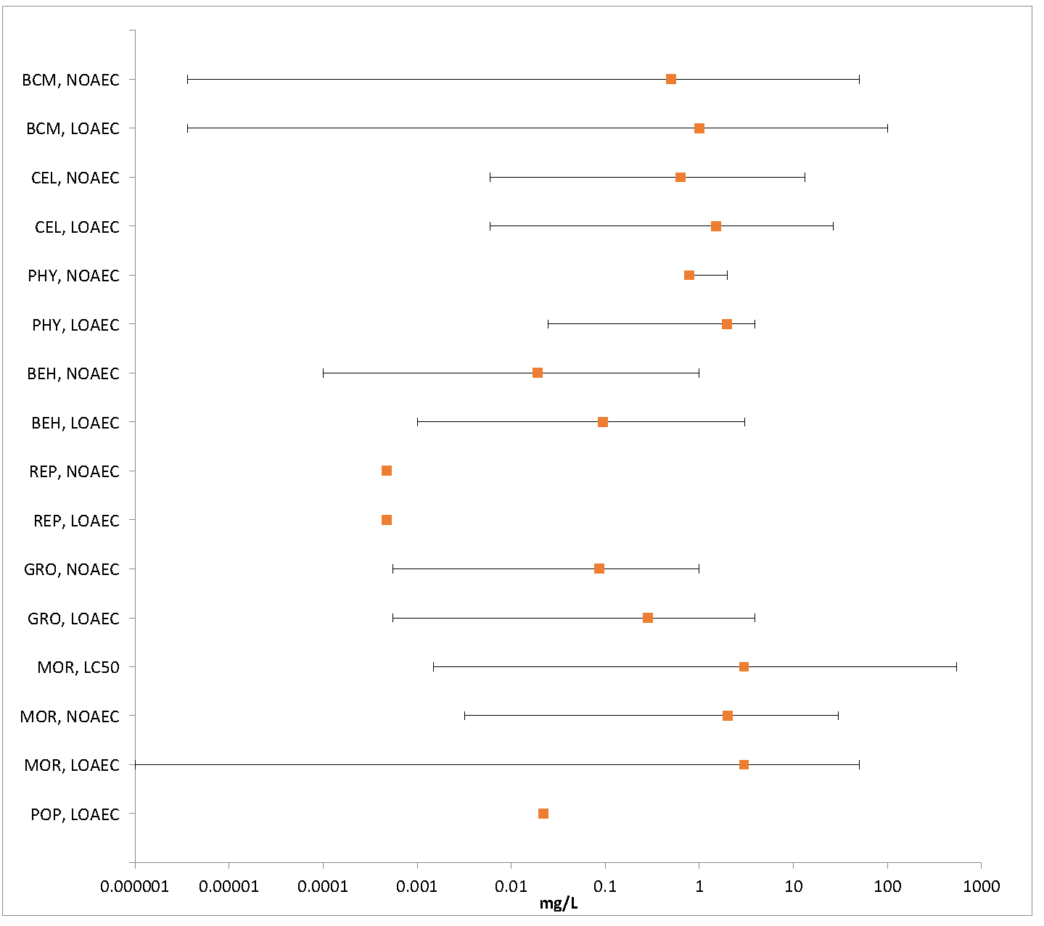
Figure 2-1. Summary Array of Fish (freshwater and estuarine/marine) Exposed to Diazinon
Orange symbols represent mean endpoint values and bars represent the data range (BCM=Biochemical; CEL=Cellular; PHY=Physiological; BEH=Behavioral; REP=Reproduction; GRO=Growth; MOR=Mortality; POP=Population)

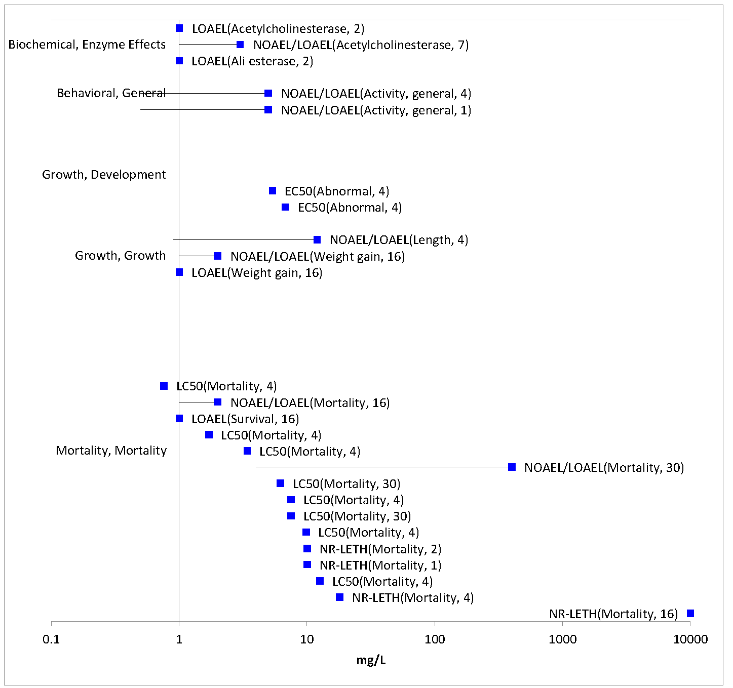
Figure 2-2. Toxicity Endpoints for Amphibians Exposed to Diazinon
Data are separated by types of effects (e.g., growth, mortality). Bars represent concentration span between study NOEC and LOEC.

Lines of Evidence for Fish and Aquatic-Phase Amphibians

Effects on Mortality of Fish and Aquatic-Phase Amphibians

Mortality data for diazinon are available for 50 fish species, including 45 freshwater species, 5 estuarine/marine species, and 10 amphibian species based on studies submitted by the registrant or identified in the ECOTOX database. These data encompass a total of 24 fish families and 5 amphibian families.

Generally, open-literature mortality data were reviewed by EFED if they were either among the most sensitive endpoints in the entire database or if they fell near the 5th, 50th, or 95th percentile of the species sensitivity distribution for fish and aquatic-phase amphibians or if they were reviewed for a previous assessment (e.g., listed species litigation assessment).

Acute mortality toxicity tests performed with 96-hour exposure durations are presented in Table 2-3 and include 41 fish species and 3 amphibian species. The tabular presentation of mortality data are limited to this exposure duration as it is the mostly commonly used in fish toxicity studies and ensures comparability of the data. However, studies with other exposure durations are also considered in the mortality arrays (Figures 2-3 and 2-4) and lines of evidence discussion in this effects characterization.

Ninety-six hour acute toxicity estimates (LC₅₀) for diazinon range from 85 to 545,000 µg/L and span four orders of magnitude (Table 2-3), indicating a wide range of sensitivity among fish and aquatic-phase amphibians. The most sensitive 96-hr LC₅₀ available for diazinon was conducted with a formulation, Dragon 25E (25% a.i.), which was tested on the Mesa silverside, Chirostoma jordani (LC₅₀ = 1.5 µg/L; E160182). However, based on a recent communication with the registrant, a similar 25% a.i. formulation is not currently registered in the U.S. and is considered of limited relevance for this assessment. The next most sensitive acute mortality estimate is for the European eel Anguilla anguilla (LC₅₀ = 85 µg/L; E6712) conducted with technical-grade diazinon (95% a.i.).

Based on the available data, the rainbow trout (Oncorhynchus mykiss) appears to be rather sensitive to diazinon, possessing 3 of the 10 most sensitive LC₅₀ values in the dataset. Yet, other species from the same genus (O. tshawytscha) possess 96-hr LC₅₀ values that are among the highest (least sensitive) in the dataset. Beyond rainbow trout, there is no obvious pattern of taxon-specific acute sensitivity, with the 10 lowest 96-hr LC₅₀ values representing eight different families of fish. It should also be noted that the rainbow trout is a commonly tested fish species and that the lack of any observable taxonomic pattern in toxicity data may be due to the heterogeneous nature of the acute toxicity dataset.

The most sensitive amphibian species in the available database (Rana boyli; LC₅₀ = 1,700 µg/L; E118706) is approximately 20 times less sensitive to diazinon as compared to the most sensitive fish species. However, there is a paucity of amphibian lethality data and the available endpoints are interspersed within the range of fish mortality data. Therefore, it is not possible to conclude whether amphibians are more or less sensitive overall than fish in terms of mortality.

Table 2-3. Available Median Lethal Concentration (LC₅₀) Data for Fish and Amphibians Exposed to Diazinon as TGAI or Formulation
Species | Common Name | LC₅₀  (µg/L) | Medium | Test Material | Ref#
Anguilla anguilla | Common Eel | 85* | FW | TGAI | E15687
Oncorhynchus mykiss | Rainbow Trout | 90* | FW | TGAI | E6797
Oncorhynchus mykiss | Rainbow Trout | 90* | FW | TGAI | MRID 40094602
Lepomis macrochirus | Bluegill | 140 | FW | TGAI | E13000
Mugil cephalus | Striped Mullet | 150* | EM | TGAI | MRID 40228401
Lepomis macrochirus | Bluegill | 170* | FW | TGAI | E6797
Rutilus kutum | Kutum | 200 | FW | Formulation² | E153779
Channa striata | Snake-Head Catfish | 400 | FW | Formulation² | E88370
Oncorhynchus mykiss | Rainbow Trout | 400* | FW | TGAI | E13000
Lepomis macrochirus | Bluegill | 440* | FW | TGAI | E664
Salvelinus fontinalis | Brook Trout | 450* | FW | TGAI | E664
Lepomis macrochirus | Bluegill | 480* | FW | TGAI | E664
Salvelinus namaycush | Lake Trout, Siscowet | 600* | FW | TGAI | E6797
Salvelinus fontinalis | Brook Trout | 800* | FW | TGAI | E664
Cyprinus carpio | Carp | 960 | FW | Formulation² | E80835
Cirrhinus mrigala | Carp, Hawk Fish | 1,000 | FW | Formulation² | E45088
Salvelinus fontinalis | Brook Trout | 1,100* | FW | TGAI | E664
Menidia beryllina | Inland Silverside | 1,100 | EM | TGAI | E73146
Oncorhynchus mykiss | Rainbow Trout | 1,200 | FW | Formulation² | E153572
Cyprinodon variegatus | Sheepshead Minnow | 1,500* | EM | TGAI | E5604
Jordanella floridae | Flagfish | 1,500* | FW | TGAI | E664
Cyprinodon variegatus | Sheepshead Minnow | 1,500* | EM | TGAI | MRID 40228401
Oncorhynchus clarkii | Cutthroat Trout | 1,700* | FW | TGAI | E6797
Rana boylii¹ | Foothill Yellow-Legged Frog | 1,700* | FW | TGAI | E118706
Jordanella floridae | Flagfish | 1,800* | FW | TGAI | E664
Heteropneustes fossilis | Indian Catfish | 2,300 | FW | TGAI | E7375; E15179
Cyprinus carpio | Common Carp | 2,300 | FW | Formulation² | E7598
Pangasius hypophthalmus | Shark Catfish | 2,520* | FW | TGAI | E160541
Silurus glanis | Wels, European Catfish | 2,600 | FW | Formulation² | E88377
Barbonymus gonionotus | Java Barb | 2,700 | FW | TGAI | E85632
Oncorhynchus clarkii | Cutthroat Trout | 2,800* | FW | TGAI | E6797
Oreochromis niloticus | Nile Tilapia | 2,800* | FW | TGAI | E120740
Poecilia reticulata | Guppy | 3,000 | FW | Formulation² | E546
Channa punctata | Snake-Head Catfish | 3,100 | FW | TGAI | E85632
Psetta maxima | Left-Eyed Flounder, Turbot | 3,300* | EM | TGAI | E159160
Poecilia reticulata | Guppy | 3,400* | FW | TGAI | E5370
Huso huso | Beluga | 3,400 | FW | Formulation² | E84455
Pseudacris regilla¹ | Pacific Chorus Frog | 3,400* | FW | TGAI | E118706
Cichlidae (sp. not indicated) | Cichlid | 3,800* | FW | TGAI | E84361
Barbus grypus | Shirbout | 3,900 | FW | Formulation² | E160916
Rutilus rutilus | Roach | 4,500* | FW | TGAI | E153739
Pimephales promelas | Fathead Minnow | 4,700 | FW | TGAI | E45073
Carassius carassius | Crucian Carp | 5,000 | FW | Formulation² | E546
Pimephales promelas | Fathead Minnow | 6,000* | FW | TGAI | E65773
Clarias gariepinus | Zambezi Barbel | 6,200* | FW | TGAI | E121110
Melanotaenia duboulayi | Eastern Rainbow Fish | 6,400* | FW | TGAI | E85626
Anabas testudineus | Climbing Perch | 6,600* | FW | TGAI | E85632
Pimephales promelas | Fathead Minnow | 6,600* | FW | TGAI | E68197
Pimephales promelas | Fathead Minnow | 6,600* | FW | TGAI | E664
Clarias gariepinus | Zambezi Barbel | 6,600* | FW | TGAI | E121110
Pimephales promelas | Fathead Minnow | 6,800* | FW | TGAI | E664
Rana boylii¹ | Foothill Yellow-Legged Frog | 7,500* | FW | TGAI | E92498
Pogonichthys macrolepidotus | Sacromento Splittail | 7,500 | FW | TGAI | E65773
Oncorhynchus mykiss | Rainbow Trout | 8,000 | FW | Formulation² | E546
Ictaluridae (sp. not indicated) | Catfish | 8,000 | FW | Formulation² | E546
Melanotaenia duboulayi | Eastern Rainbow Fish | 8,900* | FW | TGAI | E85626
Lampetra tridentata | Pacific Lamprey | 8,900* | FW | TGAI | E153571
Carassius auratus | Goldfish | 9,000* | FW | TGAI | E13000
Pimephales promelas | Fathead Minnow | 9,400* | FW | TGAI | E12859
Oryzias latipes | Japanese Medaka | 9,600 | FW | TGAI | E74895
Cyprinus carpio | Common Carp | 9.800 | FW | Formulation² | E156024
Xenopus laevis¹ | African Clawed Frog | 9,800 | FW | Formulation² | E153564
Pimephales promelas | Fathead Minnow | 10,000* | FW | TGAI | E664
Xiphophorus maculatus | Southern Platyfish | 10,500* | FW | TGAI | E160917
Melanotaenia duboulayi | Eastern Rainbow Fish | 11,500* | FW | TGAI | E85626
Melanotaenia duboulayi | Eastern Rainbow Fish | 11,800* | FW | TGAI | E85626
Xenopus laevis¹ | African Clawed Frog | 12,600 | FW | Formulation² | E153564
Xiphophorus helleri | Green Swordtail | 14,300* | FW | TGAI | E159006
Trichogaster trichopterus | Blue Or 3-Spot Gourami | 14,500* | FW | TGAI | E159005
Clarias batrachus | Walking Catfish | 14,800* | FW | TGAI | E14634
Ctenopharyngodon idella | Grass Carp, White Amur | 15,100* | FW | TGAI | E120888
Cyprinus carpio | Common Carp | 16,000 | FW | Formulation² | E76924
Oncorhynchus tshawytscha | Chinook Salmon | 29,500* | FW | TGAI | E82750; E84761
Oryzias latipes | Japanese Medaka | 30,700 | FW | TGAI | E74895
Oryzias latipes | Japanese Medaka | 31,000 | FW | TGAI | E74895
Oryzias latipes | Japanese Medaka | 33,400 | FW | TGAI | E74895
Oncorhynchus tshawytscha | Chinook Salmon | 545,000* | FW | TGAI | E82750; E84761
FW = Freshwater; EM = Estuarine/Marine
*Value used to derive SSD
¹ Amphibian species
² Open literature studies were assumed to have been conducted with a formulation if the reported % a.i. was < 80%.
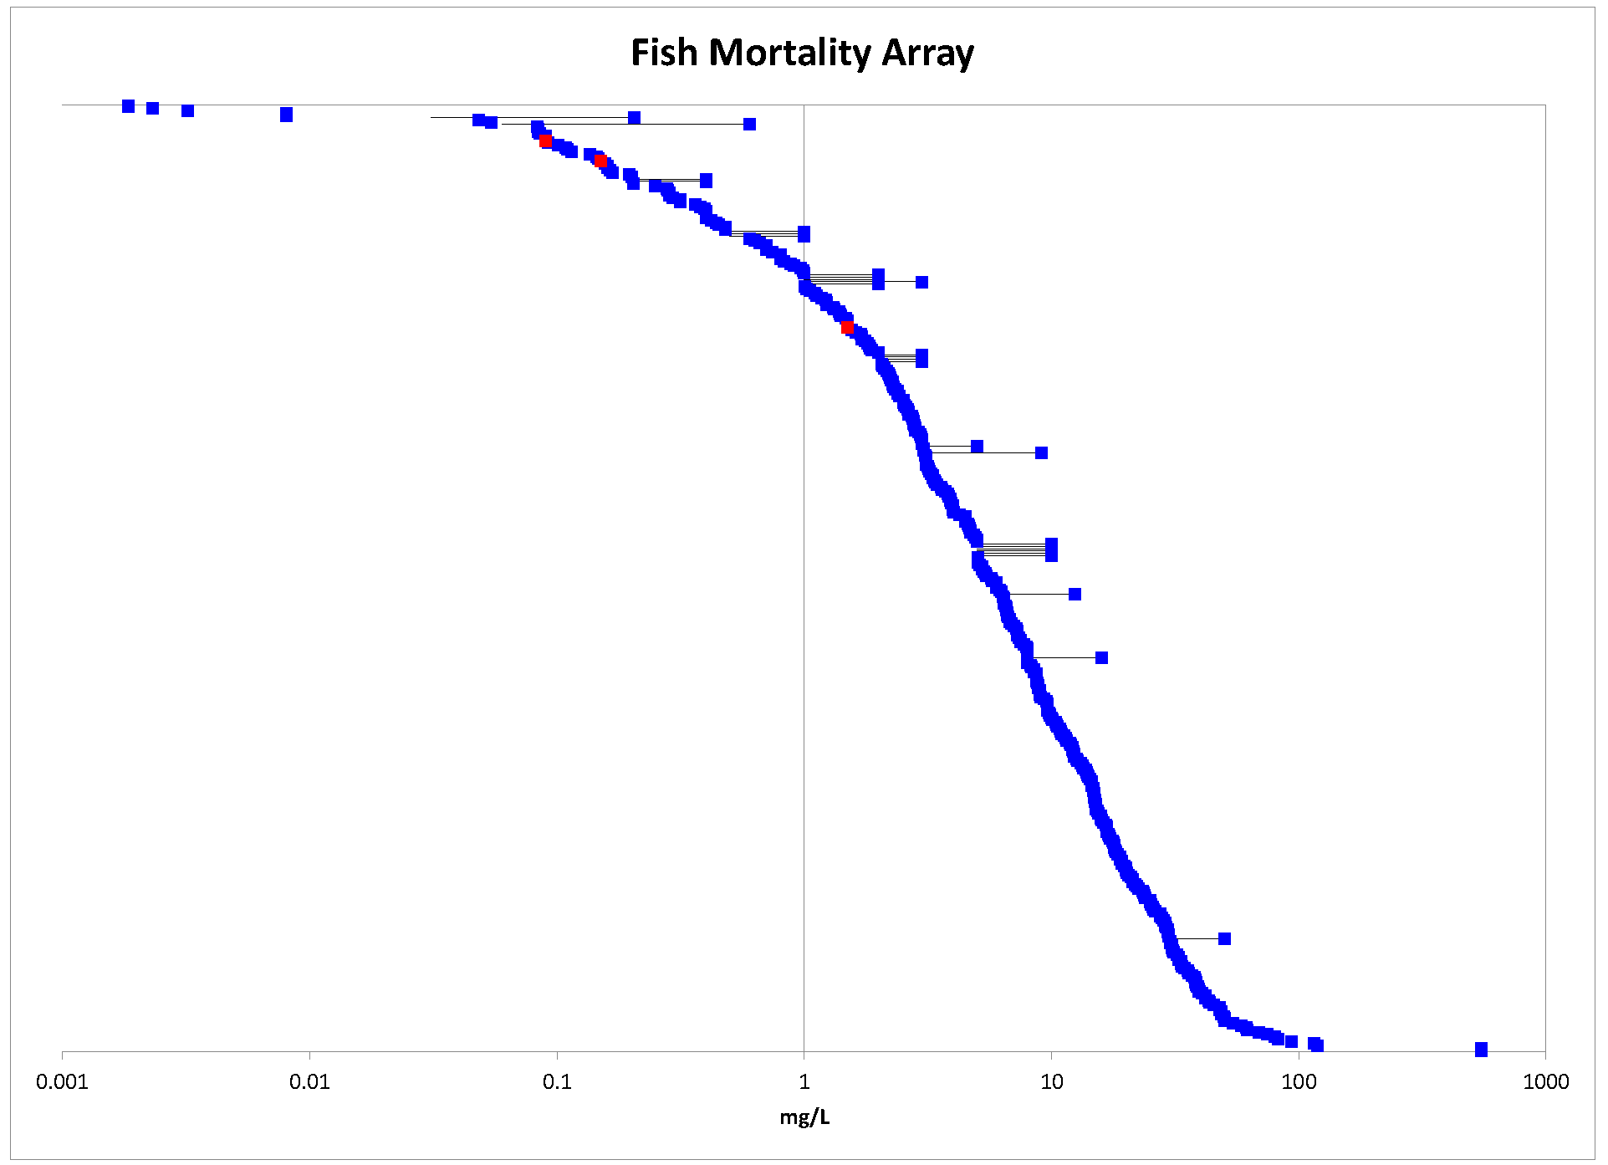
Figure 2-3. Mortality Endpoints for Fish Exposed to Diazinon
Species names and endpoint types (e.g., NOAEC, EC₅₀) are not included in the array because there are too many endpoints to display detailed information. The data have been log₁₀-transformed for the purposes of presentation. Blue symbols represent studies in the ECOTOX database; red symbols represent registrant studies.

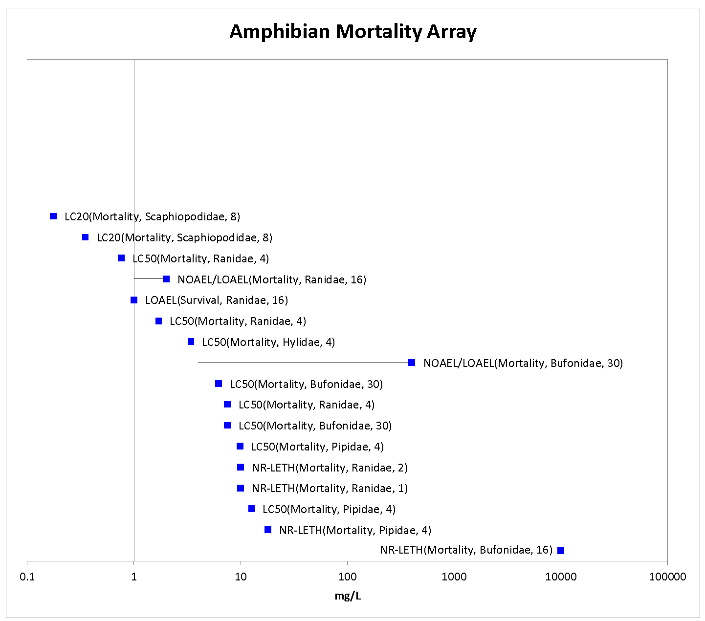
Figure 2-4. Mortality Endpoints for Aquatic-phase Amphibians Exposed to Diazinon
Specific type of effect, study duration (where available), and species family are indicated in parentheses after each endpoint. The data have been log₁₀-transformed for the purposes of presentation.

An SSD was generated for fish and aquatic-phase amphibians by limiting the available acute mortality dataset to studies conducted for a duration of 96 hours with technical grade diazinon. This dataset included 26 fish species (24 freshwater species and 2 estuarine/marine species) and 2 amphibian species. There were insufficient data to generate separate SSDs for amphibians or for freshwater and estuarine/marine fish, as most available acute toxicity data are for freshwater fish species.

In order to generate SSDs, five potential distributions were considered (log-normal, log-logistic, log-triangular, log-gumbel, and Burr). Model-averaged SSDs and model-averaged quantiles, including the HC₀₅ were estimated and are presented in Table 2-4. The cumulative distribution function for the SSD is presented in Figure 2-5. In general the SSD shows a reasonably good fit, though the model tends to overestimate tolerance for more sensitive organisms (see lower 20% of distribution in Figure 2-5). The model-averaged HC₀₅ estimate is 237.9 ug/L (SE = 115.3 ug/L, CV = 0.48). The resulting threshold for direct effects is 20.9 μg/L (since no slope was available for the endpoints near the HC05, the default slope of 4.5 was used), and the threshold for indirect effects is 123.5 μg/L. APPENDIX 2-6 includes additional details of how this SSD was derived.

Table 2-4. Model-averaged Quantile Estimates (in ug/L) from Five Distributions Fit Using Maximum Likelihood
Quantile | Mean | SE | CV
HC₀₅ | 237.9 | 115.3 | 0.48
HC₁₀ | 433.2 | 193.9 | 0.45
HC₅₀ | 3368.2 | 964.8 | 0.29
HC₉₀ | 27084.6 | 11543.7 | 0.43
HC₉₅ | 49300.5 | 27633.8 | 0.56

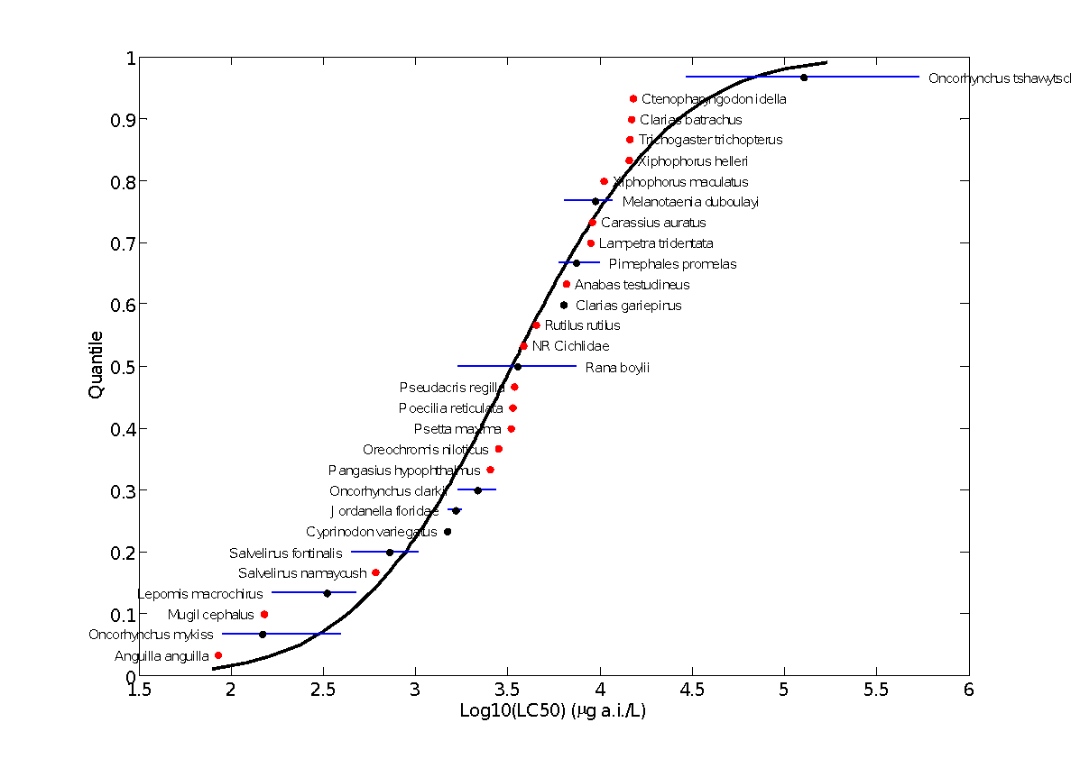
Figure 2-5 Model-averaged SSD for Aquatic Vertebrates Exposed to Diazinon
Red points indicate single toxicity values. Black points indicate multiple toxicity values. Blue lines indicate full range of toxicity values for a given species.

Sublethal Effects to Fish and Aquatic-Phase Amphibians

Major categories of sublethal effects (i.e., growth, reproduction, behavior, and acetylcholinesterase inhibition) are discussed in the following sections, and the most sensitive endpoints available for each type of effect are presented in Table 2-5. The most sensitive endpoint available in the effects database is for anti-cholinesterase activity by formulated diazinon; however, this study is classified as qualitative and is not used as a threshold for risk assessment. The most sensitive quantitatively useful endpoint for technical grade diazinon is for reproductive effects to sheepshead minnow.

Table 2-5. Most Sensitive Reviewed Fish and Aquatic-phase Amphibians Sublethal Effects Data
Effect Group | Endpoint  (µg/L) | Magnitude/Type of Effect*  (Duration) | Species | Test Substance  (% a.i.) | MRID/ ECOTOX  Reference  (Classification)
Growth | <0.55 (NOAEC)  0.55 (LOAEC) | ↓Mean total length (16%)³  ↓Mean weight (40%)³  (6-8 months) | Brook Trout  (Salvelinus fontinalis) | TGAI  (92.5%) | 40910904/  R00DI007; E664  EPA Study  (Acceptable)
Repro-  duction | <0.05 (NOAEC)  0.05 (LOAEC) | ↓Emergence  (2 minutes) | Atlantic Salmon (Salmo salar) | TGAI | E84407  (Qualitative)¹
 | <0.47 (NOAEC)  0.47 (LOAEC) | ↓Egg production per day (31%)  (108 days) | Sheepshead Minnow (Cyprinodon variegatus) | TGAI  (92.6%) | 40914801/  RO0DI008/  E5604  (Acceptable)
Behavior | 0.1 (NOAEC)  1.0 (LOAEC) | ↑Number of food strikes and swimming activity in presence of predatory alarm signal^{2,4}  (2 hours) | Chinook Salmon  (Oncorhyn-chus tshawytscha) | TGAI⁵ | E62247  (Qualitative)
AChE Inhibition | <0.0036 (NOAEC)  0.0036 (LOAEC) | ↓AChE activity in muscle tissue²  (5, 15, and 30 days⁶) | Common Carp  (Cyprinus carpio) | Formula-tion²  (63%) | E88371  (Qualitative)¹
* Magnitude of effect is based on study LOAEC
¹ Qualitative studies are not used to identify thresholds and are only used for purposes of characterization
² Magnitude of effect not reported at LOAEC
³ Effect was observed in progeny following direct parental exposure
⁴ Effect attributed to impaired olfaction
⁵ Percent purity of test substance not reported
⁶ Effects were significant at all three exposure periods

Effects on Growth of Fish and Aquatic-Phase Amphibians

Twenty-two studies evaluating the effects of diazinon on growth are available either from the registrant or the open literature (Figure 2-6). Sixteen of these studies were conducted with freshwater fish species, while only two studies were conducted with estuarine/marine fish and four studies with amphibians. Growth effects of diazinon on fish across all registrant-submitted studies and open-literature studies range from 0.55 to 100,000 µg/L, spanning six orders of magnitude. Amphibian growth endpoints in the ECOTOX dataset range from 2.1 to 12,000 µg/L, indicating that growth effects of diazinon on amphibians are occurring at a similar (although not as extreme) range of concentrations as in fish.

The most sensitive growth-related endpoint available for diazinon for either fish or aquatic-phase amphibians is from an EPA laboratory study (E664; MRID 40910904) in which mature brook trout (Salvelinus fontinalis) were exposed to technical grade diazinon for 6-8 months at concentrations ranging from 0.55 to 9.6 µg/L. Eggs from exposed parental brook trout were collected and allowed to hatch and grow until 122 days post-hatch. At test termination, progeny in all parental treatment groups were significantly (p<0.05) smaller and weighed significantly less than control fish, resulting in NOAEC and LOAEC values of <0.55 and 0.55 µg/L, respectively. Reductions in length and weight of progeny relative to controls at the LOAEC were 16% and 40%, respectively. Transfer of progeny between concentrations indicated that effects noted for progeny of both species at lower concentrations were the result of parental exposure alone and not the exposure of progeny following fertilization.

The most sensitive growth-related endpoint available for aquatic-phase amphibian is based on significant body mass effects observed in leopard frogs (Lithobates pipiens) during a mesocosm study at 2.1 µg/L diazinon technical (E114296). In this study, significant growth effects occurred at the same concentration as mortality. This study is discussed further in the mesocosm study section.

The next most sensitive growth endpoint is from an early life-stage study in the estuarine/marine sheepshead minnow (C. variegatus; MRID 44244802), in which two replicates of 60 embryos per treatment level were exposed to technical grade diazinon (87.3% a.i.) at mean-measured concentrations ranging from 4.3 to 56 µg a.i./L. Statistically significant (p<0.05) effects on length, wet weight, and dry weight of surviving juveniles were observed in the 8.0 µg a.i./L treatment group, resulting in a study NOAEC of 4.3 µg a.i./L. No significant effects on percent hatch or post-hatch juvenile survival occurred in this study.

Although thresholds were not based on growth effects because they did not represent the most sensitive endpoints among known sublethal effects, it should be noted that a NOAEC was not established in the brook trout study (E664; MRID 40910904), which reported the most sensitive growth effects in the dataset. Therefore, it is possible that growth effects may occur at lower levels than captured in the available dataset.

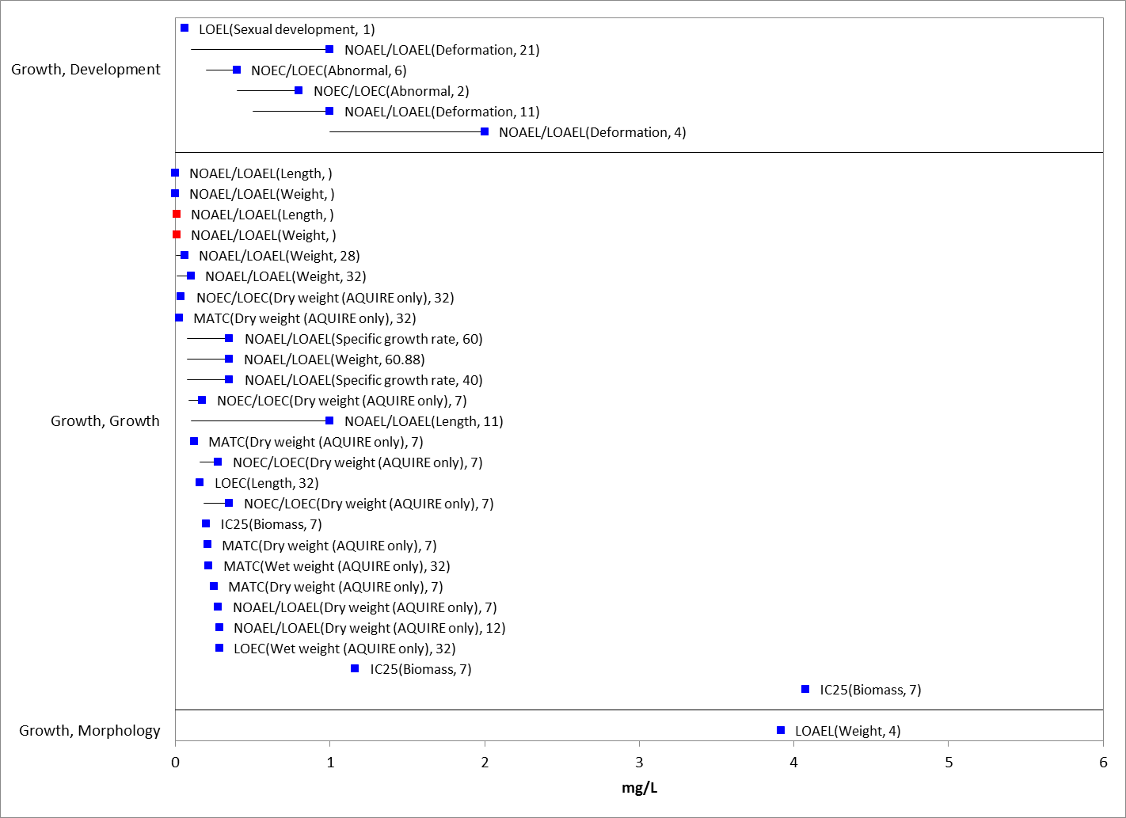
Figure 2-6. Growth Endpoints for Fish Exposed to Diazinon
Specific type of effect, study duration (where available) are indicated in parentheses after each endpoint. Blue symbols represent studies in the ECOTOX database; red symbols represent registrant studies.
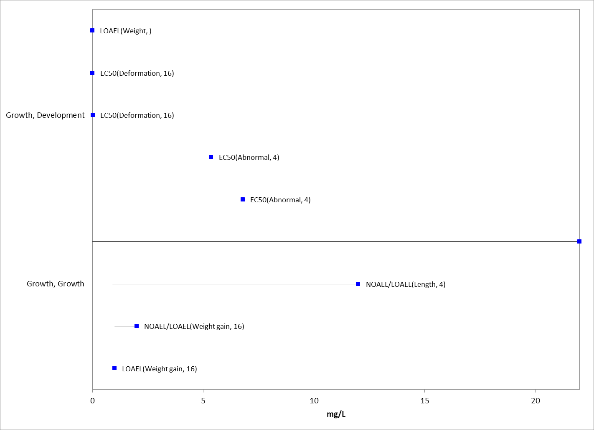
Figure 2-7. Growth Endpoints for Aquatic Amphibians Exposed to Diazinon
Specific type of effect, study duration (where available) are indicated in parentheses after each endpoint. Blue symbols represent studies in the ECOTOX database.

Effects on Reproduction of Fish and Aquatic-Phase Amphibians

Only a small number of reproduction-related studies in fish (i.e., less than 10) are available from either the registrant or the open literature, and all studies are discussed below. Therefore, no array was created for this type of effect. No reproduction studies were identified for amphibians.

The most sensitive reproductive endpoint available for diazinon is from a partial fish life-cycle test (MRID 40914801; E5604) conducted with estuarine/marine sheepshead minnows in which juvenile (F₀) fish and their offspring (F₁) were exposed to mean-measured concentrations, ranging from 0.47 to 6.5 µg/L for 108 days, with an additional 32-day recovery/observation period. The number of eggs produced per day was significantly (p<0.05) reduced at all test concentrations relative to controls, resulting in a non-definitive NOAEC of <0.47 µg/L, but there was no significant effects of the survival or growth of progeny exposed to diazinon.

A partial fish life-cycle test was also conducted with fathead minnows (MRID 46867001) in which 8-week old fish were exposed to diazinon technical (87.5% a.i.) for 54 days and then allowed to spawn for an additional 62 days in which exposure to diazinon continued (116-day total exposure). Embryos were exposed to the same concentration as adults for 9 days and evaluated until 28-days post-hatch. Mean-measured concentrations during the study ranged from 0.427 to 7.77 µg a.i./L. The only reproductive effect in this study was a 40% reduction in the number of eggs per spawn relative to the control at a mean-measure concentration of 1.95 µg a.i./L. Although, no statistically significant effects for this endpoint were observed at higher or lower test concentrations in this study, the magnitude of the effect was considered too substantial to disregard. The only other endpoint significantly affected in this study was 28-day post-hatch survival of F₁ fish at the highest test concentration (7.77 µg a.i./L).

As described in the preceding section on growth effects, no impacts to hatch or larval survival occurred at concentrations in which growth effects were observed in early life-stage studies with estuarine/marine sheepshead minnows (MRID 44244802) and freshwater fathead minnows (MRID 40782301). However, study designs in which fertilized eggs are raised until the juvenile stage, do not account for a wide range of reproductive endpoints, including fecundity, and therefore do not definitively indicate that reproductive effects in fish and aquatic-phase amphibians are less sensitive than corresponding growth effects in the same species.
In a reproductive study with Atlantic salmon (Salmo salar), fewer fry successfully hatched following exposure to 0.05 μg/L diazinon compared to other treatment groups. Exposure to 0.05 μg/L diazinon caused fry to emerge later compared to controls. Disruption of the normal pattern of emergence was greater (p<0.01) when embryos were exposed to the pesticides separately, rather than in combination (ECOTOX 84407).

Effects on Behavior of Fish and Aquatic-Phase Amphibians

Eleven studies on behavioral effects of diazinon are available from either the registrant or the open literature. Ten of these studies were conducted on freshwater fish species and one study was conducted on amphibians (E118706). Six of the 11 behavioral studies were conducted with salmonid species or with zebrafish (cyprinidae). Thus, there is not a diverse taxonomic representation in the behavioral effects dataset.

In the most sensitive behavioral study (Scholz et al. 2000; E62247), diazinon exposure to Chinook salmon (Oncorhynchus tshawytscha) resulted in statistically significant (p<0.05) effects to swimming and feeding behavior at concentration of 1 and 10 ug/L. Fish remained more active and fed more frequently in the presence of an alarm stimulus (skin extract) relative to controls. There was not a clear dose-response relationship in the study as the middle diazinon treatment group (1 µg/L) was most affected (as compared to 0.1 and 10 µg/L treatments), indicating uncertainty in the types of effects that will be elicited by any given concentration of diazinon outside of those tested in the study. Although the type of anti-predator behavior exhibited in this study may be considered an essential behavior of this or other species, the impact of a temporary loss of olfactory function and associated altered swimming and feeding behavior on survival, growth, or reproduction was not directly tested in the study and is a source of uncertainty. The effect of diazinon on Chinook salmon homing success was also examined in the same article in which significantly (p<0.05) fewer salmon returned to their natal spawning grounds after exposure to 10 µg/L diazinon.

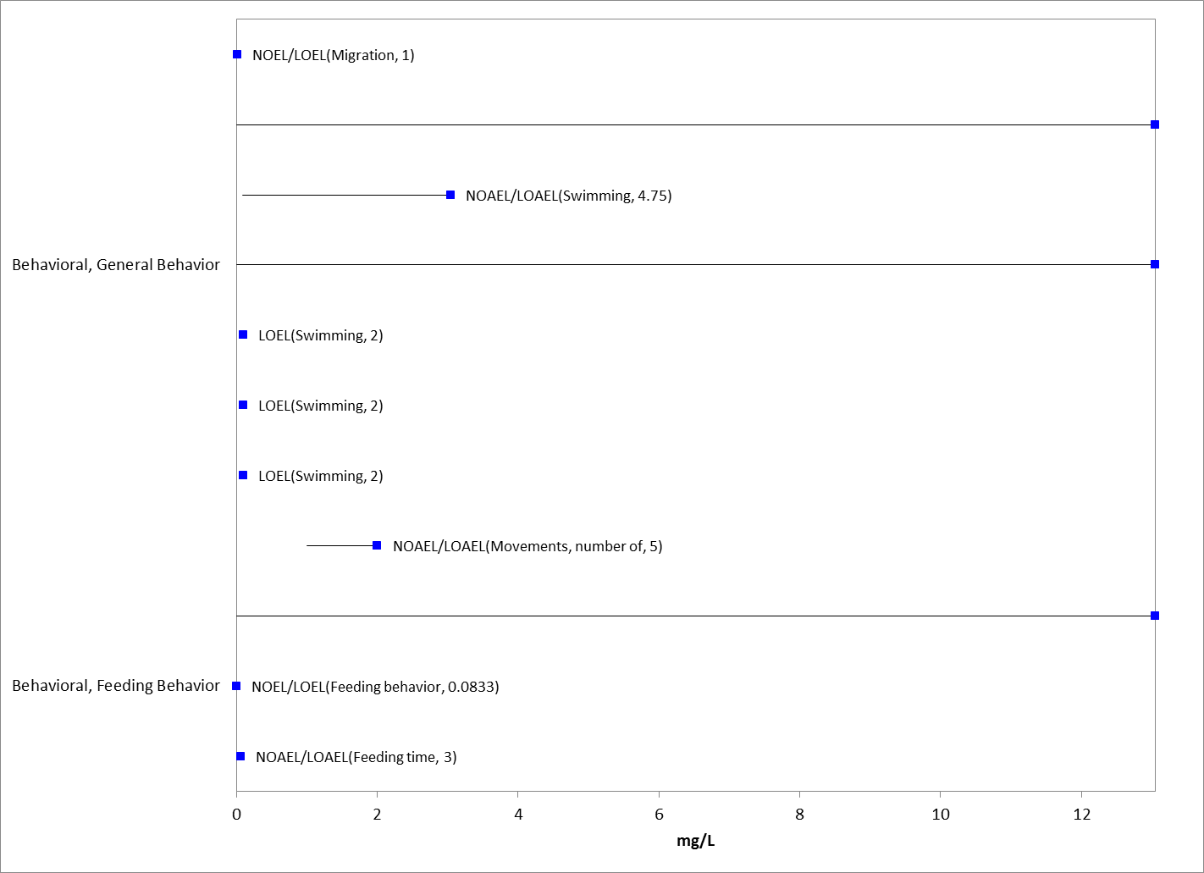
Figure 2-8. Behavior Endpoints for Fish Exposed to Diazinon
Specific type of effect, study duration (where available) are indicated in parentheses after each endpoint. Blue symbols represent studies in the ECOTOX database.

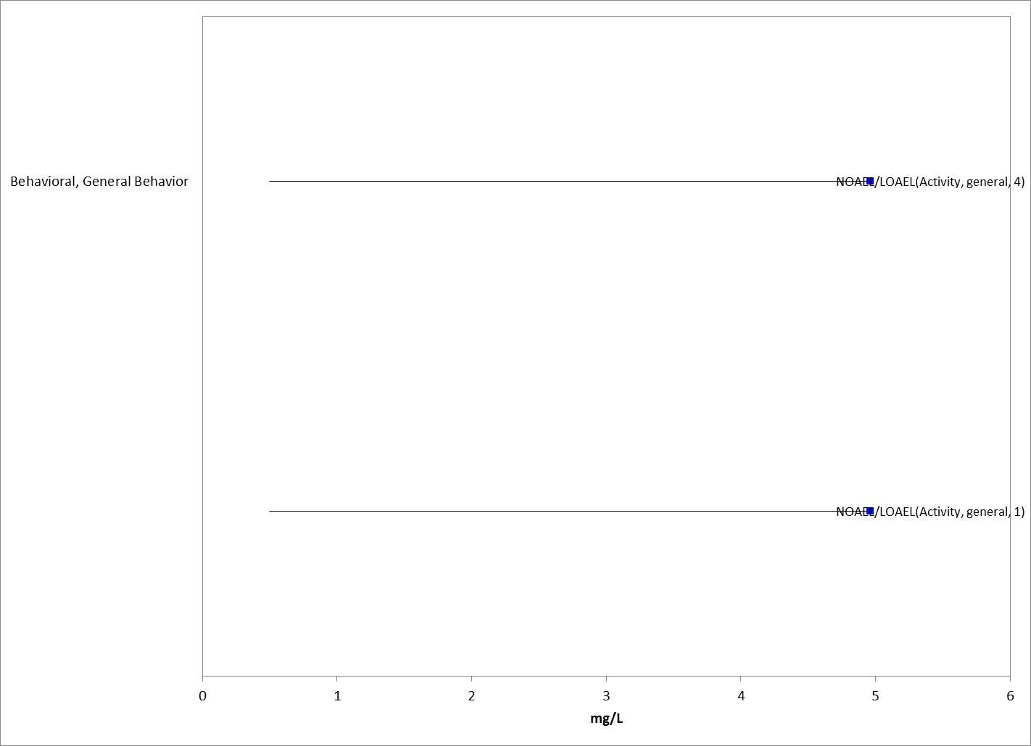
Figure 2-9. Behavior Endpoints for Aquatic Amphibians Exposed to Diazinon
Specific type of effect and study duration (where available) are indicated in parentheses after each endpoint. Blue symbols represent studies in the ECOTOX database.

Effects on Sensory Function of Fish and Aquatic-Phase Amphibians

In another study with Atlantic salmon (Salmo salar), statistically significant (p<0.05) effects on olfactory functions were affected at 1.0 µg/L diazinon (Moore and Waring, 1996; ECOTOX 45079). The reproductive priming effect of the female pheromone prostaglandin F_{2a} on the levels of expressible sperm (milt) in males was reduced after exposure to diazinon at 0.5 µg/L.

Acetylcholinesterase (AChE) Inhibition in Fish and Aquatic-Phase Amphibians

Sixteen studies evaluating the effects of diazinon on AChE activity were captured in the ECOTOX database, representing 8 families of fish and 1 family of amphibians. The range of concentrations, in which anti-cholinesterase activity was observed based on the study LOAEC, was 0.0036 µg/L (C. carpio; E88371) to 5,000 µg/L in medaka (Oryzias latipes; Hamm et al. 1998, E59879), representing a six-order-of-magnitude difference between the least and most sensitive AChE effects in the dataset. It should be noted that 7 of the 16 studies examining AChE effects, including the two most sensitive studies (e.g., E88371; E88453), were conducted with formulations; some of the formulation studies did not report the product name or constituents of the formulation.

Oruc et al. (2006, E88453; 2007, E88371; 2011, E160447) conducted a series of similarly designed studies in common carp (Cyprinus carpio), evaluating effects of diazinon at concentrations of 0.0036, 0.018, and 0.036 µg/L on AChE activity in different tissue types after 5, 15, and 30 days of exposure. The formulation used in these studies, Basudin 60, appears to be marketed in Turkey and contains 60% diazinon, but is similar to a currently registered US formulation AG500 (based on communication with registrant). In these studies, statistically significant (p<0.05) inhibition of acetylcholinesterase activity was observed at all concentrations tested in muscle (37-56% inhibition), brain (19-26% inhibition), and liver tissue, but not kidney tissue; while, significant AChE effects were observed at the lowest (0.0036 µg/L) and highest (0.036 µg/L), but not the middle (0.018 µg/L), concentration in gill tissue. However, a dose-response, with increasing AChE inhibition at increasing diazinon concentrations, was only recorded in liver tissue. The lack of dose response in other tissue types may be due to the close proximity of chosen diazinon test concentrations (only a single order of magnitude spread) and the fact that exposure was based on nominal concentrations; therefore, there is some uncertainty around the concentration at which AChE effects occurred.

In a study with C. jordani (Dzul-Caamal et al. 2012), AChE activity was significantly reduced at 0.004 µg/L diazinon (23% and 17% inhibition in brain and muscle tissue, respectively), which was approximately an order of magnitude lower than the LC₁₀ (0.06 µg/L) and two orders of magnitude lower than the LC₅₀ (1.5 µg/L) from the same study and exposure duration. There is some uncertainty associated with this data since it was conducted with a 25% formulation of diazinon that is not similar to any product currently registered in the U.S.

Goodman et al. (1979, E5604) examined AChE inhibition and reproductive effects in the sheepshead minnow following 108 days of exposure to diazinon concentrations ranging from 0.47-6.5 µg/L. This study also included a subsequent 32-day recovery/observation period in diazinon-free water. Both the average number of eggs per female per day and acetylcholinesterase activity in the brain were significantly reduced at all test concentrations for both endpoint types. The magnitude of AChE inhibition varied greatly at each test level and over the course of the study, ranging from 17-77%, but generally increased with increasing test concentration. Statistically significant (p<0.05) effects on AChE activity were largely seen by Day 4 of the study and persisted until Day 108. While there were signs of recovery during the post-treatment period, the timing and magnitude of recovery across exposure groups was not fully evaluated. This study indicates that reproductive impacts in sheepshead minnow, and possibly other fish species, are occurring at similar concentrations as anti-cholinesterase activity, and that recovery is possible under laboratory conditions, which may differ from conditions in the wild. The timing associated with recovery is unknown.

A study by Gaworecki et al. (2009; E115405) in hybrid striped bass (Morone saxatilis x M. chrysops) compared concentrations in which brain AChE activity from diazinon was affected relative to feeding behavior. After six days of exposure to diazinon at concentrations ranging between 19.1 to 102 µg/L there was no significant impact in the time required to capture prey fish associated with a 66.3% reduction in brain AChE activity at the lowest treatment level (19.1 µg/L), while feeding behavior was significantly (p<0.05) impacted at the medium treatment level (64 µg/L) in which 82.2% AChE inhibition was observed. It was also noted that there was recovery in terms of feeding behavior at the medium (64 µg/L) but not at the highest (102 µg/L) test concentration during a six-day post-exposure observation period. This study suggests that a very high reduction in AChE activity is needed to significantly impact this particular behavioral measure in this particular species hybrid.

In another behavioral study by Beauvais et al. (2000), juvenile rainbow trout (O. mykiss) were exposed to technical grade diazinon (98%) at nominal concentrations of 250, 500, and 1,000 µg/L for 96 hours followed by a 48-hour recovery period. Brain AChE activity was significantly (p<0.05) impacted at the middle concentration (500 µg/L) after 96 hours of exposure and at all concentrations at the end of the 48-hour recovery period. Although the magnitude of reduction in AChE was not reported, Figure 1 of this article indicates an inhibition range of approximately 25-40% as compared to control fish. Only AChE effects after the recovery period appear to show a clear dose response, with increasing inhibition occurring with increasing exposure concentrations. There was a moderate relationship between AChE activity and fish total swimming distance (r²=0.44; p=0.02) and average swimming speed (r²=0.42; p=0.02), but an insignificant relationship between AChE activity and degree of turning (r²=0.27; p=0.08) and tortuosity of path (r²=0.28; p=0.08). No mortalities were observed at any test concentration during the study. Brewer et al. (2001) published a near identical study showing a weak to moderate relationship between AChE concentration and swimming behavior in rainbow trout.

Although there is some uncertainty in concentrations at which AChE inhibition was observed in the series of studies by Oruc et al. (2006, 2007, 2011) due to a lack of dose-response, these data do indicate that certain tissue types (e.g., brain, muscle) may be more susceptible to impaired acetylcholinesterase activity. Furthermore, quantitatively more robust studies such as Goodman et al. (1979) and Dzul-Caamal et al. (2012) both support the occurrence of statistically significant (p<0.05) impacts to AChE activity in brain and muscle tissue at concentrations below one part per billion. The remaining 12 ECOTOX studies evaluating AChE activity in fish and amphibians all report NOAEC or LOAEC values above 10 parts per billion.

The WoE from the available data indicate that the relationship between impaired acetylcholinesterase activity and whole-organism effects is uncertain in terms of the concentration at which they co-occur and the magnitude of AChE inhibition needed to elicit and higher level effects (Table 2-6). Only a few studies in the available database (e.g., Dzul-Caamal, 2012; Oruc et al., 2006, 2007, and 2011) demonstrate AChE effects at lower concentrations than the most sensitive whole-organism endpoints. The study by Goodman et al. (1979) indicates that a 20-41% reduction in AChE activity was associated with statistically significant (p<0.05) impacts on reproduction at the lowest concentration tested (0.47 µg/L), while the study by Gaworecki et al. (2009) suggests that very high levels of impaired acetylcholinesterase activity (~80%) are required to produce significant changes in feeding behavior. These different lines of evidence indicate that the degree of AChE inhibition is not, by itself, a reliable predictor of survival, growth, and reproductive effects at the individual level. Moreover, anticholinesterase effects appear to be highly variable in terms of test concentrations, exposure duration, magnitude, recovery time, and species.

Table 2-6. Comparison Anti-cholinesterase Activity and Whole-Organism Effects in Fish
Species | Anti-Cholinesterase Activity |  | Lowest Whole-Organism Endpoint  (µg/L) | Reference
 | Endpoint  (µg/L) | Inhibition at LOAEC  (Tissue Type)
Chirostoma jordani | LOAEC=0.004 | 23% (brain)  17% (muscle) | LC₁₀=0.06  LC₅₀=1.5  (Mortality) | Dzul-Caamal et al. 2012; E160182³
Cyprinus carpio | LOAEC=0.0036 | ≥19% (brain)  ≥37% (muscle) | Not Assessed | Oruc et al. 2006, E88453; 2007, E88371; 2011, E160447
Cyprinodon variegatus | LOAEC=0.47 | 21-40% (brain) | LOAEC=0.47  (Avg. number of eggs per female) | Goodman et al. 1979, E5604
Morone saxatilis x M. chrysops (hybrid) | LOAEC=19.1 | 66.3% (brain) | LOAEC=64¹  (Feeding behavior) | Gaworecki et al. 2009; E115405²
¹ Associated with an 82.2% reduction AChE activity
² This study has not been formally reviewed by OPP EFED
³ Note: this study was conducted with a formulation that is not similar to any product currently registered in the U.S. (as per communication with the registrant)

  - Incident Reports for Fish and Aquatic-Phase Amphibians

As a result of the Diazinon Registration Eligibility Decision, a number of use restrictions have been imposed on diazinon that have resulted in substantial changes to its use pattern. Incidents reported since the RED involving fish include two that occurred in 2007 and involved the death of 1000 fish (I021339-001 and IO21178-001). These incidents were associated with grain storage and industrial sites. Given these use patterns, it is unlikely that they reflect current use patterns of diazinon.

  - Summary of Effects to Fish and Aquatic-Phase Amphibians

Overall, the most sensitive sublethal effects on growth (NOAEC<0.55 µg/L), reproduction (NOAEC<0.47 µg/L), and behavior (NOAEC = 0.1 µg/L) in fish and aquatic-phase amphibians all occur at similar concentrations (approximately 0.1 to 1 µg/L). In addition, as demonstrated in the array in Figure 2-5, these sensitive sublethal effects occur at similar concentrations as the several most sensitive lethal effects in the available toxicity dataset. Moreover, in an amphibian mesocosm study, which is among the most sensitive in the available database (Relyea 2009; E114296), effects to survival and growth occur at the same low test concentration (NOAEC = 2.1 µg/L). However, since the entire range of 96-hr acute toxicity data for fish and aquatic-phase amphibians (Table 2-3) is higher (less sensitive) than the most sensitive sublethal effect endpoints, the 1-in-a-million lethality threshold derived from the SSD is less sensitive than the sublethal threshold by several orders of magnitude. Therefore, examination of sublethal thresholds for risk estimation is critical in this assessment to avoid underestimating potential non-lethal impacts of diazinon to both fish and aquatic-phase amphibians.

There is no evidence that aquatic-phase amphibians are more or less sensitive than fish to diazinon across different types of effects, nor is there evidence that estuarine/marine fish are more or less sensitive than freshwater fish. This may be, in part, due to the paucity of toxicity data available for aquatic-phase amphibians or estuarine/marine fish.

Effects Characterization for Aquatic Invertebrates

  - Introduction to Aquatic Invertebrate Toxicity

The effects of diazinon on aquatic invertebrates have been studied extensively, including both freshwater and estuarine/marine invertebrates. There are registrant-submitted studies involving aquatic invertebrates, including acute and chronic laboratory studies with either technical or formulated diazinon. In addition to registrant-submitted studies, the ECOTOX database contains approximately 130 open literature toxicity studies on aquatic invertebrates that were considered for use in this assessment. APPENDIX 2-2 and APPENDIX 2-5 includes the bibliography of studies that are included in this effects characterization and those that were excluded, respectively. Studies were excluded if they were considered invalid, were not reported in environmentally relevant exposures units, or involved granular formulations, which are no longer registered in the U.S. and thus are not part of the action.

Studies from the open literature and registrant submissions are used to derive thresholds and to characterize effects to aquatic invertebrates in a weight-of-evidence approach. This section presents the thresholds for direct effects to listed species of aquatic invertebrates and thresholds for effects to aquatic invertebrates that may indirectly affect listed species that depend upon these taxa. This section also discusses the WoE available for different types of effects on aquatic invertebrates, including lethality, decreases in growth and/or reproduction, AChE inhibition, and impacts on behavior. In addition, this section discusses ecological incidents on aquatic invertebrates that are associated with diazinon.

In this effects characterization, when sufficient data are available for diazinon, different thresholds or lines of evidence are identified for freshwater and estuarine/marine invertebrates. Also, sensitivity of mollusks versus other aquatic invertebrates are discussed as lines of evidence, although separate thresholds are not derived for mollusks in this assessment.

Multiple studies in the open literature are available that examined the effects of diazinon on aquatic communities (e.g., mesocosm) with particular emphasis on aquatic plants, invertebrates and aquatic-phase amphibians. Some of these studies report effects at concentrations near or below the established threshold toxicity values. Given the potential for multiple interactions occurring simultaneously in these studies among the test organisms (potential for both direct and indirect effects on a taxa), these studies were not used to establish thresholds, but they are included in the weight-of-evidence analysis for aquatic taxa.

Threshold Values for Aquatic Invertebrates

Lethal thresholds for risk assessment are derived from species sensitivity distributions (SSD) of survival from aquatic invertebrate acute toxicity studies, while sublethal thresholds are based on the most sensitive sublethal effects identified among registrant-submitted studies and open literature in the ECOTOX database (Tables 3-1 and 3-2). As the most sensitive toxicity values used to derive thresholds are based on studies conducted with technical grade active ingredient, these endpoints may be used for evaluating exposures from runoff plus spray drift as well as from spray drift exposure alone. Endpoints from studies involving exposures from TGAI and formulated products were considered for the thresholds and are included in the arrays. Studies from which threshold values are derived will be discussed in more detail in the respective lines of evidence sections for various types of effects (e.g., mortality, behavior, reproduction)

There were sufficient toxicity data to calculate SSDs for aquatic invertebrates. Therefore, the aquatic invertebrate direct effects mortality threshold is based on the 1 in a million effect from the HC₀₅ from the SSD for the taxon (Table 3-1). Mortality thresholds for indirect effects represent a 10% mortality level to the 5th percentile species estimated from the SSD. Since the SSD analysis supports pooling of the freshwater and estuarine/marine toxicity data, single thresholds are used for direct and indirect effects to survival for all aquatic invertebrates (see APPENDIX 2-8 for SSD regression results).

Separate sublethal thresholds were derived for freshwater and estuarine/marine invertebrates based on the large toxicity dataset available in the ECOTOX database and from registrant-submitted data.

The most sensitive toxicity value suitable for establishing a sublethal threshold for freshwater invertebrates was a reduction in fecundity in Ceriodaphnia dubia at 0.228 µg/L (LOEC), with a corresponding NOEC of 0.123 µg/L. It should be noted that a statistically significant increase mortality was also observed at the LOEC for fecundity (i.e., 0.228 µg/L).

The most sensitive toxicity value suitable for establishing a sublethal threshold for estuarine/marine invertebrates was a reduction in dry weight in Americamysis bahia at 0.42 µg/L (LOEC), with a corresponding NOEC of 0.23 µg/L. There was no statistically significant increase in mortality at the observed LOEC for growth (i.e., 0.42 µg/L).

Direct and indirect effects thresholds for freshwater and estuarine/marine invertebrates are presented in Tables 3-1 and 3-2.

Table 3-1. Direct Effects Thresholds for Determining Effects to Listed Aquatic Invertebrates
Group | Effect (endpoint) | Value (unit: µg/L) | Duration of exposure | Source
Freshwater Invertebrates | Mortality  (1/million) | 0.044² | 48/96 hours | HC₀₅ from SSD¹  (0.5 µg/L; slope 4.5)
 | Fecundity  (NOEC) | 0.123 | 7-days | E161081
Estuarine/Marine Invertebrates | Mortality  (1/million) | 0.044² | 48/96 hours | HC₀₅ from SSD¹  (0.5 µg/L; slope 4.5)
 | Growth: Weight  (NOEC) | 0.23 | 28 | MRID 44244801
¹ Details on derivation of SSD are provided in APPENDIX 2-8 and in the “Mortality” characterization section below.
² Freshwater and estuarine/marine species mortality thresholds are the same because pooled data for all aquatic invertebrate species is considered the most appropriate for risk assessment based on SSD analysis (see APPENDIX 2-8 for further information).

Table 3-2. Indirect Effects Thresholds for Determining Effects to Listed Species That Depend on Aquatic Invertebrates
Group | Effect (endpoint) | Value (unit: µg/L) | Duration of exposure | Source
Freshwater Invertebrates | Mortality  (10% mortality) | 0.259² | 48/96 hours | HC₀₅ from SSD¹  (0.5 µg/L; slope 4.5)
 | Fecundity  (LOEC) | 0.228 | 7 days | E161081
Estuarine/Marine Invertebrates | Mortality  (10% of HC₀₅) | 0.259² | 48/96 hours | HC₀₅ from SSD¹  (0.5 µg/L; slope 4.5)
 | Growth: Weight  (LOEC) | 0.42 | 28 days | MRID 44244801
¹ Details on derivation of SSD are provided in APPENDIX 2-8 and in the “Mortality” characterization section below.
² Freshwater and estuarine/marine species mortality thresholds are the same because pooled data for all aquatic invertebrate species is considered the most appropriate for risk assessment based on SSD analysis (see APPENDIX 2-8 for further information).

Summary Data Arrays for Aquatic Invertebrates

Data arrays are used to present the entire spectrum of data available from either the open literature or unpublished studies submitted by registrants. Figures 3-1 through 3-3 show toxicity arrays for all freshwater and estuarine/marine aquatic invertebrates, as well as for mollusks. Data in the arrays are grouped by the type of effect (e.g., behavior, reproduction, mortality). Orange symbols represent mean endpoint values for each type of effect, and bars represent the data range. APPENDIX 2-1 includes all the data used to generate these arrays. The different types of effects are discussed further in their respective sections below.

Array endpoints were excluded if they were not reported in units representing environmentally relevant exposures (e.g., lb/acre), or if they were based on granular formulations, which are no longer registered in the U.S. In addition, EC_{x} values were not included in arrays if they were non-definitive (i.e., greater than the highest concentration tested). Figures 3-1 and 3-2 only present the range of LOECs and NOECs (NOECs must have a corresponding LOEC to be represented in an array) and LC₅₀ values for each effect type since there are too many toxicity studies with aquatic invertebrates in general to display individual endpoint values from each study. For mollusks, individual endpoints are maintained as a unique value in the data array (Figure 3-3).

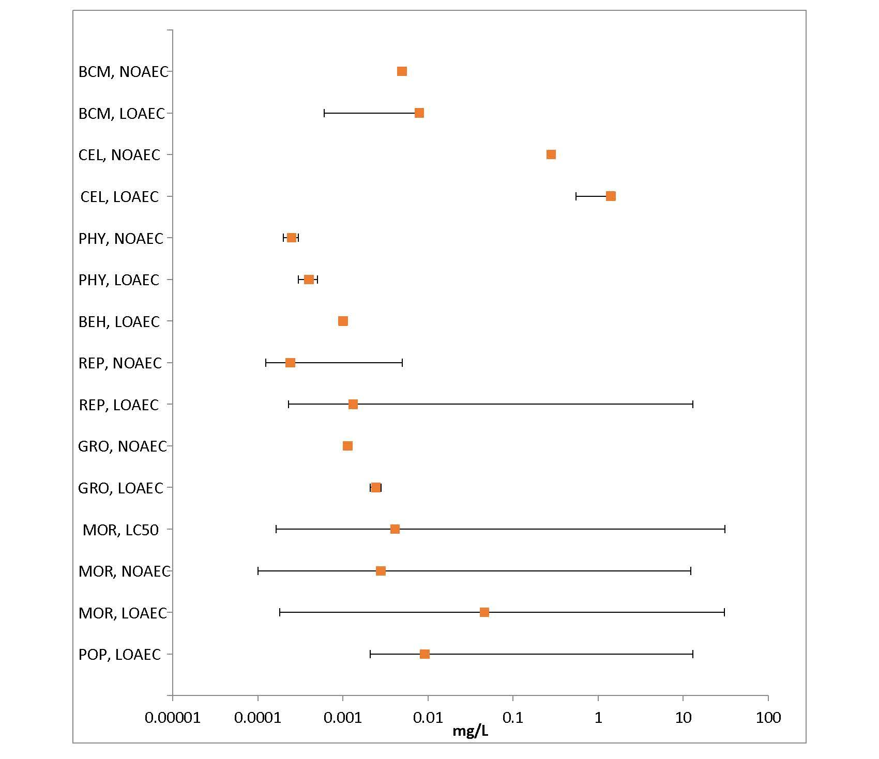
Figure 3-1. Summary Array of Freshwater Invertebrates Exposed to Diazinon
Orange symbols represent mean endpoint values and bars represent the data range (BCM=Biochemical; CEL=Cellular; PHY=Physiological; BEH=Behavioral; REP=Reproduction; GRO=Growth; MOR=Mortality; POP=Population)

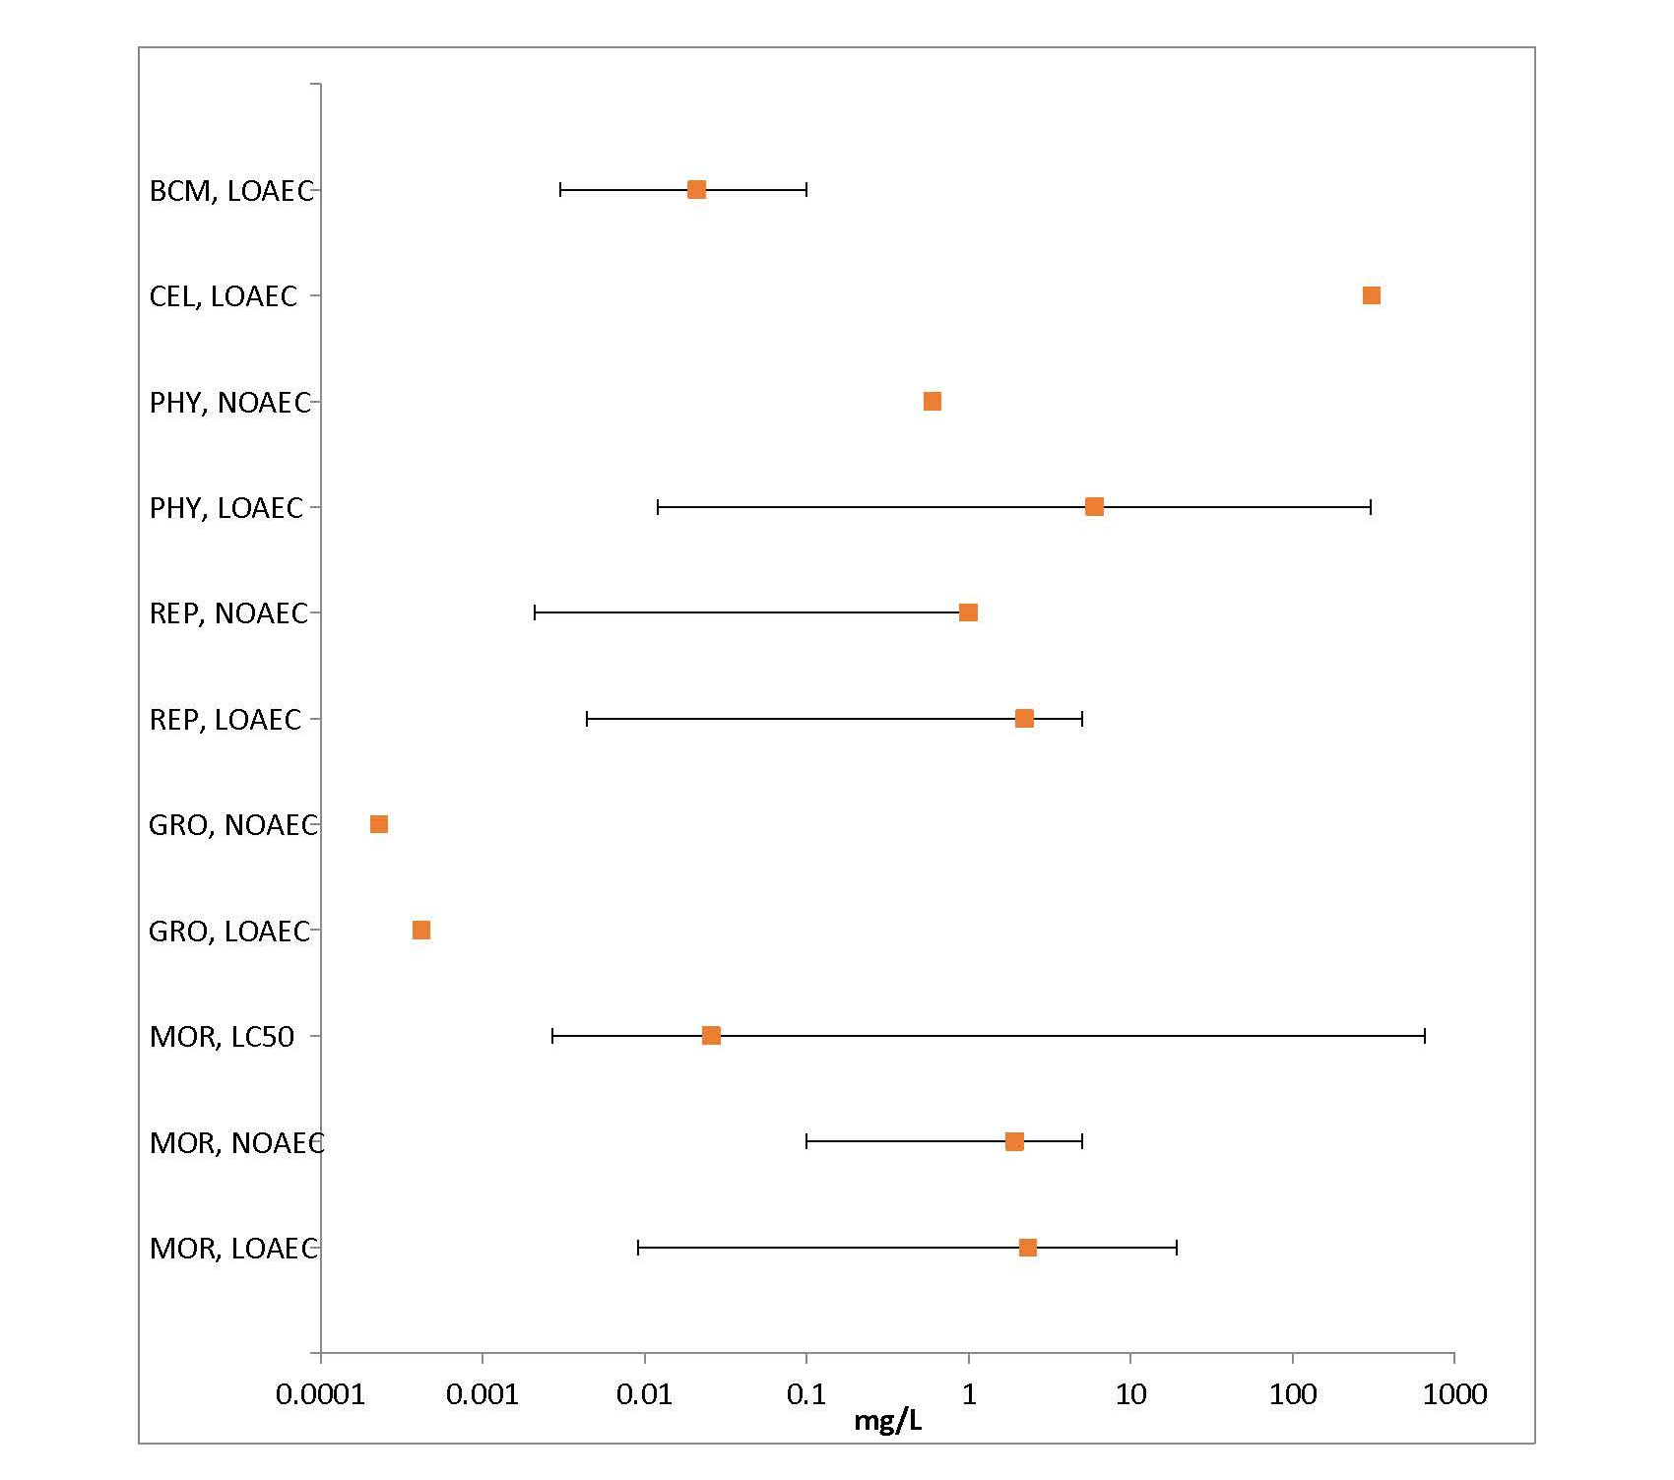
Figure 3-2. Summary Array of Freshwater Invertebrates Exposed to Diazinon
Orange symbols represent mean endpoint values, and bars represent the data range (BCM=Biochemical; CEL=Cellular; PHY=Physiological; BEH=Behavioral; REP=Reproduction; GRO=Growth; MOR=Mortality)

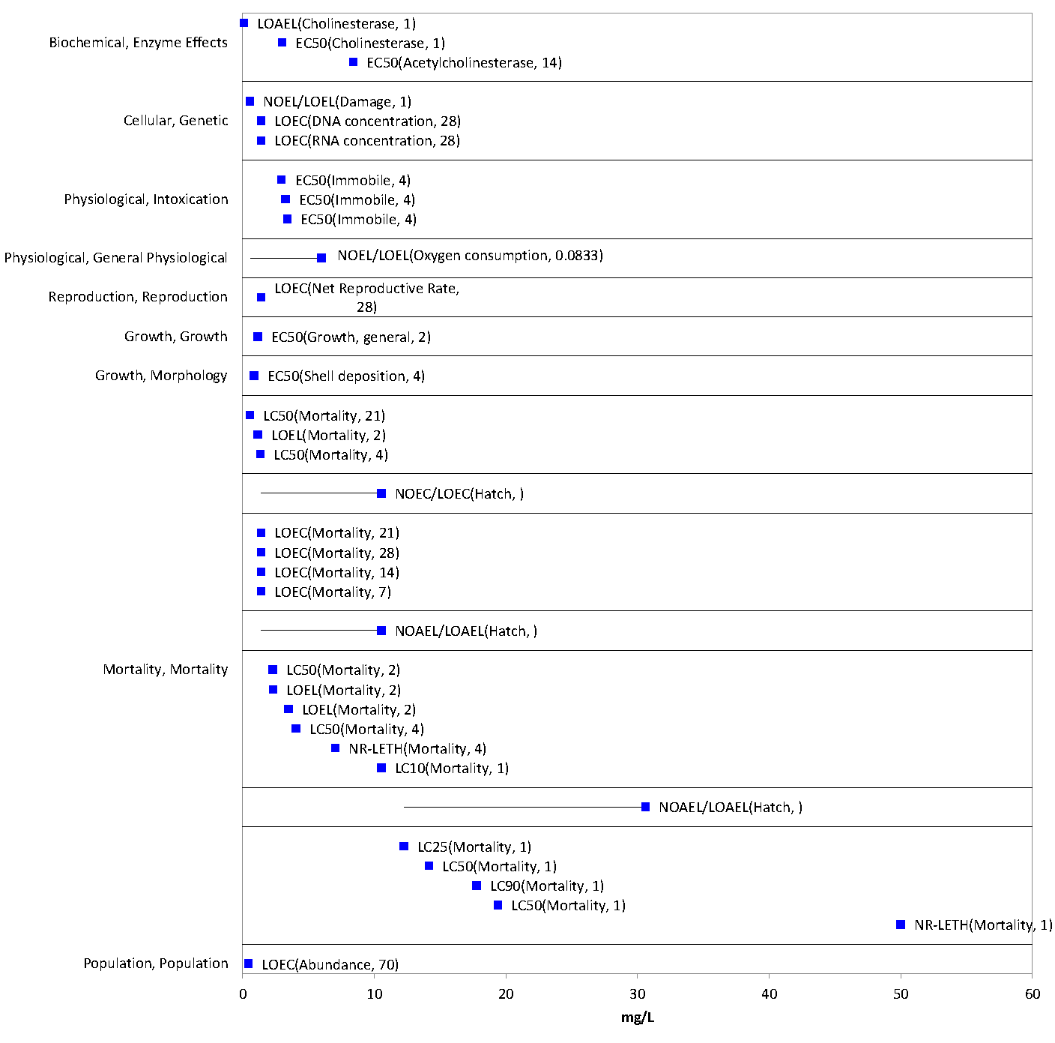
Figure 3-3. Toxicity Endpoints for Mollusks Exposed to Diazinon
Data are separated by types of effects (e.g., growth, mortality). Specific types of effect and study duration (where available) are indicated in parentheses after each endpoint.

Lines of Evidence for Aquatic Invertebrates

Effects on Mortality of Aquatic Invertebrates

Mortality data for diazinon are available for 69 aquatic invertebrate species, including 50 freshwater species and 19 estuarine/marine species, based on studies submitted by the registrant or identified in the ECOTOX database. These data comprised a total of 28 orders of aquatic invertebrates, including 10 species of mollusk (including saltwater and freshwater species of clams and bivalves).

Acute mortality toxicity tests performed with 48- or 96-hour exposure durations are presented in Table 3-3. The tabular presentation of mortality data are limited to these exposure durations as they are the mostly commonly used in acute invertebrate toxicity studies and ensure comparability of the data. However, studies with other exposure durations are also considered in the mortality arrays (Figures 3-4 through 3-6) and WoE discussion in this effects characterization.

Acute mortality estimates (48 or 96 hours) for diazinon technical and formulations range from 0.21 to 31,000 µg/L and span five orders of magnitude (Table 3-3), indicating a wide range of sensitivity to diazinon among aquatic invertebrates. The most sensitive 48- or 96-hour median lethal endpoint for diazinon is for the freshwater cladoceran Ceriodaphnia dubia (48-hour LC₅₀ = 0.21 µg/L; Banks et al. 2005, E76752). In addition to 48- and 96-hour acute toxicity studies, the most sensitive acute mortality endpoint for aquatic invertebrates overall also occurred in C. dubia (LC₅₀ = 0.164 µg/L; Deanovic et al. 2013, E161081) after a 7-day exposure to technical grade diazinon.

Many of the more sensitive 48- or 96-hour mortality endpoints are based on studies with technical grade diazinon, indicating that there is not substantial evidence that formulations significantly increase the effect of the active ingredient on aquatic invertebrates. In addition, given that the sensitivity of C. dubia to diazinon technical is similar for 48-hour and 7-day exposures (less than a two-fold difference in LC₅₀ values), it does not appear that study durations longer than 48 to 96 hours result in markedly different rates of survival in at least some species of aquatic invertebrates.

Based on the available dataset, C. dubia appears to be particularly sensitive to diazinon, as do aquatic arthropods in general. Other groups of aquatic invertebrates, including mollusks, rotifers, and annelids appear to be much less sensitive to diazinon on an acute exposure basis. The lower sensitivity of mollusks is further visualized by comparing the distribution of endpoints among the arrays (Figures 3-4 through 3-6). However, it should be noted that aquatic arthropods represent the large majority of the available acute mortality dataset for diazinon, and therefore the differential sensitivity among taxa is not well-supported.

The mortality arrays also suggest that freshwater invertebrate species may be more sensitive than estuarine/marine species (Figures 3-4 and 3-5). However, as indicated above, the preponderance of mortality data is for freshwater rather than estuarine/marine species.

Table 3-3. Available Median Lethal Concentration (LC₅₀) Data for Aquatic Invertebrates Exposed to Diazinon as TGAI or Formulation for 48 or 96 Hours.
Genus | Species | Group (Medium) | LC₅₀/EC₅₀ (µg/L) | Test Material¹ | Reference No.
Ceriodaphnia | dubia | Arthropoda (FW) | 0.21* | Tech. | E76752
Ceriodaphnia | dubia | Arthropoda (FW) | 0.25* | Tech. | E16043
Ceriodaphnia | dubia | Arthropoda (FW) | 0.26* | Tech. | E18190
Ceriodaphnia | dubia | Arthropoda (FW) | 0.29* | Tech. | E18190
Ceriodaphnia | dubia | Arthropoda (FW) | 0.32* | Tech. | E18190
Ceriodaphnia | dubia | Arthropoda (FW) | 0.33* | Tech. | E16043
Ceriodaphnia | dubia | Arthropoda (FW) | 0.33* | Tech. | E62060
Ceriodaphnia | dubia | Arthropoda (FW) | 0.35* | Tech. | E16043
Ceriodaphnia | dubia | Arthropoda (FW) | 0.35* | Tech. | E18190
Ceriodaphnia | dubia | Arthropoda (FW) | 0.36* | Tech. | E16043
Ceriodaphnia | dubia | Arthropoda (FW) | 0.38* | Tech. | E62060
Ceriodaphnia | dubia | Arthropoda (FW) | 0.40* | Tech. | E65773
Ceriodaphnia | dubia | Arthropoda (FW) | 0.41* | Tech. | E16844
Ceriodaphnia | dubia | Arthropoda (FW) | 0.43* | Tech. | E16043
Ceriodaphnia | cornuta | Arthropoda (FW) | 0.43* | Tech. | E88789
Ceriodaphnia | dubia | Arthropoda (FW) | 0.45* | Tech. | E71888
Ceriodaphnia | dubia | Arthropoda (FW) | 0.47* | Tech. | E16844
Ceriodaphnia | dubia | Arthropoda (FW) | 0.48* | Tech. | E18190
Ceriodaphnia | dubia | Arthropoda (FW) | 0.52* | Tech. | E18190
Daphnia | magna | Arthropoda (FW) | 0.52 | Form. | MRID  121283
Ceriodaphnia | dubia | Arthropoda (FW) | 0.57* | Tech. | E16043
Ceriodaphnia | dubia | Arthropoda (FW) | 0.58* | Tech. | E18190
Caridina | laevis | Arthropoda (FW) | 0.59 | Form. | E100785
Ceriodaphnia | dubia | Arthropoda (FW) | 0.59* | Tech. | E16043
Ceriodaphnia | dubia | Arthropoda (FW) | 0.66* | Tech. | E16043
Daphnia | magna | Arthropoda (FW) | 0.70* | Tech. | E6449
Daphnia | magna | Arthropoda (FW) | 0.80* | Tech. | E6449
Daphnia | pulex | Arthropoda (FW) | 0.80* | Tech. | E6797
Daphnia | magna | Arthropoda (FW) | 0.83* | Tech. | MRID  109022
Cyrnus | trimaculatus | Arthropoda (FW) | 1.1* | Tech. | E55077
Ephoron | virgo | Arthropoda (FW) | 1.1* | Tech. | E66378
Daphnia | magna | Arthropoda (FW) | 1.1 | Form. | MRID 40509803
Hydropsyche | angustipennis | Arthropoda (FW) | 1.3* | Tech. | E20217
Hydropsyche | angustipennis | Arthropoda (FW) | 1.3* | Tech. | E54582
Caridina | laevis | Arthropoda (FW) | 1.3* | Form. | E100785
Simocephalus | serrulatus | Arthropoda (FW) | 1.4* | Tech. | E6797
Caridina | laevis | Arthropoda (FW) | 1.5 | Form. | E100785
Daphnia | magna | Arthropoda (FW) | 1.5* | Tech. | E6449
Caridina | laevis | Arthropoda (FW) | 1.6 | Form. | E100785
Daphnia | magna | Arthropoda (FW) | 1.7* | Tech. | E160445
Cheumatopsyche | brevilineata | Arthropoda (FW) | 1.8* | Tech. | E152279
Simocephalus | serrulatus | Arthropoda (FW) | 1.8* | Tech. | E6797
Procloeon | sp. | Arthropoda (FW) | 1.9* | Tech. | E90039
Gammarus | fasciatus | Arthropoda (FW) | 2.0* | Tech. | E6797
Paratya | compressa ssp. improvisa | Arthropoda (FW) | 2.3* | Tech. | E18945
Ephoron | virgo | Arthropoda (FW) | 2.4* | Tech. | E66378
Palaemonetes | pugio | Arthropoda (EM) | 2.7* | Tech. | E73146
Hydropsyche | angustipennis | Arthropoda (FW) | 2.9* | Tech. | E20217
Hydropsyche | angustipennis | Arthropoda (FW) | 2.9* | Tech. | E54582
Daphnia | magna | Arthropoda (FW) | 3.1* | Tech. | E160445
Daphnia | magna | Arthropoda (FW) | 3.2* | Tech. | E159999
Gammarus | pulex | Arthropoda (FW) | 4.1* | Tech. | E150303
Americamysis | bahia | Arthropoda (EM) | 4.2* | Tech. | MRID 40625501
Hyalella | azteca | Arthropoda (FW) | 4.3* | Tech. | E64955
Americamysis | bahia | Arthropoda (EM) | 4.8* | Tech. | E4891
Simulium | vittatum | Arthropoda (FW) | 4.9* | Tech. | E152234
Daphnia | magna | Arthropoda (FW) | 6.1* | Tech. | E100842
Hyalella | azteca | Arthropoda (FW) | 6.2* | Tech. | E352
Ampelisca | abdita | Arthropoda (EM) | 6.3* | Tech. | E73146
Palaemonetes | pugio | Arthropoda (EM) | 6.8* | Tech. | E73146
Ephoron | virgo | Arthropoda (FW) | 6.9* | Tech. | E60179
Americamysis | bahia | Arthropoda (EM) | 8.2* | Tech. | E73146
Gammarus | pulex | Arthropoda (FW) | 8.4* | Tech. | E150303
Americamysis | bahia | Arthropoda (EM) | 8.5* | Tech. | E13513
Americamysis | bahia | Arthropoda (EM) | 8.7* | Tech. | E73146
Chironomus | tentans | Arthropoda (FW) | 10.2* | Tech. | E352
Ephoron | virgo | Arthropoda (FW) | 11.8* | Tech. | E55077
Gammarus | pulex | Arthropoda (FW) | 12.9* | Tech. | E153560
Ampelisca | abdita | Arthropoda (EM) | 15.4* | Tech. | E73146
Gammarus | pseudolimnaeus | Arthropoda (FW) | 16.8* | Tech. | E85464
Penaeus | duorarum | Arthropoda (EM) | 21* | Tech. | E13513
Chironomus | riparius | Arthropoda (FW) | 23* | Tech. | E54582
Pteronarcys | californica | Arthropoda (FW) | 25* | Tech. | E6797
Hydropsyche | angustipennis | Arthropoda (FW) | 29* | Tech. | E54582
Chironomus | riparius | Arthropoda (FW) | 32* | Tech. | E54582
Lestes | congener | Arthropoda (FW) | 47* | Tech. | E7775
Orthetrum | albistylum ssp. speciosum | Arthropoda (FW) | 140* | Tech. | E7119
Chironomus | riparius | Arthropoda (FW) | 167* | Tech. | E54582
Chironomus | riparius | Arthropoda (FW) | 450* | Tech. | E61180
Dugesia | tigrina | Platyhelminthes (FW) | 630 | Form. | E13793
Ischadium | recurvum | Mollusca (EM) | 1354 | Form. | E84369
Haliotis | varia | Mollusca (EM) | 2300* | Tech. | E85640
Pomacea | paludosa | Mollusca (FW) | 2950* | Tech. | E45086
Artemia | salina | Arthropoda (EM) | 2954 | Form. | E153647
Pomacea | paludosa | Mollusca (FW) | 3270* | Tech. | E45086
Pomacea | paludosa | Mollusca (FW) | 3390* | Tech. | E45086
Corbicula | manilensis | Mollusca (FW) | 4067 | Form. | E84369
Lumbriculus | variegatus | Annelida (FW) | 5852* | Tech. | E352
Lumbriculus | variegatus | Annelida (FW) | 9700* | Tech. | E61180
Lumbriculus | variegatus | Annelida (FW) | 9980* | Tech. | E69471
Dugesia | tigrina | Platyhelminthes (FW) | 11640* | Tech. | E69471
Brachionus | calyciflorus | Rotifera (FW) | 31000* | Tech. | E3963
Brachionus | calyciflorus | Rotifera (FW) | 31000* | Tech. | E17689
FW = Freshwater; EM = Estuarine/Marine
*Value used to derive SSD
¹ Open literature studies were assumed to have been conducted with a formulation if the reported percent a.i. was less than 80%.
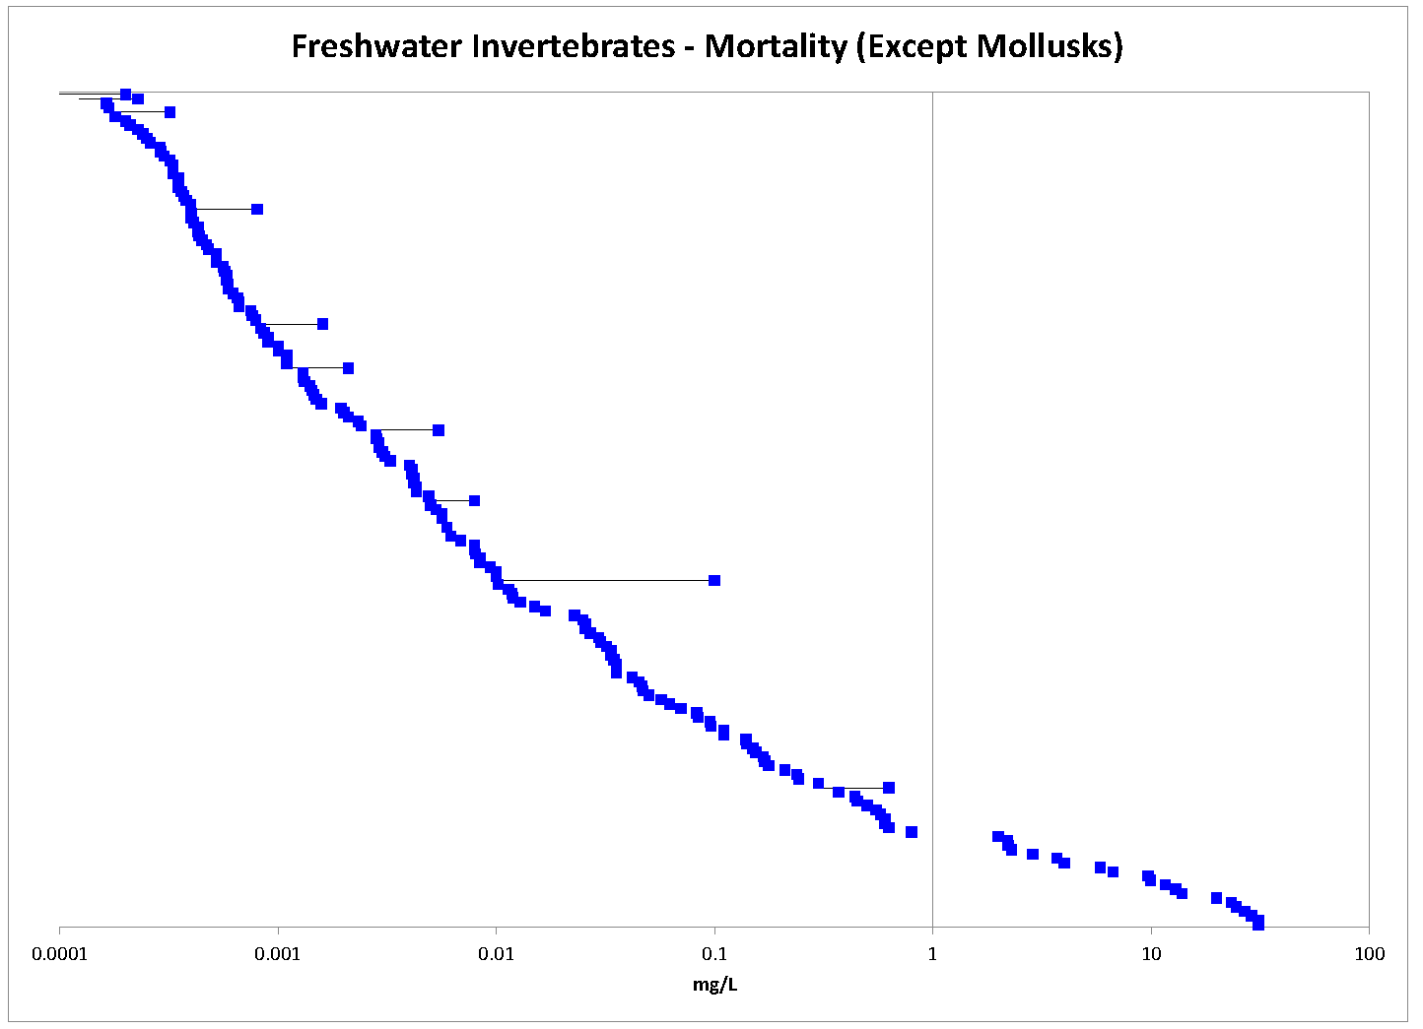
Figure 3-4. Toxicity Endpoints for Freshwater Invertebrates Exposed to Diazinon
Data do not include species of mollusk. Species names and endpoint types (e.g., NOAEC, EC₅₀) are not included in the array because there are too many endpoints to display detailed information. The data have been log₁₀-transformed for the purposes of presentation.

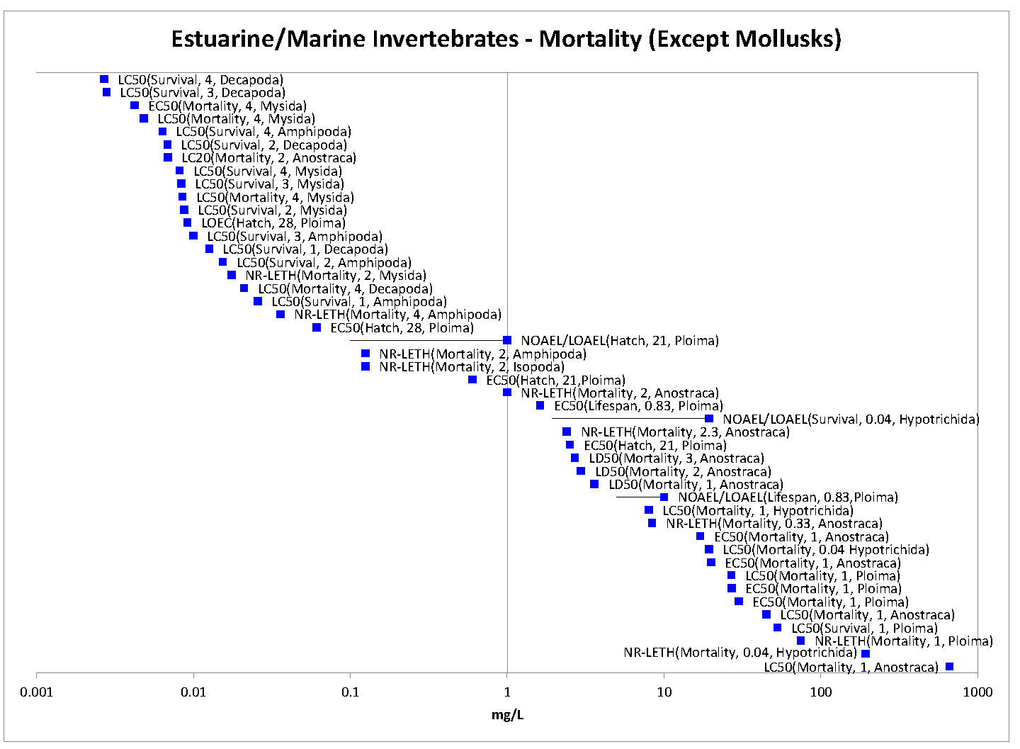
Figure 3-5. Toxicity Endpoints for Estuarine/Marine Aquatic Invertebrates Exposed to Diazinon
Data do not include species of mollusk. Specific type of effect, study duration (where available), and species order are indicated in parentheses after each endpoint. The data have been log₁₀-transformed for the purposes of presentation.
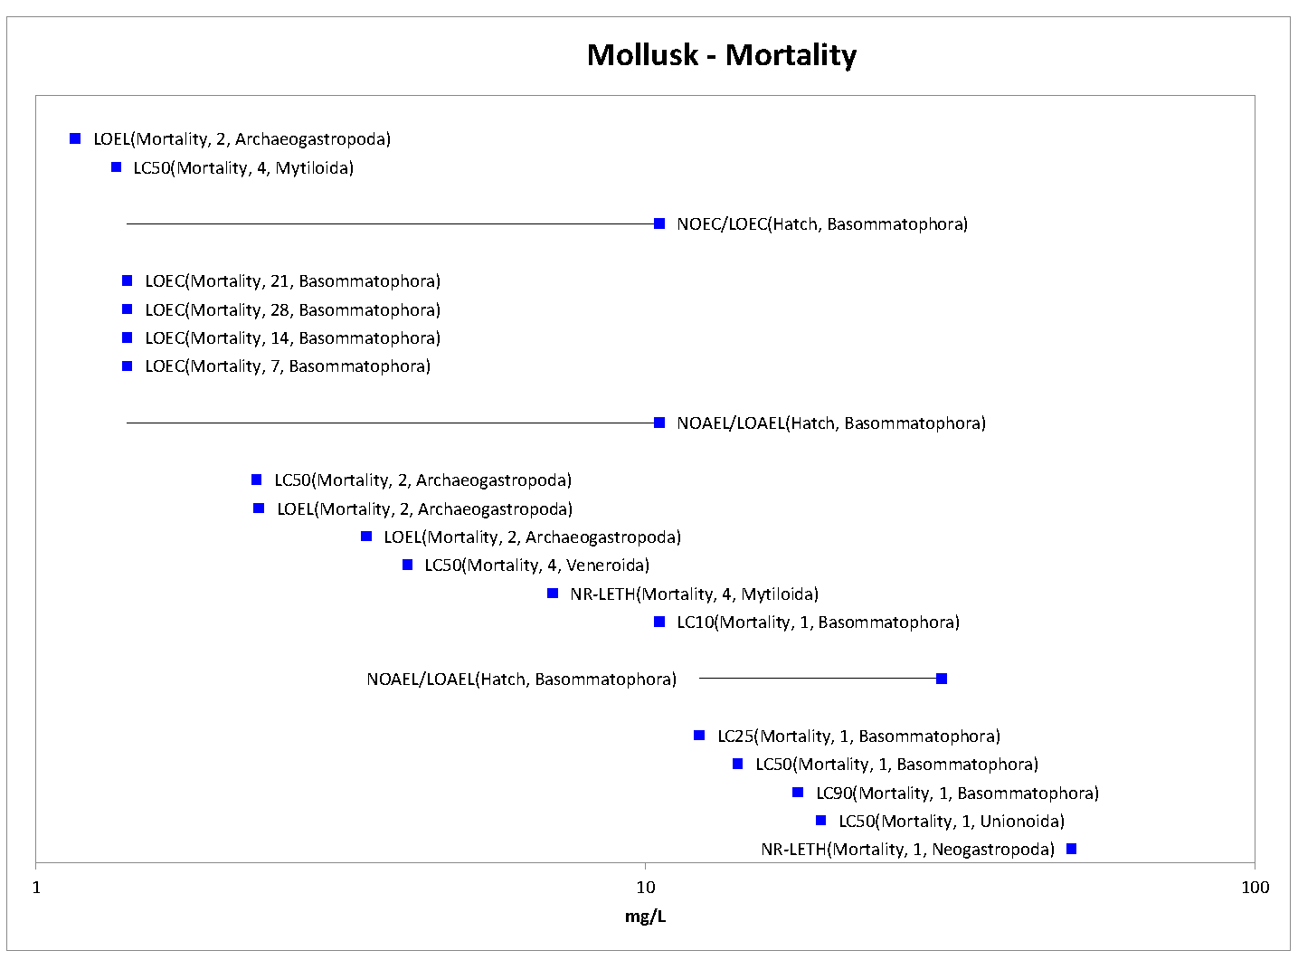
Figure 3-6. Toxicity Endpoints for Aquatic Mollusks Exposed to Diazinon
Specific type of effect, study duration (where available), and species order are indicated in parentheses after each endpoint. The data have been log₁₀-transformed for the purposes of presentation.

The available 48- and 96-hour acute toxicity studies conducted with technical grade diazinon were used to derive SSDs for aquatic invertebrates. This dataset included 29 species of aquatic invertebrates (24 freshwater species and 9 estuarine/marine species) and 2 mollusk species (1 freshwater snail and 1 saltwater snail) in particular. In order to generate SSDs, five potential distributions were considered (log-normal, log-logistic, log-triangular, log-gumbel, and Burr). Of the five distributions tested, the gumbel distribution provided the best fit for pooled results (i.e., freshwater and estuarine/marine species combined) and for freshwater test results alone, whereas the triangular distribution provided the best fit for the estuarine/marine test results. Summary statistics from model-generated SSDs, including the HC₀₅, were estimated and are presented in Table 3-4 for models with the best fit. The cumulative distribution function for the pooled species SSD is presented in Figure 3-7. Regression of SSD parameters on estuarine/marine versus freshwater status did not support separating the SSDs by medium, but rather support a combined SSD of pooled results (see APPENDIX 2-8 for regression results). In addition, graphical examination of the separate estuarine/marine and freshwater SSDs show that they lie entirely within the 95% confidence limits of the pooled SSD (Figure 3-8).

The model-averaged HC₀₅ estimate for pooled aquatic invertebrate species is 0.5 ug/L (SE = 0.25 ug/L, CV = 0.51). The resulting threshold for direct effects is 0.044 μg/L, and the threshold for indirect effects is 0.259 μg/L. APPENDIX 2-8 includes further details of how this SSD was derived.

Table 3-4. Summary Statistics for Best-fit SSDs for Aquatic Invertebrates Exposed to Diazinon
Statistic | Pooled Results | Freshwater Results | Estuarine/Marine Results
Best distribution (per AIC_{c}) | gumbel | gumbel | triangular
Goodness of fit P-value | 0.53 | 0.55 | 0.75
CV of the HC₀₅ | 0.51 | 0.60 | 2.65
HC₀₅ | 0.00050 | 0.00040 | 0.00034
HC₁₀ | 0.00085 | 0.00069 | 0.00074
HC₅₀ | 0.010 | 0.008 | 0.021
HC₉₀ | 0.4 | 0.4 | 0.6
HC₉₅ | 1.8 | 1.9 | 1.4
Mortality Threshold (slope = 4.5) | 0.000044 | 0.000035 | 0.000030
Indirect Effects Threshold (slope = 4.5) | 0.000259 | 0.000208 | 0.000174
Results are reported in mg diazinon/L.
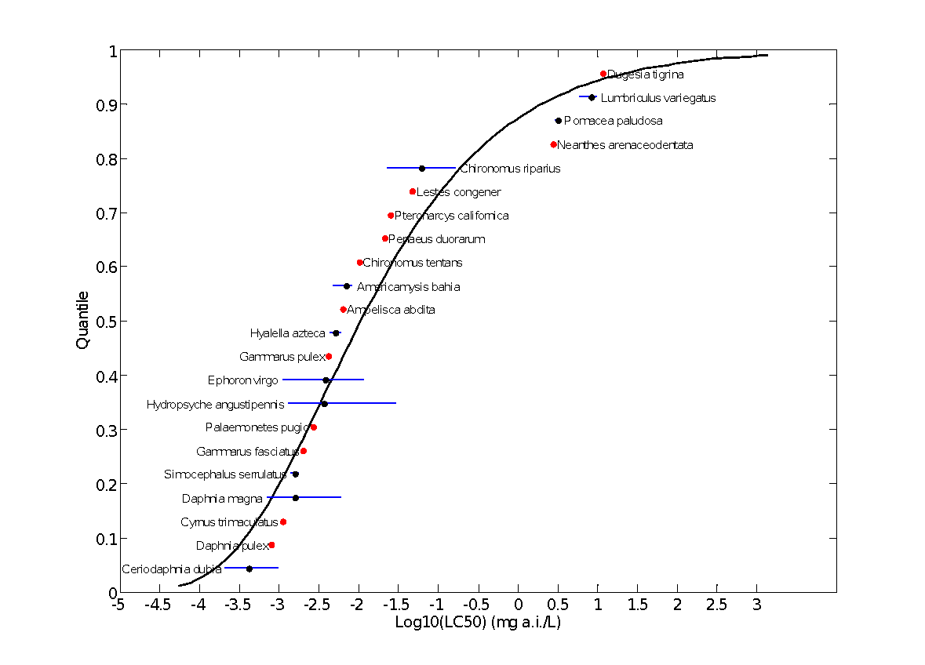
Figure 3-7. Log-gumbel SSD for Diazinon Toxicity Values for Pooled Invertebrates
Red points indicate single toxicity values. Black points indicate multiple toxicity values. Blue lines indicate the full range of toxicity values for a given taxon.

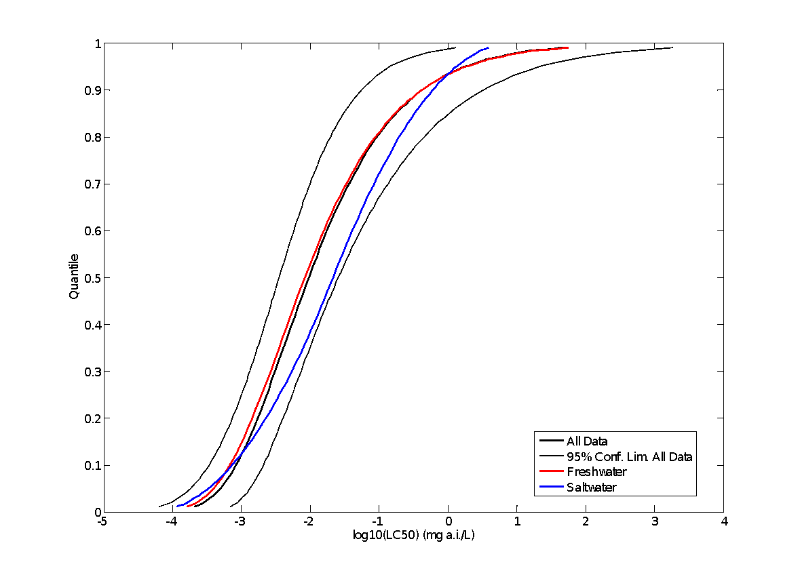
Figure 3-8. SSDs for Pooled (gumbel), Freshwater (gumbel), and Saltwater (triangular) Test Results
EFED’s incident database (EIIS) was searched on March 18, 2015 and did not contain any incidents with aquatic invertebrates associated with diazinon.

Sublethal Effects on Aquatic Invertebrates

Major categories of sublethal effects (i.e., growth, reproduction, behavior, and acetylcholinesterase inhibition) are discussed in the following sections. The most sensitive NOECs/LOECs available for each type of effect for freshwater and estuarine/marine invertebrates are presented in Tables 3-5 and 3-6, respectively. The most sensitive sublethal endpoint available in the entire effects database for aquatic invertebrates is for effects to reproduction in Ceriodaphnia dubia, resulting from exposure to technical-grade diazinon (E161081).

Table 3-5. Most Sensitive Freshwater Invertebrate Sublethal Effects Data
Effect Group | Endpoint  (µg/L) | Magnitude/Type of Effect*  (Duration) | Species | Test Substance  (% a.i.) | MRID/ECOTOX  Reference  (Classification)
Growth | 1.1 (NOEC)  2.1 (LOEC) | ↓Weight  (10 days) | Scud  (Hyalella azteca) | TGAI (99.5%) | E161081  (Quantitative)
Repro-duction | 0.123 (NOEC)  0.228 (LOEC) | ↓Offspring production (41%)  (7 days) | Water Flea  (Ceriodaphnia dubia) | TGAI (99.5%) | E161081  (Quantitative)
Behavior | 1 (LOEC) | ↓Distance moved  (8 hours) | Non-biting midge  (Chironomus riparius) | TGAI (100%) | E120752¹
AChE Inhibition | 0.9 (LOEC) | ↓Acetylcholinesterase activity  (4 days) | Scud  (Hyalella azteca) | TGAI (>98%) | E64955¹
* Magnitude of effect is based on study LOEC
¹ Studies are acceptable for ECOTOX but have not been formally reviewed by EFED

Table 3-6. Most Sensitive Estuarine/Marine Invertebrate Sublethal Effects Data
Effect Group | Endpoint  (µg/L) | Magnitude/Type of Effect*  (Duration) | Species | Test Substance  (% a.i.) | MRID/ECOTOX  Reference  (Classification)
Growth | 0.23 (NOEC)  0.42 (LOEC) | ↓Weight¹  (28 days) | Opposum Shrimp  (Americamysis bahia) | TGAI (99.5%) | MRID 44244801  (Acceptable)
Repro-duction | 2.1 (NOEC)  4.4 (LOEC) | ↓Number of offspring  (22 days) | Opposum Shrimp  (Americamysis bahia) | TGAI (100%) | E85670³
Behavior | ND² | ND | ND | ND | ND
AChE Inhibition | 12 (LOEC) | ↓Acetylcholinesterase activity  (7 days) | White Shrimp  (Litopenaeus vannamei) | TGAI (100%) | E49408³
ND = No Data Available
* Magnitude of effect (if available) is based on study LOEC
¹ Magnitude of effect not reported at LOEC
² No data are available on behavioral effects to estuarine/marine invertebrates
³ Studies are acceptable for ECOTOX but have not been formally reviewed by EFED

Effects on Growth of Aquatic Invertebrates

A small number of growth-related studies (approximately 9) are available from either the registrant or the open literature (Table 3-7). The dataset is comprised of roughly half NOEC/LOEC values and half EC_{x} values, as well as roughly half freshwater species and half estuarine/marine species. Only two growth studies were conducted on one species of mollusk (estuarine/marine bivalve).

The most sensitive growth-related endpoint available for diazinon is from a registrant-submitted study (MRID 44244801) in estuarine/marine mysid shrimp (A. bahia). Following a 28-day exposure, impaired growth (weight) occurred in treated mysids relative to controls resulting in NOEC and LOEC values of 0.23 and 0.42 ug/L, respectively. The most sensitive growth-related endpoint for a freshwater invertebrate species is for Daphnia magna (EC₅₀ = 0.53 ug/L; E18872, Fernandez-Casalderrey et al., 1995) and was reported in ECOTOX as a general growth effect. From the limited available dataset, it is not possible to determine if growth in freshwater and saltwater invertebrate differs substantially in response to diazinon. On one hand, the most sensitive growth endpoint is based on an estuarine/marine species (A. bahia); on the other hand, every other estuarine/marine growth endpoint in the available dataset is less sensitive than endpoints from freshwater counterparts.

The more sensitive of the two growth-related endpoints from mollusks is from a registrant-submitted study (MRID 40625502) with eastern oysters (Crossostrea virginica). Following a 96-hour exposure, shell deposition (in mm) was reduced by 30-70% at concentrations ≥0.48 mg/L diazinon, resulting in an EC₅₀ value of 880 µg/L (95% CI 630-1,100 µg/L). The dataset is insufficient to determine the relative sensitivity of mollusks versus other aquatic invertebrates in terms of growth.

Table 3-7. Studies Reporting Effects to Growth in Aquatic Invertebrates
Species | Order | Endpoint Type | Endpoint Value (µg/L) | Duration | Endpoint Measure | Medium | ECOTOX No.
Americamysis bahia | Mysida | NOEC  LOEC | 0.23  0.42 | 28 | Weight | EM | MRID 44244801
Daphnia magna | Diplostraca | EC50 | 0.53 | 21 | Growth, general | FW | E18872
Hyalella azteca | Amphipoda | NOEC  LOEC | 1.14  2.8 | 10 | Weight | FW | E161081  Quantitative
Hyalella azteca | Amphipoda | NOEC  LOEC | 1.14  2.1 | 10 | Weight | FW | E161081  Quantitative
Hyalella azteca | Amphipoda | EC25 | 1.41 | 10 | Weight | FW | E161081  Quantitative
Chironomus riparius | Diptera | EC50 | 35.2 | 2 | Length | FW | E54582
Chironomus riparius | Diptera | EC50 | 57.3 | 4 | Length | FW | E54582
Artemia salina | Anostraca | EC50 | 520 | 3 | Abnormal | EM | E153647*
Artemia salina | Anostraca | EC50 | 763 | 2 | Abnormal | EM | E153647*
Crassostrea virginica | Ostreoida | EC50 | 880 | 4 | Shell deposition | EM | MRID 40625502
Artemia salina | Anostraca | EC50 | 1,120 | 1 | Abnormal | EM | E153647*
Crassostrea virginica | Ostreoida | EC50 | 1,150 | 2 | Growth, general | EM | E45074
Paracentrotus lividus | Echinoida | NOEL | 608,000 | 1.25 | Length | EM | E84759*
Paracentrotus lividus | Echinoida | NOEL | 3,043,000 | 1.25 | Length | EM | E84759
* Study endpoint appears to be based on testing with a diazinon formulation. All other studies appear to have been conducted with diazinon technical.

Effects on Reproduction of Aquatic Invertebrates

Approximately 15 reproduction studies are available from either the registrant or the open literature. The most sensitive reproductive endpoint is from a 7-day static renewal test with the freshwater cladoceran Ceriodaphnia dubia (E161081, Deanovic et al. 2013) in which survival and fecundity (total number of progeny) were both evaluated. The 7-day NOEC, LOEC, and EC25 values for fecundity were reported as 0.123, 0.228, and 0.177 µg/L (95% CI 0.160-0.208) µg/L, based on measured concentrations. Reductions in fecundity were 41%, 100%, and 100% at treatment concentrations of 0.228, 0.560, and 1.1 µg/L, respectively. The NOEC and LOEC values for mortality are the same as fecundity, indicating that survival and reproductive effects are occurring at similar levels.

The available dataset for reproduction contains too few taxa to make conclusions about relative reproductive sensitivity to diazinon, as the majority of available reproductive endpoints are either from cladocerans (e.g., Ceriodaphnia dubia) or from rotifers (order: Ploima). The lowest reproductive endpoint for an estuarine/marine invertebrate (A. mysis; NOEC/LOEC=2.1/4.4 µg/L; E85670) is approximately an order of magnitude higher than the lowest freshwater invertebrate reproductive endpoint indicated above. Moreover, there is only a single reproductive endpoint available for mollusks (freshwater snail; Biomphalaria alexandrina; LOEC=1.41; E158191), which is approximately four orders of magnitude higher than the lowest freshwater invertebrate reproductive endpoint indicated above

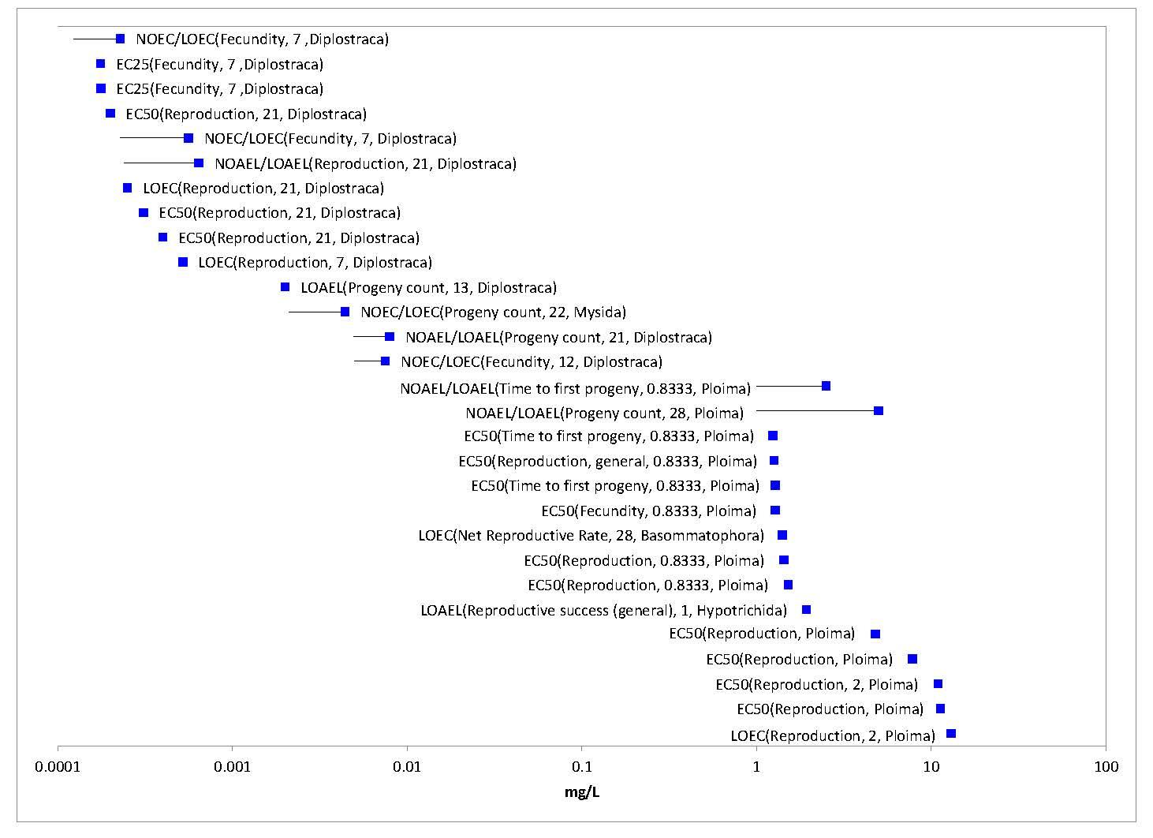
Figure 3-9. Reproduction Effects Data Array for Aquatic Invertebrates
Text in parentheses following each endpoint represents the specific endpoint measured, study duration in days, and taxonomic order. The data have been log₁₀-transformed for the purposes of presentation.

Effects on Behavior of Aquatic Invertebrates

Only one study reporting a behavioral endpoint as a NOEC/LOEC was identified from either registrant-submitted data or the open literature (E120752; Beauchard et al. 2009). This study indicates an effect on locomotion (distance travelled) in the non-biting midge, Chrinomus riparius, but has not been reviewed as it does not constitute a more sensitive endpoint relative to other sublethal effects discussed above. All other available behavioral endpoints were reported as ECx values. All available behavioral data is presented in Table 3-8. Based on the small dataset and the wide range of endpoint types, it is not possible to make any conclusions about the relative behavioral sensitivity of different aquatic invertebrate taxa. However, as noted for several other types of effects, daphnids appear to be particularly sensitive to diazinon as compared to other taxonomic groups. No mollusk behavioral data are available for diazinon based on the available dataset.

Table 3-8. Studies Reporting Effects to Behavior in Aquatic Invertebrates
Species | Order | Endpoint Type | Endpoint Value (µg/L) | Duration  (Days) | Endpoint Measure | Water Type | ECOTOX No.
Daphnia magna | Diplostraca | EC50 | 0.47 | 1 | Filtration rate | FW | E4009
Daphnia magna | Diplostraca | EC50 | 0.6 | 1 | Feeding behavior | FW | E4009
Chironomus riparius | Diptera | LOAEL | 1 | 0.3 | Distance moved | FW | E120752
Acartia tonsa | Calanoida | EC50 | 2.6 | 4 | Equilibrium | SW | E742
Hydropsyche angustipennis | Trichoptera | EC50 | 3.7 | 2 | General activity | FW | E54582
Hydropsyche angustipennis | Trichoptera | EC50 | 10 | 4 | General activity | FW | E54582
Chironomus riparius | Diptera | EC50 | 18 | 4 | General activity | FW | E54582
Chironomus | Diptera | EC50 | 19 | 4 | Swimming | FW | E79402
Chironomus riparius | Diptera | EC50 | 20 | 2 | General activity | FW | E54582
Chironomus riparius | Diptera | EC50 | 23 | 2 | General activity | FW | E54582
Chironomus tentans | Diptera | EC50 | 30 | 4 | Swimming | FW | E56553
Chironomus tentans | Diptera | EC50 | 31 | 4 | Swimming | FW | E81665
Chironomus tentans | Diptera | EC50 | 38 | 4 | Swimming | FW | E56553
Brachionus calyciflorus | Ploima | EC50 | 131 | 0.2 | Feeding behavior | FW | E6725
Brachionus calyciflorus | Ploima | EC50 | 132 | 0.2 | Filtration rate | FW | E6725
* Study endpoint appears to be based on testing with a diazinon formulation. All other studies appear to have been conducted with diazinon technical.

Effects on Sensory Function of Aquatic Invertebrates

Effects on sensory function of aquatic invertebrates were not identified.

AChE Inhibition in Aquatic Invertebrates

Only five studies reporting effects to acetylcholinesterase (AChE) activity were identified from the open literature with endpoints ranging from 0.9 to 8,400 µg/L diazinon (Table 3-9). However, these studies were not formally reviewed as anti-cholinesterase effects occur at diazinon concentrations above those at which mortality and reproductive effects are seen. On a species basis, there is some evidence that anti-cholinesterase activity may occur at somewhat similar concentrations as those for mortality and other sublethal effects. For example, in the amphipod H. azteca, effects to AChE activity, growth, and survival occurred at 0.9, 2.1, and 2.1 µg/L, respectively (Anderson and Lydy, 2002; E64955). In D. magna, the same effect levels (21-day LOAEC = 7.9 µg/L) are reported for mortality and AChE inhibition in one study (Jemec et al., 2007; E100844), yet significant impacts to 21-day survival are reported at an order of magnitude lower concentration (0.32 µg/L) in a registrant-submitted study (MRID 40782302). Thus, there is no evidence that effects on AChE activity occur at lower concentrations than other higher level effects. However, given the paucity of AChE-related data, it is not possible to make any conclusions about the relative sensitivity of different aquatic invertebrate taxa to diazinon.

In addition to AChE-related effects, the ECOTOX database also contains four studies examining other types of biochemical effects indicated as “general biochemical effect” (1 study), “enzyme activity” (2 studies), “protein content” (1 study), and “glutathione s-transferase” (1 study). The study reporting general biochemical effects (Wener and Nagel, 1997; E18129) demonstrated significant impacts to heat shock protein responses in 3 amphipod species, H. azteca, Rhepoxynius abronius, and Ampelisca abdita, at 0.6, 3, and 30 µg/L, respectively, as compared to 24-hr LC₅₀ values of 30, 9.2, and 21 µg/L for the same species, respectively, from the same study. The 2 studies reporting effects to enzyme activity (Rompas et al., 1989, E3043; Burbank and Snell, 1994, E16059) appear to have involved AChE-related effects to rotifers (Brachionus calyciflorus) and penaeid shrimp (Penaeus japonicus), but at levels above 1,000 µg/L. The single study reporting effects to protein content and glutathione s-transferase (E100844), indicate significant effects to these endpoints at the same concentration as AChE activity, mortality, and reproduction (number of progeny) (NOAEC/LOAEC for all effect types are 5.0/7.9 µg/L).

Table 3-9. Studies Reporting Effects to Acetylcholinesterase Activity (AChE) in Aquatic Invertebrates
Species | Order | Endpoint Type | Endpoint Value (µg/L) | Duration | ECOTOX No.
Hyalella azteca | Amphipoda | LOAEL | 0.9 | 4 | E64955
Daphnia magna | Diplostraca | NOAEL  LOAEL | 4.95  7.92 | 21 | E100844
Daphnia magna | Diplostraca | NOAEL | 7 | 2 | E100842
Litopenaeus vannamei | Decapoda | LOAEL | 12 | 7 | E49408
Ruditapes philippinarum | Veneroida | LOAEL | 100 | 1 | E153573
Ruditapes philippinarum | Veneroida | EC50 | 3,010 | 1 | E153573
Crassostrea virginica | Ostreoida | EC50 | 8,400 | 14 | E45074
All these studies were conducted with technical grade diazinon.

Incident Reports for Aquatic Invertebrates

No incidents involving aquatic invertebrates have been reported recently for diazinon.

Summary of Effects to Aquatic Invertebrates

Based on the available dataset, survival and reproductive endpoints appear to be the most sensitive to diazinon and occur at similar concentrations in their lower range. The lowest LC₅₀ values and the lowest reproductive LOEC for aquatic invertebrates both occur at approximately 0.2 µg/L. Moreover, in a 7-day study with C. dubia (E161081, Deanovic et al., 2013), the NOEC and LOEC values for reproduction and mortality are the same (0.123 and 0.228 for NOEC and LOEC, respectively), and are among the most sensitive endpoints in the entire aquatic invertebrate dataset. It should be noted that many of the most sensitive available LC₅₀ values, as well as the most sensitive reproductive endpoint for aquatic invertebrates, are from the freshwater cladoceran C. dubia, indicating that this species may be among the most sensitive to diazinon. Generally, estuarine/marine invertebrates as well as mollusks appear to be less sensitive to diazinon as compared to freshwater invertebrates; however, there is also a bias in the dataset since the preponderance of studies have been conducted on freshwater arthropods.

Effects Characterization for Aquatic Plants

  - Introduction to Aquatic Plant Toxicity

Eleven studies are available to characterize the effects of diazinon on aquatic plants. Data were obtained from registrant-submitted, unpublished studies and from the open literature. The data are discussed below, along with a description of the established thresholds. APPENDIX 2-2 and APPENDIX 2-5 includes the bibliography of included and excluded studies relevant to plant toxicity data for diazinon, respectively. APPENDIX 2-3 includes reviews of a subset of studies from the open literature.

  - Threshold Values for Aquatic Plants

Table 4-1 includes the thresholds that will be used in assessing diazinon’s direct effects to listed aquatic plants and indirect effects to species that depend upon aquatic plants. The appropriate direct effects thresholds will also be used in cases where a listed species has an obligate relationship involving plants (e.g., coral have an obligate relationship for non-vascular aquatic plants).

Quantitative data for algae were used to set the thresholds for non-vascular and vascular aquatic plants because insufficient data were available to establish separate thresholds. Also, insufficient data were available to distinguish between responses of aquatic plants exposed to diazinon in freshwater and saltwater habitats; therefore, the thresholds for aquatic plants will be used for species in both habitats. There is potential uncertainty in assuming that saltwater does not impact the toxicity of diazinon on plants.

Table 4-1. Direct and Indirect Effects Thresholds for Aquatic Plants Exposed to Diazinon
Effect | Exposure route | Endpoint (Effect) | Value | Test species | Source
Direct | Runoff + Drift | NOEC (based on decrease in biomass at 1.0 mg/L) | 0.5 mg a.i./L | Green Algae  (Scenedesmus quadricauda) | ECOTOX# 102905
Indirect | Runoff + Drift | EC50 (Decrease in biomass) | 3.7 mg/L | Green algae  (Selenastrum capricornutum) | MRID 40509806

  - Summary Data Arrays for Aquatic Plants

The available data for aquatic plants are arrayed in Figure 4-1.

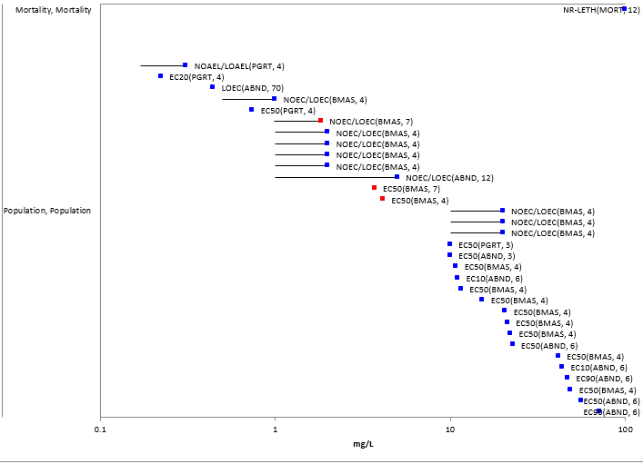
Figure 4-1. Array of Available Endpoints for Aquatic Plants Exposed to Diazinon (TGAI and Formulated)
Red points represent registrant-submitted data. Blue points represent data from the open literature. Effect codes: ABND = abundance, BMAS = biomass, MORT = mortality, PGRT = population growth rate.

  - Lines of Evidence for Aquatic Plants

    - Effects on Mortality of Aquatic Plants

No mortality data were available for aquatic plants exposed to diazinon.

    - Sublethal Effects to Aquatic Plants

      - Effects on Growth of Aquatic Plants

Table 4-2 includes the data included in the array (Figure 4-1) that were considered for establishing the direct effects threshold. This threshold is a NOEC of 0.5 mg/L, based on a reduction in biomass of green algae at 1 mg/L (ECOTOX#102905). This value is within a factor of 2 of NOEC values available for 5 other test species (ECOTOX#102905 and MRID 4059806). This indicates that the selected threshold is representative of several different species of algae and is conservative. Data excluded from consideration for establishment of the threshold include NOEC values with no LOECs. These data are considered qualitative and do not appear in the array.

Table 4-2. NOEC and LOEC Values from Lab Studies Involving Aquatic Plants Exposed to Diazinon
Test species | Effect | Exposure duration (d) | NOEC (mg/L) | LOEC (mg/L) | TGAI/ formulation | Source (ECOTOX#)
Rice (Oryza sativa) | GERM | 4 | 0.00643 | NA | Formulation | 153578
Rice (Oryza sativa) | LGTH | 4 | 0.00643 | NA | Formulation | 153578
Rice (Oryza sativa) | LGTH | 4 | 0.00643 | NA | Formulation | 153578
Green algae (Chlorella vulgaris) | PGRT | 4 | 0.17 | 0.31 | TGAI | 160446
Green Algae (Scenedesmus quadricauda) | BMAS | 4 | 0.5 | 1 | TGAI | 102905
Green algae (Selenastrum capricornutum) | BMAS | 4 | 0.98 | 1.83 | TGAI | MRID 40509806
Blue-Green Algae (Anabaena flos-aquae) | BMAS | 4 | 1 | 2 | TGAI | 102905
Green algae (Raphidocelis subcapitata) | BMAS | 4 | 1 | 2 | TGAI | 102905
Green algae (Scenedesmus obliquus) | BMAS | 4 | 1 | 2 | TGAI | 102905
Green algae (Chlorella pyrenoidosa) | BMAS | 4 | 1 | 2 | TGAI | 102905
Watermeal (Wolffia brasiliensis) | ABND | 12 | 1 | 5 | TGAI | 9184
Red algae (Champia parvula) | GREP | 13 | 1 | NA | unknown | 88030
Blue-green algae (Microcystis aeruginosa) | BMAS | 4 | 10 | 20 | TGAI | 102905
Blue-Green Algae (Microcystis flos-aquae) | BMAS | 4 | 10 | 20 | TGAI | 102905
Green algae (Chlorella vulgaris) | BMAS | 4 | 10 | 20 | TGAI | 102905
NA = not available
Effect codes: ABND = abundance, BMAS = biomass, DVRS = diversity, evenness (of community), GERM = germination, GREP = reproduction, LGTH = length, PGRT = population growth rate.

Although a data point from ECOTOX#160446 potentially represents a lower value (i.e., NOEC = 0.17; LOEC = 0.31 mg/L), this study is considered qualitative, and thus is not appropriate for establishment of the direct effects threshold. A review of this study is provided in APPENDIX 2-3.

Table 4-2 includes the effects data available for plants exposed to diazinon that were included in the array (Figure 4-1). EC50 values included in this table were considered for establishment of the indirect effects threshold for species that depend upon non-vascular aquatic plants (excluding obligate relationships). EC50 values vary by orders of magnitude, ranging from 0.73 to 56 mg/L. The threshold is set to 3.7 mg/L, based on a decrease in biomass of green algae (MRID 40509806). Although a data point from ECOTOX#160446 potentially represents a lower value (i.e., EC50 = 0.742 mg/L), this study is considered qualitative, and thus is not appropriate for establishment of the threshold.

Only one study (ECOTOX# 9184), which is considered qualitative (APPENDIX 2-3), is available to characterize potential effects of diazinon on vascular aquatic plants. In this study, an increase in the population of Watermeal (Wolffia brasiliensis) was observed with exposures of 5 and 10 mg/L diazinon. The resulting NOEC is 1 mg/L. This value is comparable to NOEC and LOEC values for algae (Table 4-1). The EC50 for watermeal (Wolffia brasiliensis) appears to be in the range of 10-50 mg/L. This is consistent with the range of EC50 values available for algae (Table 4-2). In using the thresholds for algae to represent all aquatic plants, it is assumed that the algae data are representative of vascular plants. There is uncertainty in extrapolating the results of single celled plants to multicellular plants that have specialized tissues. Although one species of vascular aquatic plant was tested (i.e., watermeal), no data are available for the responses of rooted aquatic macrophytes to diazinon exposures.

Table 4-3. Effects Data (ECx values) for Aquatic Plants Exposed to Diazinon. Values are from laboratory studies.
Test species | Effect | Percent decrease | Exposure duration (d) | Endpoint value (mg/L) | TGAI/ formulation | Source (ECOTOX#)
Green algae (Chlorella vulgaris) | PGRT | 20 | 4 | 0.223 | Formulation | 160446
Green algae (Chlorella vulgaris) | PGRT | 50 | 4 | 0.742 | Formulation | 160446
Green algae (Selenastrum capricornutum) | BMAS | 50 | 7 | 3.7 | TGAI | MRID 40509806
Green algae (Selenastrum capricornutum) | BMAS | 50 | 4 | 4.14 | TGAI | MRID 40509806
Green algae (Selenastrum capricornutum) | PGRT | 50 | 3 | >10 | TGAI | 2478
Green algae (Selenastrum capricornutum) | ABND | 50 | 3 | >10 | TGAI | 2478
Green algae (Chlorella pyrenoidosa) | BMAS | 50 | 4 | 11 | TGAI | 102905
Green algae (Scenedesmus obtusiusculus) | ABND | 10 | 6 | 11.05 | Formulation | 61937
Blue-green algae (Microcystis flos-aquae) | BMAS | 50 | 4 | 12 | TGAI | 102905
Green algae (Pseudokirchneriella subcapitata) | BMAS | 50 | 4 | 15 | TGAI | 102905
Green algae (Scenedesmus quadricauda) | BMAS | 50 | 4 | 21 | TGAI | 102905
Blue-Green Algae (Microcystis aeruginosa) | BMAS | 50 | 4 | 21 | TGAI | 102905
Blue-Green Algae (Anabaena flos-aquae) | BMAS | 50 | 4 | 22 | TGAI | 102905
Green algae (Scenedesmus obtusiusculus) | ABND | 50 | 6 | 22.78 | Formulation | 61937
Green algae (Chlorella vulgaris) | BMAS | 50 | 4 | 42 | TGAI | 102905
Blue-Green Algae (Anabaena flos-aquae) | ABND | 10 | 6 | 43.75 | Formulation | 61937
Green algae (Scenedesmus obtusiusculus) | ABND | 90 | 6 | 46.95 | Formulation | 61937
Green algae (Scenedesmus acutus var. acutus) | BMAS | 50 | 4 | 49 | TGAI | 102905
Blue-Green Algae (Anabaena flos-aquae) | ABND | 50 | 6 | 55.96 | Formulation | 61937
Blue-Green Algae (Anabaena flos-aquae) | ABND | 90 | 6 | 71.59 | Formulation | 61937
Effect codes: ABND = abundance, BMAS = biomass, PGRT = population growth rate.

      - Effects on Reproduction of Aquatic Plants

No reproductive effects data were available for aquatic plants exposed to diazinon.

  - Incident Reports for Aquatic Plants

There are no reported ecological incidents for aquatic plants associated with applications of diazinon.

Aquatic Community-based (mesocosm) Studies

Field or mesocosm studies were specifically searched in the ECOTOX database using the terms “cosm,” “field,” and “interaction.” Only two studies were identified. Three mesocosm studies are available which examined the effects of diazinon on aquatic communities, with particular emphasis on aquatic plants, invertebrates, and aquatic-phase amphibians. Some of these studies report effects at concentrations near or below the established threshold toxicity values. Given the potential for multiple interactions occurring simultaneously in these studies among the test organisms (potential for both direct and indirect effects on a taxa), these studies were not used to establish thresholds, but they are included in the WoE for effects of diazinon relevant to aquatic organisms.

  - Aquatic Plants

Mesocosm data for aquatic plants are summarized in Table 5-1.

In a registrant-submitted mesocosm study (MRID 42563901), 450-m² ponds were monitored following 6 applications of the formulated product Diazinon AG500. These applications were intended to represent alternating spray drift and runoff events, separated by l-wk intervals. Sampling occurred every 2 weeks, with 3 sampling periods before diazinon exposures, 4 sampling periods during the application period, and 7 sampling periods occurring after the applications. Nominal treatment concentrations were equivalent to 5.7, 11.4, 22.9, 45.8 and 91.5 µg a.i./L. Maximum measured concentrations in water were approximately 50% of nominal (i.e., 2.5, 4.9, 10.0, 20.0, 38.0 µg a.i./L). Statistically significant decreases (representing<20% effect) were observed in the highest treatment level (38 µg a.i./L) for taxonomic richness of phytoplankton and periphyton. A statistically significant decrease in taxonomic richness and density of periphyton was also observed at 20 µg a.i./L, suggesting a NOEC of 10 µg a.i./L for unicellular aquatic plants, in particular diatoms (Bacillariophyceae). Chlorophyll-a and dry weight were not significantly different in controls and treatments. No treatment related effects in fresh or dry weight of aquatic macrophytes (Chara sp., Najas sp.) were observed.

In another mesocosm study (which involved overlapping authors of the registrant study discussed above), diazinon was applied 3 separate times to mesocosms at 8 different concentrations ranging 2.4-443 µg/L (time-weighted average of measured concentrations). The design of this study was similar to the registrant-submitted study. The study authors reported that no significant effects were observed in phytoplankton, periphyton, or macrophytes exposed to diazinon.

Relyea (2009) investigated the effects of diazinon exposures (TGAI, 2.1 µg/L) on mesocosms (1300 L cattle tanks) containing plankton, zooplankton and tadpoles. Phytoplankton biomass was no different than the control; however, periphyton biomass was significantly lower than the control (at days 25 and 36). The study author indicated that this impact to periphyton may have been an indirect effect of impacts to zooplankton, which lead to less grazing on phytoplankton, which in turn out-competed the periphyton for light.

Table 5-1. Effects Data for Mesocosm Studies Involving Diazinon
Source (ECOTOX#) | Effects observed for phytoplankton | Effects observed for periphyton | Effects observed for vascular aquatic plants | TGAI/ formulation | Number of concentrations tested | Range of concentrations tested (mg/L, measured) | Duration (d)
114296 | No effects to chlorophyll a concentrations at days 16 and 35 of exposure to 0.0021 mg/L diazinon. | Relative to controls, a significantly different decrease in biomass was observed at days 16 and 35 of exposure to 0.0021 mg/L diazinon. | Vascular aquatic plants were not included in mesocosms. | TGAI | 1 | 0.0021 | 35
MRID 42563901 | Effects to community diversity observed at 0.038 mg/L (peak measured concentration). No effects level was 0.020 mg/L. | Effects to community diversity observed at 0.020 mg/L (peak measured concentration). No effects level was 0.010 mg/L. | No effects to biomass observed at all test levels (highest level was 0.038 mg/L). | Formulation | 5 | 0.0025-0.038 | 196
16753 | No significant differences in chlorophyll-a or biomass at all treatments (max: 0.443 mg/L). | No significant differences in chlorophyll-a or biomass at all treatments (max: 0.443 mg/L). | No significant differences in biomass at all treatments (max: 0.443 mg/L). | TGAI | 8 | 0.0024-0.443 | 70

  - Aquatic Invertebrates

Two mesocosm or field studies were conducted with aquatic invertebrates. In the same mesocosm study as discussed above (MRID 42563901; Giddings et al., 1996), ponds were monitored following six applications of diazinon, alternating between spray drift events and simulated runoff events separated by one-week intervals. Nominal treatment concentrations were equivalent to 5.7, 11.4, 22.9, 45.8, and 91.5 µg a.i./L of pond water. Diazinon was shown to have strongly affected the cladocerans, where abundance was significantly reduced in all treatments in 5 (36%) of 14 sample periods. Tricoptera abundance was also significantly reduced in all treatments for 29% of the sample periods. Dipterans were also significantly affected. The overall impact of diazinon on the aquatic community was that many aquatic invertebrates were affected at treatment concentrations greater than 11 µg a.i./L; however, most taxa other than cladocerans recovered after treatment. Although significant reductions were observed in macroinvertebrate abundance throughout the study period, fish and plants were generally unaffected by the diazinon treatments.
In another study (E100786; Bouldin et al., 2007), Diazinon 4E was mixed with sediment in a mixing chamber, mixed with lake water, and then allowed to run off into constructed wetlands. Water, sediment, and plant samples were subsequently analyzed for diazinon concentrations from 0.5 hours to 26 days. Corbicula fluminea were placed into wetlands and AChE activity and shell growth were subsequently measured. Water collected from wetlands over various stages of the study was used to conduct 48-hour acute toxicity tests with Ceriodaphnia dubia and Pimephales promelas. In addition, survival and growth of Chironomus dilutus was evaluated in a 10-day laboratory sediment study using sediments collected from artificial wetlands receiving diazinon runoff. Survival in C. dubia was significantly affected over a wide range of post-exposure periods at estimated exposure concentrations below the detection limit (0.01 µg/L) following diazinon runoff, while P. promelas survival was not significantly affected. C. dilutus survival and/or growth was significantly affected by sediment collected 0.5 hours to 26 days post-exposure. Shell growth in C. fluminea was significantly reduced from 7-26 days post-exposure, while AChE inhibition was detected in clams from most wetlands below 30% of control AChE activity. Diazinon concentration was measured in water, sediment, and plants from wetlands and was at its peak 9-hours after initial dosage in water, 0.5 hours in sediment, and 3 hours in plants.

  - Fish and Aquatic-Phase Amphibians

Six mesocosm or field studies conducted with fish or aquatic-phase amphibians were identified for diazinon; three of these studies are discussed in the text below, while the remaining three studies are presented in Table 5-2. One study (E114296) was conducted with amphibians, while the remaining studies were conducted with fish.

The most sensitive growth-related endpoint available for aquatic-phase amphibians is based on a mesocosm study in which tadpoles of gray tree frogs (Hyla versicolor) and leopard frogs (Lithobates pipiens) were exposed to a single concentration (2.1 µg/L) of technical diazinon in four experimental replicates (E114296). There was a 20% reduction in survival in leopard frogs along with a significant reduction of body mass at metamorphosis, although the magnitude of reduction in growth was not reported. Gray tree frogs were not affected at the single concentration tested. This study indicates that effects to survival and growth may occur at similar concentrations in some species, although the fact that only a single concentration was tested limits the utility of this study for determining the relative sensitivity of growth versus mortality effects.

In the same mesocosm study as discussed above (MRID 42563901; Giddings et al., 1996), 450-m² ponds were monitored following six applications of diazinon, alternating between spray drift events and simulated runoff events separated by one-week intervals. Nominal treatment concentrations were equivalent to 5.7, 11.4, 22.9, 45.8, and 91.5 µg a.i./L of pond water. Although significant reductions were observed in macroinvertebrate abundance throughout the study period, fish and plants were generally unaffected by the diazinon treatments.

In another study discussed above, which was conducted in constructed wetlands (E100786; Bouldin et al., 2007), Diazinon 4E was mixed with sediment in a mixing chamber, mixed with lake water, and then allowed to run off into wetlands. Water, sediment, and plant samples were subsequently analyzed for diazinon concentrations from 0.5 hours to 26 days. Water collected from wetlands over various stages of the study was used to conduct 48-hour acute toxicity tests with Pimephales promelas as well as with the crustacean C. dubia (aquatic invertebrate). In addition, survival and growth of Chironomus dilutus was evaluated in a 10-day laboratory sediment study using sediments collected from artificial wetlands receiving diazinon runoff. Survival in C. dubia was significantly affected over a wide range of post-exposure periods at estimated exposure concentrations below the detection limit (0.01 µg/L) following diazinon runoff, while P. promelas survival was not significantly affected. C. dilutus survival and/or growth was significantly affected by sediment collected 0.5 hours to 26 days post-exposure. Diazinon concentration was measured in water, sediment, and plants from wetlands and was at its peak 9-hours after initial dosage in water, 0.5 hours in sediment, and 3 hours in plants.

Based on the few mesocosm studies available, there appears to be some evidence that at least some species of amphibians may be similarly sensitive to diazinon under laboratory conditions in terms of growth and survival effects, while there is no similar parallel between fish mesocosm and laboratory studies. It is worth noting that there is evidence that aquatic invertebrates were significantly affected by diazinon in mesocosm studies, which could indirectly impact fish as a prey base.

Table 5-2. Mesocosm or Field Studies for Diazinon with Fish or Aquatic-phase Amphibians Available in ECOTOX
Species | Family | Endpoint Type | Endpoint Value (µg/L) | Duration  (Days) | Endpoint Measure | ECOTOX No.
Lepomis macrochirus | Centrarchidae  (Fish) | NOEC | 0.0092 | 70 | BMAS | E16753
 |  | NOEC | 0.022 |  | MORT
 |  | LOEC | 0.022 |  | BMAS
 |  | LOEC | 0.054 |  | MORT
Channa striata | Channidae  (Fish) | LOAEL | 0.017 | 3 | CEST | E112013
 |  | LOAEL | 0.13
Cyprinus carpio | Cyprinidae  (Fish) | NOAEL | 640² | 21 | GAIN | E7598
 |  |  |  |  | BMAS
 |  |  |  |  | SURV
 |  |  |  |  | GRRT
 |  |  |  |  | WGHT
¹ Study duration not reported in ECOTOX
² Endpoint unit for this study are grams/hectare

Effects Characterization for Birds

Introduction to Bird Toxicity

The effects of diazinon on birds have been studied extensively. There are 44 unpublished studies submitted by registrants involving birds, including acute oral, sub-acute dietary, reproduction and field studies with technical or formulated diazinon. ECOTOX includes 41 citations from the open literature. These data are from toxicity tests that focus on different avian life stages, including embryos, juveniles and adults. These data include laboratory studies as well as semi-field and field studies. Toxicity data included in this section pertain to technical grade active ingredient (TGAI) and formulations that are representative of current registrations. Data from exposures involving granular formulations were excluded because they are no longer registered.

Studies from the open literature and registrant submissions are used to characterize effects to birds in a WoE approach. This section presents the thresholds for direct effects to listed species of birds and thresholds for effects to birds that may indirectly affect listed species that depend upon birds (e.g., Northern aplomado falcon diet relies upon small birds). This section also discusses the data available for different types of effects on birds, including lethality, decreases in growth, decreases in reproduction, AChE inhibition and impacts on behavior.

In addition, this section discusses the incident reports (which relate to avian mortality) that have occurred since 2006, when diazinon use was altered substantially as a result of RED risk mitigations. Many incidents involving birds exposed to diazinon were reported prior to 2006; however, those incident reports are not included here because they likely involved applications of diazinon that would result in different exposures compared to those allowed on current labels.

APPENDIX 2-3 includes reviews of several studies from the open literature. APPENDIX 2-2 and APPENDIX 2-5 includes the bibliography of avian toxicity studies that are included in this effects characterization and those that were excluded, respectively. Studies were excluded if they were considered invalid or involved formulations (i.e., granular, microencapsulated) that are not currently registered and thus are not part of the action. Some data were excluded from this effects characterization if they were expressed in units that cannot be translated into units of concentration (mg a.i./kg-diet), dose (mg a.i./kg-bw) or application rate (lb a.i./A). Arrays of those data are depicted in APPENDIX 2-1.

Threshold Values for Birds

The available data can be broken out into three groups of units: mg a.i/kg-bw (oral dose), mg a.i/kg-diet and lb a.i./A. Endpoints are available to establish thresholds for lethality and sublethal effects to birds for mg a.i/kg-bw and mg a.i/kg-diet. Direct and indirect effects thresholds for birds are presented in Tables 6-1 and 6-2, respectively.

Table 6-1. Direct Effects Thresholds for Determining Effects to Listed Birds
Effect (endpoint) | Value | Unit | Test species | Duration of exposure | Source
Mortality (1/million) | 2.5 | mg a.i/kg-diet | brown headed cowbird | 5 days | MRID 40895308;  LC50 = 38 mg/kg-diet; slope = 4.0
 | 0.019 | mg a.i/kg-bw | Mallard duck, bobwhite quail, ring-necked pheasant, Canada goose, red-winged blackbird, brown-headed cowbird, starling | Single dose | HC05 from SSD, scaled to 100 g BW
 | 0.0032 | lb a.i./A | Canada goose | 5 days | ECOTOX# 85970; LC50 = 0.31 (includes diet and dermal exposures); slope = 2.4
Behavior  (48-53% inhibition of AChE in brain, plasma) | 4.0 | mg a.i/kg-diet | Mallard duck | 10 weeks | MRID 41322901
Behavior (sitting, inability to walk; NOEL) | 0.316 | mg a.i/kg-bw | Mallard duck | Single dose | MRID 40895301

Table 6-2. Indirect Effects Thresholds for Determining Effects to Listed Species That Depend upon Birds
Effect (endpoint) | Value | Unit | Test species | Duration of exposure | Source
Mortality (10%) | 18 | mg a.i/kg-diet | brown-headed cowbird | 5 days | MRID 40895308;  LC50 = 38 mg/kg-diet;  slope = 4.0
 | 0.19 | mg a.i/kg-bw | multiple (see Table 2) | Single dose | HC05 from SSD, scaled to 100 g BW
 | 0.091 | lb a.i./A | Canada goose | 5 days | ECOTOX# 85970; LC50 = 0.31 (includes diet and dermal exposures); slope = 2.4
Behavior  (48-53% inhibition of AChE in brain, plasma) | 4.0 | mg a.i/kg-diet | Mallard duck | 10 weeks | MRID 41322901
Behavior (sitting, inability to walk; LOEL) | 0.681 | mg a.i/kg-bw | Mallard duck | Single dose | MRID 40895301

Summary Data Arrays for Birds

Figures 6-1 through 6-3 include the toxicity endpoints from scientifically valid studies from the open literature (depicted in blue) and unpublished studies submitted by registrants (depicted in red). APPENDIX 2-1 includes the data used to generate these arrays.

These figures differ by their units (note the x axis). Endpoints from the open literature were excluded if they did not have environmentally relevant exposure routes (e.g., intraperitoneal injection) or do not have units that can be related to an environmentally relevant exposure. Data in these arrays are grouped by the type of effect (e.g., behavior, reproduction, mortality). Each of these effects are discussed separately below. The concentration-based and application rate-based arrays include data for the mortality, growth, reproduction, and behavior lines of evidence. The dose-based array includes data for the mortality and behavior lines of evidence.

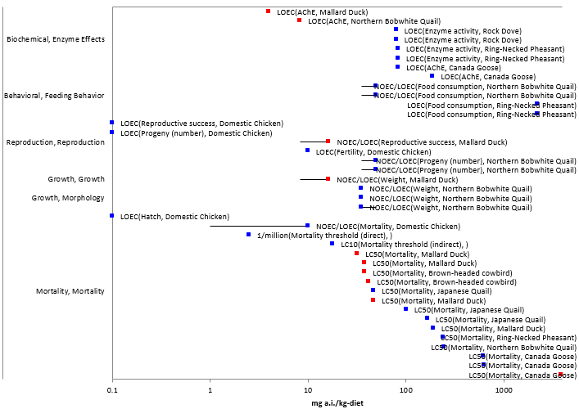
Figure 6-1. Dietary-based Endpoints for Birds Exposed to Diazinon
Data are from unpublished registrant submissions (red) and open literature studies (blue).

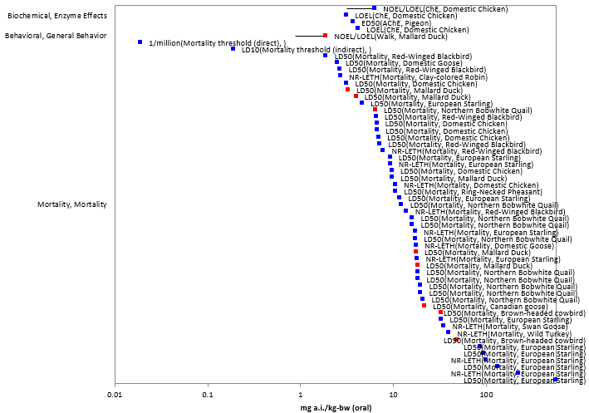
Figure 6-2. Dose-based Endpoints for Birds Exposed to Diazinon (Normalized to 100g BW)
Data are from unpublished registrant submissions (red) and open literature studies (blue).

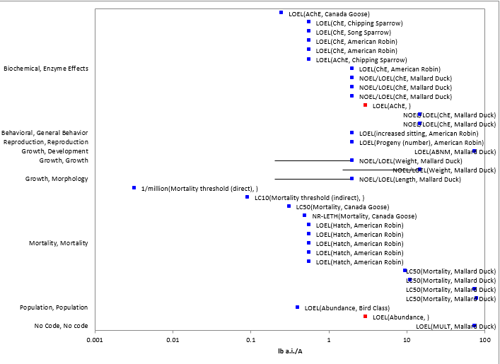
Figure 6-3. Application Rate-based Endpoints for Birds Exposed to Diazinon
Data are from registrant submissions (red) and open literature studies (blue). Note that the maximum application rate of diazinon is 4 lb a.i./A.

  - Lines of Evidence for Birds

Effects on Mortality of Birds

When considering all of the lines of evidence, the mortality line of evidence has the most data. The endpoints considered for the mortality line of evidence are included in Figures 6-4 through 6-6. Based on the AOP for animals exposed to diazinon, endpoints representative of AChE inhibition are included in the mortality line of evidence. The mortality and AChE endpoints are discussed below.

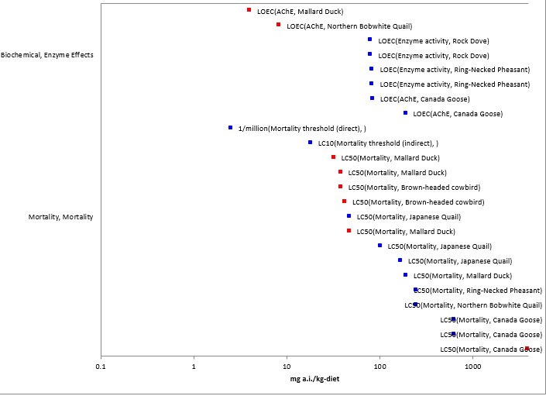
Figure 6-4. Dietary-based Endpoints and Thresholds Used for Mortality Line of Evidence

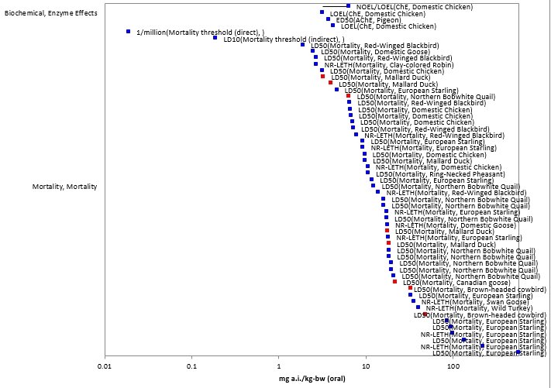
Figure 6-5. Dosed-based Endpoints and Thresholds Used for Mortality Line of Evidence

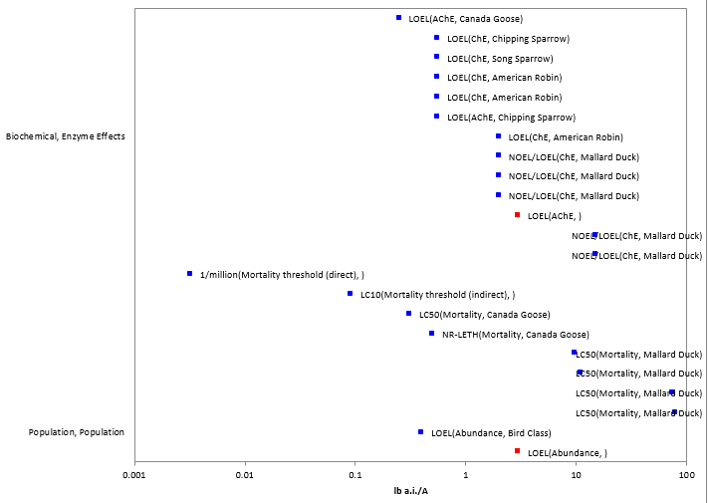
Figure 6-6. Application Rate Based Endpoints and Thresholds Used for Mortality Line of Evidence
Dietary-based laboratory studies

Dietary-based LC50 values are available for several test species and three orders. Values range from 32-3912 mg a.i./kg-diet (Table 6-3). Based on these results, diazinon is considered very highly toxic (i.e., LC₅₀<50 mg a.i./kg-diet) to birds. The brown-headed cowbird (LC₅₀ of 38 mg a.i./kg-diet; MRID 40895308), generates the most conservative threshold (i.e., 2.5 mg a.i./kg-diet) due to a slope of 4.0 and a low LC₅₀. Although there is a lower LC₅₀ value available (32 mg a.i./kg-food; MRID 40895302), there is no slope available; therefore the default of 4.5 will be used. With this slope, a threshold of 2.8 mg a.i./kg-diet is derived.

Table 6-3. Median Lethal Concentrations Resulting from Sub-acute Dietary Exposures
Test species | Order | LC50 (mg a.i/kg-diet) | Test substance | Ref #
Mallard Duck (Anas platyrhynchos) | Anseriformes | 32 | TGAI | MRID 40895302
Brown-headed cowbird (Molothrus ater) | Passeriformes | 38 | TGAI | MRID 40895308
Mallard Duck (Anas platyrhynchos) | Anseriformes | 38 | formula | MRID 40895304
Brown-headed cowbird (Molothrus ater) | Passeriformes | 42 | formula | MRID 40895310
Japanese Quail (Coturnix japonica) | Galliformes | 47 | TGAI | ECOTOX 35243
Japanese Quail (Coturnix japonica) | Galliformes | 101 | formula | ECOTOX 50181
Japanese Quail (Coturnix japonica) | Galliformes | 167 | TGAI | ECOTOX 50181
Mallard Duck (Anas platyrhynchos) | Anseriformes | 191 | TGAI | ECOTOX 35243
Ring-Necked Pheasant (Phasianus colchicus) | Galliformes | 244 | TGAI | ECOTOX 35243
Northern Bobwhite Quail (Colinus virginianus) | Galliformes | 245 | TGAI | ECOTOX 35243
Canada Goose (Branta canadensis) | Anseriformes | 623 | TGAI | ECOTOX 85970
Canada Goose (Branta canadensis) | Anseriformes | 634 | Formula | ECOTOX 85970
Canada Goose (Branta canadensis) | Anseriformes | 3912 | TGAI | MRID 49547101

Dose-based laboratory studies

Several different test species representing 3 orders of birds have been subjected to acute oral toxicity studies, yielding LD₅₀ values that range from 1.18 to 602 mg a.i./kg-bw (Table 6-4). Based on these values, diazinon is considered very highly toxic (i.e., LD₅₀<10 mg a.i./kg-bw) to birds.

A subset of the available LD₅₀ values for birds were used to derive a species sensitivity distribution (SSD). Because the intent of the SSD is to represent differences in species’ responses to diazinon and to minimize other variables, LD₅₀s were selected if they were from studies conducted with TGAI and adult birds. Adult birds were selected because they are included in the majority of the tests used to derive LD₅₀s. The SSD for dose-based exposures to birds is depicted in Figure 6-7. The HC₀₅ for diazinon, which is used to derive dose-based thresholds for mortality, is 0.43 mg a.i./kg-bw. Other summary statistics for the SSD are provided in Table 6-5. APPENDIX 2-9 includes the details of how this SSD was derived.

Table 6-4. Available Median Lethal Doses (oral) for Birds Exposed to Diazinon as TGAI or Formulation
Test species | Order | LD50 (mg a.i/kg-bw) | Test material | Ref #
Mallard Duck (Anas platyrhynchos) | Anseriformes | 1.18 | Formula | MRID 40895307
Mallard Duck (Anas platyrhynchos) | Anseriformes | 1.44* | TGAI | MRID 40895301
Red-Winged Blackbird (Agelaius phoeniceus) | Passeriformes | 2.4 | TGAI | ECOTOX 55700
Domestic Goose (Anser anser) | Anseriformes | 2.75 | Formula | ECOTOX 153755
Domestic Chicken (Gallus domesticus) | Galliformes | 3 | TGAI | ECOTOX 74129
Red-Winged Blackbird (Agelaius phoeniceus) | Passeriformes | 3.4 | TGAI | ECOTOX 55700
Mallard Duck (Anas platyrhynchos) | Anseriformes | 3.54* | TGAI | ECOTOX 50386
Ring-Necked Pheasant (Phasianus colchicus) | Galliformes | 4.33* | TGAI | ECOTOX 50386
European Starling (Sturnus vulgaris) | Passeriformes | 5 | TGAI | ECOTOX 53000
Northern Bobwhite Quail (Colinus virginianus) | Galliformes | 5.2* | TGAI | MRID 109015
Canadian goose (Branta canadensis) | Anseriformes | 6.16* | TGAI | FEODIA08
Domestic Chicken (Gallus domesticus) | Galliformes | 6.32 | Formula | ECOTOX 108322
Mallard Duck (Anas platyrhynchos) | Anseriformes | 6.38* | TGAI | MRID 40922902
Domestic Chicken (Gallus domesticus) | Galliformes | 6.4 | Formula | ECOTOX 161092
Domestic Chicken (Gallus domesticus) | Galliformes | 6.66 | Formula | ECOTOX 161092
Mallard Duck (Anas platyrhynchos) | Anseriformes | 6.66* | TGAI | MRID 40922901
Red-Winged Blackbird (Agelaius phoeniceus) | Passeriformes | 8.3 | TGAI | ECOTOX 55700
Red-Winged Blackbird (Agelaius phoeniceus) | Passeriformes | 9.1* | TGAI | ECOTOX 55700
Domestic Chicken (Gallus domesticus) | Galliformes | 9.2 | Formula | ECOTOX 100302
European Starling (Sturnus vulgaris) | Passeriformes | 10 | TGAI | ECOTOX 53000
Northern Bobwhite Quail (Colinus virginianus) | Galliformes | 10* | TGAI | ECOTOX 37111
European Starling (Sturnus vulgaris) | Passeriformes | 12.7 | TGAI | ECOTOX 55700
Northern Bobwhite Quail (Colinus virginianus) | Galliformes | 13* | TGAI | ECOTOX 37112
Northern Bobwhite Quail (Colinus virginianus) | Galliformes | 13* | TGAI | ECOTOX 37112
Northern Bobwhite Quail (Colinus virginianus) | Galliformes | 14* | TGAI | ECOTOX 37112
Northern Bobwhite Quail (Colinus virginianus) | Galliformes | 15* | TGAI | ECOTOX 37112
Northern Bobwhite Quail (Colinus virginianus) | Galliformes | 15* | TGAI | ECOTOX 37112
Northern Bobwhite Quail (Colinus virginianus) | Galliformes | 16* | TGAI | ECOTOX 37112
Northern Bobwhite Quail (Colinus virginianus) | Galliformes | 16* | TGAI | ECOTOX 37112
Northern Bobwhite Quail (Colinus virginianus) | Galliformes | 17* | TGAI | ECOTOX 37112
European Starling (Sturnus vulgaris) | Passeriformes | 35.6 | TGAI | ECOTOX 55700
Brown-headed cowbird (Molothrus ater) | Passeriformes | 46.4 | Formula | MRID 40895309
Brown-headed cowbird (Molothrus ater) | Passeriformes | 69* | TGAI | MRID 40895303
European Starling (Sturnus vulgaris) | Passeriformes | 93.2 | TGAI | ECOTOX 55700
European Starling (Sturnus vulgaris) | Passeriformes | 102 | TGAI | ECOTOX 55700
European Starling (Sturnus vulgaris) | Passeriformes | 145 | TGAI | ECOTOX 55700
European Starling (Sturnus vulgaris) | Passeriformes | 602* | TGAI | ECOTOX 55700
*Value used to derive SSD.

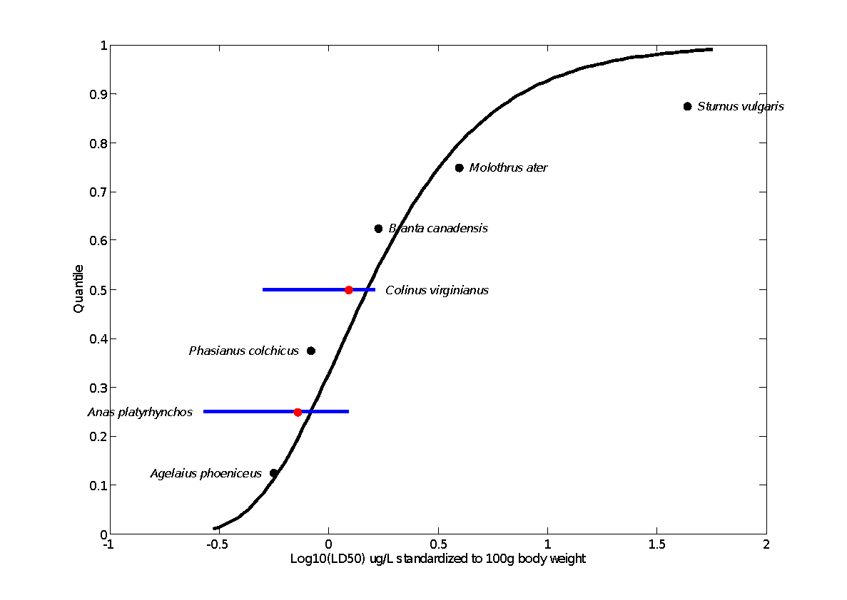
Figure 6-7. Log-gumbel SSD Fit for Bird Diazinon Data Using Maximum Likelihood
Red points indicate single toxicity values. Black points indicate multiple toxicity values. Blue lines indicate the full range of toxicity values for a given species. All values are standardized to a 100 g bird using Mineau Scaling Factor = 0.63 (Mineau, 1996).

Table 6-5. Summary Statistics for SSDs Fit to Diazinon Test Results for Birds
Statistic | Value
Best distribution (per AIC_{c}) | Log-gumbel
Goodness of fit P-value | 0.70
CV of the HC₀₅ | 0.39
HC₀₅ | 0.43
HC₁₀ | 0.54
HC₅₀ | 1.51
HC₉₀ | 7.63
HC₉₅ | 14.15
Mortality Threshold¹ | 0.019
Indirect Effects Threshold¹ | 0.187
¹Derived using slope of 3.53

ECOTOX reference 55700 included toxicity studies with juvenile and adult red-winged blackbirds and starlings exposed to diazinon (Table 6-6). The available data indicate that 1) hatchlings (0-3 days old) are most sensitive to diazinon; 2) as juveniles age, they become less sensitive; and 3) juvenile birds are more sensitive to diazinon compared to adults. For red-winged blackbirds, juveniles are more sensitive by a factor of 1.1-3.8. For starlings, juveniles are more sensitive by a factor of 4.2-47.

Table 6-6. LD₅₀ Values (mg/kg-bw) for Red-winged Blackbirds and Starlings of Different Ages Exposed to Diazinon
Red-winged blackbird |  | Starling
Age | LD₅₀ (95% CI) | Age | LD₅₀ (95% CI)
0-3 d | 2.4 (1.28-6.14) | 2 | 12.7 (10.9-15.1)
4-7 d | 3.4 (1.32-9.02) | 5 | 35.6 (23.1-69.3)
8-11 d | 8.3 (6.61-10) | 9 | 93.2 (72-126)
>11 d | NA | 15 | 102 (80.9-145)
 |  | 19 | 145 (NA)
Adult | 9.1 (3.88-15.9) | Adult | 602 (398-893)
NA = not available

Semi-field and field studies

The currently registered maximum application rate of diazinon is 4 lb a.i./A. Vyas et al. 2006 (ECOTOX #85970) reported mortality in Canada geese held in outdoor pens that were treated with 0.25-2 lb a.i./A (100% mortality at rates of 0.5-2 lb a.i./A). The LD₅₀ from the semi-field study (i.e., 0.31 lb a.i./A), is used to derive mortality thresholds for birds. Based on quantified residues on grass (food of birds in pens) and on birds’ feet, this endpoint represents the combined exposure through diet and dermal routes. There is uncertainty associated with the link between the diazinon exposure and effects observed in geese included in the semi-field study due to potential impacts of toxin producing fungi that may be present on grass and high levels of tryptophan in grass. These factors represent potential confounding stressors.

In another semi-field study with bobwhite quail kept in pens (Wang et al., 2001; ECOTOX # 56802), mortality was not observed at 2 lb a.i./A. In addition, some field studies have reported decreases in bird abundance in areas where diazinon was applied at 0.4 (ECOTOX #37883) and 3 lb a.i./A (MRID 41577401).

    - Sublethal Effects to Birds

Effects on Growth of Birds

A limited number of studies are available to evaluate potential impacts to growth of birds that are exposed to diazinon at sub-lethal levels. Figures 6-8 and 6-9 depict the growth based endpoints expressed as dietary-based concentrations and as application rates, respectively. No dose-based endpoints are available to quantify effects of diazinon on growth.

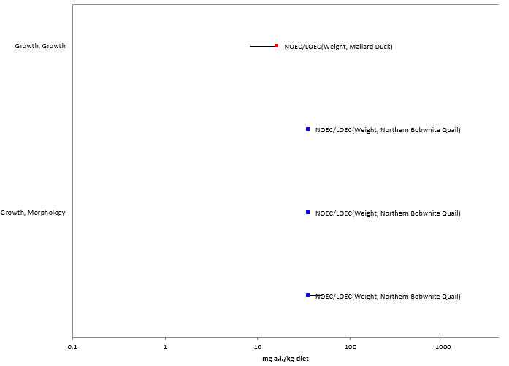
Figure 6-8. Dietary-based Growth Endpoints for Birds Exposed to Diazinon

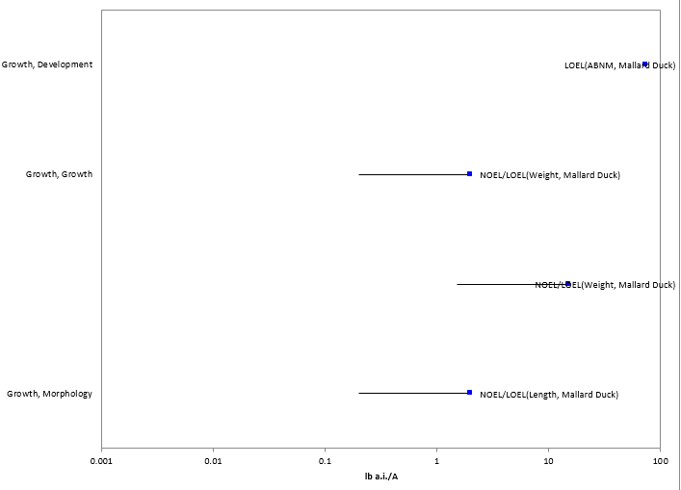
Figure 6-9. Application Rate-Based Growth Endpoints for Birds Exposed to Diazinon
In a registrant submitted reproduction study with mallard ducks (MRID 41322901), control male birds gained an average of 57 g during the course of the test, while males exposed to diazinon in food at 16.3 mg a.i./kg-diet lost an average of 17 g. In a reproduction study involving bobwhite quail, Stromborg (1981, ECOTOX # 35482) reported that adult males exposed to 72 mg a.i./kg-diet lost approximately 10% of their body weight.

Hoffman and Eastin (1981; ECOTOX#35250) reported a 11% decrease in weight of mallard embryos of eggs treated with 2 lb a.i./A diazinon in oil. When treated at 15 lb a.i./A in an aqueous emulsion, no effects to growth were observed.

No thresholds were based on growth effects because they did not represent the most sensitive among the sublethal effects.

Effects on Reproduction of Birds

Several studies are available that investigate the reproductive effects of diazinon on birds (Table 6-7, Figures 6-10 and 6-11). These data were not used to set the sublethal effects thresholds for the following reasons: 1) considerable uncertainties associated with the study representing the lowest endpoints (ECOTOX 38642); 2) a lower concentration based endpoint is available compared to the reproductive endpoint from MRID 41322901; and 3) the field studies where effects were observed in American robins included only one application rate. All of the data included in Figures 6-10 and 6-11 will be used in a WoE analysis to consider potential reproductive effects to birds who survive diazinon exposures.

Table 6-7. Reproductive Effects Observed in Studies Involving Diazinon
Test species | Reproductive effects observed at LOEC (percent of control) | NOEC/LOEC (mg a.i./kg-food) | Test mater-ial | Source
Domestic chicken | 1. Decrease in percent of fertile eggs (7%)  2. Decrease in number of chicks hatched per hen (20.9%)  3. Decrease in egg production (12%) | None/0.1 | Formula | ECOTOX 38642
Mallard duck | 1. Decrease in weight of surviving chicks (at day 14; 32%)  2. Decrease in number of 14-day old hatchling survivors per hen (41%)  3. Increase in number of days in production (60%)  4. Increase in number of eggs laid per hen (59%) | 8.3/16.3 | TGAI | MRID 41322901
Bobwhite quail | None | 32.0/none | TGAI | MRID 41322902
Bobwhite quail | Decrease in egg production | 35/50 | Formula | ECOTOX 35482
American robin | Decreasing in hatching in nests exposed to 0.56 lb a.i./A | None | Formula | ECOTOX  40193
Chipping sparrow, song sparrow | No impact to hatching in nests exposed to 0.56 lb a.i./A | None | Formula | ECOTOX  40193
American robin | Decrease (26% relative to control) in number of surviving fledglings observed in nests treated with 2 lb a.i./A | None | Formula | ECOTOX 40041
Bobwhite quail | No effects to hatchability or immune response in chicks. Exposure was direct spray onto eggs. | 4.0 lb a.i./A | Formula | ECOTOX 40200

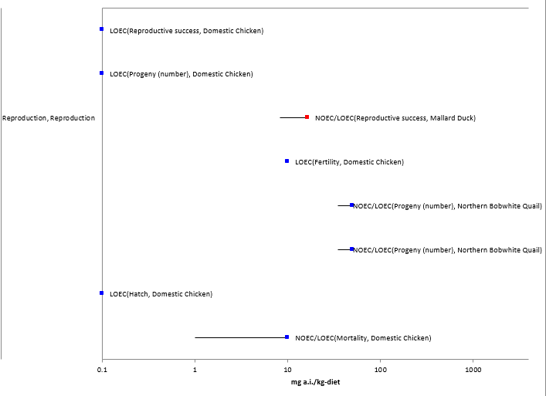
Figure 6-10. Dietary-based Endpoints for Reproductive Effects

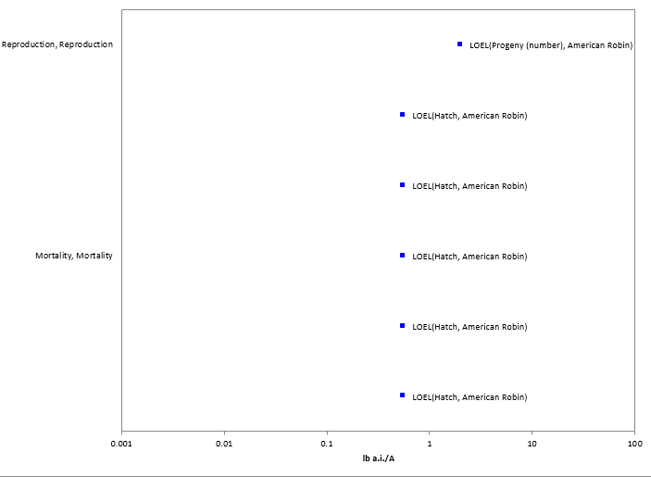
Figure 6-11. Application Rate-based Endpoints for Reproductive Effects

Effects on Behavior of Birds

The dose-based threshold for sublethal effects is based on behavioral effects observed in MRID 40895301. In this acute, dose-based study, mallards exposed to 0.681 mg a.i./kg-bw were unable to walk, resulting in a NOEC of 0.316. This endpoint is considered relevant to the fitness of an individual because limited locomotion would potentially increase the likelihood that an individual would be susceptible to predation as well as an inability to fly and thus migrate.
Other behavioral related endpoints reported in the open literature are summarized in Table 6-8.

Table 6-8. Behavioral Effects Observed in Studies Involving Diazinon
Test species | Behavioral effects observed at LOEC | NOEC/LOEC | Test material | Source
Mallard duck | Inability to walk | 0.316/0.681 mg a.i.../kg-bw | TGAI | MRID 40895301
Pigeon | No effects to flight observed | 1 mg a.i./kg-bw/none | TGAI | ECOTOX 100846
Bobwhite quail | Decrease in feeding | 35/50 mg a.i./kg-diet | formula | ECOTOX 35482
Ring-necked pheasant | Decreases in food consumption observed at 2200 mg a.i./kg-food | none | formula | ECOTOX 47473
American robin | Increased time sitting on nest (birds exposed to 2 lb a.i./A) | none | formula | ECOTOX 40041

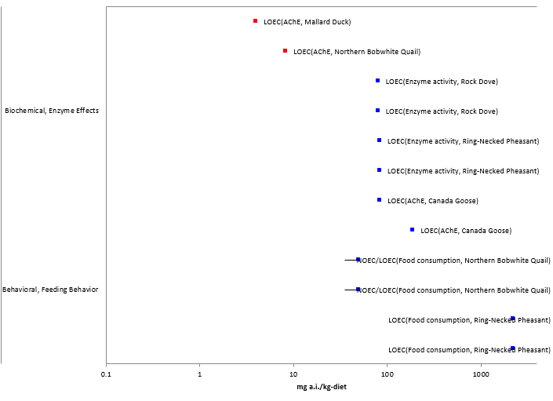
Figure 6-12. Dietary-based Endpoints for Behavioral Line of Evidence

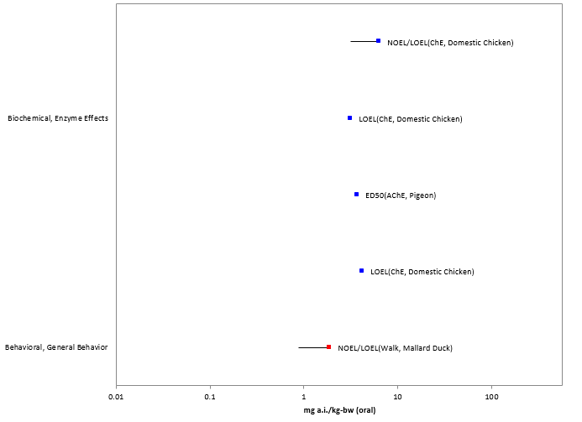
Figure 6-13. Dose-based Endpoints Relevant to Behavior Line of Evidence

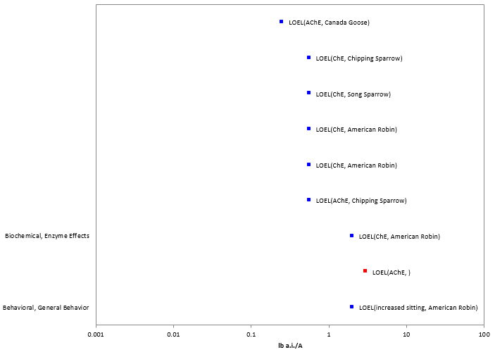
Figure 6-14. Application Rate-based Endpoints Relevant to Behavior Line of Evidence
Available literature suggests that widely varying levels of AChE inhibition are associated with observed behavioral effects in birds. Hart (1993) reported reductions of flying and singing and increases in resting in birds that had 39% inhibition of AChE in the brain. Feeding activity was reduced in birds with 27% decrease in AChE and posture was altered in birds with 12% inhibition of AChE. The authors suggested a threshold of 30-40% brain AChE inhibition for feeding and movement effects. Holmes and Boag (1990) exposed zebra finches to fenitrothion and found that birds with ≥50% inhibition of brain AChE were less active.

In a reproduction study available for mallard ducks (MRID 41322901), 53% inhibition of AChE was observed in brains of males exposed to 4 mg a.i./kg-diet. Thirty-eight per cent and 45% inhibition of AChE was observed in plasma of females and males, respectively, exposed to the same concentration. The dietary-based sublethal effects threshold is set to 4 mg a.i./kg-diet based on this study because 1) it is the lowest dietary-based endpoint that is considered quantitative; 2) AChE is relevant to the AOP for animals exposed to diazinon, and 3) the levels of inhibition are relevant to levels where other behavioral effects relevant to the fitness of birds have been impacted.

Effects on Sensory Function of Birds

No toxicity data are available to describe potential sensory effects of diazinon on birds.

      - AChE Inhibition in Birds

Given the mode of action of diazinon, it is expected that the chemical will have an impact on AChE. Inhibition of AChE interferes with proper neurotransmission in cholinergic synapses and neuromuscular junctions. This inhibition can lead to mortality and behavioral effects (e.g., decreases in feeding and locomotion). Therefore, available effects data for AChE inhibition are included in the mortality and behavioral lines of evidence. Many studies submitted by pesticide registrants and available in the open literature quantified AChE levels in the brains or blood (plasma) of birds exposed to diazinon. A subset of the available studies are discussed below.

In two registrant-submitted reproductive studies (MRIDs 41322901 and 41322902), AChE was inhibited at levels ranging from 3% to 85% in birds exposed to 4-32 mg/kg-diet (Table 6-9). Mortality was not observed in these studies.

Table 6-9. Decreases in AChE Observed in Reproductive Studies
Test concentration (mg a.i./kg-diet) | Mallard Duck (MRID 41322901) |  |  |  | Bobwhite Quail (MRID 41322902)
 | Brain: % ChE inhibition* |  | Plasma: % ChE inhibition* |  | Brain: % ChE inhibition* |  | Plasma: % ChE inhibition*
 | Males | Females | Males | Females | Males | Females | Males | Females
4.0 | 53% | No inhibition | 45% | 38% | NA | NA | NA | NA
8.3 | 14% | 38% | 69% | 54% | 10% | 40% | 49% | 47%
16.3 | 70% | 68% | 77% | 68% | 3% | 35% | 64% | 69%
32 | NA | NA | NA | NA | none | 40% | 85% | 85%
NA = not applicable
*relative to controls

Vyas et al. 2006 (ECOTOX 85970) exposed Canadian geese (Branta canadensis) to diazinon in the diet and observed mortality and AChE inhibition in the brain. These subacute laboratory toxicity studies were conducted according to standard methods. Table 6-10 includes the author’s LC₅₀ values as well as the range of AChE inhibition in the brains of surviving and dead exposed birds compared to controls. In general, the AChE inhibition of dead birds is higher (78-93%) compared to the inhibition in surviving birds (19-54%). AChE was significantly lower in all exposed birds compared to controls. (The lowest test concentrations were 190 and 84 mg a.i./kg-food in the TGAI and formulation tests, respectively). In a semi-field experiment conducted as part of this study, 59-77% AChE was observed in dead birds exposed to diazinon (through diet and dermal exposure) at rates ranging 0.5-2 lb a.i./A.

Table 6-10. Results from Sub-acute Dietary Toxicity Studies Conducted with Goslings Exposed to TGAI and Formulated Diazinon (ECOTOX 85970).
Lab/field | Test material | LC50 (95% confidence interval) | Slope (95% confidence interval) | Range of brain AChE inhibition (% decrease relative to controls)
 |  |  |  | Surviving birds | Dead birds
Lab | TGAI | 623 (397-1210) mg a.i./kg-diet | 2.5 (0.8-4.1) | 36-54 | 78-93
Lab | DZN 50W | 634 (404-1064) mg a.i./kg-diet | of 2.4 (1.2-3.5) | 19-40 | 82-92

Additional AChE endpoints available for birds are depicted in Figures 6-12 to 6-14. Because the mortality-based thresholds (1/million values) are protective of all endpoints available for ChE inhibition, AChE inhibition was not used to set the threshold. These data are discussed again below in the context of the behavioral effects line of evidence.

  - Incident Reports for Birds

EFED’s incident database (EIIS) contains hundreds of reports of mortality to birds that are associated with diazinon. Many of these incidents are associated with uses that are no longer registered, particularly granular formulations and residential uses. The use patterns of diazinon were mitigated substantially in the mid 2000’s as a result of the Diazinon Registration Eligibility Decision (RED} (e.g., rates were reduced, uses were cancelled, aerial applications were limited to lettuce). Since that time, several incidents have been reported to the EPA. Table 6-11 summarizes the incidents of avian mortality that have been reported since 2006. These reports include several different species at locations throughout the U.S. Little information associated with these incidents is available (i.e., diazinon application rate; use site, legality); however, the certainty index associated with all four incidents was “highly probable”. Details associated with the application of diazinon (e.g., formulation, application rate) are not available. It should be noted that although labels were altered to reflect RED risk mitigation, existing stocks of diazinon products may have been used after this point. The most recent incident reports from 2009 and 2013 are most likely to be the most representative of current uses of diazinon.

Table 6-11. Reported Mortalities of Birds Associated with Uses of Diazinon. For all of these incidents, the certainty index is “highly probable” and the legality is undetermined.
Species | Number of dead birds | Date of incident | Location | Incident ID | Comments
Canada goose | 39 | 5/11/2006 | Moses Lake, WA | I018980-043 | Formulation unknown
Canada goose | 7 | 8/8/2006 | Lake Shafer, IN | I018980-031 | Formulation unknown
Mallard duck | 1 | 8/8/2006 | Lake Shafer, IN | I018980-031 | Formulation unknown
Mallard duck | 8 | 10/15/2009 | Black River, VA | I021455-004 | Diazinon was quantified in birds, 91-93% cholinesterase inhibition reported. Formulation unknown
Brown headed cowbirds, common grackles, red-winged blackbirds | 100 | 12/31/13 | Salem Co, NJ | I026953-004 | Diazinon was quantified in collected tissues. Formulation unknown

Effects Characterization for Reptiles

No toxicity data are available for reptiles exposed to diazinon. The available toxicity data and thresholds for birds will be used as a surrogate for reptiles. There is notable uncertainty in using birds as surrogates for reptiles as it is assumed that they will have similar responses to diazinon. The actual sensitivities of reptiles to diazinon relative to birds is unknown.

Effects Characterization for Terrestrial-phase Amphibians

There is only one study available for terrestrial-phase amphibians exposed to diazinon (ECOTOX 503986). In this acute oral toxicity study, bullfrogs, as well as mallards and pheasants were dosed with diazinon. The LD₅₀ for the bullfrog was a non-definitive value of >2000 mg a.i./kg-bw reported. The mallard and pheasant LD₅₀ values were 3.54 and 4.33 mg a.i./kg-bw, respectively. For the 1 tested amphibian species, the acute toxicity was at least 3 orders of magnitude less sensitive compared to the tested bird species.

There are insufficient data on amphibians in the terrestrial environment to derive separate thresholds for amphibians. Therefore, the available toxicity data for birds will be used as a surrogate for terrestrial-phase amphibians. There is notable uncertainty in using birds as surrogates for terrestrial-phase amphibians as it is assumed that they will have similar responses to diazinon. Because only one study from one amphibian test species is available, the relative sensitivities of birds and amphibians cannot be quantified.

Effects Characterization for Mammals

Introduction to Mammal Toxicity

Diazinon is an insecticide that kills invertebrates by inhibiting cholinesterase activity, thereby preventing the natural breakdown of various cholines and ultimately causing the neuromuscular system to seize. Relevant to mammals, it was used previously on pet collars and continues to be used on cattle ear tags. In contrast to other wildlife taxa, the mechanism and consequences of cholinergic toxicity in exposed mammals are well understood. Experimental and epidemiological data have informed US EPA’s understanding of the relationship between diazinon-induced cholinesterase inhibition, clinical signs of toxicity, and potential morbidity and mortality at higher levels of exposure in mammals.
The available test data span four orders (and families) of terrestrial mammals: Artiodactyla (Bovidae, two studies), Carnivora (Canidae, three studies), Lagomorpha (Leporidae, one study), and Rodentia (Muridae, 68 studies). Mortality thresholds are derived from empirically determined median lethal (LD₅₀) values. For sublethal effects, the biological evaluation for diazinon relies upon a weight-of-evidence analysis previously conducted by the Agency to establish points of departure for human health risk assessment. The points of departure are based upon cholinesterase inhibition in the laboratory rat and are expressed as the lower confidence limit on a benchmark dose value (BMDL₁₀). This value serves as the direct sublethal effects threshold in the current analysis. The full suite of available endpoints is presented visually in the form of data arrays for context and for consideration in the lines of evidence. The arrays include no observed or lowest observed effects level (NOEL/LOEL) values from older studies, which are lower than the BMDL₁₀ but are superseded by that benchmark dose analysis. No ecological incident reports relevant to mammals have been received since 2006, when diazinon use was altered substantially as a result of RED mitigations. Taken as a whole, the data are used to further characterize the potential hazard using a qualitative weight-of-evidence approach.

  - Threshold Values for Mammals

The threshold values for mammals are based upon experimentally determined endpoints for diazinon exposures of varying durations. The mortality thresholds are based upon the lowest available median lethal dose (LD₅₀) value identified from single dose (acute) exposures in the available open literature and unpublished data. For sublethal effects, human health risk assessments for diazinon utilize mammalian cholinesterase inhibition data to establish points of departure, which are similar in concept to risk assessment threshold values. As more robust datasets have become available, US EPA has transitioned from primarily selecting NOEL/LOEL values as points of departure to a more sophisticated approach, which uses the lower confidence limit on a benchmark dose (BMD) value, i.e., the BMDL₁₀. While the resulting value is by definition slightly greater than the lowest available NOEL or LOEL from a single study, there is greater confidence in the reliability of the BMDL₁₀ value because the data have already been subject to a weight-of-evidence analysis (within the context of diazinon mammalian toxicity data) and internal EPA peer review by an expert panel of toxicologists. Therefore, for the purpose of this biological evaluation, the BMDL₁₀ for cholinesterase inhibition in mammals is used as the threshold value for direct sublethal effects of diazinon, and the BMD₁₀ is used as the threshold for indirect sublethal effects.

Direct and indirect effects thresholds are presented for acute mortality endpoints in Table 9-1 and for sublethal effects in Table 9-2. The data from which threshold values are derived are discussed in more detail in the following sections, arranged by lines of evidence. For mammals, threshold values and data arrays (next section) in this assessment are based on endpoints expressed in, or readily converted to milligram per kilogram body weight (mg/kg bw). The number of species tested in the available studies is limited; therefore, a species sensitivity distribution is not provided.

Table 9-1. Direct and Indirect Effects Thresholds Based on the Most Sensitive Acute (single dose) Mortality Endpoints (LD₅₀).

Exposure Unit | Threshold Type | Value | Source  (ECOTOX or MRID No.) | Exposure Route | Duration
mg/kg bw | Direct (1/million) | 2.38  ug/g bw | Mouse (Mus musculus)  LD₅₀ = 105 ug/g bw  Slope = 2.89  E85110 | Oral | Single dose,  9 day observation of adult female mice during gestation
 | Indirect (1/10) | 37.8  ug/g bw

Table 9-2. Sublethal Direct and Indirect Effects Thresholds for Mammals
Exposure Unit | Threshold Type  (endpoint value) | Value | Source | Exposure Route | Duration
mg/kg bw | Direct | 0.35 mg/kg bw/day | Comparative cholinesterase assay  CD Rat (Rattus norvegicus)  BMDL₁₀= 0.35 mg/kg bw/day  BMD₁₀=0.52 mg/kg bw/day  MRID 46166302 | Oral | 7 day, repeat dose
 | Indirect | 0.52 mg/kg bw/day

Summary Data Arrays for Mammals

The following data array (Figure 9-1) provides a visual summary of the available data for diazinon effects on mammals. Effects concentrations are on the horizontal (X) axis, and the effect and endpoint type (e.g., Mortality, LD₅₀) are identified on the vertical (Y) axis. The data are obtained from registrant-submitted ecotoxicity studies and from open literature studies, which have been screened as part of the US EPA ECOTOX database review process. A discussion of effects, including more detailed data arrays, follows the summary and is organized according to lines of evidence. Endpoints which cannot be readily converted to values with assessment-relevant units (i.e., mg/kg bw for mammals) based on the information in the ECOTOX record are briefly discussed later in the chapter but are excluded from the arrays. Citations for all available data (included and excluded) are provided in APPENDIX 2-2 and APPENDIX 2-5, respectively. Data points associated with the arrays are summarized in APPENDIX 2-1.

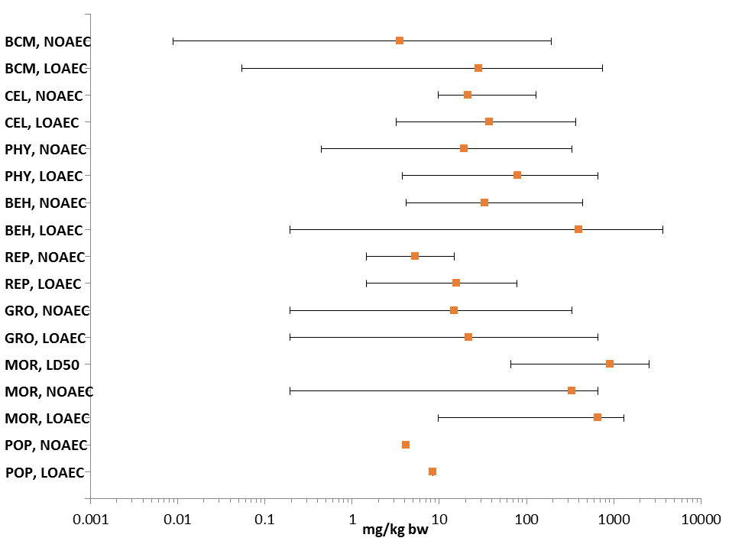
Figure 9-1. Summary Data Array for Mammalian Toxicity Endpoints Adjusted for Body Weight (mg/kg bw)
^{BCM:} Biochemistry. ^{BEH:} Behavior. ^{CEL:} Cellular. ^{GRO:} Growth. ^{LD50:} Median lethal dose. ^{LOAEC:} Lowest observed adverse effects concentration. ^{MOR:} Mortality. ^{NOAEC:} No observed adverse effects concentration. ^{PHY:} Physiology. ^{POP:} Population. ^{REP:} Reproduction.

Lines of Evidence for Mammals

Effects on Mortality of Mammals

In a laboratory study of mortality and reproductive toxicity, Mufti and Ullah (1991, E85110) exposed adult female mice (Mus musculus) to formulated diazinon (Basudin 60EC, Ciba-Geigy) via oral gavage on day 6 of gestation. Maternal mortality was observed at all treatment levels with 14% mortality at 50 ug/g bw (n=7) and 100% mortality at 500 ug/g bw (n = 16) and 1,000 ug/g bw (n=19). No maternal mortality was observed in controls (n=5). The reviewer-determined LD₅₀ value was 105 ug/g bw, with 95% confidence limits of 67.6 to 140 ug/g bw and a dose-response slope of 2.89. The LD₅₀ value is used to derive direct and indirect effects thresholds for diazinon toxicity to mammals in this assessment. Fetal effects were difficult to interpret in the presence of maternal toxicity, but when mothers survived to test termination, fetal crown-rump length and weight appeared to decrease in a dose-dependent manner. The study authors characterized this observation as a tendency toward dwarfism. The statistical significance of effects was not determined by the study authors. Previous ecological risk assessments for diazinon have relied upon the LD₅₀ value of 936 mg/kg bw (males and females combined) from a registrant-submitted study with oral (gavage) exposure in the rat (Rattus norvegicus) (MRID 41334607). The 95% confidence limits were 742 - 1,180 mg/kg bw.

Figure 9-2 provides an overview of the experimental dataset for diazinon-related mortality in mammals, including data discussed above. In general, each array presents data for a specific type of exposure unit with values plotted against the horizontal (X) axis on a logarithmic scale. The data labels identify the type of effect observed, the phylogenetic order, and the study duration (when known). A red box around the data label signifies that the data point was used to establish a threshold value for effects to listed species. Both open literature data captured in ECOTOX and unpublished studies submitted to US EPA are included, when available. Data points for EPA-reviewed, unpublished studies are red and are noted with an asterisk. When both no effect and lowest effect levels (e.g., NOAEL/LOAEL values) are determined by a study, a line to the left of the data point represents the difference between these two values. Unless noted otherwise, all data are specific to mammals. Data arrays in subsequent sections are formatted similarly.
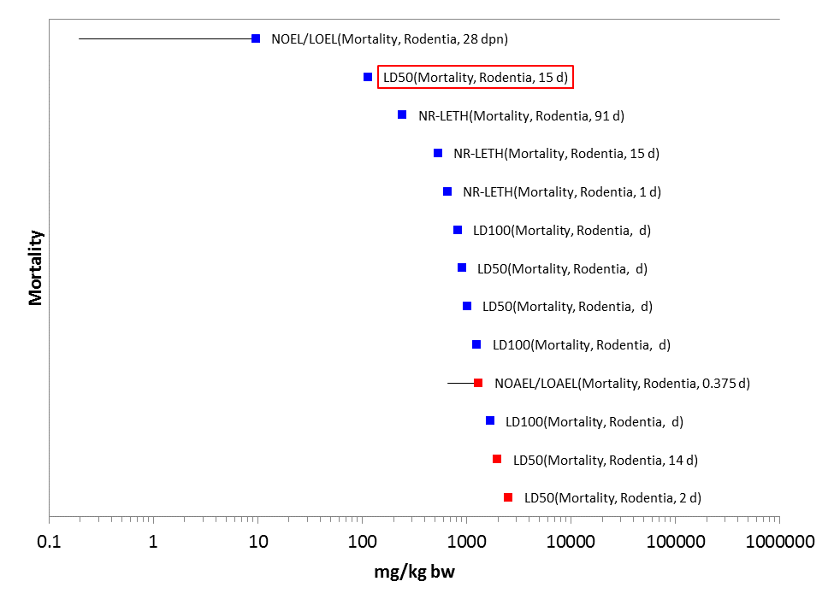
*
*
*
Figure 9-2. Array of Mortality Endpoints Adjusted for Body Weight

Sublethal Effects to Mammals

9.4.2.1. Effects on Growth of Mammals

In a neurobehavioral study previously reviewed by US EPA’s Health Effects Division (HED), Spyker and Avery (1977, E39570) noted that maternal body weight gain was lower during pregnancy in mice exposed to diazinon at 0.18 mg/kg bw/day and at 9.0 mg/kg bw/day, as compared to controls. Body weight gain was also lower in mouse pups whose mothers were exposed to diazinon at 9.0 mg/kg bw/day, as compared to controls. As shown in Figure 9-3, other studies have demonstrated effects on body weight, body weight gain, and developmental endpoints at exposure levels that are greater than the BMDL₁₀ for cholinesterase inhibition.
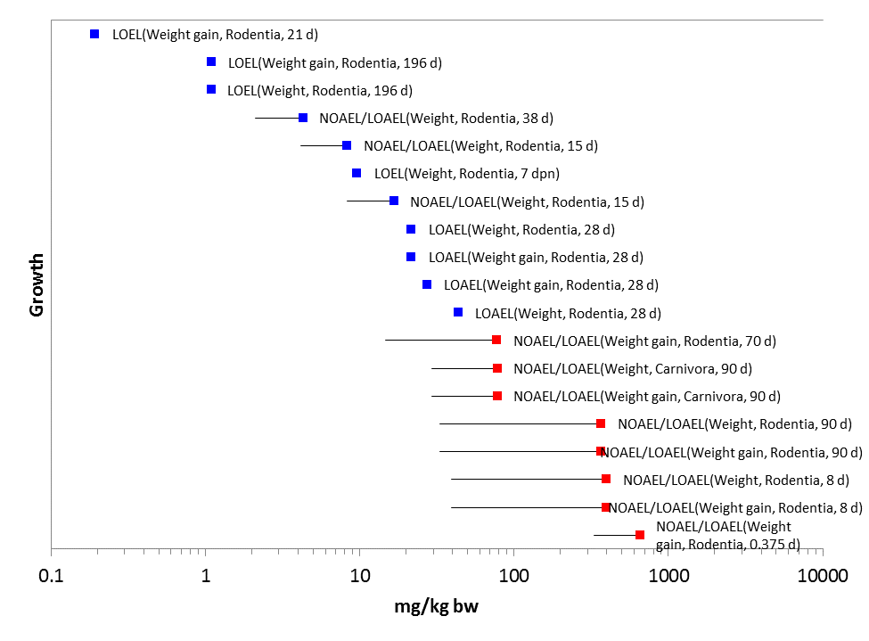
*
*
*
*
*
*
*
*

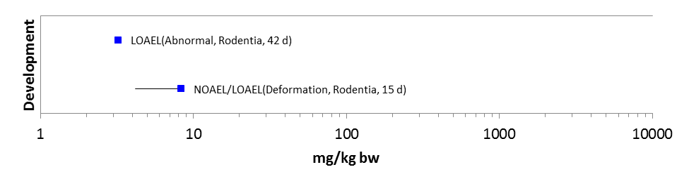
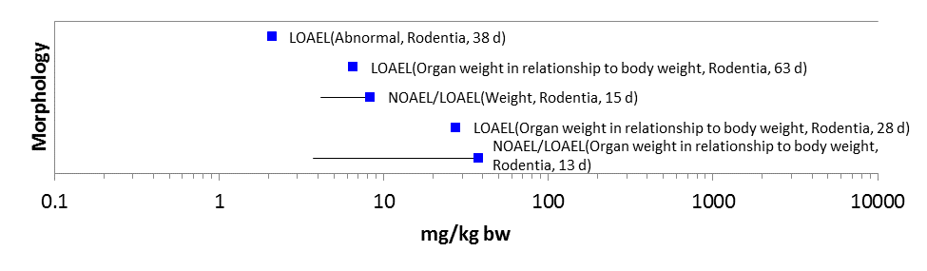
Figure 9-3. Array of Growth and Development Endpoints Adjusted to Body Weight

9.4.2.2. Effects on Reproduction of Mammals

Relatively few studies are available which primarily examine reproductive toxicity of diazinon in mammals. All experiments were performed with rodents. Studies discussed in the preceding lines of evidence included observations of fetal effects (Mufti and Ullah 1991, E85110) and lower offspring body weight gain (Spyker and Avery 1977, E39570) in the mouse, both in the presence of maternal toxicity. In addition to these data, unpublished studies submitted by the registrant reported effects on body weight, fertility, number of offspring, vaginal opening, and gestation time at exposures between 1 and 100 mg/kg bw. Open literature studies identified effects on motility, mating index, and post-implantation loss within the same range of exposure levels. These effects were seen at doses greater than the BMDL₁₀ for cholinesterase inhibition.

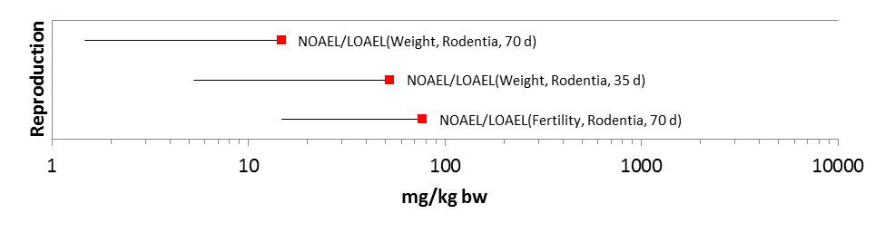
*
*
*
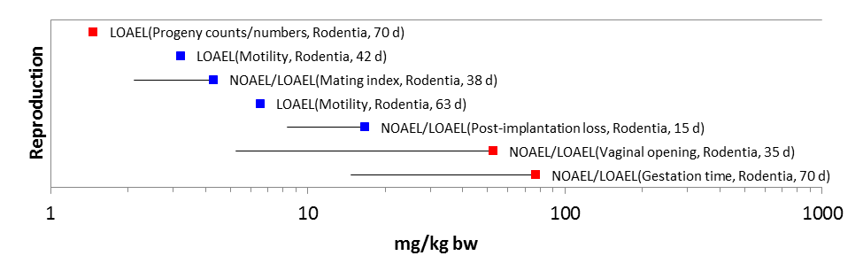
*
*
*
Figure 9-4. Arrays of Reproductive Endpoints Adjusted for Body Weight

9.4.2.3. Effects on Behavior of Mammals

Spyker and Avery (1977, E39570) dosed adult female mice with diazinon in peanut butter following mating and daily until parturition. Offspring were examined for developmental landmarks and subjected to a variety of sensory and locomotor tests, including righting reflex, climbing, startle response, swimming, clinging, and exploration. The study authors reported impaired neuromuscular function (strength or coordination) in later trials with offspring of mothers exposed at 0.18 and 9.0 ug/g bw/day. However, the overall effects (considering all trials) were not statistically significant, and the authors noted that open field tests performed at the same doses showed no effect. The Health Effects Division reviewed the data from Spyker and Avery (1977) in support of the 1986 registration standard for diazinon and concluded that there was “no significant evidence of diazinon effects on the nervous system.” Therefore, the data point for effects on coordination is presented in the array for context but is not used to establish a threshold value.

Other studies that examined effects of diazinon on activity and coordination in rodents more consistently observed impairments at exposure levels similar to or above the level where clinical signs of cholinergic toxicity were observed. These clinical signs may not have been observed in the same study depending on the experimental design and timing of observations relative to dosing. Specifically, convulsions (MRID 41158101, MRID 43543902) and impaired mobility (MRID 43132204) were observed in animals exposed at approximately 80 mg/kg bw and above. An unpublished neurobehavioral study with diazinon observed impairment of swimming in the rat at a slightly lower dose (approximately 50 mg/kw bw) (MRID 46195601). Effects on stereotypy (MRID 43132204), aggression (MRID 40815003), grip strength (MRID 43543902), and general activity (Geraldi et al. 2008, E153607) were observed at doses of 300 mg/kg bw and above.
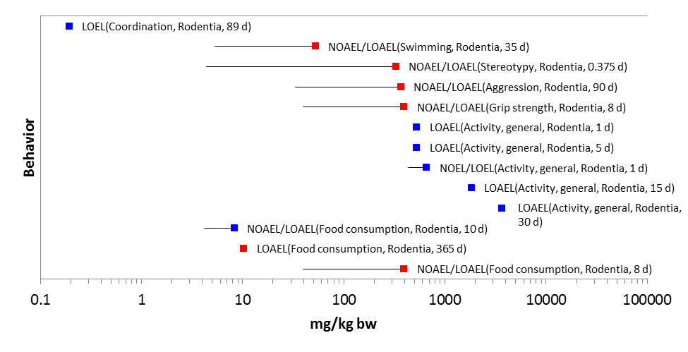
*
*
*
*
*
*
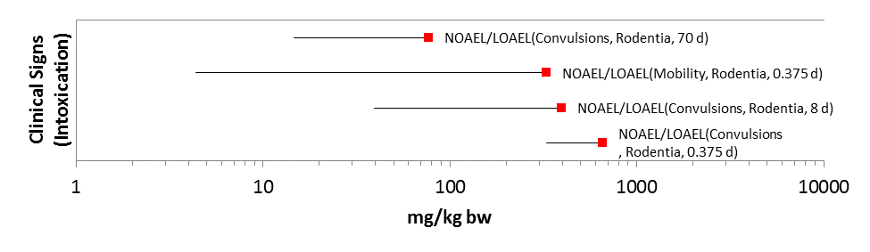
*
*
*
*
Figure 9-5. Arrays of Behavioral Endpoints Adjusted for Body Weight

9.4.2.4. Effects on Sensory Function of Mammals

There are no data available in the ECOTOX database for diazinon effects on sensory function in mammals. Spyker and Avery (1977, E39570) recorded developmental landmarks including sensory function in offspring of mice exposed to diazinon in peanut butter. No sensory inhibitions were observed.

9.4.2.5. Cholinesterase Inhibition in Mammals

The threshold values for diazinon direct and indirect sublethal effects are based upon the benchmark dose analysis of a repeat dose comparative cholinesterase assay (MRID 46166302). The benchmark dose analysis accounts for the empirically determined dose-response (inhibition response) curve for diazinon exposure in mammals. Although statistically significant differences in biochemical parameters, including cholinesterase activity, were observed at lower doses in other studies, an expert panel of US EPA toxicologists concluded that the repeat dose comparative cholinesterase assay with diazinon provides the most scientifically sound, reliable, and relevant data for use in risk assessment.

Repeated exposure to diazinon in the comparative cholinesterase assay (MRID 46166302) resulted in statistically and biologically significant decreases in the cholinesterase activity in plasma, red blood cell (RBC), and brain of young adult rats, and in PND 11, PND 17, and PND 21 pups. In adults, effects were noted at 0.3 mg/kg bw/day in females after repeated exposures. After repeated exposures, effects were noted in PND 17 pups at 0.3 mg/kg bw/day in both sexes. Repeated doses of 0.03 mg/kg caused no significant effects. The BMD₁₀ was established as 0.52 mg/kg bw/day, and the BMDL₁₀ was established as 0.35 mg/kg bw/day based on inhibition of red blood cell (RBC) cholinesterase activity in female rat pups.
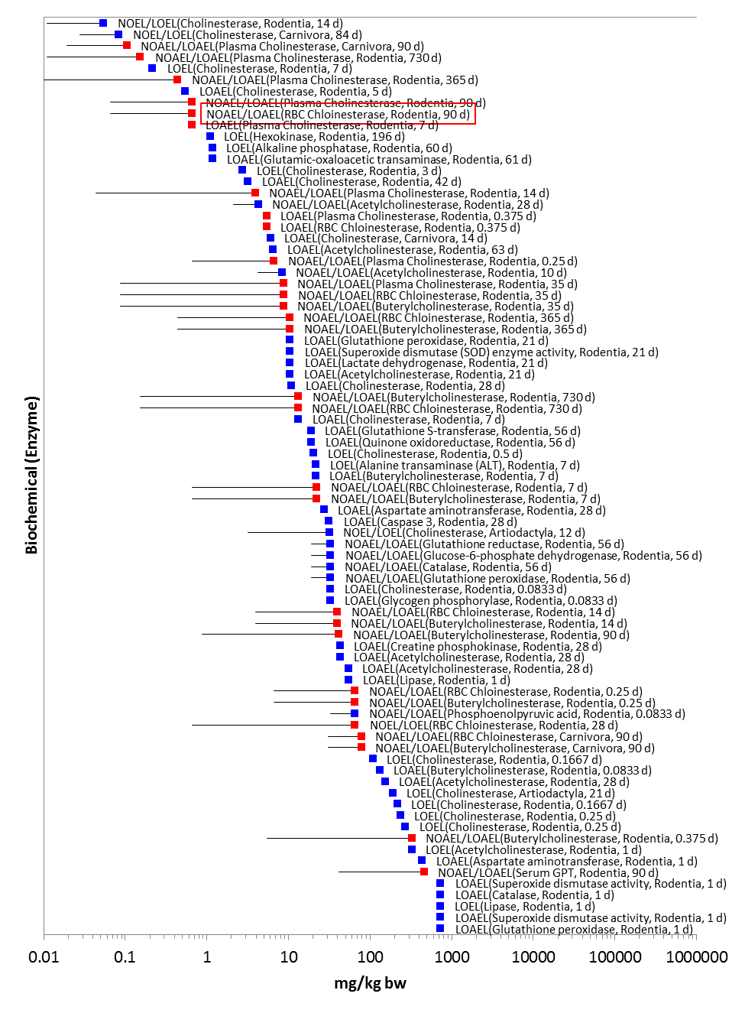
*
*
*
*
*
*
*
*
*
*
*
*
*
*
*
*
*
*
*
*
*
*
*
*
*
*
*
*
*
Figure 9-6. Arrays of Cholinesterase (and Other Enzyme) Endpoints Adjusted for Body Weight

9.4.2.6. Other Effects on Mammals: Genetic, Cellular, and Biochemical Parameters

For mammals exposed to diazinon, other biochemical effects in the open literature are reported for enzyme activity other than cholinesterase (included in the previous array) and general clinical chemistry, including uroporphyrin, protein, lipids, glycogen, and other parameters. Observations are generally presented as NOAEL/LOAEL values, which establish a baseline for statistically significant effects but do not correspond to a given magnitude of effect.

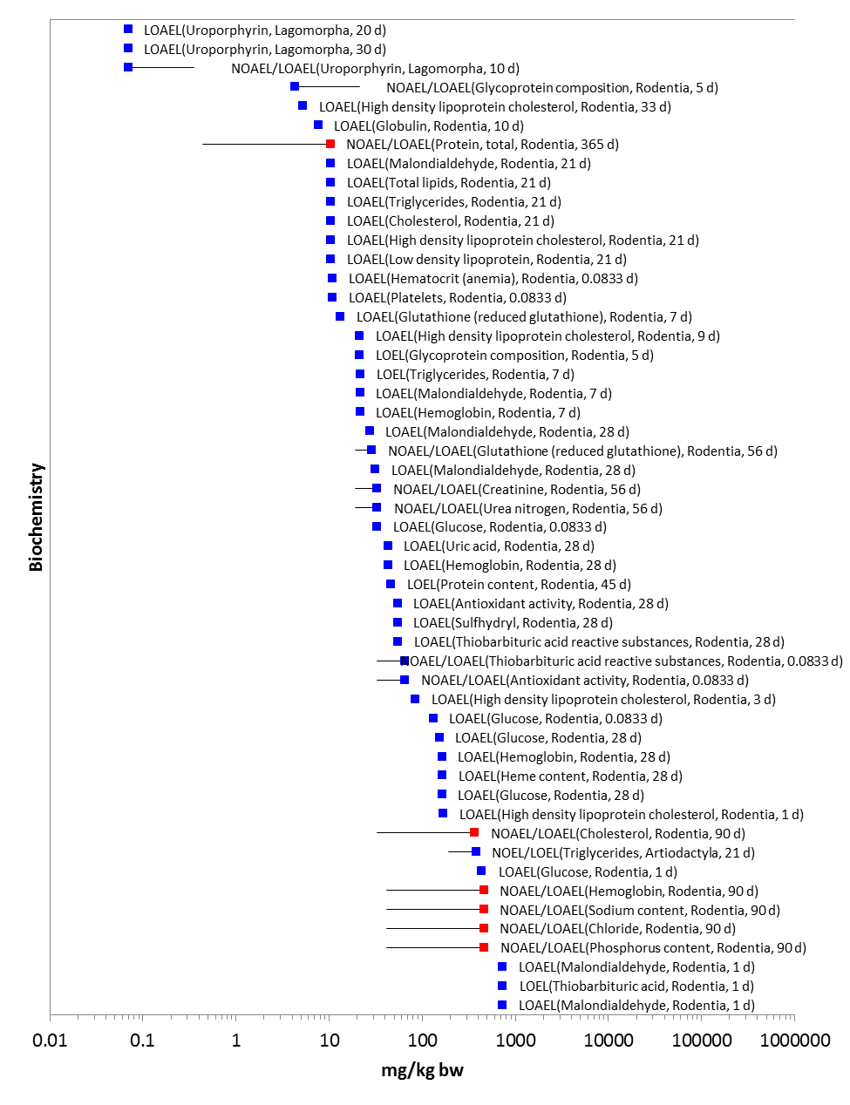
*
*
*
*
*
*

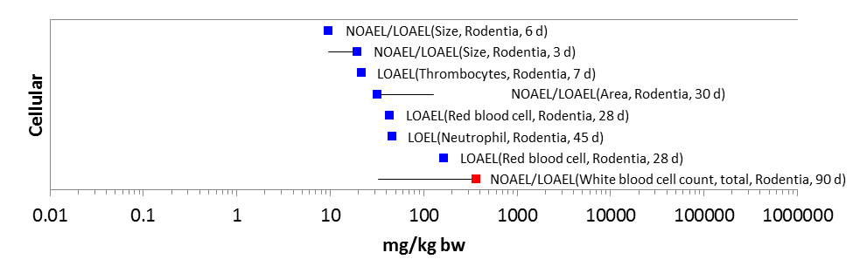
*
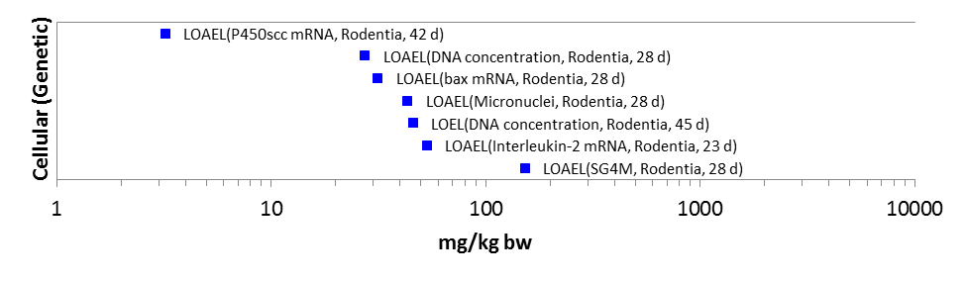
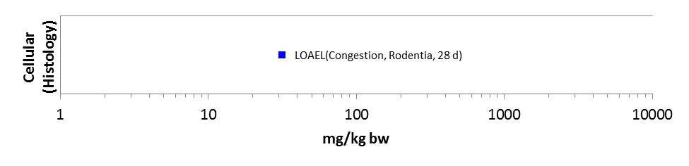
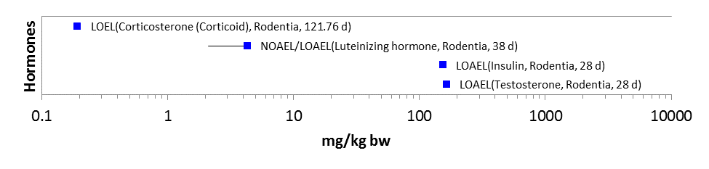
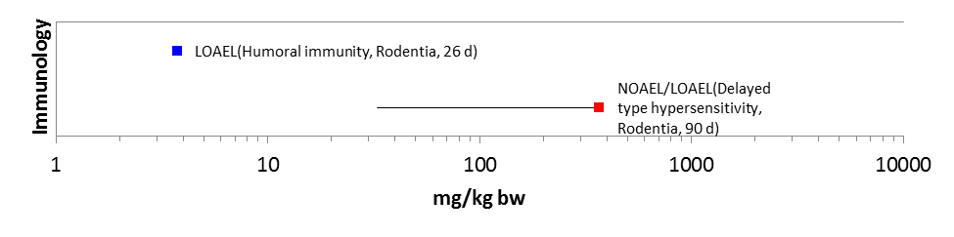
*
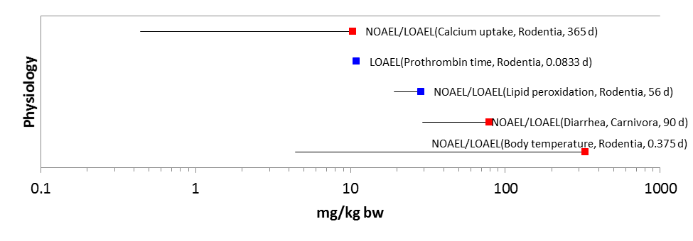
*
*
*
Figure 29-7. Arrays of Physiological Endpoints Adjusted for Body Weight

Field and Field-like Studies and Population-level Effects with Mammals

Six field or field-like studies were included in the ECOTOX report (Table 9-3). These data are discussed briefly here for characterization. They are not included in data arrays or considered for threshold derivation due to uncertainties in exposure levels and the variable nature of field studies. Behavioral and reproductive effects were noted in certain rodent species, but the majority of observations across studies with rodents and livestock revealed no effects. Mohammad et al. (2007, E100491) examined cholinesterase inhibition in the domestic cow (Bos taurus) exposed to a single treatment level of formulated diazinon (60% a.i.) over a two-hour period. No effects were reported, and there was insufficient information to quantify the exposure, which was reported only as a percentage. Similarly, Mount (1984, E104021) saw no effects on cholinesterase inhibition in a 7-day study with a goat (Capra hircus) exposed to diazinon (87.6% a.i.) at 5 mg/kg bw. Sheffield and Lochmiller (2001, E56801) reported effects on behavioral and reproductive endpoints in various rodent species exposed to a formulated diazinon (47.5% a.i.) at 0.56 lbs a.i./A in a prairie grassland ecosystem; however, there were no effects on population-relevant endpoints such as abundance or recapture ratio at 4.5 lbs a.i./A. In a separate volume, Sheffield (1996, E884472) reported effects on rodent body temperature, cholinesterase activity, and in some cases reproductive behavior at 0.5 lbs a.i./A, but in other cases no effects were seen on reproductive behavior up to 4 lbs a.i./A. There were no effects on relative organ weight up to 4 lbs a.i./A (Sheffield 1996, E884472). Wang et al. (2001, E56802) observed no effects on the number of reproducing organisms or population growth rate in the grey-tailed vole (Micortus canicaudus) exposed to diazinon at 2.22 lbs a.i./A. Spradberry and Tozer (1996, E54433) saw no effects on weight gain in a 140-day study with the domestic cow, but the exposure level was reported only as a percentage.
Table 9-3. Observations from Field and Field-like Studies with Diazinon Reported in ECOTOX Database
Scientific Name | Common Name | Observation | Endpoint | Duration (d) | Value | Units | Source
Bos taurus | Domesticated cattle | Weight gain | NOAEL | 140 | 20 | ppm | E54433
Microtus ochrogaster | Prairie vole | Reproductive behavior changes | LOEL | 16 | 0.56 | lb/acre | E56801
 |  | Pregnant, paris or gravid | LOEL | 30 | 0.56
 |  | Recapture ratio | NOEL | 30 | 4.5
Mus musculus | House mouse | Abundance | NOEL | 30 | 4.5
Reithrodontomys fulvescens | Fulvous harvest mouse | Reproductive behavior changes | LOEL | 2 | 0.56
 |  | Pregnant, paris or gravid | LOEL | 30 | 0.56
Reithrodontomys humulis | Eastern harvest mouse | Abundance | NOEL | 30 | 4.5
 |  | Recapture ratio | NOEL | 30 | 4.5
Sigmodon hispidus | Hispid cotton rat | Behavioral changes, general | LOEL | 30 | 0.56
 |  | Reproductive behavior changes | LOEL | 2 | 0.56
 |  | Reproductive behavior changes | LOEL | 30 | 0.56
 |  | Pregnant, paris or gravid | LOEL | 30 | 0.56
 |  | Abundance | NOEL | 30 | 4.5
Microtus canicaudus | Gray-tailed vole | Population growth rate | NOEL | 50 | 2.22 | lb/acre | E56802
 |  | Reproducing organisms | NOEL | 50 | 2.22
Microtus ochrogaster | Prairie vole | Body temperature | LOAEL | 2 | 0.5 | lb/acre | E88472
 |  | Cholinesterase | LOAEL | 2 | 0.5
 |  | Reproductive behavior changes | LOAEL | 16 | 0.5
 |  | Reproductive behavior changes | LOAEL | 2 | 0.5
 |  | Recapture ratio | NOAEL | 30 | 4
 |  | Organ weight : body weight | NOAEL | 30 | 4
Mus musculus | House mouse | Recapture ratio | NOAEL | 30 | 4
Reithrodontomys fulvescens | Fulvous harvest mouse | Reproductive behavior changes | LOAEL | 16 | 0.5
 |  | Reproductive behavior changes | LOAEL | 2 | 0.5
 |  | Body temperature | LOAEL | 2 | 0.5
 |  | Cholinesterase | LOAEL | 2 | 0.5
 |  | Recapture ratio | NOAEL | 30 | 4
 |  | Organ weight : body weight | NOAEL | 30 | 4
Sigmodon hispidus | Hispid cotton rat | Reproductive behavior changes | LOAEL | 2 | 0.5
 |  | Organ weight : body weight | NOAEL (LOAEL) | 30 | 0.5 (4)
 |  | Body temperature | LOAEL | 2 | 0.5
 |  | Cholinesterase | LOAEL | 2 | 0.5
 |  | Reproductive behavior changes | NOAEL (LOAEL) | 16 | 0.5 (4)
 |  | Recapture ratio | NOAEL | 30 | 4
Bos taurus | Domesticated cattle | Cholinesterase | NOAEL | 0.0833 | 0.036 | ppm | E100491
Capra hircus | Wild goat | Cholinesterase | NOAEL | 7 | 5 | mg/kg bw | E104021

As shown in the array below, one 15-day laboratory study identified an effect on sex ratio at approximately 8 mg/kg bw.

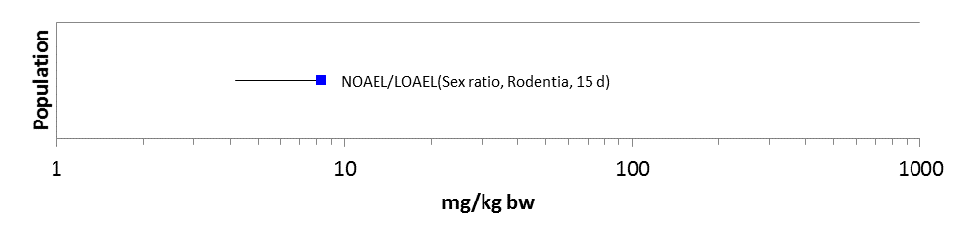
Figure 9-8. Array of Population Relevant Endpoints Adjusted for Body Weight

Effects to Mammals Not Included in Arrays

In addition to the field studies described above, data from nine studies in ECOTOX were excluded from the data arrays, generally because the records lacked sufficient information to convert values into units relevant to the exposure analysis. The citations for these studies are provided in APPENDIX 2-2.
Four of these studies examined dermal exposure in the mouse (Mus musculus) (Sogorb et al. 1993, E90688), rat (Rattus norvegicus) (Nichol et al. 1983, E88385), rabbit (Oryctolagus cuniculus) (Yehia et al. 2007, E100112), and cow (Bos taurus) (Danielson and Golsteyn 1997, E84471). Effects included 100% mortality in the mouse (Sogorb et al. 1993, E90688); differences in cell count, biochemistry, and relative organ weight in the rabbit (Yehia et al. 2007, E100112); and differences in cholinesterase activity in the cow (Danielson and Golsteyn 1997, E84471). No effects were seen on feeding efficiency or weight gain in the cow (Danielson and Golsteyn 1997, E84471) or on biochemistry in the rat (Nichol et al. 1983, E88385).

Study durations ranged from 5 days to 100 days. The dermal exposure levels were reported in different units and therefore could not be straightforwardly compared. Four studies, all published by the same group of authors, presented results of diazinon exposure in vitro with cell lines of the pig (Sus sp.) and mouse (Mus musculus). The lowest IC₅₀ value was 22 micromolar (µM) for maturity in cell culture from the pig (Casas et al. 2010; E121217). Differences in mitosis and cell number were observed in the same study at 25 µM (Casas et al. 2010; E121217). Effects on cell viability were observed at 100 µM but not at 50 µM (Betancourt et al. 2006, E88387). The highest in vitro diazinon concentration tested with the pig cell line was 500 µM (Ducolomb et al. 2009, E121218). No statistical differences were seen in fertilization, cell mortality, attainment of morula stage, or cell cleavage, and the IC₅₀ for fertilization was estimated to be near the highest concentration (i.e., 502 µM) (Ducolomb et al. 2009, E121218). In the mouse cell line, a statistical difference in cell mortality was noted at 225 µM but not at 188 µM (Bonilla et al. 2008, E118159).

Finally, Boyd and Carsky (1969, E111914) reported differences in body temperature, food consumption, and weight gain in the rat (Rattus norvegicus) exposed to diazinon in combination with various dietary restrictions (e.g., low protein). Exposure levels were reported as a range from minimum (50 mg/kg bw) to maximum (700 mg/kg bw), but a single, specific exposure level was not identified in association with the reported effects (Boyd and Carsky, 1969; E111914). These values are within the range of values presented in the preceding lines of evidence for diazinon effects on mammals; therefore, their exclusion does not substantively impact the conclusions of this assessment.

Incident Reports for Mammals

The US EPA Ecological Incident Information System (EIIS, v. 2.1.1, last updated Jan. 26, 2015) was searched for diazinon-related incident reports on September 29, 2015. The search identified no reports of adverse effects on mammals potentially associated with diazinon use after 2006, when implementation of RED mitigations for diazinon altered certain use patterns.

Effects Characterization for Terrestrial Invertebrates

Introduction to Terrestrial Invertebrate Toxicity

Diazinon is an insecticide that kills invertebrates by inhibiting cholinesterase activity, thereby preventing the natural breakdown of various cholines and ultimately causing the neuromuscular system to seize. As an insecticide, its lethality to terrestrial invertebrates has been well documented in the literature. Various studies have also examined effects on cholinesterase activity parallel to effects on apical endpoints such as mortality and growth. However, there is insufficient information at this time to determine the magnitude of effect on terrestrial invertebrate cholinesterase activity from a particular diazinon exposure that would be likely to result in mortality or other adverse fitness consequences for an individual. Data from the literature illustrate that the slope of exposure-response curves for terrestrial invertebrates exposed to diazinon is often relatively steep, and adverse effects on fitness parameters such as growth are generally seen only at levels that also elicit significant mortality. Therefore, this assessment utilizes mortality endpoints from various exposure routes and durations as the basis for establishing thresholds for potential direct effects in listed species and indirect effects in species that rely upon terrestrial invertebrates. Supporting data on growth and physiological effects are presented and used to further characterize the potential hazard using a qualitative weight-of-evidence approach. Incident reports of adverse effects on terrestrial invertebrates are discussed, but all pre-date 2006, when diazinon use was altered substantially as a result of RED mitigations.

Threshold Values for Terrestrial Invertebrates

The threshold values for terrestrial invertebrates are based upon experimentally determined endpoints for diazinon exposures of varying durations. Direct and indirect effects thresholds are presented for acute mortality endpoints in Table 10-1 and for endpoints from various exposure durations in Table 10-2. In this assessment, threshold values based on endpoints from non-acute exposures (e.g., > 96 hours) represent the actual experimental endpoint (e.g., NOAEC, LOAEC, LC₅₀, LD₅₀). The data from which threshold values are derived are discussed in more detail in the following sections, arranged by lines of evidence. In most cases, endpoints for mortality were the lowest values, representing the most sensitive effect. For certain unit types, thresholds are based on other effects such as emergence or abundance; however, these effects typically occurred at exposures only slightly below levels where mortality was seen, sometimes in the same study.

Although data from observations of sublethal effects, including growth and biochemical endpoints, are available, significant growth and developmental effects generally were not seen at treatment levels independent of mortality. Biochemical parameters such as protein content were more variable and were occasionally affected at treatment levels far below those where clearly adverse effects on fitness were seen. However, in the absence of data for diazinon, which associate a given magnitude of biochemical effect with a downstream (apical) outcome in terrestrial invertebrates, biochemical endpoints are

presented for consideration within the lines of evidence but are not used to establish quantitative thresholds for sublethal effects of diazinon exposure to terrestrial invertebrates.

Threshold values and data arrays (next section) in this assessment are based on endpoints expressed in, or readily converted to, the following exposure units: milligram per kilogram body weight (mg/kg bw), milligram per kilogram soil (mg/kg soil), microgram per honey bee (ug/bee), milligram per kilogram diet (mg/kg diet), and pounds active ingredient per acre (lbs a.i/A). For mass per unit area exposures (e.g., pounds per acre, lbs a.i/A) , in addition to determining a single most sensitive endpoint, the data are considered together in the data arrays to illustrate the range of treatment levels that have elicited various effects in terrestrial invertebrates in situ and ex situ. A species sensitivity distribution is not provided given the variation in experimental designs and types of exposure.

Table 10-1. Direct and Indirect Effects Thresholds Based on the Most Sensitive Acute (<96 hr) Mortality Endpoints (LC₅₀ or LD₅₀)
Exposure Unit | Threshold Type | Value | Source | Exposure Route | Duration
mg/kg bw | Direct (1/million) | 0.02  ug/g bw | LD₅₀ = 0.15 ug/g bw  Slope = 4.87  E100430 | Contact | 24-hr
 | Indirect (1/10) | 0.08  ug/g bw
mg/kg soil | An acute (<96 hour) LC₅₀ or LD₅₀ value is not available.
ug/bee | Direct (1/million) | 0.02  ug/bee | LD₅₀ = 0.052 ug/beeE070542 | Contact | 24-hr
 | Indirect (1/10) | 0.04  ug/bee
mg/kg diet | An acute (<96 hour) LC₅₀ or LD₅₀ value is not available.
lbs a.i/A | An acute (<96 hour) LC₅₀ or LD₅₀ value is not available.

Table 10-2. Direct and Indirect Effects Thresholds Based on the Most Sensitive Endpoints for All Exposure Durations.
Exposure Unit | Threshold Type  (endpoint value) | Value | Source | Exposure Route | Duration
mg/kg bw | Direct | 0.15 ug/g bw | LD₅₀ = 0.15 ug/g bw  E100430 | Contact | 24-hr
 | Indirect
mg/kg soil | Direct | 3.09  ug/g dry substrate | LC₅₀ = 3.09 ug/g dry substrate  E040294 | Contact (soil) | 6-wk
 | Indirect
ug/bee | Direct | 1.2 x 10⁻⁷  ug/larvae | LD₁₀ = 1.2 x 10⁻⁷ ug/larvae  E070351 | Ingestion | Unspeci-fied
 | Indirect
mg/kg diet | Direct | 5 ug/g dry food | Mortality NOAEC =  5 ug/g dry food; E084972 | Ingestion | 2-wk
 | Indirect | 10 ug/g dry food | Mortality LOAEC =  10 ug/g dry food; E084972
lbs a.i/A | Direct | 0.25 lbs a.i/A | Abundance LOAEC =  0.25 lbs a.i/A; E088771 | Contact | 24-hr
 | Indirect

Summary Data Arrays for Terrestrial Invertebrates

The following data arrays provide a visual summary of the available data for diazinon effects on terrestrial invertebrates. Effects concentrations are on the horizontal (X) axis and the effect and endpoint type (e.g., Mortality, LD₅₀) are identified on the vertical (Y) axis. A discussion of effects follows the arrays. The data are obtained from registrant-submitted ecotoxicity studies and from open literature studies which have been screened as part of the US EPA ECOTOX database review process. Endpoints that cannot be readily converted to values with assessment-relevant units based on the information in the ECOTOX record are briefly discussed later in this chapter but are excluded from the arrays. Citations for all available data (included and excluded) are provided in APPENDIX 2-2 and APPENDIX 2-5, respectively. Data points associated with the arrays are summarized in APPENDIX 2-1.

Data arrays are provided for each of the unit types identified for thresholds (previous section). Additional details are provided for data presented in terms of milligram per kilogram wet weight (mg/kg wet weight), milligram per kilogram soil (mg/kg soil or mg/kg dry soil), and micrograms per experimental unit (ug/eu). For the mass per unit area exposures (e.g., lbs/A), there is greater uncertainty in the identification of a most sensitive endpoint due to the variation in factors such as experimental design and actual relevance to field-scale exposure scenarios. Therefore, the identified thresholds should be considered within the context of the full data arrays. Following the summary arrays, more detailed data arrays are presented in the subsequent sections arranged by lines of evidence.

a
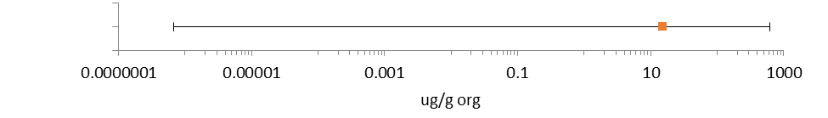
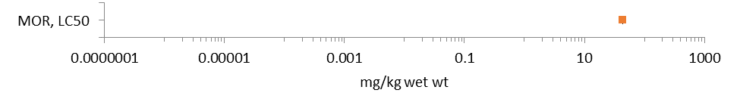
b
Figure 10-1 (a and b). Summary Data Arrays for Endpoints Adjusted for Body Weight (ug/g org or mg/kg wet weight).
^{MOR:} Mortality.

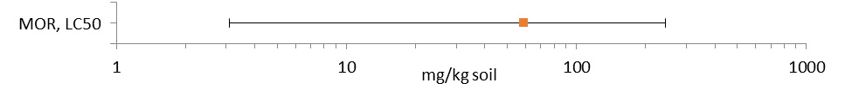
a
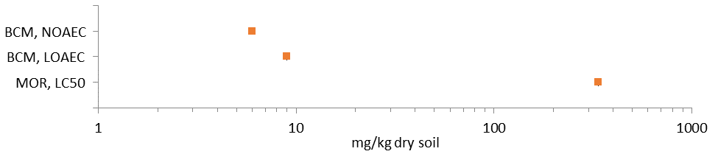
b
Figure 10-2 (a and b). Summary Data Arrays for Endpoints Reported in Terms of Soil Residues (mg/kg soil or mg/kg dry soil).
^{BCM:} Biochemical. ^{MOR:} Mortality.

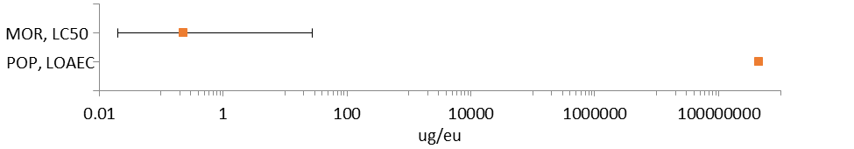
a
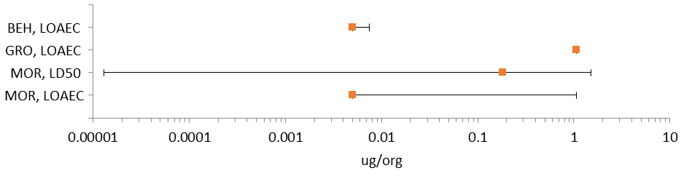
b
Figure 10-3(a and b). Summary Data Arrays for Endpoints Reported in Terms of Experimental Unit (ug/eu, ug/org).
^{BEH:} Behavior. ^{GRO:} Growth. ^{MOR:} Mortality. ^{POP:} Population (e.g., abundance).

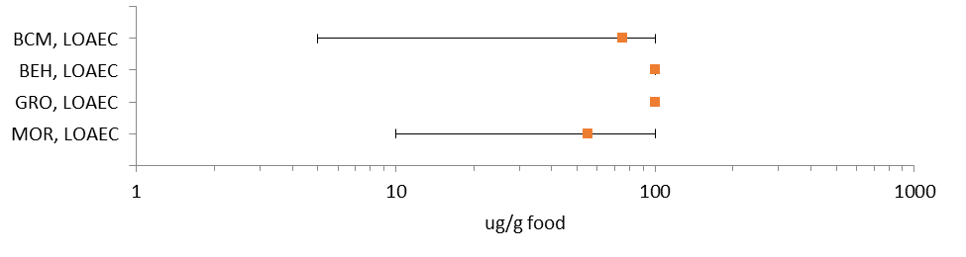
Figure 10-4. Summary Data Array for Endpoints Reported Based on Dietary Residues (ug/g food).
^{BCM:} Biochemical. ^{BEH:} Behavior. ^{GRO:} Growth. ^{MOR:} Mortality.

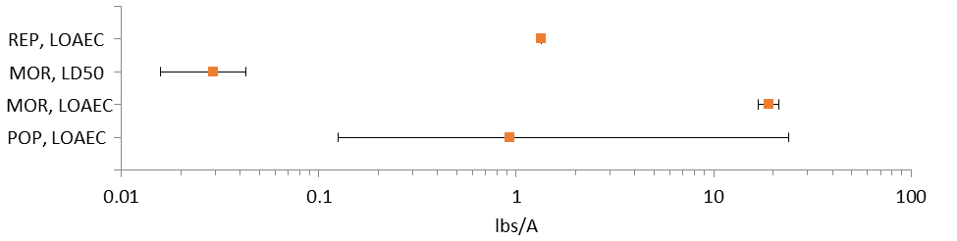
Figure 10-5. Summary Data Array for Endpoints Reported in Terms of Treatment Rate (lbs/A)

^{MOR:} Mortality. ^{POP:} Population (e.g., abundance). ^{REP:} Reproduction.

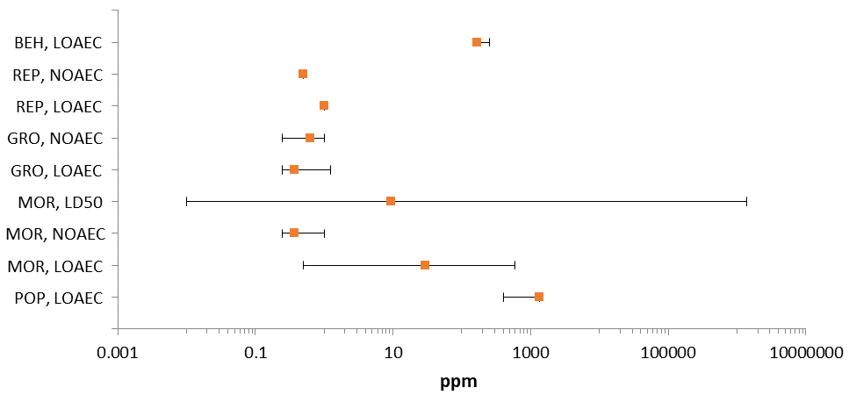
a Arthropoda
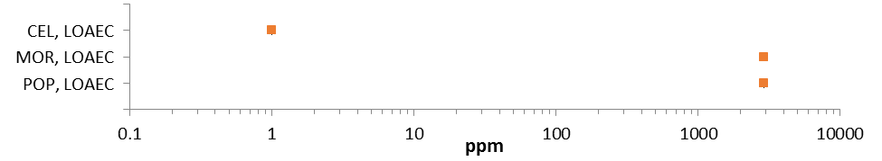
b Nemata
Figure 9 10-6 (a and b). Summary Data Array for Endpoints Reported in Terms of Parts per Million (ppm) for Arthropoda (top, a) and Nemata (bottom, b)

Note the difference in scale.
^{BEH:} Behavior. ^{CEL:} Cellular and Genetic. ^{GRO:} Growth. ^{MOR:} Mortality. ^{POP:} Population (e.g., abundance). ^{REP:} Reproduction.

Lines of Evidence for Diazinon Toxicity to Terrestrial Invertebrates

10.4.1 Effects on Mortality of Terrestrial Invertebrates

Diazinon appears to be consistently toxic to adult honey bees (Apis mellifera) via both contact (Table 10-3) and oral (Table 10-4) exposure routes when endpoints are normalized to average body weight (assuming 0.128 g/bee). Median lethal values (LD₅₀) from a single contact exposure range from 0.41 to 2.91 ug/g bw, or from 0.052 to 0.372 ug/bee. The lowest acute honey bee toxicity endpoint (24-hour LD₅₀ = 0.052 ug/bee) is used to derive threshold values for comparison to exposures reported in terms of experimental unit (mg/eu). Median lethal values (LD₅₀) from ingestion of diazinon in sucrose solution range from 0.20 to 0.24 ug/bee. However, the dose-response slope is greater for contact exposures (8.97 to 9.40) than for oral exposure (2.4) in the honey bee. A slope value of 9 is used in the threshold determination given the steep slopes associated with both honey bee contact toxicity studies.

For other arthropod species, diazinon toxicity to adult mosquitoes (Aedes aegypti) falls within the range of acute toxicity to the honey bee (Table 10-3). The most sensitive endpoint for diazinon contact toxicity in non-soil dwelling terrestrial invertebrates is the 24-hour LD₅₀ value for adult (moth) beet webworm (Pyrausta sticticalis L.), reported as 0.15 ug/g bw in Leonova and Slynko (2004). Thus, the beet webworm LD₅₀ value is used to establish thresholds of toxicity for both mortality and sublethal effects in this assessment for exposures reported in units adjusted for body weight (e.g., mg/kg bw or ug/g bw). Finally, Tanaka et al. (2000) exposed various first instar arthropods to formulated diazinon by dipping them in solution for 10 seconds and then observing for mortality over 24 hours. Among the rice planthopper (Niliparvata lugens) and 6 of its predator species, the dryinid wasp (Haplogonatopus apicalis) was the most sensitive to formulated diazinon exposure (24-hour LC₅₀ = 0.28 ppm). Sensitivity varied widely across the species tested. The least sensitive species in Tanaka et al. (2000) was the spider, Ummeliata insecticeps (24-hour LC₅₀ > 8,000 ppm). Subsequent field tests in Japan described in the same publication showed no statistically significant effect of diazinon exposure at 0.016 lbs a.i/A on the abundance of the rice planthopper or its predator species, although field data for the dryinid wasp were not reported. Nonetheless, the dryinid wasp laboratory LC₅₀ value is the lowest acute mortality endpoint and is used to derive threshold values for diazinon terrestrial invertebrate studies wherein exposure is reported in parts per million (ppm).

Table 10-3. Median Lethal Values for Acute Mortality in Terrestrial Invertebrates Exposed to Diazinon Residues through Contact
Species | Test Item (Purity) | Duration | Life Stage | LD₅₀  (Slope, 95% CI) | Reference
Honey bee  (Apis mellifera) | Later’s Diazinon, EC (12.5% a.i) | 24-hr | Adult | 0.052 ug/bee  (unspecified, 0.049 – 0.056)  0.41 ug/bee | E070542  Mackenzie and Winston (1989)
Honey bee  (Apis mellifera) | TGAI  (unspecified) | 24-hr | Adult | 1.72 ug/g bw  (9.40, unspecified)  0.22 ug/bee | MRID 5004151  Stevenson (1968)
Honey bee  (Apis mellifera) | TGAI  Diazinon  C-24480 (unspecified) | 48-hr | Adult | 2.91 ug/g bw  (8.97, unspecified)  0.372 ug/bee | MRID 5004150  Atkins et al. (1975)
Mosquito  (Aedes aegypti) | TGAI (unspecified) | 24-hr | Adult | 0.67 ug/g bw (unspecified) | E116328  Pridgeon et al. (2009)
Beet webworm (Pyrausta sticticalis L.) | TGAI (> 92% a.i) | 24-hr | Adult | 0.15 ug/g bw  4.87, 0.13 – 0.17) | E100430  Leonova and Slynko (2004)
Dryinid wasp (Haplogonatopus apicalis) | Diazinon EC (40% a.i.) | 24-hr | Eclosing females | 0.28ppm (unspecified) | E069655 Tanaka et al. (2000)
Bold values may be used to establish threshold values to assess the hazard of direct and/or indirect effects from terrestrial invertebrate mortality.

Table 10-4. Median Lethal Values for Acute Mortality in Terrestrial Invertebrates Exposed to Diazinon Residues in the Diet.
Species | Test Item | Duration | Life Stage | LD₅₀  (Slope, 95% CI) | Reference
Honey bee  (Apis mellifera) | TGAI | 24-hr | Adult | 0.20 ug/bee  (2.4, unspecified)  10 ug/mL soln | MRID 5004151  Stevenson (1968)
Honey bee  (Apis mellifera) | Unspecified formulation (16% a.i w/v) | 24-hr | Adult | 0.24 ug/bee  (unspecified) | MRID 5004413  Palmer-Jones (1958)
Bold values may be used to establish threshold values to assess the hazard of direct and indirect effects from terrestrial invertebrate mortality.

Experiments with diazinon residues in soil or sand substrate showed varying levels of mortality in test species over time (Table 10-5). The acute mortality of diazinon residues in soil has not been quantified. A 48-hour exposure caused statistically significant mortality in the adult wolf spider (Lycosa hilaris) at 12 mg/kg soil (corresponding to 2.1 lbs/A), with a NOAEL of 9 mg/kg soil (1.6 lbs/A) (Van Erp et al. 2002). However, an LC₅₀ value was not established. Similarly, a six-week exposure yielded an LC₅₀ value of 3.09 ug/g dry substrate in the isopod (Porcellionides pruinosus), but mortality within the first three weeks was reportedly less than 50% (Vink et al. 1995). Any generalization of these results should consider that the tests were performed under different conditions, with different species, and using different diazinon formulations. Nonetheless, Vink et al. (1995) provides the most sensitive endpoint for soil contact exposure, and it is used to establish effects thresholds for exposures reported in terms of soil or substrate residue (mg/kg soil).

Table 10-5. Additional Mortality Observations in Terrestrial Invertebrates Exposed to Diazinon Residues through Contact with Soil or Substrate.
Species | Test Item | Duration | Life Stage | Endpoint Type | Endpoint (Slope, 95% CI) | Reference
Wolf spider (Lycosa hilaris) | Basudin® EW, 600 g | 48-hr | Adult | NOAEL  LOAEL | 9 mg/kg soil  1.6 lbs a.i/A  12 mg/kg soil  2.1 lbs a.i/A | E082065  Van Erp et al. (2002)
Isopod (Porcellionides pruinosus) | Diazinon 60 EC  (60% a.i) | 6-wks | Adult | LC₅₀ | 3.09 ug/g dry substrate  (unspecified, 2.44 – 3.92) | E040294  Vink et al. (1995)
Bold values may be used to establish threshold values to assess the hazard of direct, sublethal effects and indirect effects of terrestrial invertebrate mortality.

In addition to the oral toxicity studies with adult honey bees, diazinon has been tested for honey bee larval toxicity (Atkins and Kellum 1986) and for toxicity to juvenile and adult isopods (Porcellionides pruinosus, Porcelio scaber) from treated food (Vink et al. 1995, Stanek et al. 2006). Actual exposure in these experimental scenarios is likely a combination of contact with and ingestion of treated food (or the treated larval medium for honey bee). This assessment uses the LD₁₀ value (1.20 x 10⁻⁷ µg/larva) for 1-2 day old honey bee larvae as a threshold value for direct and indirect effects for exposures reported in terms of experimental unit (mg/eu) (Table 10-6). The NOAEC (5 ug/g dry food) and LOAEC (10 ug/g dry food) values for juvenile isopods exposed to diazinon in the diet are used as threshold values for direct and indirect effects, respectively, for exposures reported in terms of dietary residues (mg/kg diet).

Table 10-6. Additional Mortality Observations in Terrestrial Invertebrates Exposed to Diazinon Residues through Contact in the Diet.
Species | Test Item | Duration | Life Stage | Endpoint Type | Endpoint (Slope, 95% CI) | Reference
Honey bee (Apis mellifera) | TGAI  (88.4% a.i) | Unspec-ified | Larvae | LD₅₀ | 1.2 x 10⁻⁴ ug/larvae (0.630, unspecified) | E070351  Atkins and Kellum (1986)
 |  |  |  | LD₁₀ | 1.2 x 10⁻⁷ ug/larvae (0.630, unspecified)
Isopod (Porcellionides pruinosus) | Diazinon 60 EC  (60% a.i) | 6-wks | Adult | LC₅₀ | 74.2 ug/g dry food  (unspecified, 55.4 – 99.2) * | E040294  Vink et al. (1995)
Isopod (Porcellio scaber) | Diazinon (unspecified) | 2-wks | Juvenile | NOAEC  LOAEC | 5 ug/g dry food  10 ug/g dry food * | E084972  Stanek et al. (2006)
 | Diazinon (unspecified) | 2-wk | Adult | NOAEC  LOAEC | 50 ug/g dry food  100 ug/g dry food *
Bold values may be used to establish threshold values to assess the hazard of direct, sublethal effects and/or indirect effects from terrestrial invertebrate mortality.
* The mortality endpoints in Vink et al. (1995) and Stanek et al. (2006) were not captured in the mortality data arrays but were identified when the studies were reviewed for sublethal effects, which were captured in other arrays.

Figures 10-7 through 10-11 provide an overview of the dataset for diazinon-related mortality in terrestrial invertebrates, including data discussed above. In general, each array presents data for a specific type of exposure unit with values plotted against the horizontal (X) axis, on a logarithmic scale. The data labels identify the type of effect observed, the phylogenetic order, and the study duration (when known). A red box around the data label signifies that the data point was used to establish a threshold value for effects to listed species. Both open literature data captured in ECOTOX and unpublished studies submitted to the Agency are included, when available. Data points for Agency-reviewed, unpublished studies are red and are noted with an asterisk. When both no effect and lowest effect levels (e.g., NOAEC/LOAEC values) are determined by a study, a line to the left of the data point represents the difference between these two values. Unless noted otherwise, all data are specific to arthropods. Data arrays in subsequent sections are formatted similarly.

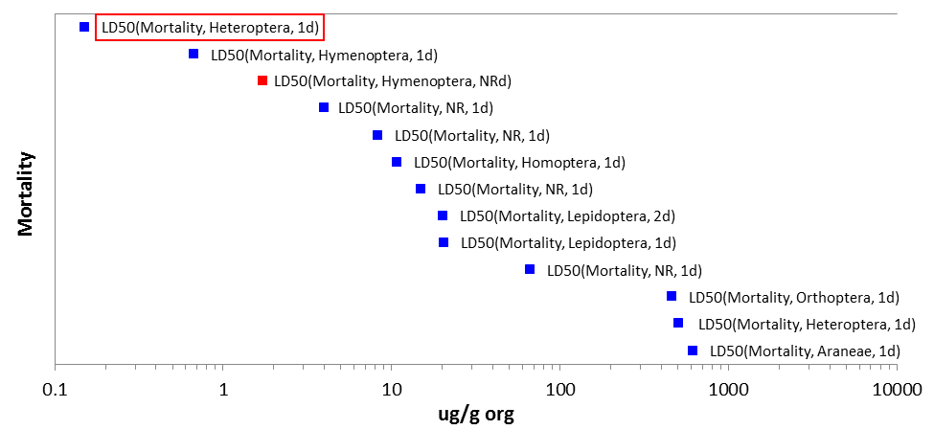
a Arthropoda
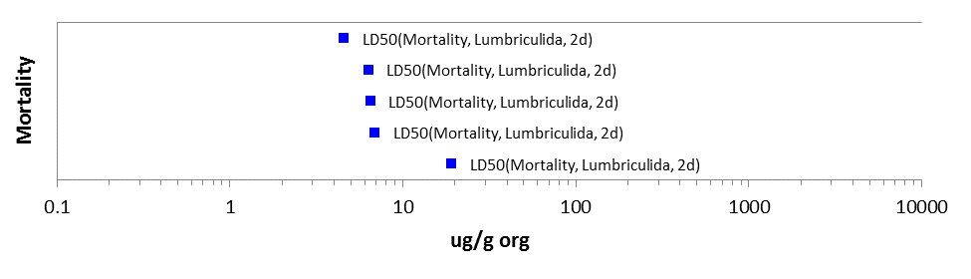
b Annelida
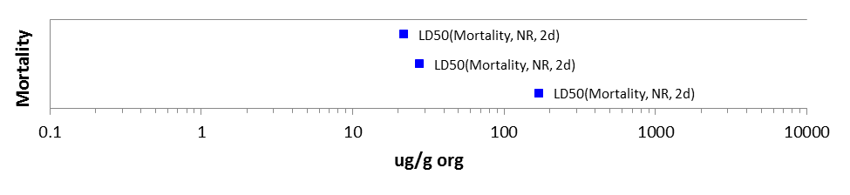
c Nemata
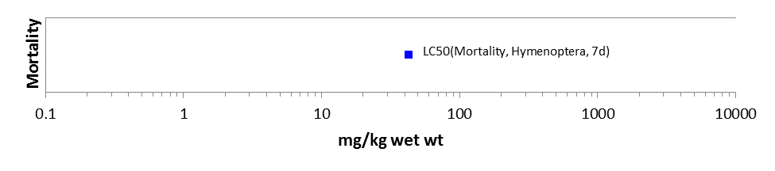
d Arthropoda

Figure 10-7. Arrays of Mortality Endpoints Adjusted for Body Weight

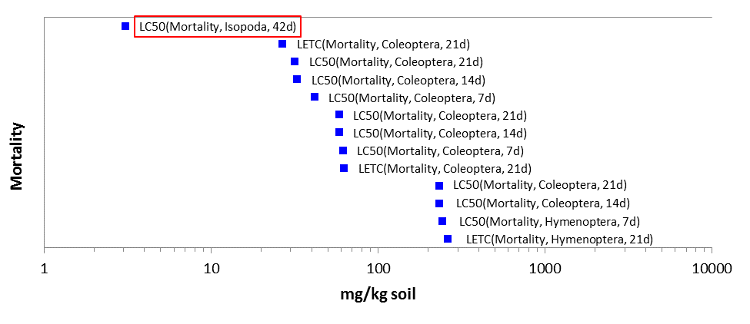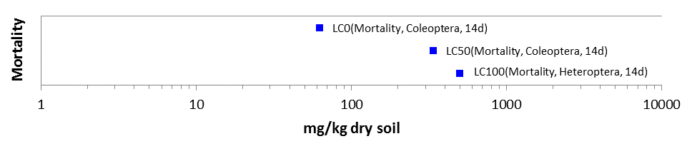
b Arthropoda
a Arthropoda
Figure 10-8. Arrays of Mortality Endpoints Based on Soil Residues

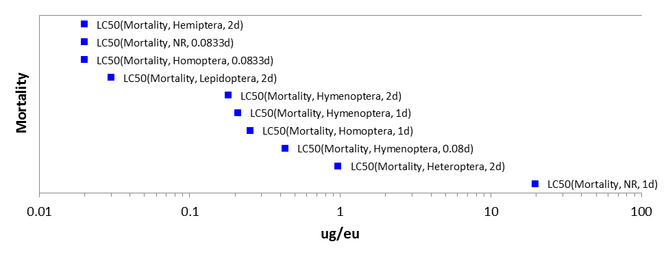
a Arthropoda
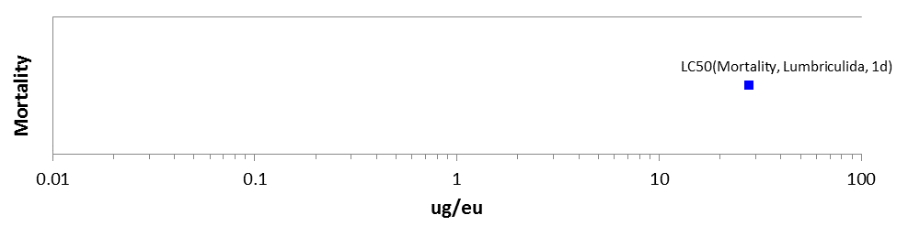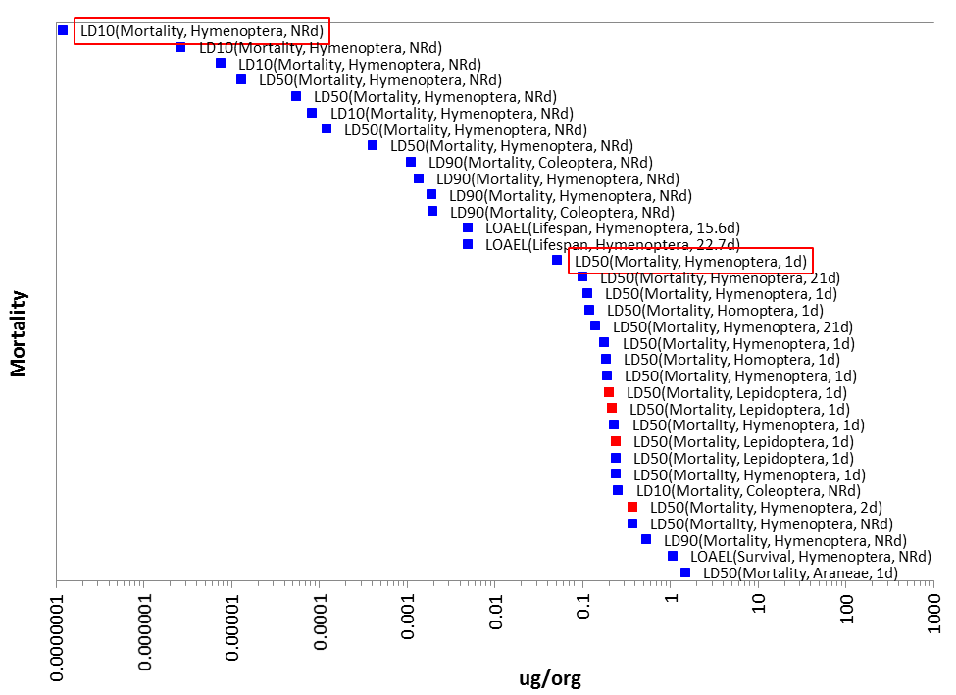
c Arthropoda
b Annelida
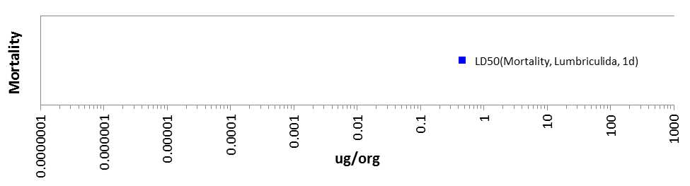
d Annelida
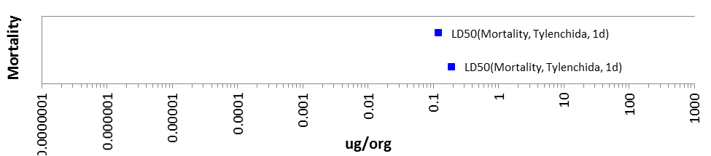
e Nemata

Figure 10-9. Arrays of Mortality Based on Experimental Unit

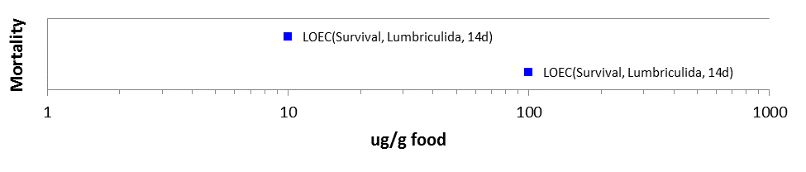
Annelida
Figure 10-10. Array of Mortality Endpoints Based on Dietary Residues

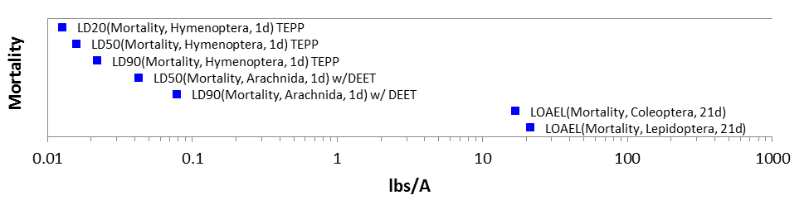
Arthropoda
Figure 10-11. Array of Mortality Endpoints Based on Treatment Rate (Mass per Unit Area)

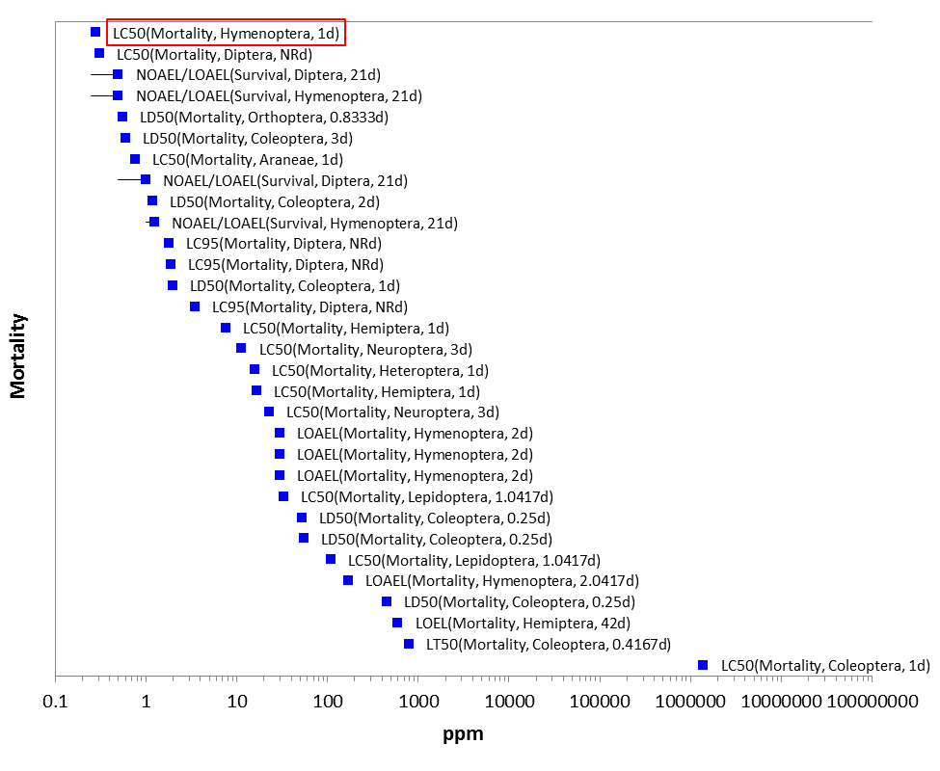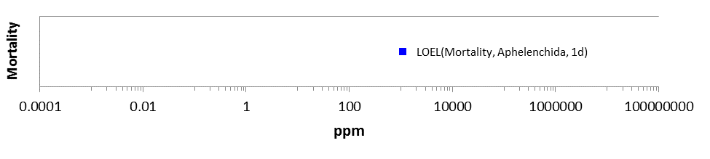
a Arthropoda
b Nemata

Figure 10-12. Arrays of Mortality Endpoints Reported in Parts per Million (ppm)

10.4.2. Sublethal Effects to Terrestrial Invertebrates

10.4.2.1. Effects on Growth of Terrestrial Invertebrates

There are no current EPA guideline (Series 850) tests which evaluate growth and development of terrestrial invertebrates exposed to a pesticide, except for the earthworm. Growth or developmental effects in terrestrial invertebrates, independent of mortality, are infrequently reported in the available open literature studies for diazinon. Growth was measured, based on changes in individual body weight, in a six-week exposure of adult isopods (P. pruinosus) exposed to formulated diazinon via substrate, but no statistically significant effects were observed (Vink et al. 1995,Table 10-7). Conversely, the same study showed significant effects on body weight at all treatment levels when adult isopods were exposed to the same formulation of diazinon in the diet over a six-week period (LOAEC = 8.7 ug/g dry food) (Table 10-8). However, these results cannot be meaningfully compared because treated substrates were not renewed, whereas treated food was replaced weekly. In a similar study by Stanek et al. (2006), no effects on juvenile or adult growth or fecal dry weight were seen in isopods (P. scaber) exposed through the diet over a two-week period (Table 10-7). The maximum treatment rate was 100 ug/g dry food. Stark et al. (1992) demonstrated that eclosion and emergence were significantly lower in fruit flies and their endoparasitoids exposed to diazinon via treated sand at 0.25 ppm and above. This endpoint is used as a threshold in the diazinon terrestrial invertebrate assessment for effects on survival, growth, and reproduction, for exposures of varying durations which are reported in ppm. In the same study, mean survival was reduced at 0.25 ppm in one fruit fly species, and the seven-day LC₅₀ values [0.06 ppm (estimated) – 0.31 ppm] were near or below the lowest treatment level (0.25 ppm). Figures 10-13 through 10-15 provide an overview of the full dataset for diazinon effects on growth and development in terrestrial invertebrates.

Arrays of Growth and Developmental Endpoints Adjusted for Body Weight
There are no data available for diazinon effects on growth or developmental endpoints expressed in terms of body weight or biomass.

Arrays of Growth and Developmental Endpoints Based on Soil Residues
There are no data available for diazinon effects on growth or developmental endpoints from exposures expressed in terms of soil or substrate residues.

Arthropoda

Figure 10-13. Array of Growth and Development Endpoints Based on Experimental Unit

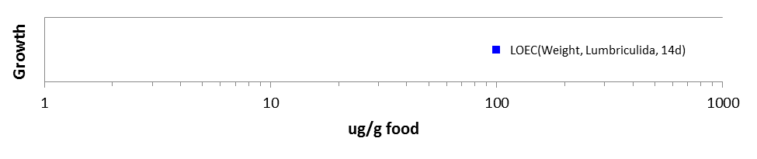
Figure 10-14. Array of Growth and Development Endpoints Based on Dietary Residues

Arrays of Growth and Developmental Endpoints Based on Treatment Rate (Mass per Unit Area)
There are no data available for diazinon effects on growth or developmental endpoints from exposures expressed in terms of treatment rate (lbs a.i./A).

Annelida
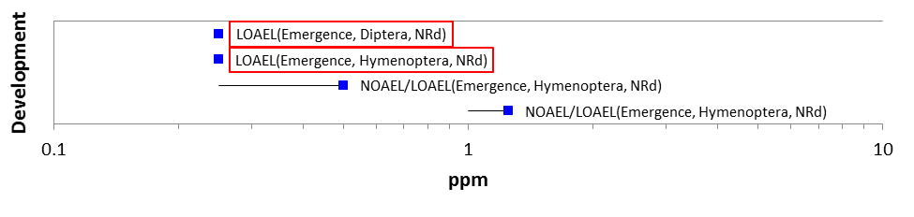
Figure 10-15. Array of Growth and Developmental Endpoints Reported in Parts per Million (ppm)

10.4.2.2. Effects on Reproduction of Terrestrial Invertebrates

Arrays of Reproductive Endpoints Adjusted for Body Weight
There are no data available for diazinon effects on reproductive endpoints expressed in terms of body weight or biomass.

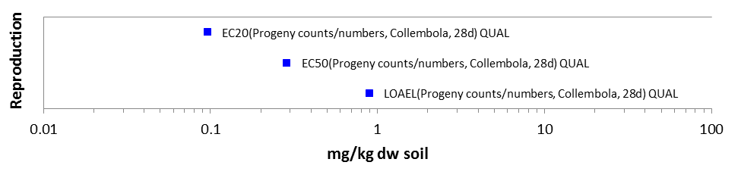
Arthropoda

Figure 10-16. Array of Reproductive Endpoints Based on Soil Residues

Arrays of Reproductive Endpoints Based on Experimental Unit
There are no data available for diazinon effects on reproductive endpoints from exposures expressed in terms of experimental unit.

Arrays of Reproductive Endpoints Based on Dietary Residues
There are no data available for diazinon effects on reproductive endpoints from exposures expressed in terms of dietary residues.

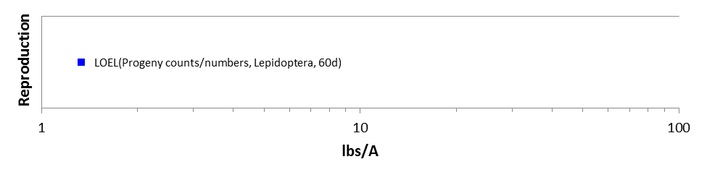
Arthropoda

Figure 10-17. Array of Reproductive Endpoints Based on Treatment Rate (Mass per Unit Area)

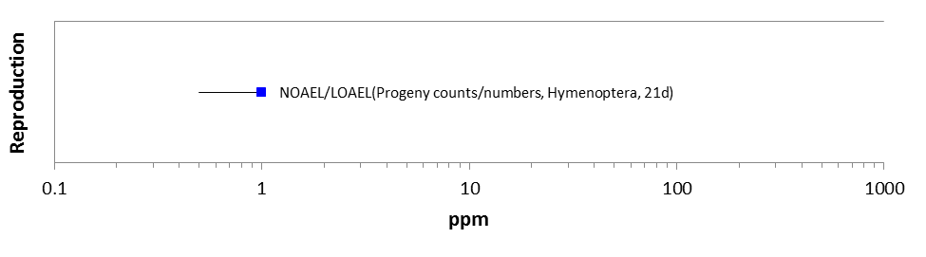
Arthropoda

Figure 10-18. Array of Reproductive Endpoints Reported in Parts per Million (ppm)

10.4.2.3 Effects on Behavior of Terrestrial Invertebrates

Arrays of Behavioral Endpoints Adjusted for Body Weight
There are no data available for diazinon effects on behavioral endpoints expressed in terms of body weight or biomass.

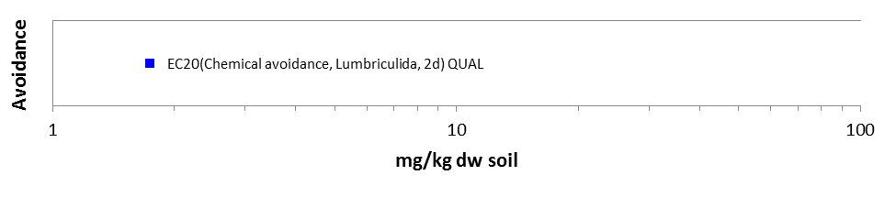
Annelida
Figure 10-19. Array of Behavioral Endpoints Based on Soil Residues

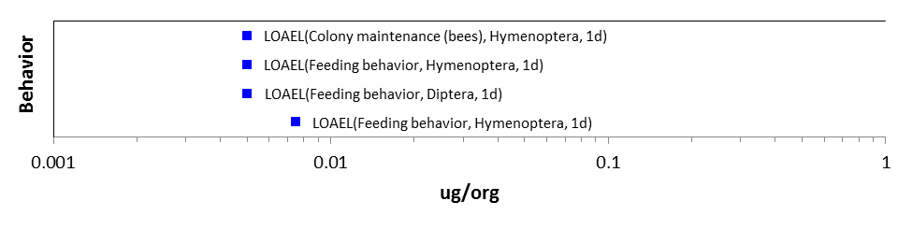
Arthropoda

Figure 10-20. Array of Behavioral Endpoints Based on Experimental Unit
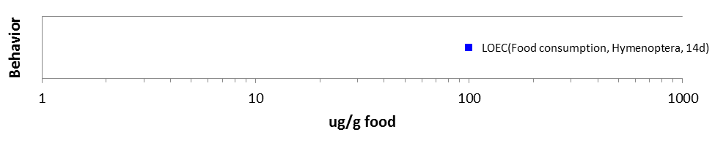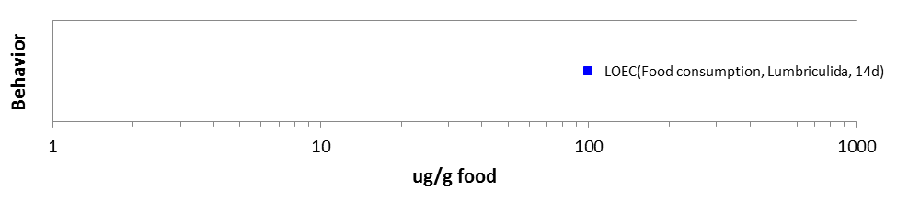
a Arthropoda
b Annelida

Figure 10-21. Array of Behavioral Endpoints Based on Dietary Residues
Arrays of Behavioral Endpoints Based on Treatment Rate (Mass per Unit Area)
b Annelida
There are no data available for diazinon effects on behavioral endpoints from exposures expressed in terms of treatment rates (lbs a.i/A).

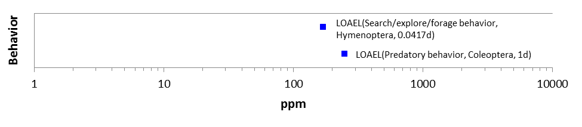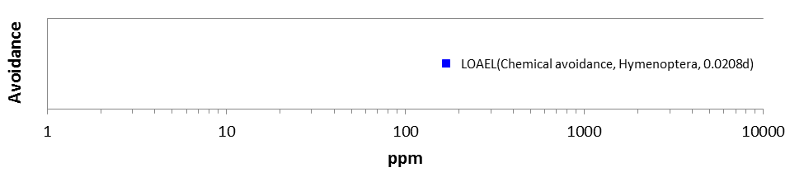
a Arthropoda
b Arthropoda

Figure 10-22. Array of Behavioral Endpoints Reported in Parts per Million (ppm)

10.4.2.4. Effects on Sensory Function of Terrestrial Invertebrates

There are no data available for diazinon effects on sensory function in terrestrial invertebrates.

10.4.2.5. Other Effects Reported for Terrestrial Invertebrates

For terrestrial invertebrates exposed to diazinon, biochemical effects in the open literature are reported for cholinesterase activity, protein, lipids, and glycogen. Observations are generally presented as NOAEC/LOAEC values or EC₅₀ values, which establish a baseline for statistically significant effects but do not correspond to a given magnitude of effect. The studies reviewed for possible quantitative use in the diazinon assessment included no IC₅₀ values (concentration that elicits an average inhibition of 50%) for biochemical effects.

Cholinesterase activity was significantly reduced in adult wolf spiders (L. hilaris) exposed to diazinon soil residues for 48 hours at 12 mg/kg soil (2.1 lbs/A) (Van Erp et al., 2002; Table 10-7). The same treatment rate elicited significant mortality. Cholinesterase activity in juvenile isopods (P. scaber) exposed to diazinon in the diet was significantly lower at all treatment levels (5 ug/g dry food and above) than in controls (Stanek et al., 2006; Table 10-8). The corresponding EC₅₀ value was 15 ug/g dry food, with 95% confidence intervals of 7.7 to 23 ug/g dry food. The percent reduction and standard error for cholinesterase activity at each treatment level were not reported. Figures in the published article showed apparently similar levels of cholinesterase activity in juvenile isopods exposed to 5 and 10 ug/g dry food, with a drop off at higher treatment levels. The NOAEC for juvenile mortality in the experiment was 5 ug/g dry food. Adult isopods exposed to the same treatment rates were less sensitive than juveniles: the EC₅₀ for cholinesterase activity (73 ug/g dry food) had unbounded 95% confidence intervals due to high variability, and fell approximately midpoint of the adult mortality NOAEC (50 ug/g dry food) and LOAEC (100 ug/g dry food). Overall, cholinesterase inhibition was consistently observed in surviving invertebrates at treatment levels concurrent with mortality, and cholinesterase inhibition at lower treatment levels was generally slight but sometimes statistically significant.

Measurements of protein, glycogen, and lipids were reported for isopods exposed to diazinon via substrate or food. Vink et al. (1995) showed that protein (NOAEC: 0.51 ug/g dry substrate) and glycogen (NOAEC: 0.24 ug/g dry substrate) were significantly lower in diazinon-treated, adult isopods (P. pruinosis) exposed for six weeks than in control specimens. There were no effects on growth via substrate exposure (Table 10-7). The parallel dietary exposure experiment with adult isopods, which showed statistically significant effects on growth at all treatment levels, showed significantly lower lipid levels (NOAEC < 8.71 ug/g dry food) but no effects on protein. The mortality LC₅₀ values for these experiments were 3.09 ug/g dry substrate and 74.2 ug/g dry food, respectively. A two-week dietary exposure caused no effect on

glycogen or lipids in juvenile or adult isopods (Stanek et al. 2006). Protein was significantly lower in both juvenile and adult isopods exposed to 100 ug/g dry food (NOAEC: 50 ug/g dry food). Significant mortality in these experiments was seen in juveniles at 10 ug/g dry food and in adults at 100 ug/g dry food. Overall, it remains unclear whether and how diazinon may directly affect bioenergetic parameters such as protein, glycogen, and lipid content in terrestrial invertebrates, and whether such effects may have adverse fitness consequences at sublethal exposure levels in the species tested.

Table 10-7. Sublethal Effects in Terrestrial Invertebrates (Adults) Exposed to Diazinon Residues through Contact with Soil or Substrate.
Species | Test Item | Duration | Effect Type | Endpoint Type | Endpoint (Slope, 95% CI) | Reference
Wolf spider (Lycosa hilaris) | Basudin® EW, 600 g | 48-hr | Cholinesterase | NOAEC  LOAEC | 9 mg/kg soil  1.6 lbs a.i/A  12 mg/kg soil 2.1 lbs a.i/A | E082065  Van Erp et al. (2002)
Isopod (Porcellionides pruinosus) | Diazinon 60 EC  (60% a.i) | 6-wks | Growth  (∆ body weight) | NOAEC  LOAEC | 5.1 ug/g dry substrate  > 5.1 ug/g dry substrate | E040294  Vink et al. (1995)
 |  |  | Protein | NOAEC  LOAEC | 0.51 ug/g dry substrate  1.1 ug/g dry substrate
 |  |  | Glycogen | NOAEC  LOAEC | 0.24 ug/g dry substrate  0.51 ug/g dry substrate

Table 10-8. Sublethal Effects in Terrestrial Invertebrates Exposed to Diazinon Residues in the Diet
Species | Test Item | Duration | Effect Type | Life Stage | Endpoint Type | Endpoint (Slope,  95% CI)  ug/g dry food | Reference
Isopod (Porcellionides pruinosus) | Diazinon 60 EC  (60% a.i) | 6-wks | Growth  (∆ body weight) | Adult | NOAEC  LOAEC | < 8.71  8.71 | E040294  Vink et al. (1995)
 |  |  | Protein |  | NOAEC  LOAEC | 186  > 186
 |  |  | Lipids |  | NOAEC  LOAEC | < 8.71  8.71
Isopod (Porcellio scaber) | Diazinon (unspec-ified) | 2-wks | Growth  (∆ body weight) | Juvenile | NOAEC  LOAEC | 100  > 100 | E084972  Stanek et al. (2006)
 |  |  | Cholin-esterase |  | EC₅₀  NOAEC  LOAEC | 15  (unspecified, 7.7 – 23)  < 5  5
 |  |  | Glycogen |  | NOAEC  LOAEC | 100  > 100
 |  |  | Protein |  | NOAEC  LOAEC | 50  100
 |  |  | Lipids |  | NOAEC  LOAEC | 100  > 100
 |  |  | Fecal dry weight |  | NOAEC  LOAEC | 100  > 100
Isopod (Porcellio scaber) | Diazinon (unspec-ified) | 2-wks | Growth  (∆ body weight) | Adult | NOAEC  LOAEC | 100  > 100 | E084972  Stanek et al. (2006)
 |  |  | Cholin-esterase |  | EC₅₀  NOAEC  LOAEC | 73  (unspecified,  <5 – 170)  10  50
 |  |  | Glycogen |  | NOAEC  LOAEC | 100  > 100
 |  |  | Protein |  | NOAEC  LOAEC | 50  100
 |  |  | Lipids |  | NOAEC  LOAEC | 100  > 100
 |  |  | Fecal dry weight |  | NOAEC  LOAEC | 100  > 100

Arrays of Physiological Endpoints Adjusted for Body Weight
There are no data available for diazinon effects on physiological endpoints expressed in terms of body weight or biomass.

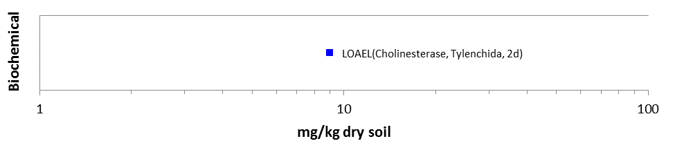
Nemata
Figure 10-23. Array of Physiological Endpoints Based on Soil or Substrate Residues

Arrays of Physiological Endpoints Based on Experimental Unit

There are no data available for diazinon effects on physiological endpoints from exposures expressed in terms of experimental unit.
a Arthropoda
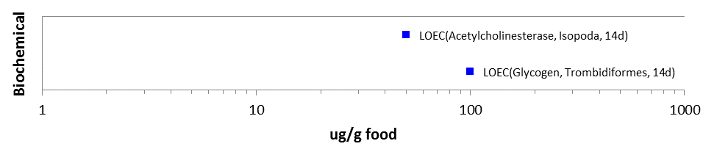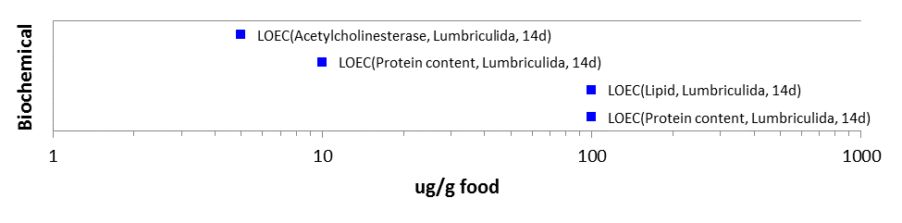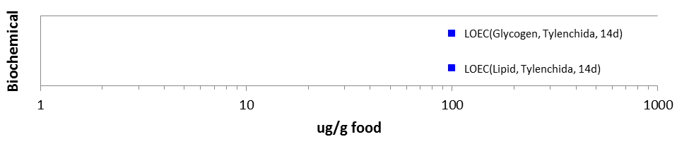
c Nemata
b Annelida

Figure 10-24. Arrays of Physiological Endpoints Based on Dietary Residues

Arrays of Physiological Endpoints Based on Treatment Rate (Mass per Unit Area)
There are no data available for diazinon effects on physiological endpoints from exposures expressed in terms of treatment rates (lbs a.i./A).

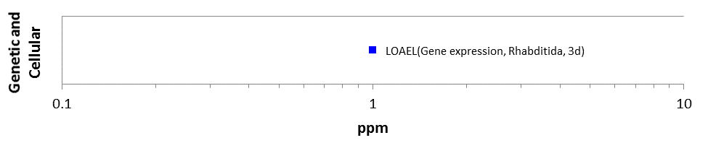
Nemata
Figure 10-25. Array of Physiological Endpoints Reported in Parts per Million (ppm)

Field and Field-like Studies and Population-level Effects for Terrestrial Invertebrates

The literature include a broad range of studies which report effects in terms of treatment rate (e.g., lbs/A) or other mass per unit area measures that can be converted to labeled treatment rates. Forty such studies have been screened through the ECOTOX database inclusion process. These data vary greatly in terms of experimental design, test specimen, formulation, and actual relevance of the exposure to field-scale treatments. Therefore, in addition to determining a single most sensitive endpoint from this body of literature, the data are considered together to illustrate the range of treatment levels that have elicited various effects in terrestrial invertebrates in situ and ex situ. The threshold value for exposures reported in mass per unit area (lbs a.i/A) is 0.25 lbs a.i/A, based on significant reduction in sawfly abundance on ash trees when exposed to formulated diazinon (Diazinon AG-500) (Solomon 1987).

Figure 10-26 provides a count of the number of studies in ECOTOX for which the most sensitive endpoint falls within a given range of labeled application rates. The lowest endpoint overall (honey bee LD₅₀: 0.02 lbs/A) is from a Jones and Connell (1954) publication with the diazinon impurity TEPP, or sulfotepp; diazinon was not tested. The sulfotepp impurity is more toxic than diazinon and may be less relevant to certain current formulations. Therefore, this study is provided for context but does not represent a threshold value for characterizing effects of diazinon exposure to terrestrial invertebrates. Most studies reported effects at treatment rates less than 1 lb/A (n=24). For seven studies, the most sensitive endpoint was equal to or greater than 4.0 lbs/A, which is greater than current labels allow.

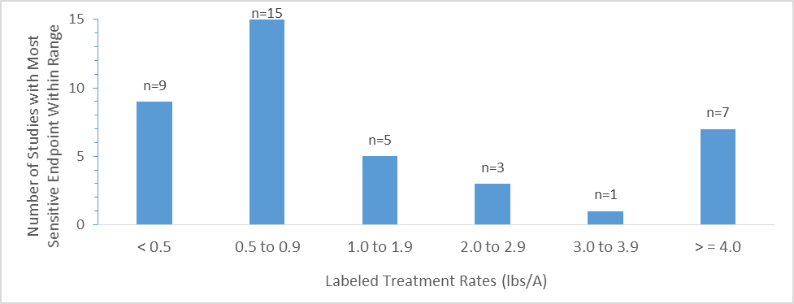
Figure 10-26. Number of Studies with Endpoints in Various Application Rate Ranges (N=40)

The number of records and lowest available endpoint value for each observation type (i.e., measured endpoint) are shown in Figure 10-27. The number of records is greater than the number of studies because most studies report values for multiple endpoints. The most common observation type is abundance (n=120). Other observations include population control (n=15), mortality (n=7), progeny counts or numbers (n=3), and hatch (n=1). Full arrays for population-level endpoints reported in terms of experimental unit (ug/eu), mass per unit area (lbs/A), and parts per million (ppm) are shown in Figure 10-28 through Figure 10-30.

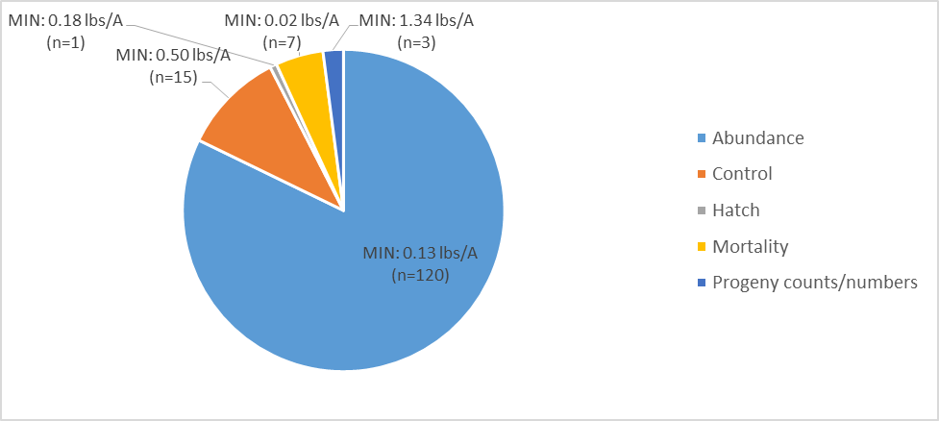
Figure 10-27. Analysis of Available Endpoints (lbs/A) by Type of Observation
.
Data callouts show MIN (lowest available endpoint value for the observation type) and n (number of ECOTOX records for the observation type).

Arrays of Population Endpoints Adjusted for Body Weight
There are no data available for diazinon effects expressed in terms of body weight or biomass for population-level endpoints.

Arrays of Population Endpoints Based on Soil Residues
There are no data available for diazinon effects on population-level endpoints from exposures expressed in terms of soil or substrate residues.

Arthropoda
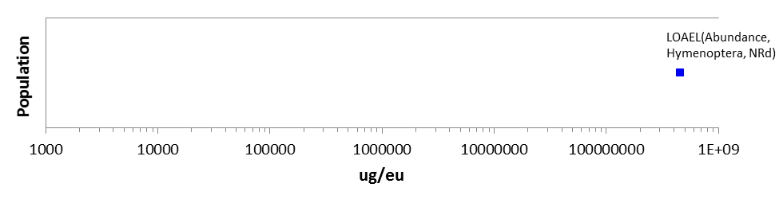

Figure 10-28. Array of Population Endpoints Based on Experimental Unit

Arrays of Population Endpoints Based on Dietary Residues
There are no data available for diazinon effects on population-level endpoints for dietary exposures.

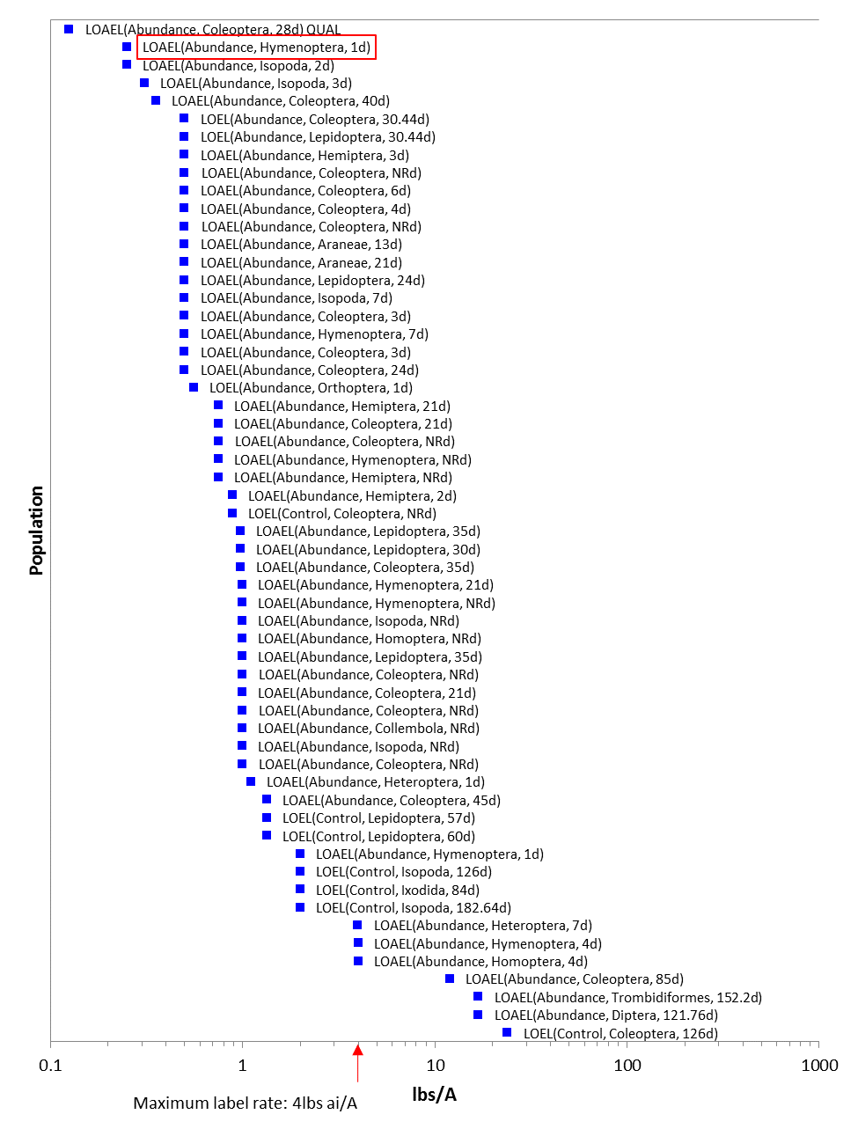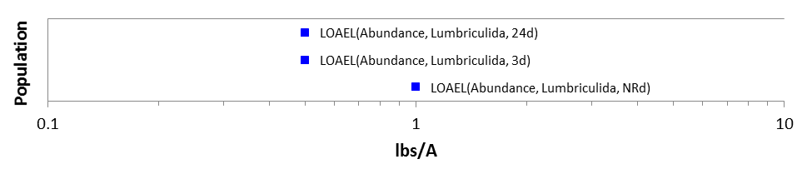
b Annelida
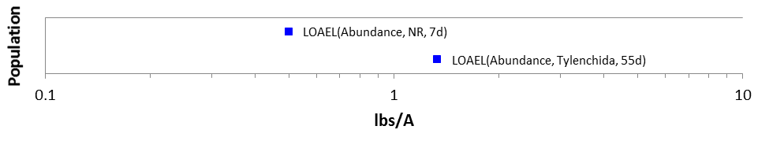
c Nemata
Figure 10-29. Arrays of Population Endpoints Based on Treatment Rate (Mass per Unit Area).

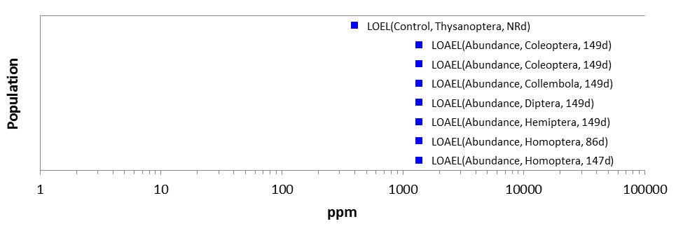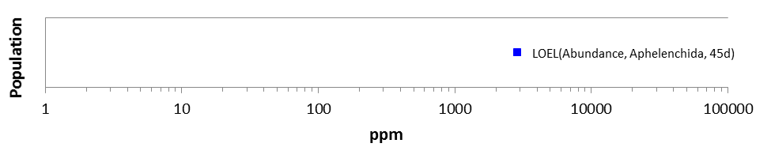
b Nemata
a Arthopoda

Figure 10-30. Arrays of Population Endpoints Reported in Parts per Million

Other Data Excluded from Arrays
Data from approximately 95 studies in ECOTOX were excluded from the data arrays, generally because the records either lacked sufficient information to convert values into units relevant to the exposure analysis or because the studies used granular formulations (no longer registered). The citations for these studies are provided in APPENDIX 2-2. The lowest endpoint value reported in ECOTOX from these excluded studies was a LOAEL (0.0000002 v/v) for cellular and genetic effects in the soil ciliate (Colpoda inflata) (E088373). The highest value was 2,900 ppm for mortality (unspecified, NR-LETH) in a laboratory bioassay with the fern nematode (Aphelenchoides fragariae) (E075893). These values are within the range of values presented in the preceding lines of evidence for diazinon effects on terrestrial invertebrates; therefore, their exclusion does not substantively impact the conclusions of this assessment.

Incident Reports for Terrestrial Invertebrates

The US EPA Ecological Incident Information System (EIIS, v. 2.1.1, last updated Jan. 26, 2015) was searched for diazinon-related incident reports on Feb. 19, 2015. The search identified three reports of adverse effects on honey bees and one report of adverse effects on butterflies potentially associated with diazinon use. The probability of association with diazinon ranged from possible to highly probable. All of these incidents occurred prior to the implementation of RED mitigations for diazinon (ca. 2006), which altered certain use patterns. They are discussed here for context since no terrestrial invertebrate incidents have been reported to EPA for diazinon subsequent to the mitigations.

Two of the reported honey bee incidents occurred in California in February 1995. In the first, the registrant reported that dead bees were found over a period of five days. Bee hives had been placed in an area adjacent to a plum orchard four days before mortality was identified. The plum orchard had been treated with an organophosphate insecticide end-use product, Supracide 25W (a.i: methidathion, PC Code 100301, CAS No. 950-37-8), at noon on the date that bee hives were first placed. Diazinon was reportedly sprayed on a nearby bee foraging area on the same day and one day prior. The number of bees affected was not reported. Tissue samples yielded 0.02 ppm diazinon and 2.6 ppm methidathion. (Incident ID: I001920-001). The second incident report submitted by the registrant had the same initial date of occurrence. The report identified a honey bee kill of unreported magnitude as being caused by application of the diazinon end-use product, Spectracide, on a nearby ranch. No residue analyses were provided. (Incident ID: I004697-088).
The third honey bee incident report was submitted by the Washington State Department of Agriculture in 1998. The diazinon data were part of a larger, tabular report of various pesticide incidents by year. The report indicated that one case of honey bee mortality was possibly associated with the application of various pesticides to a bean crop. The pesticides included diazinon and azinphos-methyl (PC Code 058001, CAS No. 86-50-0), chlorpyrifos (PC Code 059101, CAS No. 2921-88-2), and phosmet (PC Code 059201, CAS No. 732-11-6). (Incident ID: I014341-017).

Finally, in June 1995, a commercial butterfly apiary in Florida was reportedly sprayed with diazinon via ground broadcast to control ants. This was identified as an accidental misuse of the diazinon insecticide product Knox Out 2FM (flowable concentrate), which was labeled for banded use. The resulting mortality

was 200 to 400 adult butterflies (Lepidoptera sp.) from a population containing 400 to 500 individuals. The incident report suggests that butterfly watering reservoirs were contaminated with residues from workers feet. (Incident ID: I002294-001).

Effects Characterization for Terrestrial Plants

  - Introduction to Terrestrial Plant Toxicity

Thirty-one studies are available to characterize diazinon’s effects on terrestrial plants. Data were obtained from registrant-submitted, unpublished studies and from the open literature. The data are discussed below, along with a description of the established thresholds. Also discussed below is a summary of the reported incidents of effects to plants associated with applications of diazinon. APPENDIX 2-2 and APPENDIX 2-5 includes the bibliography of included and excluded studies, respectively, relevant to plant toxicity data for diazinon. APPENDIX 2-1 includes reviews of a subset of studies from the open literature.

11.2. Threshold Values for Terrestrial Plants

Table 11-1 includes the thresholds that will be used in assessing diazinon’s direct effects to listed plants and indirect effects to listed species that rely upon plants. The appropriate direct effects thresholds will also be used in cases where a listed species has an obligate relationship involving plants (e.g., coral have an obligate relationship for non-vascular aquatic plants).

As discussed below, runoff transport is not of concern for terrestrial and wetland plants because seedling emergence and germination data indicate that potential effects occur at levels above the maximum allowed application rate for diazinon (i.e., 4.0 lb a.i./A). Effects to monocots exposed to diazinon are also not of concern for the same reason. Therefore, effects thresholds are only set for terrestrial and wetland dicot species.

Table 11-1. Direct and Indirect Effects Thresholds for Listed Terrestrial and Wetland Plants Exposed to Diazinon
Effect | Exposure route | Endpoint (Effect) | Value | Test species | Source
Direct | Drift | 13% decrease in growth | 0.38 lb a.i./A | Tomato (Solanum lycopersicum) | ECOTOX# 26089
Indirect | Drift | EC25 (decrease in height in vegetative vigor study) | 3.2 lb a.i./A | Cucumber (Cucumis sativus) | MRID 40803002

11.3. Summary Data Arrays for Terrestrial Plants

The available data for terrestrial plants are arrayed in Figure 11-1.

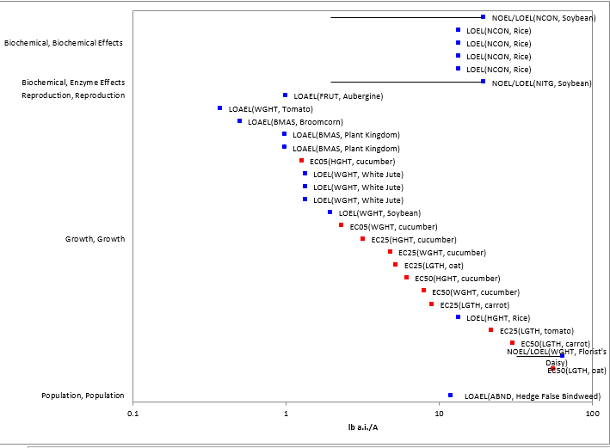
Figure 11-1. Array of Available Endpoints for Terrestrial Plants Exposed to Diazinon
Red points represent registrant-submitted data. Blue points represent data from the open literature. Effect codes: ABND = abundance, BMAS = biomass, FRUT = fruit, HGHT = height, LGTH = length, NCON = nitrogen content, NITG = nitrogenase, WGHT = weight. Blue lines indicate the maximum application rate for diazinon (4 lb a.i./A).

11.4. Lines of Evidence for Terrestrial Plants

11.4.1. Effects on Mortality of Terrestrial Plants

No toxicity data are available to characterize mortality to plants due to diazinon exposure.

11.4.2. Sublethal Effects to Terrestrial Plants

11.4.2.1. Effects on Growth of Terrestrial Plants

Toxicity studies involving terrestrial plants are focused on growth effects. Data are available for 36 different species of terrestrial plants. Effects were observed in 11 species (Tables 11-2 and 11-3). The majority of the species for which data are available showed no effects when exposed to diazinon. Note that the data in Table 11-4 include NOEL values from studies where no effects were observed (i.e., LOELs were not established). These data were not included in the array (Figure 11-1). The majority of studies reporting effects to plants are efficacy studies, designed to evaluate the effectiveness of diazinon on controlling insect pests. During the study, effects to yield of crops are measured. Endpoints from efficacy studies are not used to establish direct effects thresholds because the observed effects to plants may be explained by decreased insect pressure in treated plants compared to untreated plants.

Table 11-2. LOEL Values from Studies Involving Terrestrial Plants Exposed to Diazinon via Direct Spray. NOECs included when established.
Test species | Effect | Duration (d) | NOEL  (lb a.i./A) | LOEL  (lb a.i./A) | Source (ECOTOX#)
Tomato (Solanum lycopersicum) | WGHT | 14 | NA | 0.38 | 26089
Broomcorn (Sorghum bicolor) | BMAS | NA | NA | 0.5* | 117182
Plants | BMAS | 218 | NA | 0.98* | 91626
Aubergine (Solanum melongena) | FRUT | NA | NA | 1* | 153343
White Jute (Corchorus capsularis) | WGHT | 57 | NA | 1.3* | 86162
White Jute (Corchorus capsularis) | WGHT | 60 | NA | 1.3* | 86162
Soybean (Glycine max) | WGHT | 35 | NA | 2 | 70794
Hedge False Bindweed (Calystegia sepium) | ABND | 77 | NA | 12 | 112377
Rice (Oryza sativa) | NCON | NA | NA | 13 | 83926
Rice (Oryza sativa) | HGHT | NA | NA | 13 | 83926
Soybean (Glycine max) | NITG | 35 | 2 | 20 | 70794
Soybean (Glycine max) | NCON | 35 | 2 | 20 | 70794
Florist's Daisy (Dendranthema x grandiflorum) | WGHT | 56 | 32 | 64 | 43712
NA = not available
ABND = abundance, BMAS = biomass, DAMG = damage, FRUT = fruit, HGHT = height, NCON = nitrogen content, NITG = nitrogenase, SURV = survival, WGHT = weight.
*Study evaluating efficacy of diazinon on insect pest. Effects to insect-infested crop observed. Effects to plants may be indirect effects from difference in insect pressure between untreated control and diazinon treatment.
Grey highlighted rows used to set thresholds.

Table 11-3. Effects Data for Terrestrial Plants Exposed to Diazinon (TGAI)
Test species | Effect | Percent decrease | Exposure duration (d) | Endpoint value (lb/A) | Source (MRID)
Cucumber (Cucumis sativus) | Height reduction (VV) | 5 | 21 | 1.27 | 40803002
Cucumber (Cucumis sativus) | Weight reduction (VV) | 5 | 21 | 2.32 | 40803002
Cucumber (Cucumis sativus) | Height reduction (VV) | 25 | 21 | 3.2 | 40803002
Cucumber (Cucumis sativus) | Weight reduction (VV) | 25 | 21 | 4.81 | 40803002
Oat (Avena sativa) | Length reduction (G) | 25 | 6 | 5.26 | 40803001
Cucumber (Cucumis sativus) | Height reduction (VV) | 50 | 21 | 6.17 | 40803002
Cucumber (Cucumis sativus) | Weight reduction (VV) | 50 | 21 | 7.98 | 40803002
Carrot (Daucus carota) | Length reduction (G) | 25 | 6 | 9.03 | 40803001
Tomato (Lycopersicon esculentum) | Length reduction (G) | 25 | 6 | 22.1 | 40803001
Carrot (Daucus carota) | Length reduction (G) | 50 | 6 | 30.4 | 40803001
Oat (Avena sativa) | Length reduction (G) | 50 | 6 | 56.1 | 40803001
Tomato (Lycopersicon esculentum) | Length reduction (G) | 50 | 6 | 106 | 40803001
VV = vegetative vigor study
G = germination study
Grey highlighted rows used to set thresholds.

Table 11-4 Tested Levels Where No Effects Were Observed in Terrestrial Plants Exposed to Diazinon. LOEL values were not established. Data not included in terrestrial plant array or thresholds.
Test species | Effect | Level where no effects observed (lb a.i./A) | Source (ECOTOX#)
Alfalfa (Medicago sativa) | BMAS | 0.5 | 50972
Broomcorn (Sorghum bicolor) | BMAS | 0.5 | 114828
Broomcorn (Sorghum bicolor) | BMAS | 0.5 | 114828
Broomcorn (Sorghum bicolor) | BMAS | 0.5 | 117182
Broomcorn (Sorghum bicolor) | BMAS | 0.5 | 117182
Corn (Zea mays) | ABND | 0.5 | 96069
Grain Sorghum (Sorghum bicolor) | BMAS | 0.5 | 114803
Grain Sorghum (Sorghum bicolor) | BMAS | 0.5 | 114803
Tomato (Solanum lycopersicum) | ABND | 0.5 | 82732
Wild Carrot (Dacus carota) | ABND | 0.5 | 153606
Wild Carrot (Dacus carota) | BMAS | 0.5 | 153606
Wild Carrot (Dacus carota) | ABND | 0.5 | 153606
Wild Carrot (Dacus carota) | BMAS | 0.5 | 153606
Garden Asparagus (Asparagus officinalis) | BMAS | 0.56 | 70450
Garden Asparagus (Asparagus officinalis) | BMAS | 0.56 | 70450
Garden Asparagus (Asparagus officinalis) | BMAS | 0.56 | 70450
Garden Asparagus (Asparagus officinalis) | BMAS | 0.56 | 70450
Garden Asparagus (Asparagus officinalis) | BMAS | 0.56 | 70450
Garden Asparagus (Asparagus officinalis) | BMAS | 0.56 | 70450
Corn (Zea mays) | BMAS | 0.57 | 106407
Corn (Zea mays) | HGHT | 0.57 | 106407
Corn (Zea mays) | BMAS | 0.57 | 106407
Corn (Zea mays) | HGHT | 0.57 | 106407
Corn (Zea mays) | BMAS | 0.57 | 106407
Corn (Zea mays) | HGHT | 0.57 | 106407
Corn (Zea mays) | BMAS | 0.57 | 106407
Corn (Zea mays) | HGHT | 0.57 | 106407
Peanut (Arachis hypogaea) | ABND | 0.71 | 88031
Rice (Oryza sativa) | BMAS | 0.89 | 85252
Rice (Oryza sativa) | HGHT | 0.89 | 85252
Rice (Oryza sativa) | INFL | 0.89 | 85252
Rice (Oryza sativa) | INFL | 0.89 | 85252
Rice (Oryza sativa) | HGHT | 0.89 | 85252
Rice (Oryza sativa) | BMAS | 0.89 | 85252
Alfalfa (Medicago sativa) | BMAS | 1 | 50972
Aubergine (Solanum melongena) | BMAS | 1 | 159504
Broomcorn (Sorghum bicolor) | BMAS | 1 | 117182
Crimson Clover (Trifolium incarnatum) | BMAS | 1 | 96680
Sugar Beet (Beta vulgaris) | BMAS | 1 | 106252
Sugar Beet (Beta vulgaris) | ABND | 1 | 106252
Sugar Beet (Beta vulgaris) | BMAS | 1 | 106252
Sweet Potato (Ipomoea batatas) | BMAS | 1 | 89011
White Jute (Corchorus capsularis) | HGHT | 1 | 86162
White Jute (Corchorus capsularis) | HGHT | 1 | 86162
White Jute (Corchorus capsularis) | HGHT | 1 | 86162
Bean (Phaseolus vulgaris) | WGHT | 2 | 61217
Corn (Zea mays) | WGHT | 2 | 61217
Highbush Blueberry (Vaccinium corymbosum) | DAMG | 2 | 63909
Paradise Apple (Malus pumila) | DAMG | 2 | 100741
Soybean (Glycine max) | WGHT | 2 | 61217
Cucumber (Cucumis sativus) | HGHT | 4 | MRID 40803002
Cucumber (Cucumis sativus) | WGHT | 4 | MRID 40803002
Soybean (Glycine max) | WGHT | 4 | 56262
Soybean (Glycine max) | STRC | 4 | 56262
Soybean (Glycine max) | PCON | 4 | 56262
Soybean (Glycine max) | WGHT | 4 | 56262
Soybean (Glycine max) | STRC | 4 | 56262
Soybean (Glycine max) | PCON | 4 | 56262
Carrot (Daucus carota) | HGHT | 7 | MRID 40803002
Carrot (Daucus carota) | WGHT | 7 | MRID 40803002
Lettuce (Lactuca sativa) | HGHT | 7 | MRID 40803002
Lettuce (Lactuca sativa) | WGHT | 7 | MRID 40803002
Onion (Allium cepa) | HGHT | 7 | MRID 40803002
Onion (Allium cepa) | WGHT | 7 | MRID 40803002
Tomato (Solanum lycopersicum) | HGHT | 7 | MRID 40803002
Tomato (Solanum lycopersicum) | WGHT | 7 | MRID 40803002
Butter And Eggs (Linaria vulgaris) | ABND | 12 | 112377
Common Ragweed (Ambrosia artemisiifolia) | ABND | 12 | 112377
Common Ragweed (Ambrosia artemisiifolia) | ABND | 12 | 112377
Field Sorrel (Rumex actosella) | ABND | 12 | 112377
Field Sorrel (Rumex actosella) | ABND | 12 | 112377
Green Foxtail (Setaria viridis) | ABND | 12 | 112377
Green Foxtail (Setaria viridis) | ABND | 12 | 112377
Hedge False Bindweed (Calystegia sepium) | ABND | 12 | 112377
Jointed Charlock (Raphanus raphanistrum) | ABND | 12 | 112377
Jointed Charlock (Raphanus raphanistrum) | ABND | 12 | 112377
Lamb's-Quarters (Chenopodium album) | ABND | 12 | 112377
Lamb's-Quarters (Chenopodium album) | ABND | 12 | 112377
Orchardgrass (Dactylis glomerata) | ABND | 12 | 112377
Plants | DVRS | 12 | 112377
Plants | DVRS | 12 | 112377
Purple Crabgrass (Digitaria sanguinalis) | ABND | 12 | 112377
Purple Crabgrass (Digitaria sanguinalis) | ABND | 12 | 112377
Yellow sedge (Cyperus odoratus) | ABND | 12 | 112377
Yellow sedge (Cyperus odoratus) | ABND | 12 | 112377
Smartweed (Polygonum pensylvanicum) | ABND | 12 | 112377
Virginia Threeseed Mercury | ABND | 12 | 112377
Virginia Threeseed Mercury | ABND | 12 | 112377
Rice (Oryza sativa) | HGHT | 13 | 83926
Rice (Oryza sativa) | WGHT | 13 | 83926
Rice (Oryza sativa) | BMAS | 13 | 83926
Rice (Oryza sativa) | WGHT | 13 | 83926
Rice (Oryza sativa) | BMAS | 13 | 83926
Rice (Oryza sativa) | HGHT | 13 | 83926
Rice (Oryza sativa) | WGHT | 13 | 83926
Rice (Oryza sativa) | BMAS | 13 | 83926
Rice (Oryza sativa) | HGHT | 13 | 83926
Rice (Oryza sativa) | WGHT | 13 | 83926
Rice (Oryza sativa) | BMAS | 13 | 83926
Florist's Daisy (Dendranthema x grandiflorum) | PCON | 128 | 43712
Florist's Daisy (Dendranthema x grandiflorum) | PCON | 128 | 43712

As noted in the diazinon problem formulation, effects data are compared to either runoff or spray drift depending upon how the exposure of the effects study relates to the route of exposure. Effects studies involving direct spray of diazinon onto plants are compared to spray drift exposures. Spray drift exposure may occur directly on the vegetative portions of plants as well as directly on soil. Therefore, studies where plants are directly sprayed (e.g., vegetative vigor study) or where soil is sprayed and emerged plants are observed (e.g., seedling emergence or germination studies) are used to evaluate potential impacts due to

spray drift transport. Since pesticides transported via runoff are transported to the soil, seedling emergence studies are used to evaluate potential impacts of runoff.

The only available study to evaluate potential runoff effects is a registrant-submitted seed germination study. In a Tier I seedling emergence study (MRID 40509805), <25% effects were observed in 10 tested species exposed to diazinon applied at a rate of 10 lb a.i./A. In that same study, >25% effects to germination were observed in carrot, oat and tomato. Therefore, a Tier II germination study (MRID 40803001) was submitted for these three test species. In this study, NOECs for carrot, oat and tomato were 7.0, 5.3 and 5.3 lb a.i./A, respectively. EC25 values were 9, 5.3 and 22 lb a.i./A, respectively. Since these endpoints all exceed the maximum allowed application rate for diazinon (4.0 lb a.i./A), runoff is not considered to be of concern for plants. No threshold is set for runoff exposure.

Three studies are available in the literature that examined direct phytotoxicity associated with diazinon directly sprayed onto plants (ECOTOX#s 26089, 63909, 70794). These data indicate potential concerns for dicot species. In study 26089, emerged tomato plants sprayed with 0.38 lb a.i./A diazinon were 13% lighter compared to control plants. This value is used to set the direct effects threshold for dicot species exposed to spray drift only. For dicots, the most sensitive EC25 is 3.2 lb a.i./A (height reduction), which is from a vegetative vigor study involving cucumber (MRID 40803002). This endpoint is used to set the indirect effects threshold for dicot plants. For monocots, the most sensitive EC25 (5.26 lb a.i./A) is from the previously discussed germination study involving oats. Since this rate is well above the highest application rate registered for diazinon, spray drift exposure to monocot species will not be of concern for indirect effects to terrestrial or wetland plants.

Many listed animal species depend upon woody plant species for habitat (e.g., Kirtland’s warbler requires pine trees for nesting habitat). The established thresholds are based on annual broadleaf plants that are not necessarily representative of woody plants. There are 2 studies available in the literature to characterize the effects of diazinon on woody plants. ECOTOX#63909 reported no damage to highbush blueberry exposed to 2 lb a.i./A of diazinon. ECOTOX #100741 also reported no damage to apples treated at 2 lb a.i./A.

11.4.2.2. Effects on Reproduction of Terrestrial Plants

No data are available to describe potential reproductive effects of diazinon on plants.

11.5. Incident Reports for Terrestrial Plants

Two databases were searched for ecological incident reports to plants following diazinon applications. These included EFED’s EIIS (version 2.1.1) and OPP’s aggregate database. Both databases included incidents for plants exposed to diazinon.

EIIS includes details concerning the nature of each incident, including a description of the certainty that the observed effects were associated with diazinon exposure. This database includes 44 incidents associated with exposures of terrestrial plants to diazinon between 1994 and 2002. No incidents involving aquatic plants are included in EIIS. All but one of these incidents include uses that are no longer registered for diazinon (i.e., residential turf and ornamental) or products that are not registered (e.g., Bug-B-Gon, ortho diazinon). Incident I010837-061 involved a banded application of diazinon at 2 lb a.i./A (formulated as diazinon 50W) to an agricultural area in 2000. The certainty index associated with this incident indicated that it was possible that diazinon was the cause of the damage to terrestrial plants. Because the other incidents associated with diazinon are not allowed on currently registered products, they are not considered relevant to the current action.

The aggregate database catalogues the product name, and the number of incidents that occurred within a date range. The aggregate database includes 743 instances of effects on plants potentially associated with diazinon applications made between 1995 and 2014. Many of these incidents apply to products and uses that are no longer registered (e.g., granular formulations, residential applications) or are mistakenly applied to diazinon when the product does not include diazinon (e.g., Bug-B-Gon). When considering only incidents that are associated with currently registered uses of diazinon, only 2 incidents to plants remain. Details about the magnitude of effect, plant species affected, application rate of diazinon and application of other pesticides are unknown.

In particular, the test formulation was not identified, the control and treatment birds were maintained in separate buildings, and there was a low number of replicates and lack of reporting of statistical methods or variability. A detailed review is available in APPENDIX 2-3.
This study also yielded the lowest LD₅₀ from a test with TGAI (i.e., 1.44 mg a.i./kg-bw)
Hart, A. D. M. (1993), Relationships between behavior and the inhibition of acetylcholinesterase in birds exposed to organophosphorus pesticides. Environmental Toxicology and Chemistry, 12: 321–336.
Holmes, S.B. and P.T. Boag. 1990. Effects of the organophosphorus pesticide fenitrothion on behavior and reproduction in zebra finches. Environmental Research, 51(1): 62-75.
US EPA. 2000. Office of Pesticide Programs Science Policy on the Use of Data on Cholinesterase Inhibition for Risk Assessments of Organophosphorous and Carbamate Pesticides. August 18, 2000. Washington, DC 20460. Available online at https://www.epa.gov/pesticide-science-and-assessing-pesticide-risks/use-data-cholinesterase-inhibition-risk-assessments.
A point of departure is an empirically derived or estimated data point that is expected to be within the range of observed responses for a given type of exposure. In human health risk assessment, it may be used as the basis for extrapolation to effects at lower doses. For more information visit https://www.epa.gov/sites/production/files/2015-01/documents/benchmark_dose_guidance.pdf.
A benchmark dose (BMD) is a dose associated with a predetermined effect level (e.g., 10% adjusted for background). The BMDL₁₀ is the statistical lower confidence limit on the BMD₁₀. For more information, see US EPA. 2012. Benchmark Dose Technical Guidance. Risk Assessment Forum. Washington, DC 20460. EPA/100/R-12/001. Available online at http://www2.epa.gov/sites/production/files/2015-01/documents/benchmark_dose_guidance.pdf.
US EPA. 2000. Office of Pesticide Programs Science Policy on the Use of Data on Cholinesterase Inhibition for Risk Assessments of Organophosphorous and Carbamate Pesticides. August 18, 2000. Washington, DC 20460. Available online at http://www.epa.gov/oppfead1/trac/science/cholin.pdf.
Dose-response slope was approximated as 9 based on the average slope of other acute contact studies with diazinon, which yielded only slightly higher LD₅₀ values.
The mortality endpoints in Stanek et al. (2006) were not captured in the mortality data arrays but were identified when the studies were reviewed for sublethal effects that were captured in other arrays.
According to FIFRA data requirements, toxicity data are required for 10 species of terrestrial plants. These species must include 6 dicots and 4 monocots. Registrants may submit Tier I studies that are conducted at the highest application rate (i.e., limit test). If <25% effects to plants are observed, no additional data are required. If ≥25% effects are observed, a Tier II studies must be submitted for those species and EC₂₅ values must be quantified.
In the same study, phytotoxicity was observed when diazinon and captan were both applied to blueberries. This combination of active ingredients in tank mixes is prohibited on diazinon labels.

